Molecular Computation by DNA Hairpin Formation
Kensaku Sakamoto, Hidetaka Gouzu, Ken Komiya, Daisuke Kiga, Shigeyuki Yokoyama, Takashi Yokomori, Masami Hagiya
Science, Vol. 288, pp. 1223-1226, 2000
Abstract
Hairpin formation by single-stranded DNA molecules was exploited in a DNA-based computation in order to explore the feasibility of autonomous molecular computing. An instance of the satisfiability problem, a famous hard combinatorial problem, was solved by using molecular biology techniques. The satisfiability of a given Boolean formula was examined autonomously, on the basis of hairpin formation by the molecules that represent the formula. This computation algorithm can test several clauses in the given formula simultaneously, which could reduce the number of laboratory steps required for computation.
- Introduction
Here, we describe a DNA-based solution of the satisfiability(SAT) problem, where the main logic of computation was implemented on the basis of hairpin formation by single-stranded DNA(ssDNA) molecules.

- Methods
Example：
F = (a v b) ^ (﹁a v ﹁c)
Literal string：a-﹁a , a-﹁c , b-﹁a , b-﹁c
(a , b , c)=(? , ?, ?)
(a - ﹁a) = X..(Hairpin formation)
(a - ﹁c) = (1 , X ,0)
(b - ﹁a) = (0 , 1 ,X)
(b - ﹁c) = (X , 1 ,0)

Experiment step：
Example：
F = (a v b v ﹁c)^(a v c v d)^(a v ﹁c v ﹁d)^(﹁a v ﹁c v d)
^(a v ﹁c v e)^(a v d v ﹁f)^(﹁a v c v d)^(a v c v ﹁d)
^(﹁a v ﹁c v ﹁d)^(﹁a v c v ﹁d)
(1)、Generate the literal strings according to the given formula. This step is implemented by a ligation reaction.

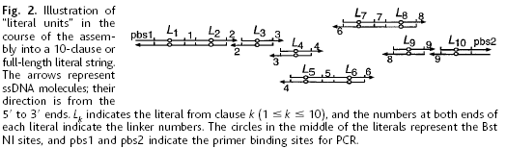

These DNA molecules for 30 literals from the 10 clauses(3 literals per
clause) were mixed in a test tube and concatenated with DNA ligation,
and the ligation products were separated by gel electrophoresis.
Note：
1. A literal string is a linear assembly of 10 literal DNA molecules.
2. 30-base literal sequences are concatenated.
3. 4-base linkers.
4. The full-length literal strings = 4*11+30*10 = 344.

(2)、Allow ssDNA molecules, each representing a literal string, to form
hairpins(Fig. 1). This step is implemented by regulating the temperature.
If the concentration of the template is kept low enough to allow hairpin formation.
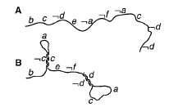
(3)、Remove the hairpin-forming molecules.
Enzymatic digestion is used to remove hairpin DNA.

Created by:Chen-Shun Liu
Date:Apr. 22, 2004

