Longest Common Subsequence between Run-length-encoded Strings: A New Algorithm with Improved Parallelism
V. Freschi, and A. Bogliolo
Information Processing Letters, Vol. 90, pp. 167-173, 2004.

- Method:
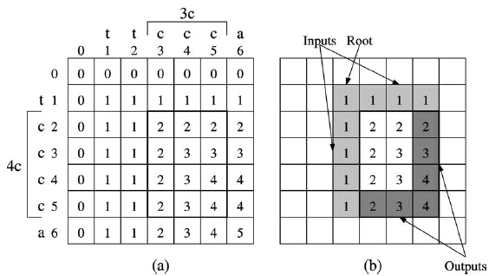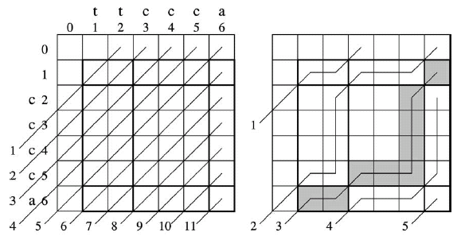
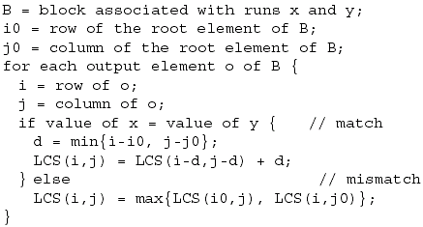

Time complexity: 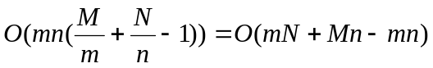
- Application to Edit Distance
The proposed approach can be applied to the related problem of ED when
C_{sub}≧C_{ins}+C_{del}
Created by : Chu-Ting Tseng
Date : May 14, 2004

