Detecting Overlapping Coding Sequences with Pairwise Alignments
Andrew E. Firth, Chris M. Brown
Bioinformatics Advance Access published on September 3, 2004.
- Introduction
- Overlapping CDSs occur where a nucleotide sequence codes for two different amino acid sequences in different read-frames.
- There are five possible read frames for a ‘secondary’ ORF relative to a ‘primary’ ORF which we label –3, -2, -1, +1, +2.
- Overlapping CDSs occur frequently in viruses, where they serve as a mechanism for fitting more genetic information into a small genome and for coregulating gene expression.
- In HBV virus, ~50% of the genome comprises overlapping CDSs.
- Current gene-finding algorithms are combination of (a)signal (e.g. splice sites, ORFs), (b) content (e.g. codon bias), (c) similarity to known sequences or conservation between species (d) expression in cDNA/EST libraries.
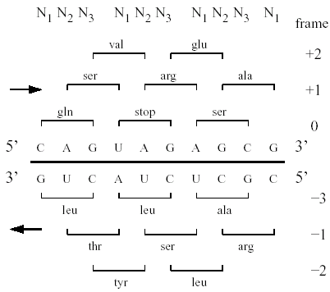
- Methods
- Double-coding Test Statistics
- N123: Mutation Rate in N1, N2, N3
  - For N123 we simply count the number of nucleotide differences between S1 and S2 in each of N1, N2, N3.
- NsNn: Synonymous and Nonsynonymous Mutation Rates
  - We step through aligned codon pairs in the primary read-frame of S₁ and S₂ and count which codon pairs are identical, non-identical but synonymous, and nonsynonymous.
- MLOGD: Maximum Likelihood Method
  - The evolution of a single-coding sequence is often modified as Makov process.
  - The probability of S₁ mutating to S₂ after time t may be expressed as 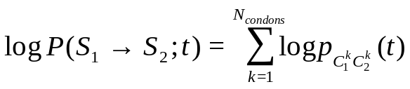 where [p_{ij}(t)] = P(t) = exp(Q_{t}), where Q_{t} is a 64×64 matrix of ‘instantaneous’ codon mutation probabilities.
  - In case of overlapping CDSs, cross-talk between adjacent codons prevents the factorization-by-codon.
  - In theory, instead of 64×64 codon matrix, we must define a single 4^{N}×4^{N} matrix that describes the entire sequence at once
  - For each nucleotide pair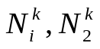 in S₁,S₂, we estimate the probability that 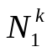 mutates to 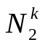 for each of the single-coding and double- coding models.
  - We define for the single-coding model, and for the double-coding model. Also P(t)=exp(Qt), and Q, C, A are nucleotide, codon, amino acid substitution matrices.
  - The probability that mutates to , after time t, is given by 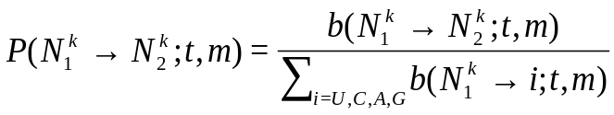, so 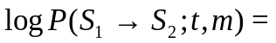 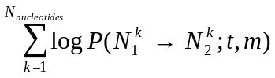, we maximize it respect to t for each of the models, giving t^{s} and t^{d} respectively.
  - . If Δ_{s,d} is positive, then the observed mutations between S1 and S2 are more consistent with double-coding, vice versa.
- Monte Carlo Sequence Evolution Model
http://psroc.phys.ntu.edu.tw/bimonth/v11/163.pdf
- Classification
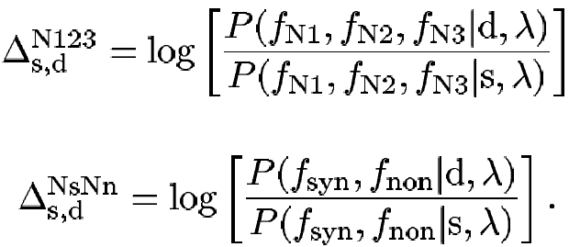
- Results
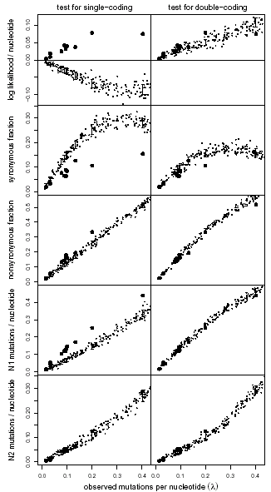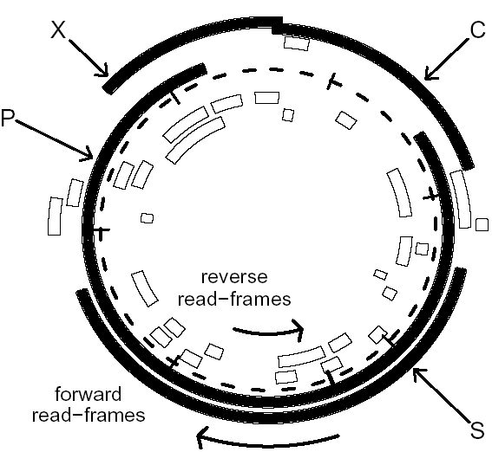

Created by : Chiu-Ting Tseng
Date : Sept. 10, 2004

