Constructing Optimal Trees from Quartets
David Bryant and Mike Steel

Journal of Algorithms, Vol. 38, pp. 237-259, 2001
Abstract
We present fast new algorithms for constructing phylogenetic trees from quartets (resolved trees on four leaves). The problem is central to divide-and-conquer approaches to phylogenetic analysis and has been receiving considerable attention from the computational biology community. Most formulations of the problem are NP-hard. Here we consider a number of constrained versions that have polynomial time solutions. The main result is an algorithm for determining bounded degree trees with optimal quartet weight, subject to the constraint that the splits in the tree come from a given collection, for example, the splits in the aligned sequence data. The algorithm can search an exponentially large number of phylogenetic trees in polynomial time. We present applications of this algorithm to a number of problems in phylogenetics, including sequence analysis, construction of trees from phylogenetic networks, and consensus methods.

- Applications

- Analysis of sequence data.
- Extracting trees from phylogenetic networks.
- Consensus trees, bootstrapping and quartet puzzling.
- Optimal trees with excluded quartets.
- Optimal trees with a given circular order.

- Basic Definitions
- split 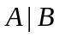:
A partition of the leaf set in to two nonempty parts,  and .
- Quartet 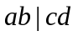:
A resolved phylogenetic tree on four leaves {a, b, c, d}.
- 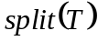: The set of all splits in .
- 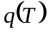: The set of quartets that agrees with.
- Weight of the tree :
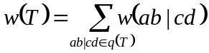 is the total weight of all the quartets.
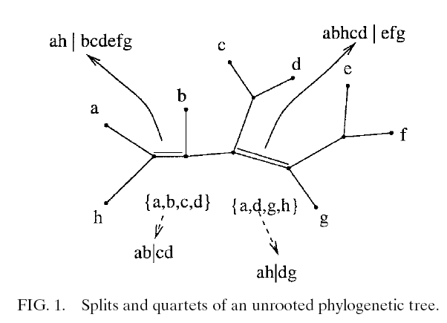

- Set of splits in three different levels: (for summarizing the result)
  - Compatible: 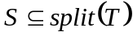 for some tree .
  - Weakly compatible:
For every 3 splits 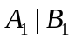, 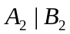, 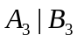, at least one of the intersections 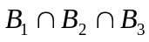, 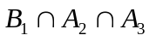, 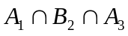, 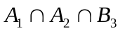
  - Maximum weakly compatible: 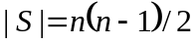
- Problem: Split Constrained Quartet Optimization
- Instance:
  - Weighting for the quartets.
  - Leaf set .
  - Set of splits of .
  - Degree bound . (e.g. binary tree: 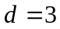)
  - Rational number . (lowest scores that acceptable)
- Question:
Is there a tree with vertex degree bounded by and 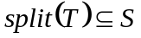 such that 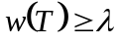?
- Result:
Let 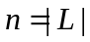 and 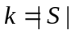. The computational complexity:
  - Polynomial time solvable for bounded . 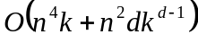
  - NP-complete without the degree bound .
  - Polynomial time solvable without degree bound where all quartet weights are nonnegative and is maximum weakly compatible.
  - NP-complete where the quartet weights can be negative and is unbounded.

- Constrained Quartet Optimization Algorithms
- Decomposition table:
The key component of the dynamical programming algorithm.
  - 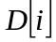: The list of possible unordered tuples.
  - 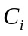: The set of all leaf according to .
  - 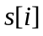: The number of possible trees according to .
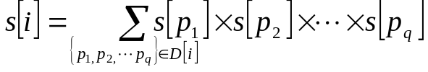
e.g.

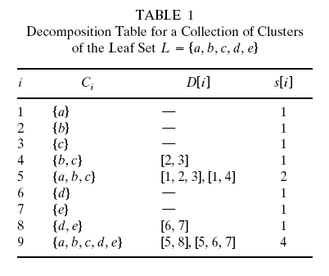
- Rooted tree and unrooted tree.
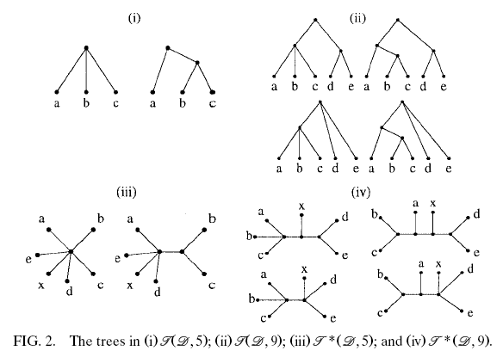
- Algorithm:
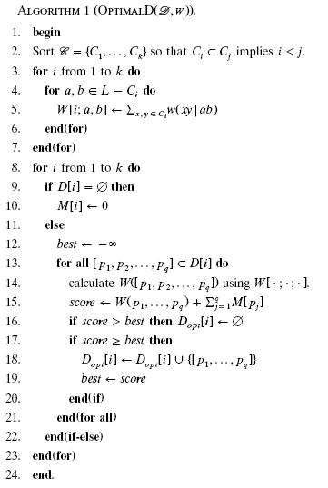

Created by : Hsing-Yen Ann
Date : Sept. 30, 2004

