Optimal Tree 3-Spanners in Directed Path Graphs
Hoàng-Oanh Le, Van Bang Le
Networks Vol. 34 No. 3 (1999), 81-87
Abstract
This article shows that each directed path graph G has a tree 3-spanner T by means of a linear-time algorithm constructing T. Moreover, the output tree 3-spanner T is optimal in the sense that G has a tree 2-spanner if and only if T is a tree 2-spanner of G.
- Introduction

Given a Graph G=(V,E), a spanning tree T is a tree t-spanner if for every 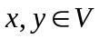, 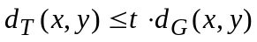, where 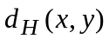denotes the distance between andin a graph H.

A graph G is said to be a directed path graph if there exists a (rooted) directed tree B and a family of directed paths 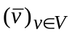in B such that,
for all vertices 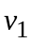,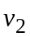,
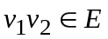if and only if 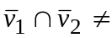.

Interval graph

Maximal Clique : maximal complete subgraph of G

Triconnected components : maximal triconnected subgraph

k-cut : a set of k vertices whose deletion disconnects the graph

binding edge : if {x,y} is a minimal 2-cut, then xy is binding edge

Lemma :
- xy is a binding edge of G if and only if there is an integer 1s<c such that {x,y} = 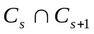.

- Let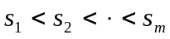be all integers in {1,2,..,c} such that 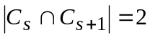
(1 i m), and write 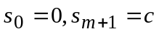. Then
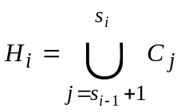 ,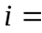1,2, .. ,m+1
are exactly the triconnected components of G.

nonseparable graph : A graph has no 1-cut
- Optimal Tree 3-Spanners in Interval Graphs
Algorithm 1
Input : An interval graph G=(V,E)
Output : A tree 3-spanner T of G such that T is a tree 2-spanner if and only if G has a tree 2-spanner
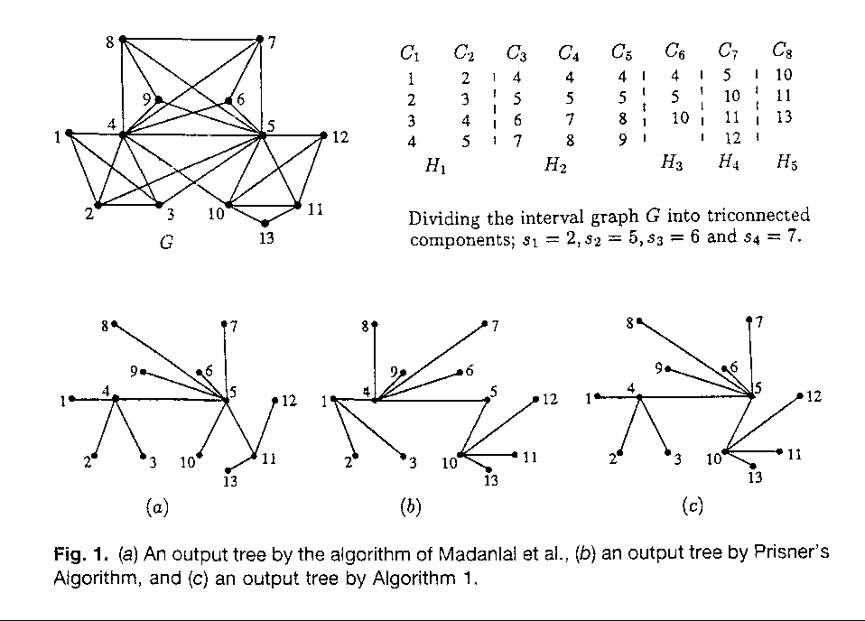
- Optimal Tree 3-Spanners in Directed Path Graphs
Algorithm 2
Input : A directed path graph G=(V,E)
Output : A tree 3-spanner T of G
The algorithm works on the cliques of G in an order like depth first search in B.
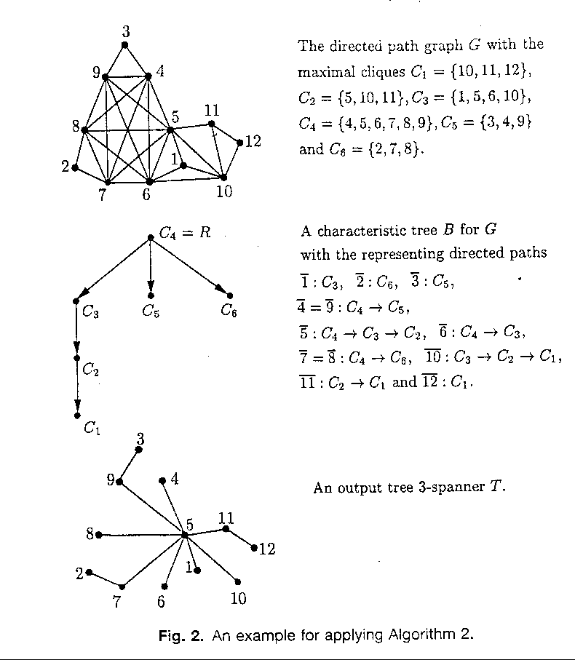
Lemma : Let G be a nonseparable directed path graph. If G has a tree 2-spanner, then G is a interval graph.

Lemma : Any directed path graph contains a tree 3-spanner. An optimal tree 3-spanner can be constructed in linear time.
- Conclusion
Created by : Jenn-Dar Chang
Date : Nov. 1, 1999

