OPTIMALLY ROUTABLE NETWORKS
ARTHUR M. FARLEY
Parallel Processing Letters Vol.8 No.4 (1998) 567-575
Abstract

This paper presents a model for representing and evaluating the complexity of routing for the message transfer task and specifies a notion of optimally routable network in terms of this model. Finally, it presents an algorithm to construct a class of optimally routable network.
- Introduction
Routing is the process, executed at each site upon receipt of a message (either from the local processor or from a neighbor site) that determines whether the message is to be received locally or to which neighbor the message is to be sent.

This paper means shortest path routing, whereby a message is forwarded along a path of shortest length to the receiver.

Specification of a communication network consists of two aspects :
Topology (relatively static aspect of the network) : as the set of sites, how they are interconnected by lines,..
Operation (general properties) : a store-and-forward or broadcast network
- A Model of Routing

Let A be the set of address assigned to site of a network. Given receipt of a message, site s computes the routing function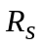:A[0,..,deg(s)]. The routing function maps address of possible (assume all sites are possible receivers) to the output queue for the edge incident with s that is to be used to forwarded the message toward its receiver or to a local receiving queue when the message has site s as its receiver.

A routing tree is a classification (decision or decoding) tree that tests the high-order bit of a receiver’s address at its root and considers subsequent bits of receiver’s address at successive levels of the tree.

The routing process at site s proceeds from the root of its routing tree according to successive bits of the receiver’s address, until a leaf is reached and an output generated.

A network is optimally routable if it has an address assignment such that each site has a routing tree of size (ie. number of internal nodes) at most 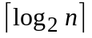.(ex: Hypercubes network, Binomial trees)

A network is efficiently routable if it has an address assignment such that each site has a routing tree that is of size 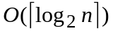.(ex: Trees with constantly bounded vertex degree are efficiently routable)

For some topologies, there does not exist an assignment of address that provides for optimal or efficient routing. (consider any site in a complete network or the central site of a star, the routing tree at any site must have size n-1)
- Algorithm for constructing Optimally Routable Graphs
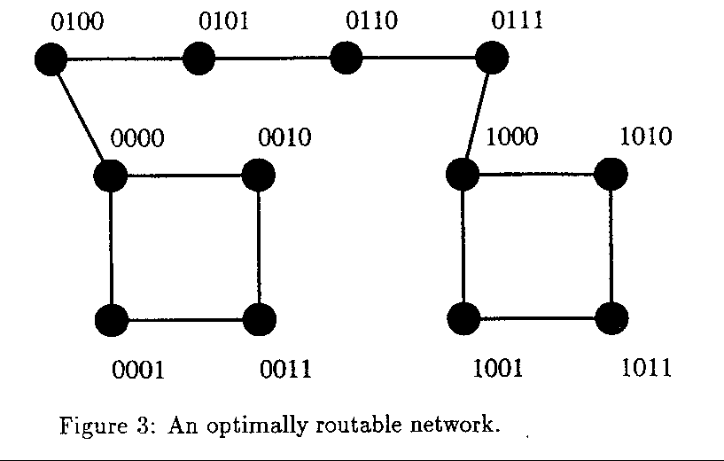4. Conclusion
Created by : Jenn-Dar Chang
Date : Aug.10, 1999

