Parallel Computations on
Reconfigurable Meshes
Russ Miller, V.K. Prasanna-Kumar,
Dionisios I. Reisis, and Quentin F. Stout
IEEE TRANSACTIONS ON COMPUTERS, Vol. 42,NO. 6, June 1993, p678-692
Abstract

This paper introduces the mesh with reconfigurable bus (reconfigurable mesh) as a model of computation, and introduces a verify of fundamental data-movement operations for the reconfigurable mesh.
- Introduction
The mesh with reconfigurable bus (reconfigurable mesh) of sizeconsists of an 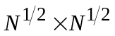array of processors connected to a grid-shaped reconfigurable broadcast bus, where each processor has four locally controllable bus switches.
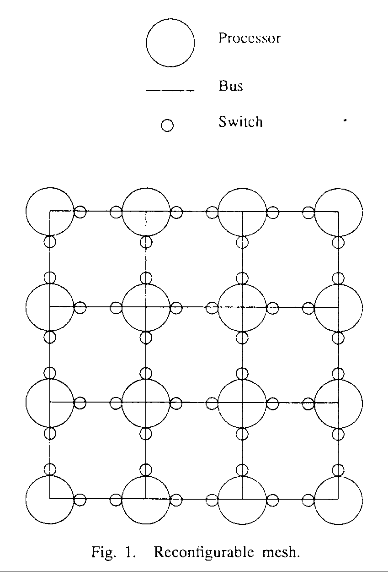
The switches allow the broadcast bus to be divided into subbuses, providing smaller reconfigurable meshes.

Two models to be considered:
(1)EW PRAM (Exclusive write model)
(2)CW PRAM (Concurrent write model)

Two computational models be discussed with respect to the delay that a broadcast requires :
- The unit-time delay model : assume the all broadcast take 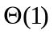time
- The log-time delay model : broadcast take 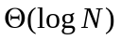time

Row (column) broadcast :
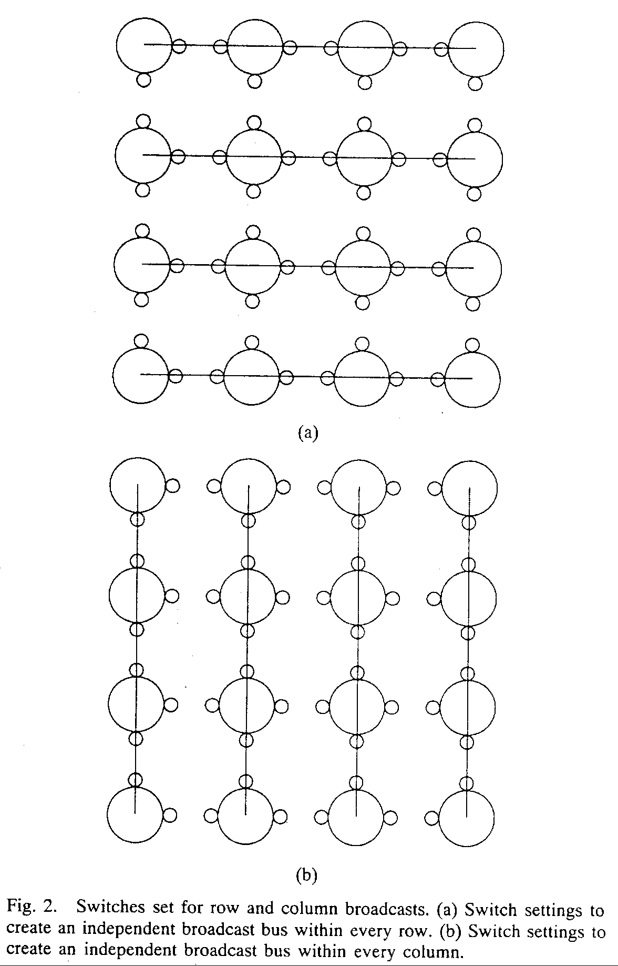

For some alg., it is useful to view the mesh as a linear array or processors :
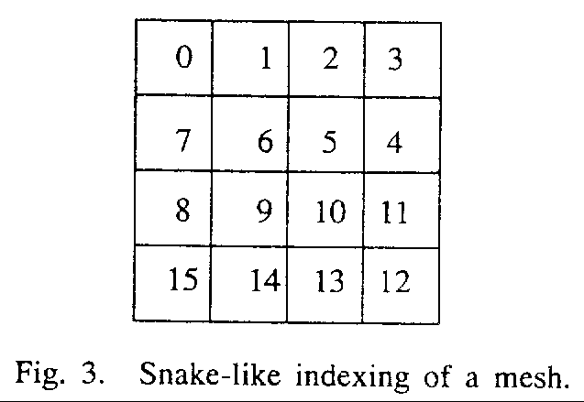
- Data Movement Using Reconfigurable Buses
Computing the logical OR operation :
Input : 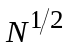 bits of data stored one bit per processor in the th row of the reconfigurable mesh
Output : result in 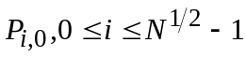
Time : time using unit-time delay model, and time using log-time delay model.

Computing the XOR operation :
Input : bits of data are stored one per processor in row 0
Time : time using unit-time delay model, and time using log-time delay model.
Motivation : first computing the XOR of values stored in even-numbered processors, then computing the XOR of values stored in odd-numbered processors and finally combining these two results.
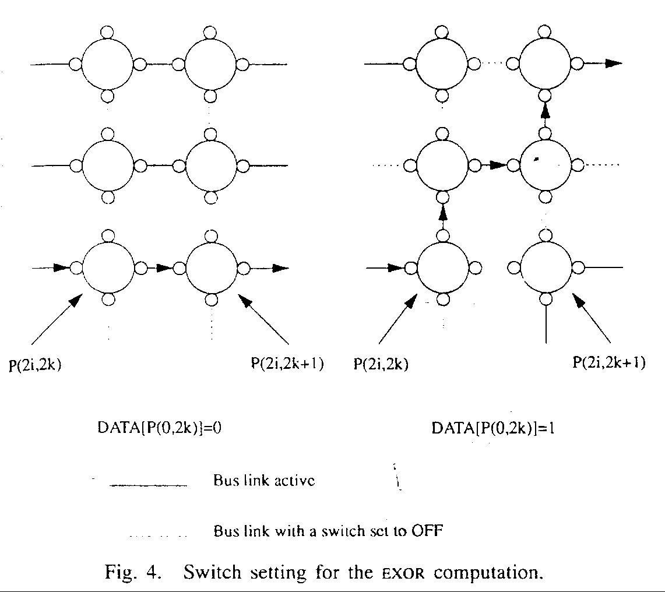
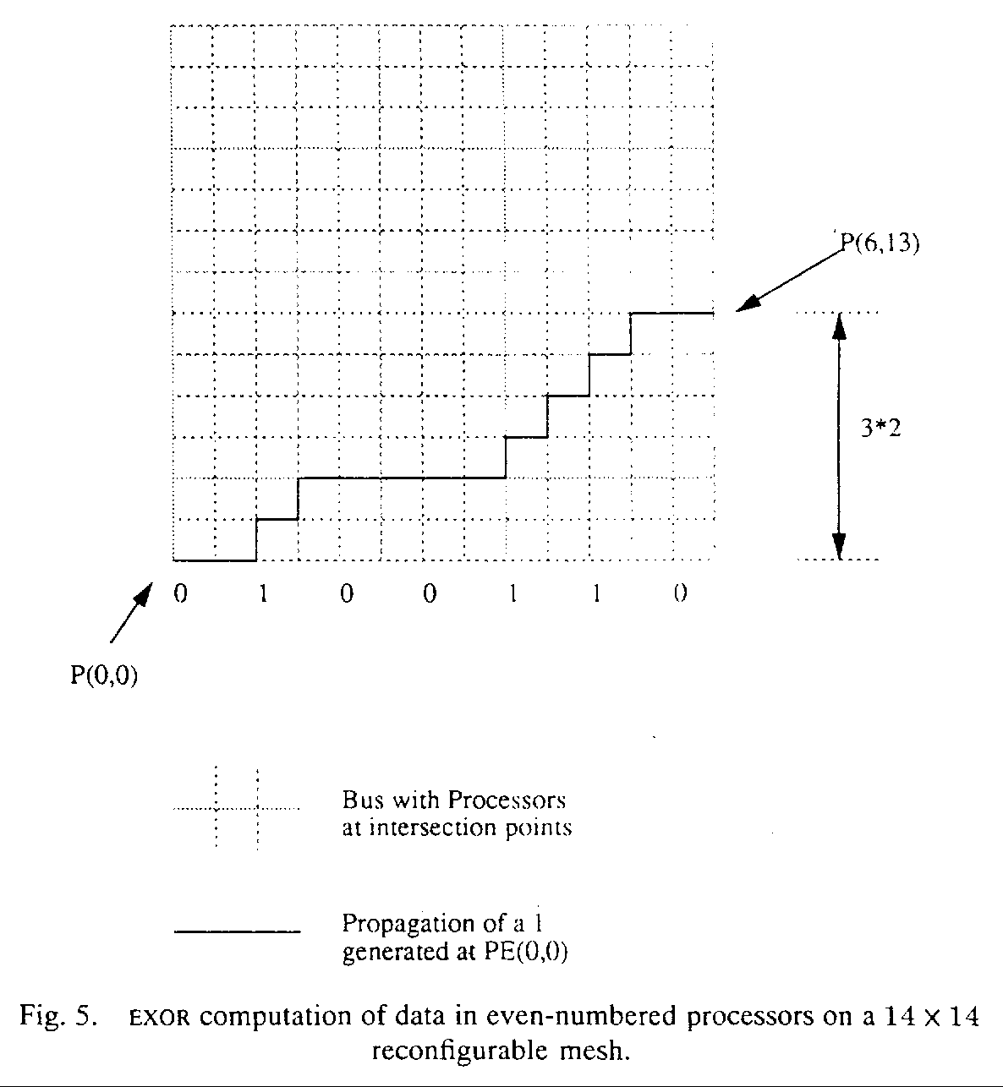
Find maximum :
(1)Input : values 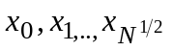stored in a row of a reconfigurable mesh of size N
Time : time using unit-time delay model, and time using log-time delay model.

(2)Input : N values stored one value per processor
Time : 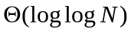(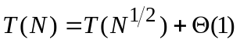) in the unit-time delay model and
(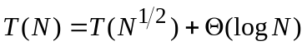) in the log-time delay model.

Parallel prefix is an important operation that can be used to sum values, broadcast data, solve problems in image processing, solve graph problems.

The parallel prefix problem requires every processor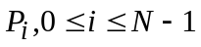to determine the th initial prefix 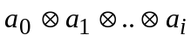,where is a binary associative operator.
An efficient mesh-based algorithm :
Assume the indexing of the processors is row major.

RAR (random access read) : models concurrent read
RAW (random access write) : models concurrent write
Algorithm for data may be moved in RAR or RAW (in order to maintain consistency, assume the master record in northwest processor)
Input : some data may be moved to the northwest processor
Time : 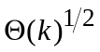time using unit-time delay model, 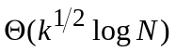time using log-time delay model
- Conclusion
Created by : Jenn-Dar Chang
Date : Sep. 7, 1999

