A CONSTANT TIME PARALLEL DETECTION OF REPETITIONS
EMMANUEL DELACOURT, JEAN-FREDERIC MYOUPO
and DAVID SEME
Parallel Processing Letters Vol. 9 No. 1 (1999), 81-92
Abstract

This paper describes a constant time solution to the detection of repetitions (with overlapping) problem using the one criterion BSR model. If the problem is only to detect the existence of any repetition then processors suffice, where n is the length of the string. If all repetitions are to be found then 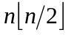 processors suffice.
- Introduction

A repetition of a string  is a substring 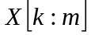 for which there are indices , (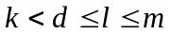) such that :
- 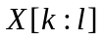 is equivalent to 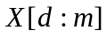,
- 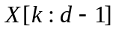corresponds to a primitive word (=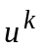 implies =and 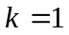),
- 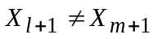

 is a period of a repetition of if 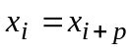 (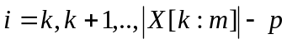). Therefore 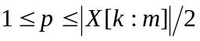
- BSR Model

Broadcast with Selective Reduction (BSR) is a extension of the CRCW PRAM, permitting an additional form of concurrent access of shared memory, namely the BROADCAST instruction.

Let us define the following symbols :
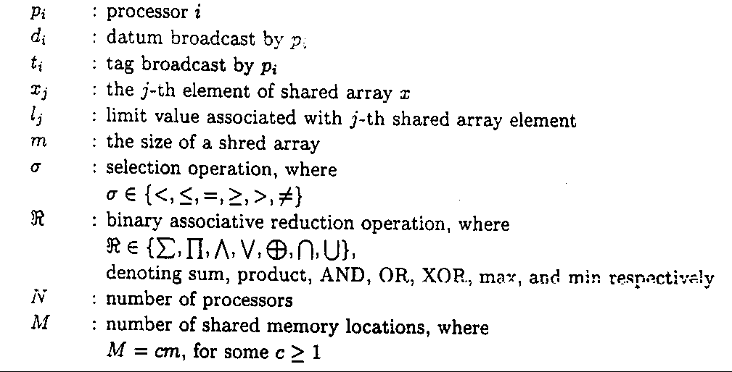
Then the BSR BROADCAST instruction is denoted by :
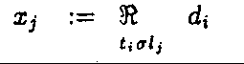
- Algorithm
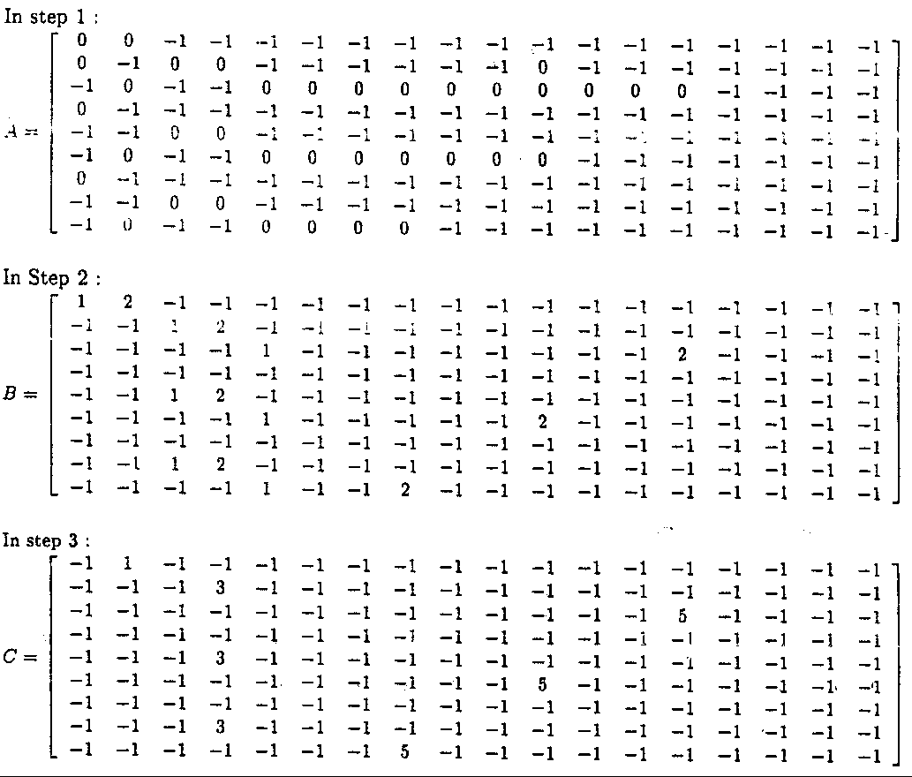
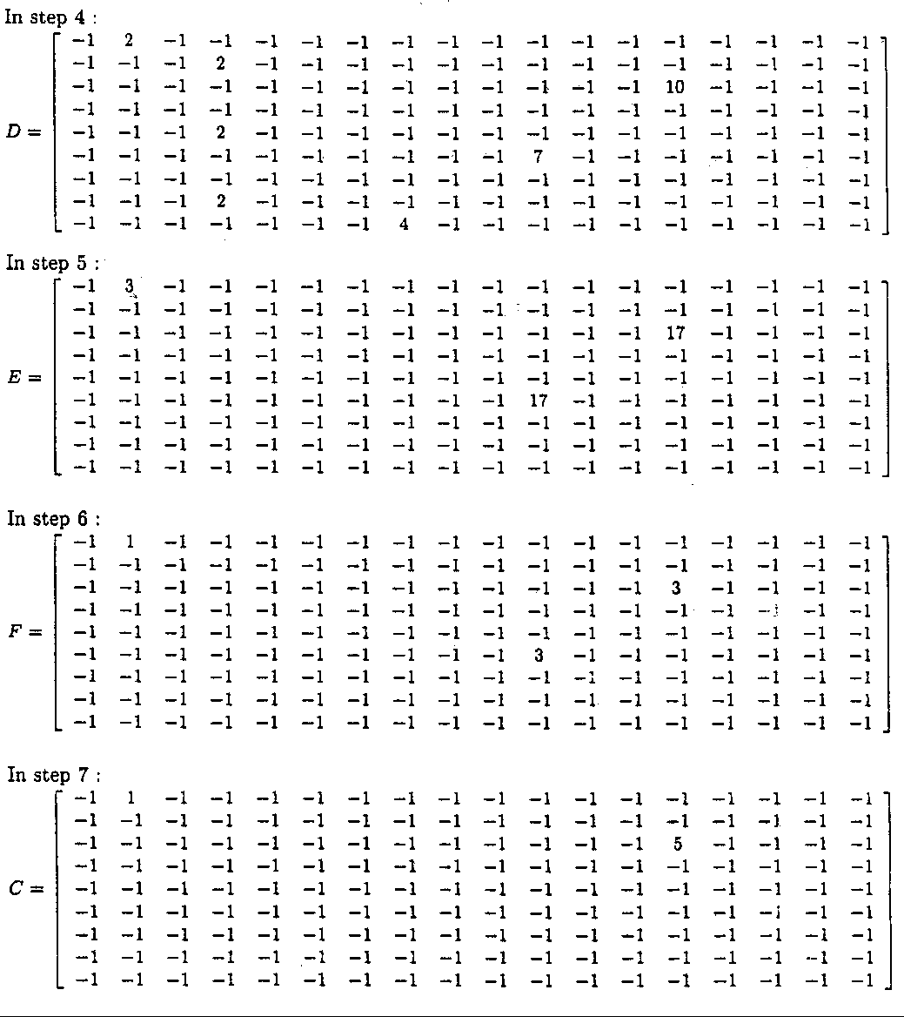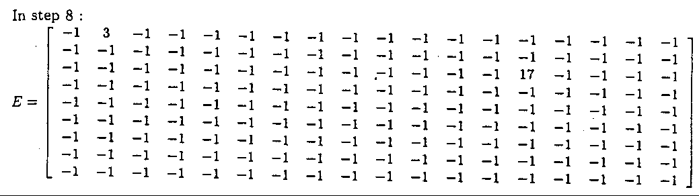
- Conclusion
Created by : Jenn-Dar Chang
Date : Sep. 28, 1999

