A SELECTION ALGORITHM FOR X+Y ON MESH
TARUN ANAND and PHALGUNI GUPTA
Parallel Processing Letters Vol. 8 No. 3 (1998), 363-370
Abstract

This paper presents a selection algorithm for finding the k-th largest element in the cartesian sum of two sets X and Y, each of size n, on a mesh connected model.
- Introduction

The cartesian sum of X+Y can be defined as

Selection in X+Y may be used to calculate the Hodges-Lehmann estimator in statistics.

The problem also finds application in other areas such as finding the p-center in weighted tree like networks and optimum distribution of effort where a number of concave functions are given.
- Parallel Algorithm
Candidate set : the set of elements which can be the k-th element

The algorithm selects the k-th element through iterations.
At an iteration, it either discard certain number of elements from the candidate set or gets the k-th element.

Pruning the candidate set is done by a partitioning element (pseudo weighted median)
Pseudo weighted median is an element in the set which is greater than at least one fourth and less than at least one fourth of the elements in the set.
Ex: A1,..,Al (# of elements w1,..wl, W=w1+..+wl)
Median : m1,..ml (sort order:m1’,..ml’ and corresponding weights be w1’, .., wl’), then mw (mi’) is pseudo weighted median, if exists i such that 1 <= i <= l satisfying :

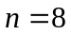, 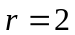,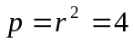
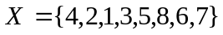
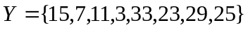
Step 1: 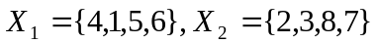
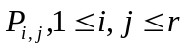is allocated 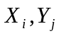 and sorts sequentially.
Step 2: Each processor sets the local variables
OffsetOne = 0
OffsetTwo = 0
Total = 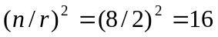
Step 3: while
- Conclusion
Created by : Jenn-Dar Chang
Date : May.11, 1999

