An Adaptive Causal Ordering Algorithm to Mobile Computing Environments
Ravi Prakash, Michel Raynal, and Mukesh Singhal
JOURNAL OF PARALLEL AND DISTRIBUTED COMPUTING, 1997, p190~p204
Abstract
This paper presents an algorithm that uses the knowledge that by eliminating other kinds of control information from the messages to efficiently enforce causal ordering of messages.
- Introduction

A distributed system is composed of a set of processors connected to each other by a communication network.

A mobile computing system is a distributed system consisting of a number of mobile and fixed processing units.

The execution of a process consist of three types of events: message send, message delivery, and internal events
Internal events: local computations at the processes.
- SYSTEM MODEL

The happened before relation induces a partial ordering on events based on their causal dependencies
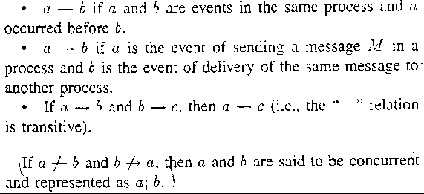
The happened before relation between events has been defined as :
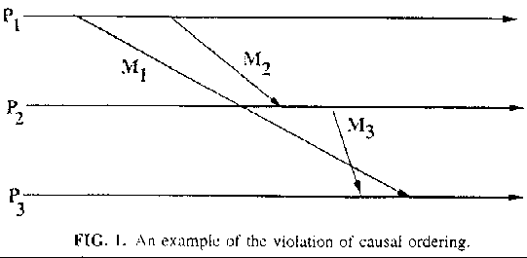
Events a, b, and c mentioned above can be either message SEND, message DELIVER, or internal events of the processes.
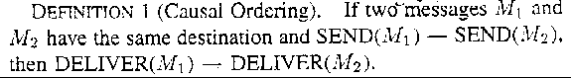
- MOTIVATION AND BASIC IDEA

Each Message needs to carry information only about its direct predecessor messages with respect to each of its destination processes.

3.1 An Example

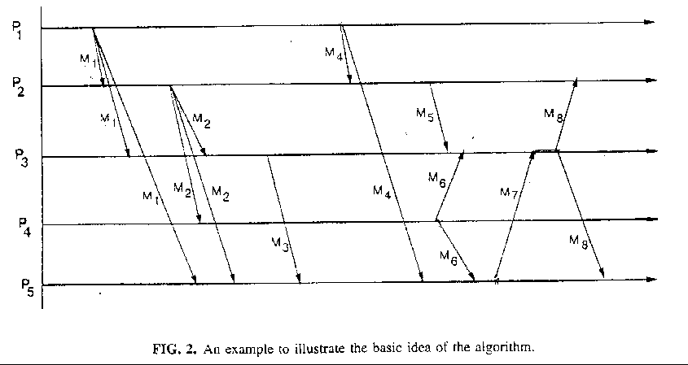
4.ALGORITHM FOR CASUAL ORDERING
4.1 Data structures
This algorithm assume the process sending message does not belong to 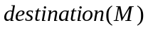
Each process 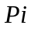 maintains an integer counter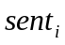 to count the sequence number of messages it has sent so far to all the other messages.
also locally maintains an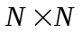 integer matrix, called 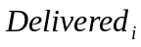, to track dependency information.(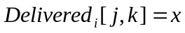 denotes 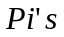 knowledge that all the messages sent by process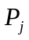 to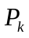, whose sequence numbers are less than or equal to, have been delivered to)
Each process also maintains a vector  of lengthto stores direct dependency information.(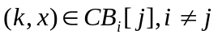)
The message carries the tuple 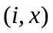 identifying the source of the message and its sequence number at the source.

4.2 The Algorithm

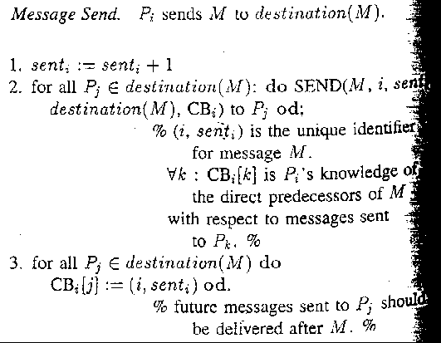
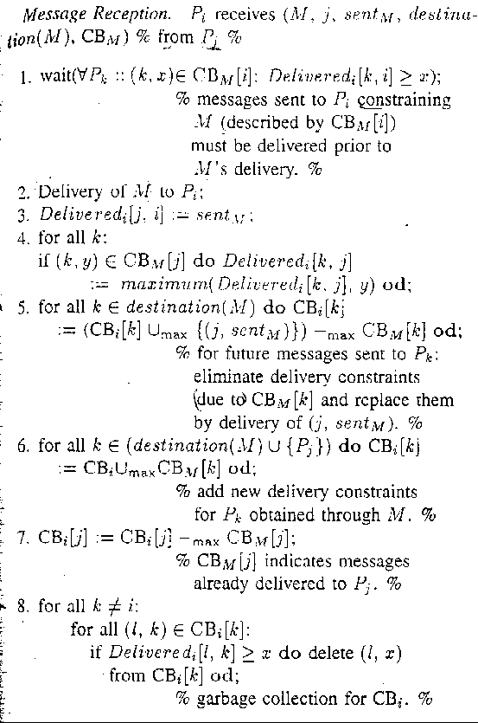
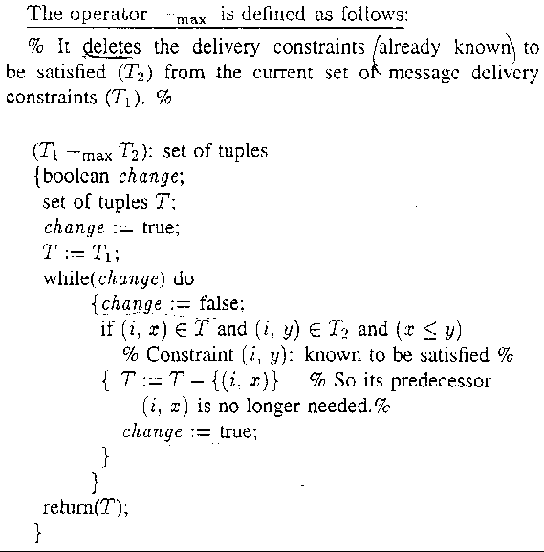
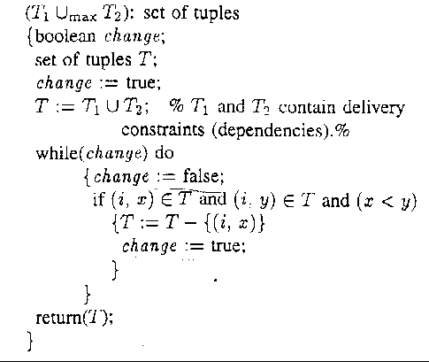
5.Conclusion
Created by : Jenn-Dar Chang
Date : May.17, 1999

