An Interleaving Transformation for Optimizing Reductions
Jan-Jan Wu
中華民國 86 年全國計算機會議, E-52 ~ E57
Abstract
This paper presents a general compilation approach, interleaving transformation, for parallelizing reductions in loops. This optimization exploits parallelism embodied in reduction loops through combination of data dependence analysis and region analysis.
- Introduction

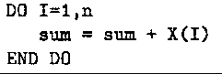
A reduction occurs when a location is updated on each loop iteration with the result of a commutative and associative operation applied to its previous contents and some data value.
One way for parallelism: divide n values using p processors
Loops that only contain dependences caused by the reduction statement, we call this class reductions basic reductions.

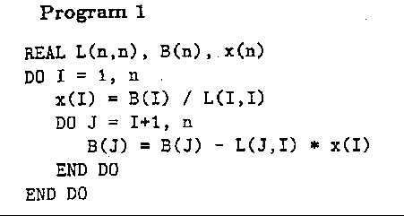
Not all reductions are basic, consider following Program 1, which solves a triangular linear system:
Two kind of data dependences exist in the outer loop:
A loop-carried dependence caused by the reduction statement, and
a loop-carried dependence caused by computing the value of 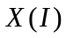
2. A motivating Example
Parallel implementation in SPMD (Single Program Multiple Data) model
2.1 Straightforward Implementations
Straightforward Parallel Implementations of the Triangular Solver
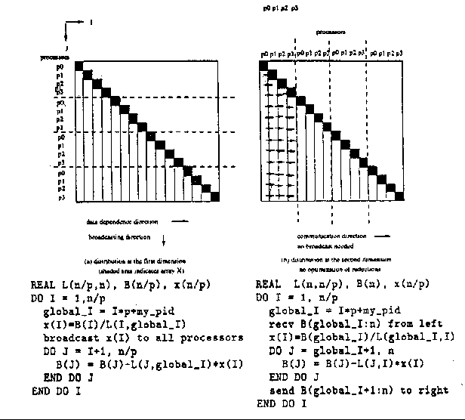
Fig1(a): Parallelization of reductions is not possible since all the outerloop iterations are assigned to a single processor
Fig1(b): Without parallelization, the computation for reductions is sequential and communications between adjacent processors are required for each outer loop iteration

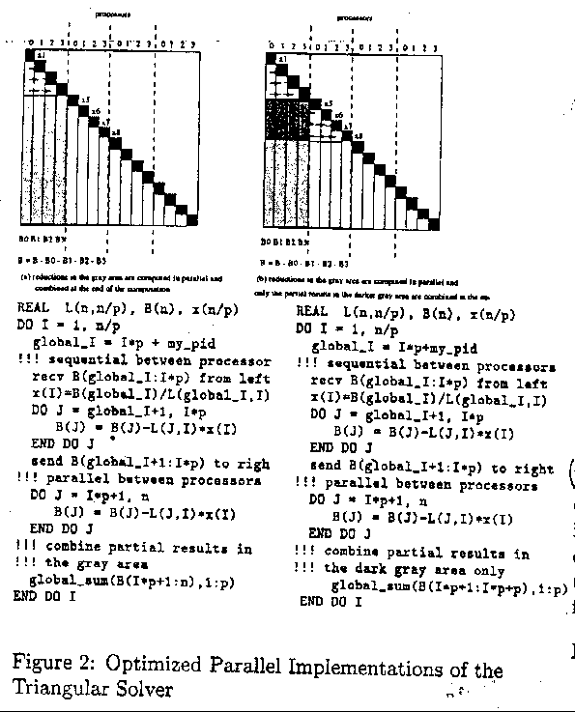
2.2 Optimized Implementations
- Input Loop Forms
A iterative spatial loops nest, consists of, zero or more levels of iterative loops followed by zero or more levels of dependent spatial loops, and then followed by one or more levels of parallel spatial loops.
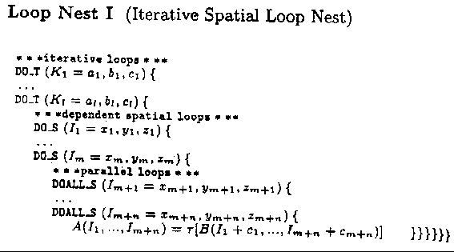
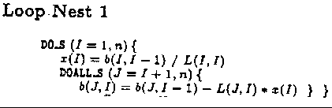
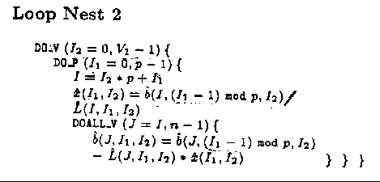
Loop Nest 1 and Loop Nest 2 are the iterative spatial loop nest and partitioned loop nest for Program 1,respectively.
- Transformation
  - Data Dependence Representation
․c (constant) :
․v (variable)
․r (reduction)
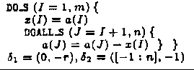
․[x:y] (interval)
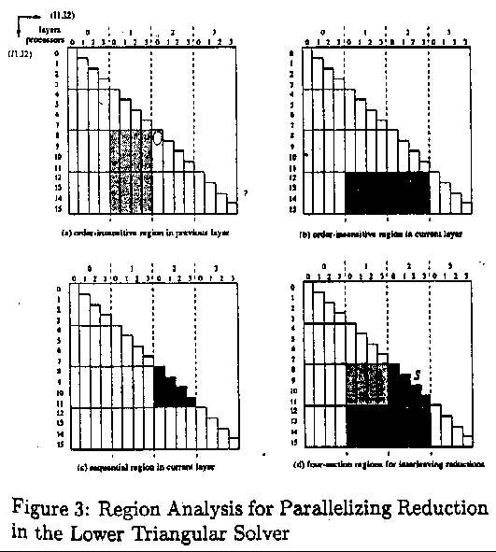
  - Region Analysis
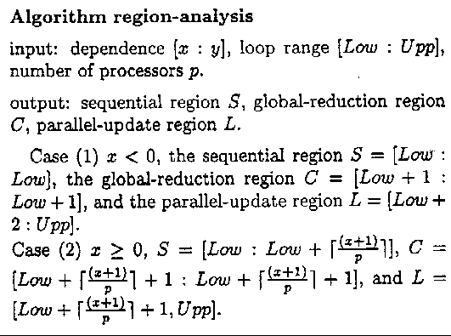
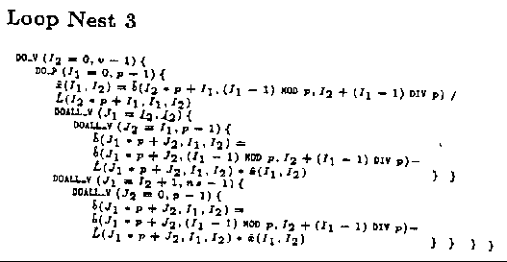
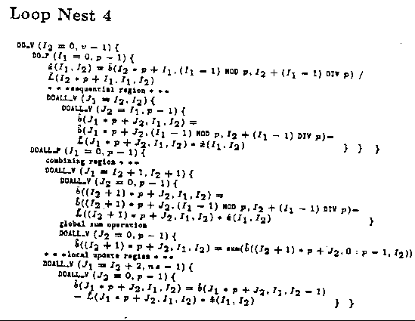
4.3 Transformation Procedure
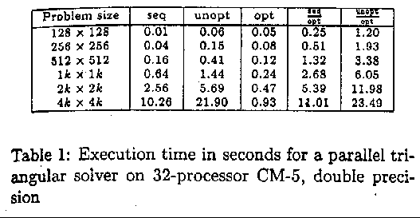
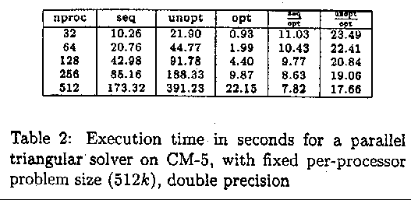
- Experimental Study
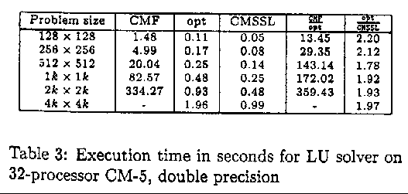
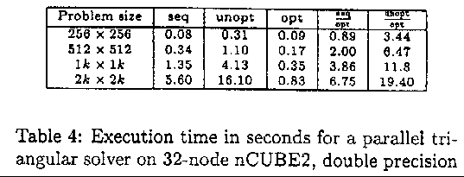
6.Conclusion
Created by : Jenn-Dar Chang
Date : May.11, 1999

