Another Fastest Systolic Algorithm for the Longest Common Subsequence Problem
Yen-Chun Lin, Jyh-Chian Chen
Dept. of Electronic Engineering NTU of Science and Technology
yclin@et.ntust.edu.tw, george@elc1.lhjc.edu.tw
Abstract
In this paper, a fast systolic algorithm for the LCS problem is presented. For two strings of length m and n, where m n, the problem can be solved in m + 2n – 1 time steps. The algorithm achieves the right lower bound of the computation time when symbols are input sequentially to a linear array of n processors. The systolic algorithm can be modified to take only m + n steps on a multicomputer by using the broadcast operation.
- Introduction

Robert and Tchuente propose using 2-D systolic array to solve the LCS problem in m + 5n – 3 time steps

Lin uses a linear systolic array of n PEs to solve the problem in m + 4n – 2 time steps

Lecroq et al. Propose using a linear array of n PEs to solve the problem in m + 2n time steps

Lin and Chen devise an even faster linear systolic array of n PEs to solve the problem in m + 2n – 1 time steps.
- Deriving a new systolic algorithm
A = A(1)A(2)..A(m), B = B(1)…B(n), m n
LCS(i,j) : an LCS of A(1)..A(i) and B(1)..B(j)
L(i,j) : length of LCS(i,j), 1 i m, 1jn
: empty string
It is easy to see that the following property exists:
For 1 i m, 1jn, L(i,0)=L(0,j)=L(0,0)=0,
LCS(i,0)=LCS(0,j)=LCS(0,0)=
if A(i)=B(j) then L(i,j)=L(i-1,j-1)+1, LCS(i,j)=LCS(i-1,j-1)B(j)
else if L(i,j-1) > L(i-1,j) then L(i,j)=L(i,j-1), LCS(i,j)=LCS(i,j-1)
else L(i,j)=L(i-1,j), LCS(i,j)=LCS(i-1,j)

Theorem 1: LCS(i-1,j-1) is equal to the first L(i-1,j-1) symbols of
LCS(i-1,j)
Proof: Consider case1: L(i-1,j-1) < L(i-1,j)
and case2: L(i-1,j-1) = L(i-1,j)

From Theorem 1, LCS(i,j)=LCS(i-1,j-1)B(j) is equal to
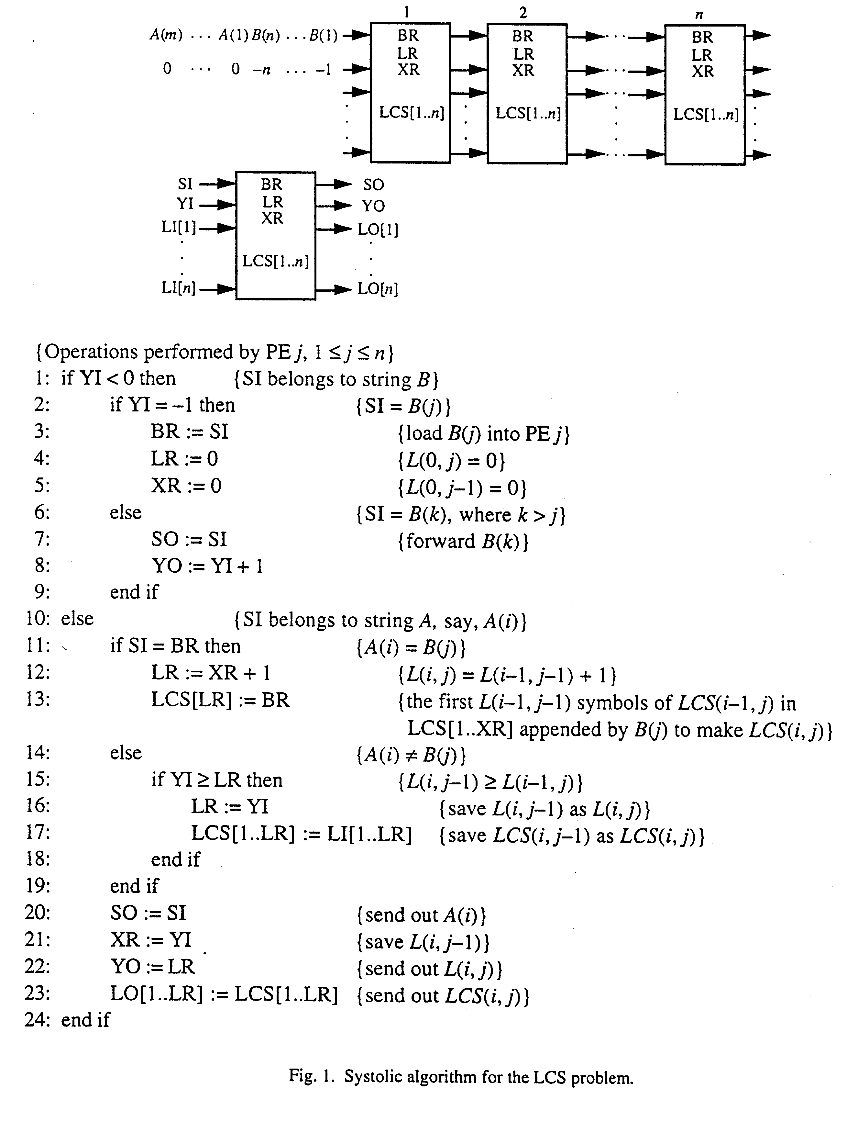
LCS(i,j) = the first L(i-1,j-1) symbols of LCS(i-1,j) appended by B(j)
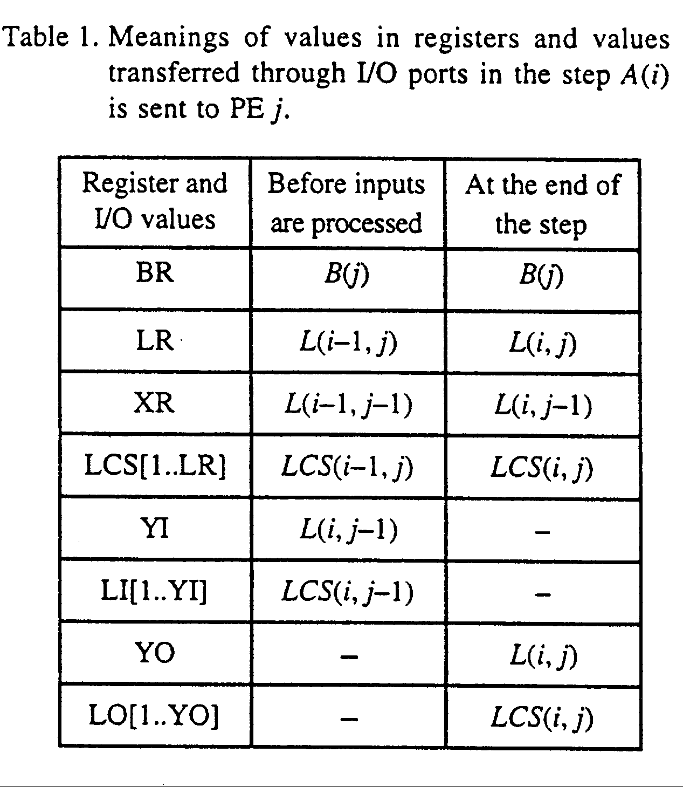
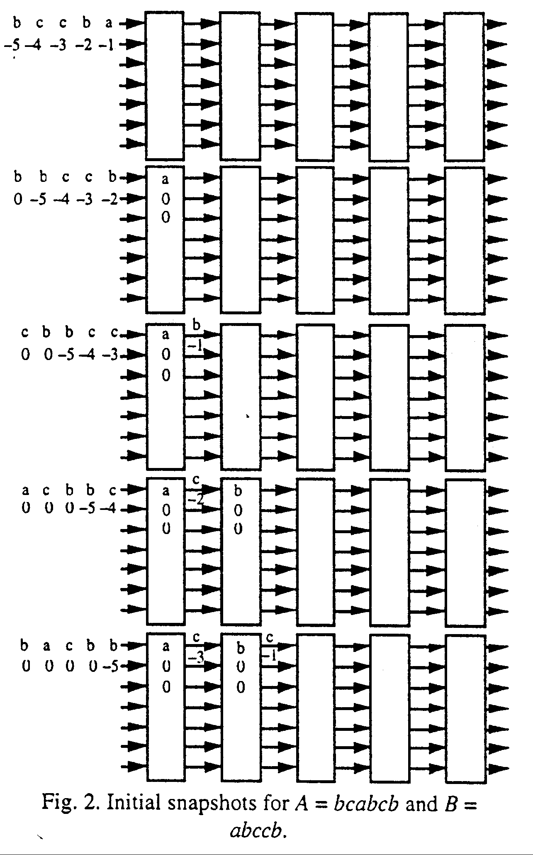
An example :
- Comparison with previous systolic algorithms

. Number of assignments in each time step :
The algorithm in this paper : at most 6 assignments
The other fastest systolic algorithm : at most 7 assignments
The second fastest algorithm : at most 6 assignments
. Number of input streams
The algorithm in this paper : 2 input streams
The other fastest systolic algorithm : 2 input streams
The second fastest algorithm : 3 input streams

Either two fastest algorithms needs in each PE one register more than the second fastest algorithm ; however, either of the two fastest algorithms uses one fewer input port and one fewer output port for each PE to transfer fewer data.
- Refinements of the algorithm
. scatter operation
. broadcast operation

Note : The scatter operation sends to each PE only 1/n of the amount of
data sent by broadcast operation, however, the scatter operation is
experimentally slower than the broadcast operation.
- Conclusion
Created by : Jenn-Dar Chang
Date : Mar.17, 1999

