An Adaptive Causal Ordering Algorithm to Mobile Computing Environments

Ravi Prakash, Michel Raynal, and Mukesh Singhal
JOURNAL OF PARALLEL AND DISTRIBUTED COMPUTING, 1997, p190~p204

Created By : Jenn-Dar Chang
Date : May.27, 1999

Outline

• Abstract
• Introduction
• System Model
• Motivation And Basic Idea
• Algorithm for Causal Ordering
• Conclusion

Abstract

This paper presents an algorithm that uses the knowledge that by eliminating other kinds of control information from the messages to efficiently enforce causal ordering of messages.

Introduction

A distributed system is composed of a set of processors connected to each other by a communication network.

A mobile computing system is a distributed system consisting of a number of mobile and fixed processing units.

The execution of a process consist of three types of events: message send, message delivery, and internal events
Internal events: local computations at the processes.
System Model

The happened before relation induces a partial ordering on events based on their causal dependencies.The happened before relation between events has been defined as :
•a↓b if a and b are events in the same process and a occurred before b.
•a↓b if a is the event of sending a message M in a process and b is the event of delivery of the same message to another process
•If a↓b and b↓c then a↓c
System Model(Conti)

Events a, b, and c mentioned above can be either message SEND, message DELIVER, or internal events of the processes.

Definition (Causal Ordering). If two messages M1 and M2 have the same destination and SEND(M1)↓SEND(M2), then DELIVER(M1)↓DELIVER(M2)

MOTIVATION AND BASIC IDEA

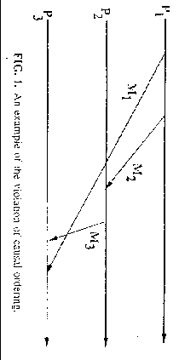
Each Message needs to carry information only about its direct predecessor messages with respect to each of its destination processes.
Algorithm for Causal Ordering

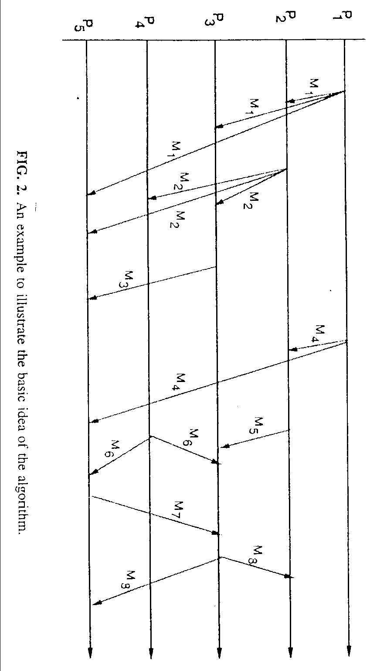

Conclusion

Causal ordering is preserved because the message delivery constraints at the destination processes ensure that a message is delivered to the destination process after its direct predece- ssor and before its direct successor messages with respect to the destination.

