A Divide-and-Conquer Algorithm to find the kth largest Element in X+Y

Chang-Biau Yang, Jenn-Dar Chang

Created By : Jenn-Dar Chang
Date : Jan. 6, 2000

Outline

• Abstract
• Introduction
• An Example
• Compute rank Algorithm
• Bound Finding Algorithm
• A Divide-and-Conquer Algorithm
• Conclusion

Abstract

Here, we presents a divide-and-conquer algorithm to find the kth largest element in X+Y. First, we use a binary search strategy to find a lower bound (or upper bound) and a lower bound pair (or upper bound pair), and then use it to divide the sequence into subsequences to find the kth largest element. Finally, we merge the lower bounds and upper bounds and the value of the lower bound is the kth largest element in X+Y.
Introduction

Selection in X+Y may be used to calculate the Hodges-Lehmann estimator in statistics.

The Problem also finds a application in other areas such as finding the p-center in weighted tree like networks and optimum distribution of effort where a number of concave functions are given.

An Example

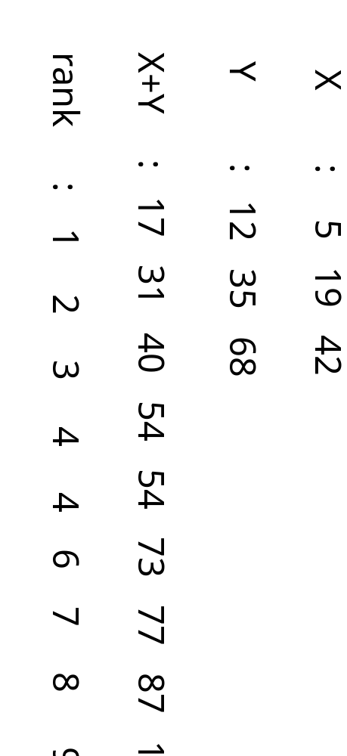

Compute rank Algorithm
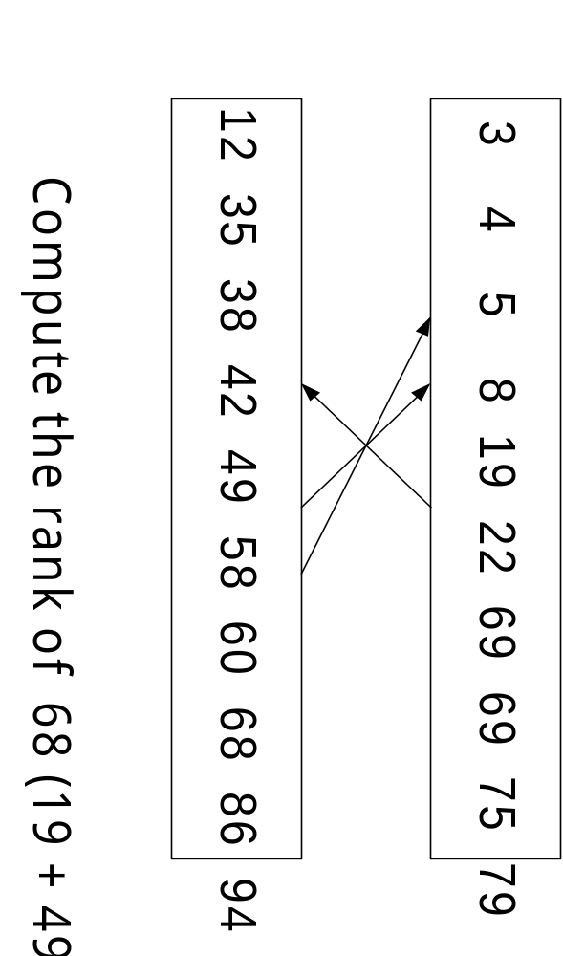
Time Complexity : O(n)
Bound Finding Algorithm
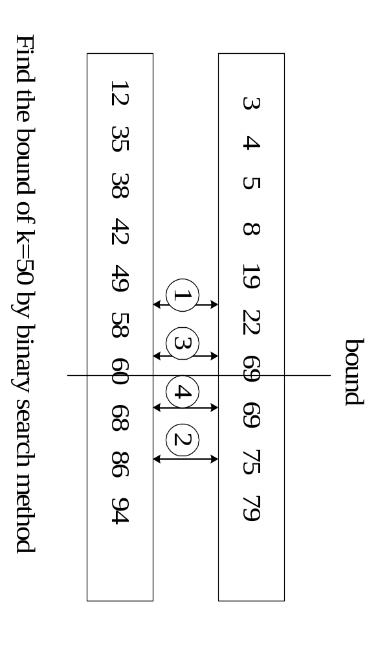
Time Complexity : O(nlogn)
A Divide-and-Conquer Algorithm
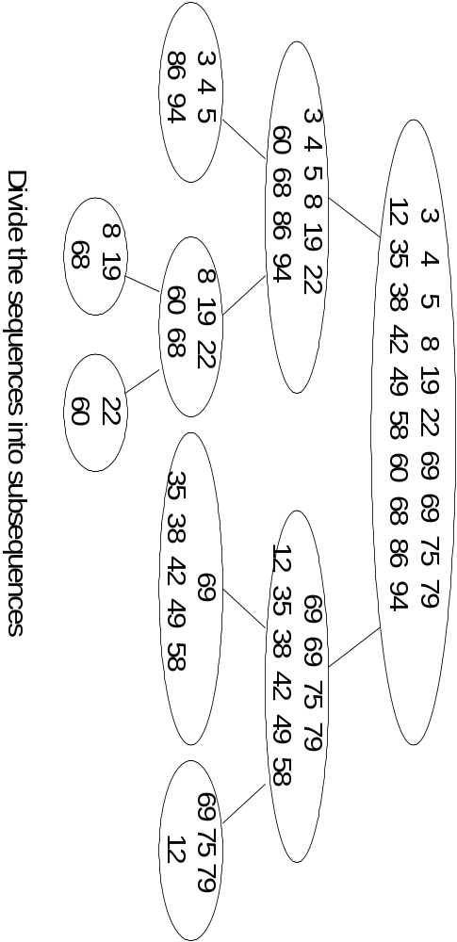
A Divide-and-Conquer Algorithm
(Conti)
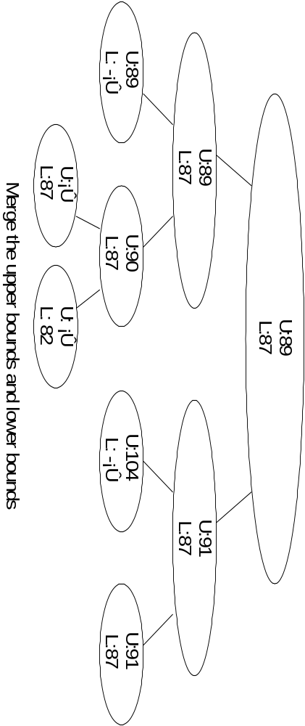
Time Complexity : O(nlogn*logn)
Conclusion
In the future, we will try to construct this algorithm under the Reconfigurable mesh Model and try to reduce the time that this algorithm to spend.
