DISTRIBUTED SCHEDULING

Abstract
This chapter has presented several key issues in load distributing and describe several load distributing algorithms .
1.Introduction
A distributed scheduler is a resource management component of a distributed operating system that focuses on judiciously and transparently redistributing the load of the system among the computers such that overall performance of the system is maximized.
2. MOTIVATION
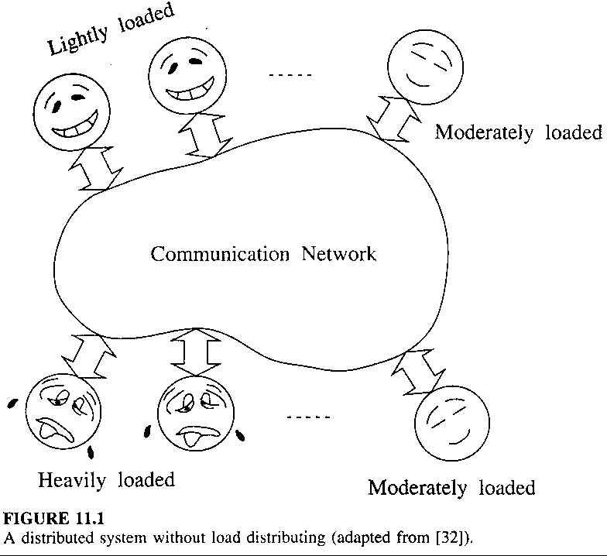
Due to random arrival of tasks and their random CPU service time requirement.

Useless of load distributing:
All processors are equally powerful and, over the long term, have equally heavy workloads.
- ISSUE IN LOAD DISTRIBUTING

Load
The CPU queue length are good indicators of load because they correlate well with the task response time.(Showed by Zhou)

Classification of Load Distributing Algorithms
Basic function: transfer load (tasks) from heavily loaded computers to idle or lightly loaded computers

Broadly characterized:
Dynamic: use system state information to make load
distributing decision
static : decision are hard-wired using a prior knowledge
adaptive : dynamically changing the parameters to suit
system state (a special case of Dynamic alg.)

Load Balancing vs. Load Sharing
Both types of alg. strive to reduce the likelihood of an unshared state.

Load Balancing alg. transfers tasks at a higher rate than a load sharing alg.

Preemptive vs. Nonpreemptive Transfer
Preemptive : transfer of a tasks that is partially executed
Nonpreemptive: transfer of tasks that have not begun
execution
- COMPONENTS OF A LOAD DISTRIBUTING ALGORITHM

˙Transfer Policy
determines whether a node is in a suitable state to participate in a task transfer

Thresholds are expressed in units of load.

˙Selection Policy
determines whether a task should be transferred
simplest approach: select newly originated tasks that have caused the node to become a sender

Other factors to consider :
•the overhead should be minimal
•the number of location-dependent system calls should be
minimal

˙Location Policy
determines to which node a task for transfer should be sent
A widely used method : polling

˙Information Policy
triggering the collection of system state information

Tree types of information policy:
•Demand-driven: a node becomes sender or receiver
•Periodic
•State-change-driven: nodes disseminate state info. to
peers.
- STABILITY

˙The Queuing-Theoretic Perspective
When the long term arrival rate of work to a system is greater than the rate at which the system can perform work, the CPU queues grow without bound. Such a system is termed unstable.

˙The Algorithmic Perspective
If an algorithm can perform fruitless actions indefinitely with finite probability, the algorithm is said to be unstable.
- LOAD DISTRIBUTING ALGORITHMS

˙Sender-Initiated Algorithms
•Transfer policy
•Selection policy
•Location Policy
Random
Threshold

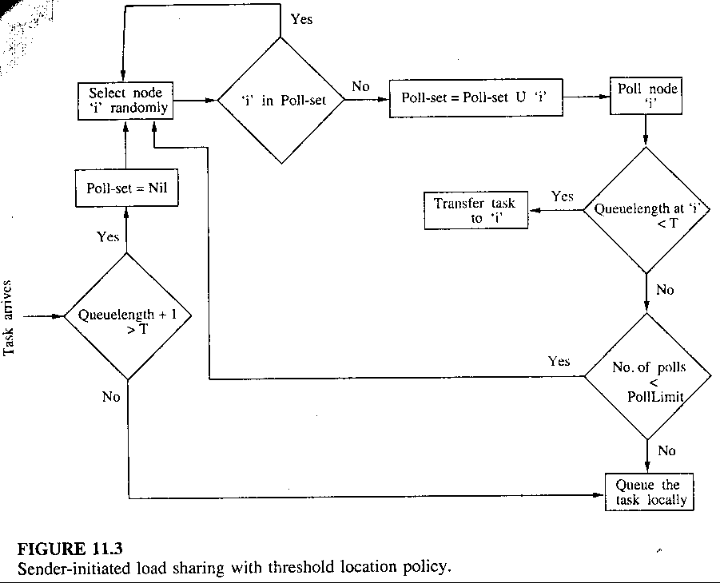
Shortest
•Information Policy: demand-driven type
•Stability: instability at high system loads

˙Receiver-Initiated Algorithms
•Transfer policy
•Selection policy
•Location Policy
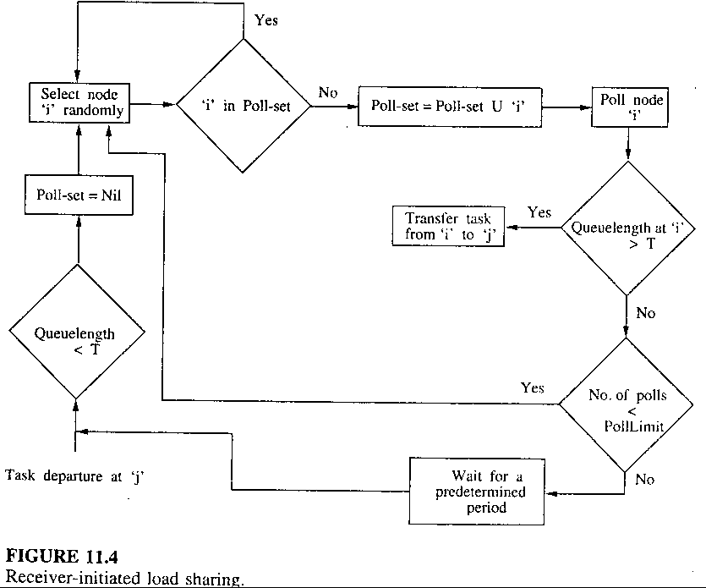
•Information Policy: demand-driven type
•Stability : do not cause system instability

˙Symmetrically Initiated Algorithms
both senders and receivers search for receivers and senders, respectively, for task transfer

have the advantages of both sender- and receiver-initiated algorithms

As in sender-initiated algorithm, polling at high system loads may result in system instability, and as in receiver-initiated algorithm, a preemptive task transfer facility is necessary.
•Transfer policy: uses two adaptive thresholds
•Selection policy
•Location Policy

sender-initiated component
. a sender broadcasts a TooHigh message, set a timeout
alarm, and listens for an Accept message until timeout
. a receiver receives message, cancel TooLow timeout,
send Accept message, and set AwaitTask timeout
. receiving Accept message, if the node is still a sender,
chooses the best task to transfer
. on expiration of TooHigh timeout, if no Accept msg.
has been received, the sender broadcasts a ChangeAve-
rage to increase the average load

receiver-initiated component
. a receiver broadcasts a TooLow msg, set a TooLow
timeout alarm, and listening for a TooHigh message
. if a TooHigh msg. is received, the receiver performs
same actions under sender-initiated alg.(see above)
. if TooLow timeout expires before receiving any TooH-
igh msgs, receiver broadcasts a ChangeAverage msg to
decrease the average load
•Information Policy: demand-driven type

˙Adaptive Algorithms
each node comprised of a senders list, a receivers list, and an OK list.
•Transfer policy: use two thresholds UT (upper bound)
and LT (lower bound)
•Selection policy
•Location Policy

sender-initiated component
. sender polls the node at the head of receivers list
. the polled node removes the sender node ID from list it
is presently in, puts it at the head of its senders list, and
informs sender whether it is a receiver, sender or OK
node
. on receipt of this reply, sender transfers the new task if
polled node is a receiver
. otherwise, polled node’s ID removed from receivers
list and put at the head of OK or senders list, then the
sender polls the node at the head of receivers list
. polling process stops if a suitable receiver is found or
the number of polls reaches a PollLimit or if receivers
list become empty

receiver-initiated component
. receiver polls the selected node (head to tail in senders
list) to determine whether it is a sender
. if polled node is a sender, transfer a task to the polling
node and informs it of its state after the task transfer
. if the polled node is not a sender, it removes receiver
node ID from list it is presently in, puts at the head of
its receivers list, and informs the receiver its state
. on receipt of the reply, receiver remove the polled node
ID from whatever list it is presently and puts at head of
appropriate list
. the polling process stops if a sender is found or if the
number of polls reaches a PollLimit or receiver is no
longer a receiver

•Information Policy: demand-driven type

˙A Stable Sender-initiated Algorithm
uses the sender-initiated load distributing component of the stable symmetrically initiated algorithm but has a modify receiver-initiated component

receiver-initiated component is replaced as following :
when a node becomes a receiver, it informs all the nodes that are misinformed about its current state. The misinformed nodes are those nodes whose receivers lists do not contain the receiver’s ID.

By this technique, this algorithm avoids receivers sending broadcast messages to inform other nodes that they are receivers.
- Conclusion
Created by : Jenn-Dar Chang
Date : Apr.12, 1999

