Partitionable Bus-Based Parallel Algorithms for Finding all Initial Palindromes and Periods of a String
Kuo-Liang Chung, Hsiu-Niang Chen
中華民國 86 年全國計算機會議, E-40 ~ E45
Abstract
This paper presents an O(1) time parallel algorithm for finding all initial palindromes and periods of the string (length is n) on an n×n RM. Then, provide a partitionable strategy when the RM doesn’t offer sufficient processors.
- Introduction

If the prefix S[1..k] of the string S[1..n] is a palindrome, then call the string S[1..n] has an initial palindrome of length k.

A string S[1..n] is said to have a period S[1..p] of length p(> 0) if S[i]=S[i+p] for i=1,..,n-p
2. Computational Model: RM

A RM has a reconfigurable bus system whose configuration can dynamically changed.

An m×n RM consists of m×n (m rows and n columns) identical processors arranged in a 2-D rectangular array with a reconfigurable bus system. The processor located in row i and column j for 1 ≤ i ≤ m and 1 ≤ j ≤ n is referred to as PE(i,j). Each processor has four ports denoted by N (north), S (south), E (east), W (west), respectively.

This paper assume that the RM is operated in a SIMD model. All processors broadcasting a value on a bus, or receiving a value from a specific bus only need O(1) time.
- The O(1) Time Parallel Algorithms
3.1 Finding all Initial Palindromes and the Shortest Initial Palindrome
Initially, processor PE(1,j) stores the data S[j] for 1 ≤ j ≤ n
Algorithm_1
1: Establish a vertical bus system for each column. Then, each processor(1,j)
for 1 ≤ j ≤ n broadcasts its own data S[j] to the others in the same column
via the vertical bus system.
2: Establish a horizontal bus system for each row. Then, each processor(j,j)
for 1 ≤ j ≤ n broadcasts its own data S[j] to the others in the same row via
the horizontal bus system.
3: Then, except the processor in the first row, each processor connects its N
and W ports.
4: Each processor PE(i,j), 1≤ i ≤ n and 1 ≤ j ≤ n, connects its E and S ports
when S[i]=S[j].Otherwise do nothing.
5: Each processor PE(1,j) 1< j ≤ n, with connection linking the E and S ports
sends the value j from the E port to the processor PE(i,1), 1≤ i ≤ n. Finally,
each processor PE(i,1) reports the value j (=i) as the length of the initial pa
-lindrome if the S port of the processor receives the value.
The following two additive steps are appended to find the shortest initial palindrome.
6: Each processor PE(i,1) for 1≤ i ≤ n first disconnects its connections.
7: Each processor PE(i,1) holding the value j (=i) first sends the value j form
the N port to the bus, then processor PE(1,1) reports the received value j
as the length of the shortest initial palindrome if the S port of PE(1,1)
receives the value j.

3.2 Finding all Periods and the Longest Period
Algorithm_2
1 2: The same as step1 and 2 in Algorithm_1.
3: Then, except the processors in the first row, each processor connects its N
and E ports.
4: Each processor PE(i,j), 1≤ i ≤ n and 1≤ j ≤ n, connects its W and S ports
when S[i]=S[j].Otherwise do nothing.
5: Each processor PE(1,j), 1< j ≤ n, with the connection linking the W and S
ports sends the value j-1 from the W port to the processor PE(i,n) for 1≤ i
≤ n. Finally, each processor PE(i,n) reports the value j-1 (=n-i) as the leng-
th of the period if the S port of the processor receives the value. Similar to
step 6 and 7 in Algorithm_1, we can find the longest and shortest periods.
- The partitionable Parallel Algorithms
Consider the case when the number of processors available is not enough.
Without loss of generality, for finding all initial palindromes, consider two case : (1) M < n ;(2) N < n and M < n

- Case 1:M < n
We partition the input string into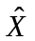pipes, where=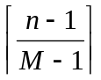, and each pipe has one overlapping entry shared with the last pipe.
Initially, suppose processor PE(1,j) stores the data S[j] for 1≤ j ≤ n.
Algorithm_3
1: The same as the step 1 in Algorithm_1.
For X=1 to begin
2: Establish a horizontal bus system for each row. Then for odd(even)X each
processor PE(i,2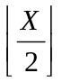(M-1) + i) (PE(i,X(M-1)-i+2)) for 1≤ i ≤ M broadca-
sts its own data S[2(M-1) + i] (S[X(M-1)-i+2]) to the other rows.
3: Then, except the processors in the first (Mth) row for odd(even) X, each
processor connects its N(S) and W ports.
4: Each processor PE(i,j), 1≤ i ≤ M and 1≤ j ≤ n, connects its E and S(N)
ports for odd(even) when S[2(M-1) + i]=S[j] (S[X(M-1)-i+2]).
Otherwise do nothing
5: Case X=1:each processor (with the connection linking the E and S ports)
PE(1,j), 1< j ≤ n, sends value j from the E port to the processor PE(i,1) or
PE(M,k). Finally, each processor PE(i,1) reports the value j(=i) as the len-
gth of the initial palindrome if S port receives the value.
Case X>1:each processor (with the connection linking the E and S(N) port
for odd(even)X, each processor PE(1,j) (PE(M,j)) holding the value sent
from pipe X-1, 1< j ≤ n-(X-1)*(M-1), send the received value from the E
port to the processor PE(i,1) or to PE(M,k)(PE(1,k)). Final,each processor
PE(i,1) reports the received value from S(N) port; PE(M,k) (PE(1,k)) keep
the received value if S(N) port receive the value.

- Case 2: N < n and M < n
Algorithm_4

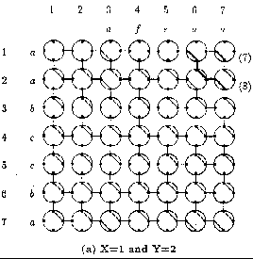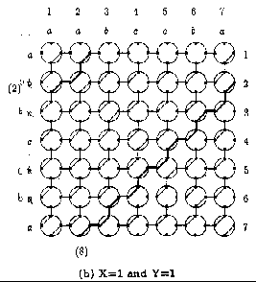

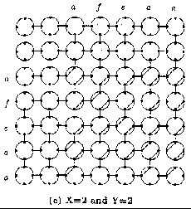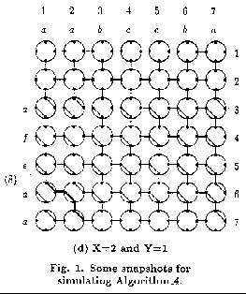
5. Conclusion
Created by : Jenn-Dar Chang
Date : Apr.14, 1999

