MULTIPROCESSOR SYSTEMS

Abstract
This chapter has presented two methods that have been used to implement multiprocessor UNIX systems : The Master-Slave configuration and a Semaphore method.

1. Introduction
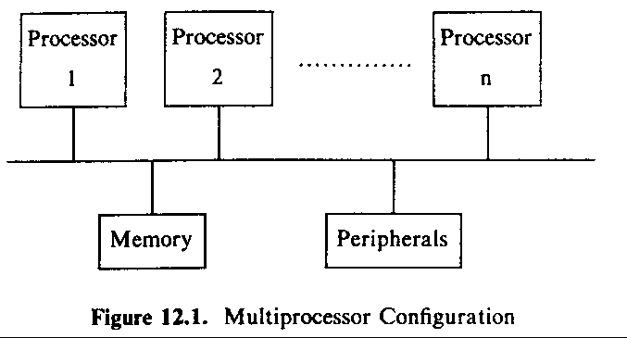
2. PROBLEM
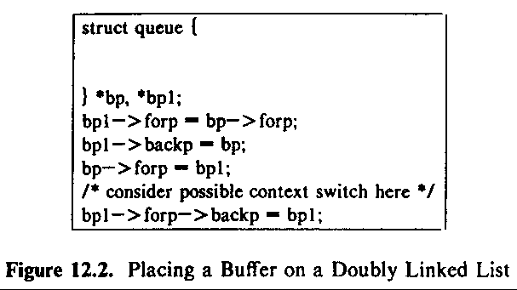
Processor A wants to place bpA after bp and processor B wants to place bpB after bp ?

Three methods for preventing such corruption:
- Execute all critical activity on one processor
- Serialize access to critical regions with locking primitives
- Redesign algorithms
- SOLUTION WITH MASTER-SLAVE PROCESSORS

Master processor (Execute in kernel mode) :
Handling all system calls and interrupts

Slave processor (Execute in user mode) :
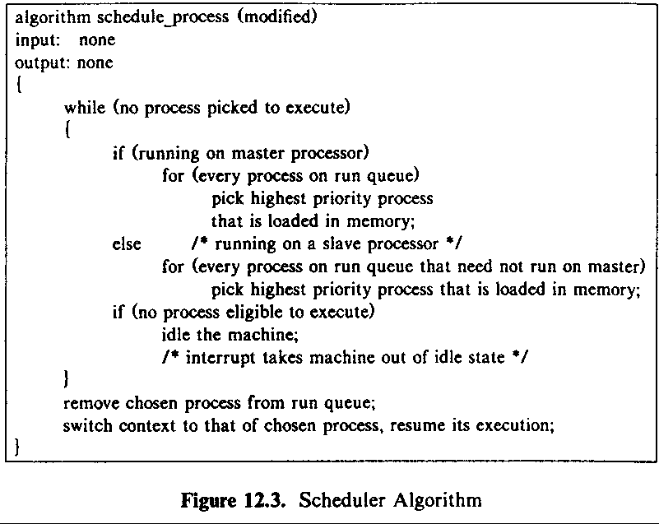
Executing processes and inform the master processor when a process makes a system call
A configuration: a master processor and two slaves
Two slave processors find one process ready for execution.
If both processors were to schedule the process simultaneously, then read, write and corrupt its address?

Two ways avoid corruption:
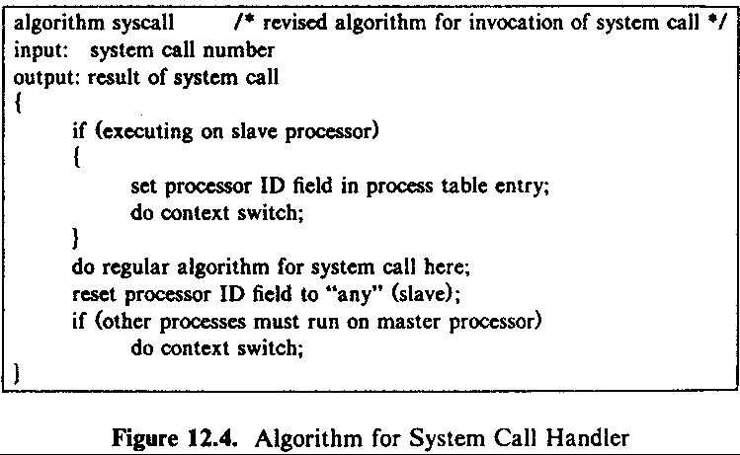
First : master specify the slave processor which process
should execute
Second : using semaphores
4. SOLUTION WITH SEMAPHORES

In uniprocessor UNIX systems:
use a sleep-lock to keep other processes out of a Critical Region

set the lock :
While (lock is set) /* test operation */
sleep (condition until lock is free);
set lock;

unlock the lock :
free lock;
wake up all processes sleeping on condition lock set;
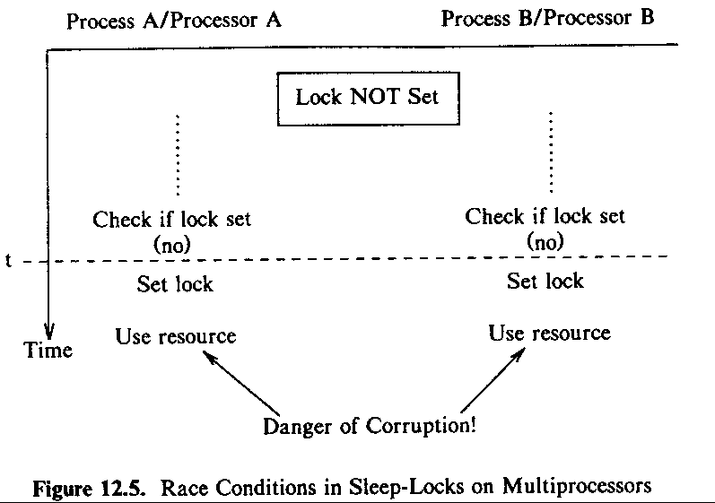
Definition of semaphores :
˙Initialization of the semaphore to a nonnegative value
˙A P decrements the value of semaphore and if the value
is less 0 then the process goes to sleep
˙A V increments the value of semaphore and if the value
greater than or equal 0 then one process wakes up
˙A conditional P decrements the value of semaphore and
if the value is greater than 0 then return true else return
false and the value of semaphore is unchanged.

Implementation of Semaphores :

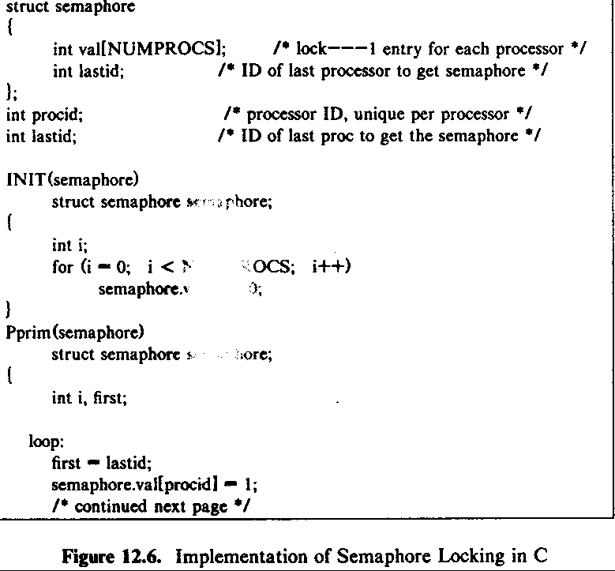
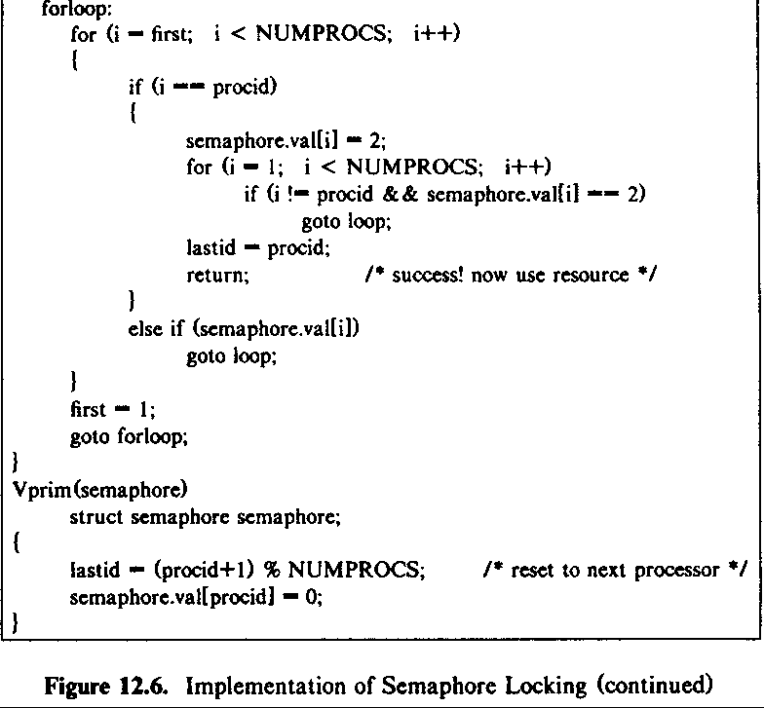
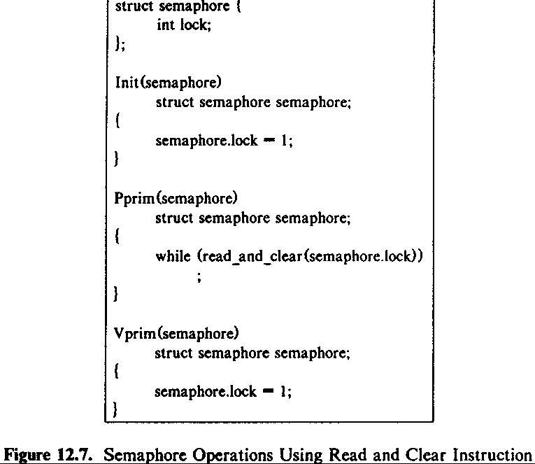
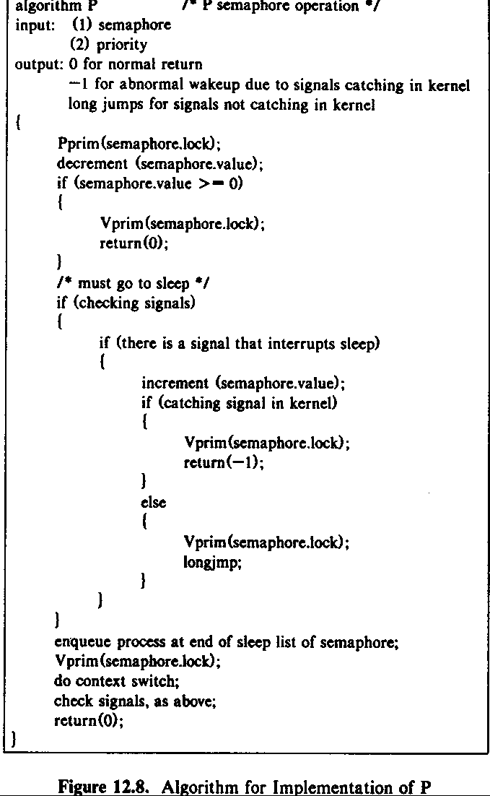
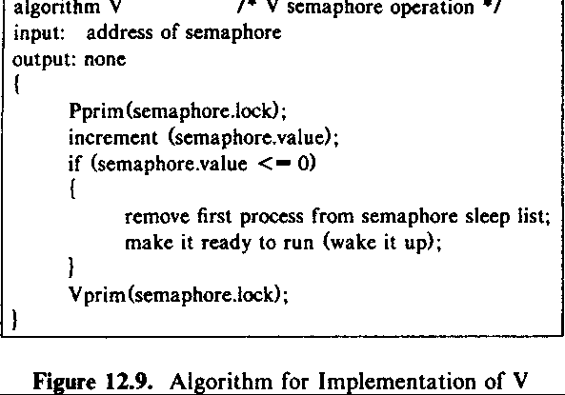
Given a primitive that returns the value of a semaphore, would the following operation be the equivalent of the wakeup function ?
while (value(semaphore) < 0)
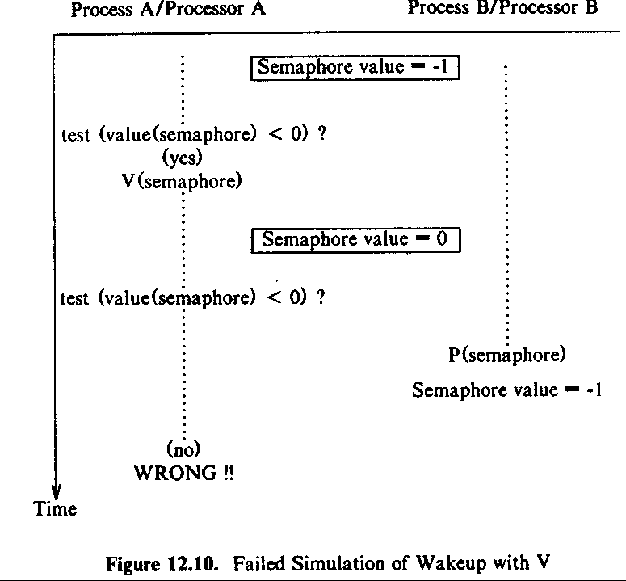
V(semaphore);
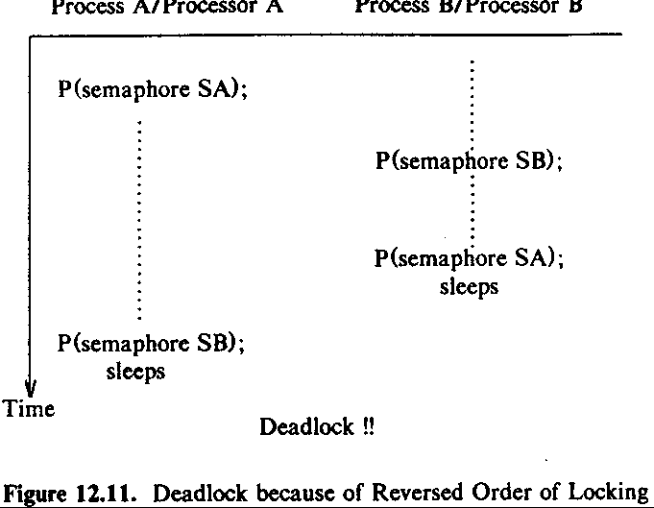
When locking several semaphores, the locking order must be consistent to avoid deadlock.
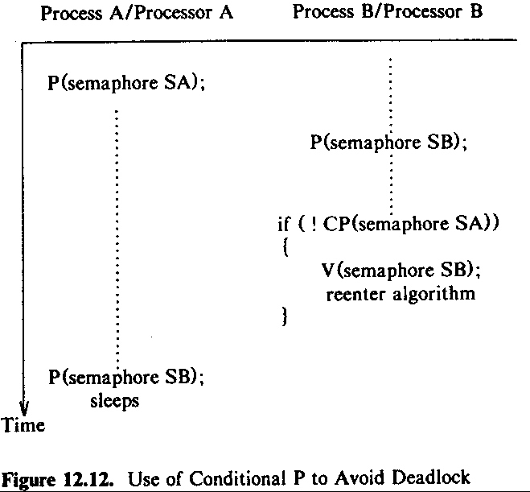
An Interrupt handler may have to lock a semaphore to prevent processes from using a resource simultaneously, but it cannot go to sleep, instead, it can execute a spin lock to avoid going to sleep as in the following:
while (! CP(semaphore));
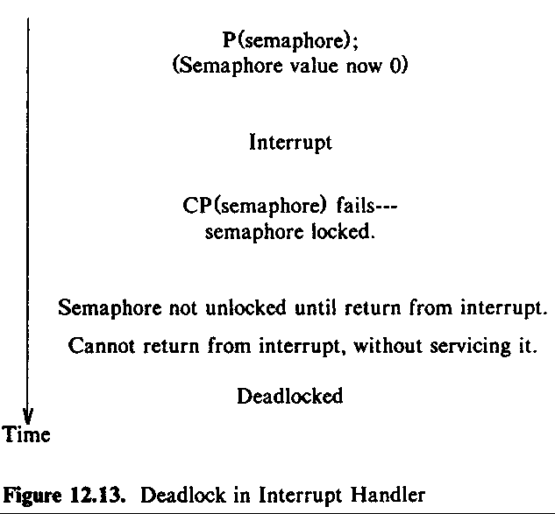
This situation is avoided by blocking out interrupts while the process has the semaphore locked.

Some Algorithms
Buffer Allocation:
Three major data structure: buffer header, hash queue,
free list

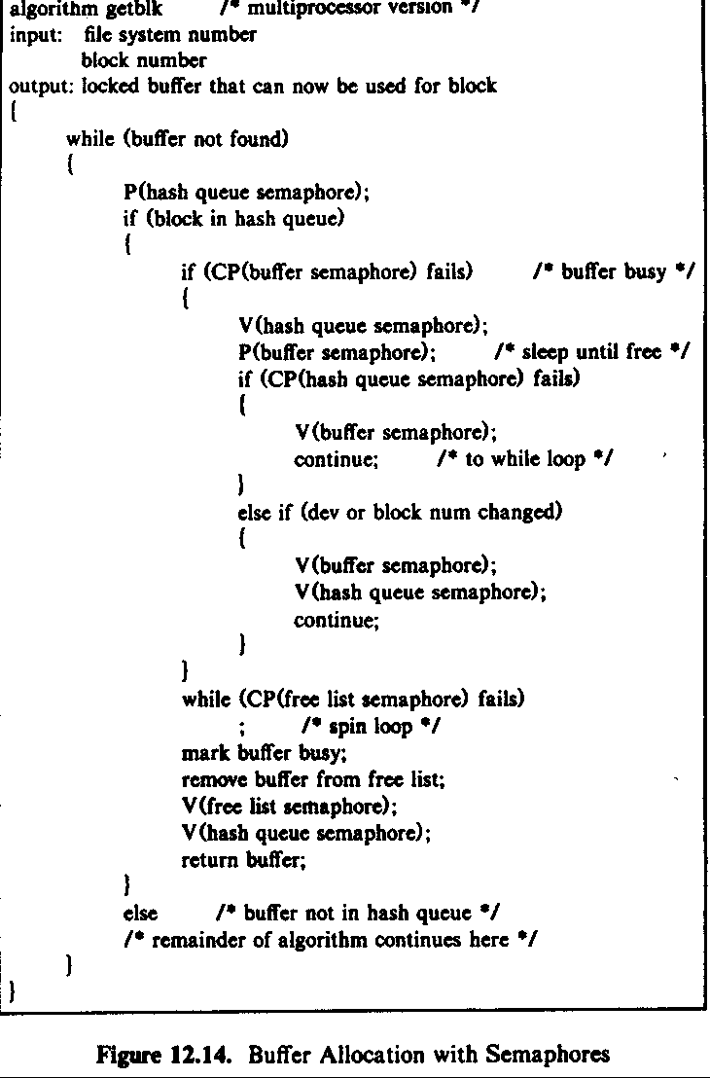
Wait/Exit:
A process sleeps in the wait system call until a child exists.

When a process exits, it does a V on the parent semaphore, awakening the parent if it was sleeping in wait.

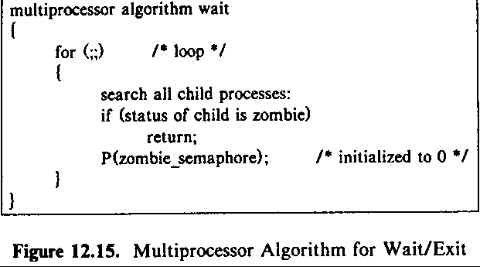
5. Conclusion
Created by : Jenn-Dar Chang
Date : Apr.12, 1999

