A PARALLEL ALGORITHM FOR FINDING A PERFECT MATCHING IN A PLANAR GRAPH
E. BAMPIS A. GIANNAKOS*
LaMI, Université d’Evry, Boulevard des Coquibus, 91025_Evry Cedex, France
- KARZANOV
Institute for System Analysis, 9, Prosp. Let Octyabrya, 117312 Moscow, Russia
Y.MANOUSSAKIS and I. MILIS
LRI, Bdt 490, Universtité de Paris Sud, 91405 Orsay Cedex, France

Received July 1996
Revised May 1998
Accepted by A. Ferreira
Abstract
In this paper we present an intuitive and simple 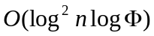 time, 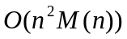 processors parallel algorithm for finding a perfect matching in a planar graph, where is the order, is the number of the distinct perfect matchings of the graph and 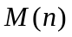 is the best sequential complexity of matrix multiplication of size n.
- Introduction
A maximum matching is a perfect one, when every vertex of the graph is connected to an edge of this matching.
2. Notations and preliminaries
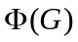 denotes the number of distinct perfect matchings of  .
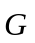denotes the digraph obtained by giving an arbitrary orientation to
the edges of .

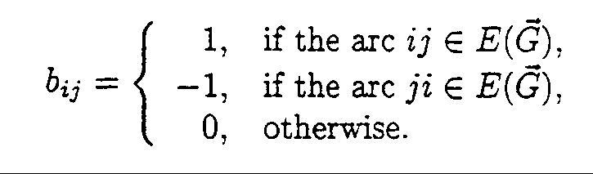
The skew adjacency matrix of , is defined as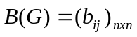, where:

The Pfaffian of a skew symmetric matrix 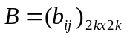 of even
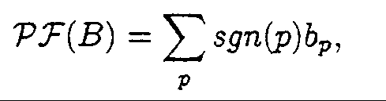dimension 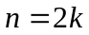, denoted by 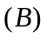, is
where  refers to all permutations 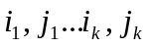 of the elements 1..2k
such that 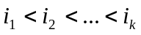and 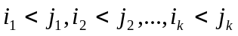.
sgn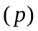 is denoted the sign of permutation
Note : 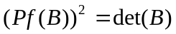

We give the graph such an orientation, that makes every term of the
Pfaffian of a same sign (negative or positive). Such orientation is
called a Pfaffian orientation.

A graphthat has been given a Pfaffian orientation will be
denoted by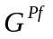.(Note :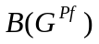 simply by 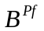)

The matrix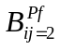obtained fromby replacing the entries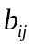and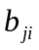with
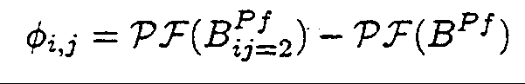
2 and –2, respectively .Thus,
is the number of the perfect matching ofto which the edge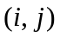
belongs.
- The Parallel Algorithm

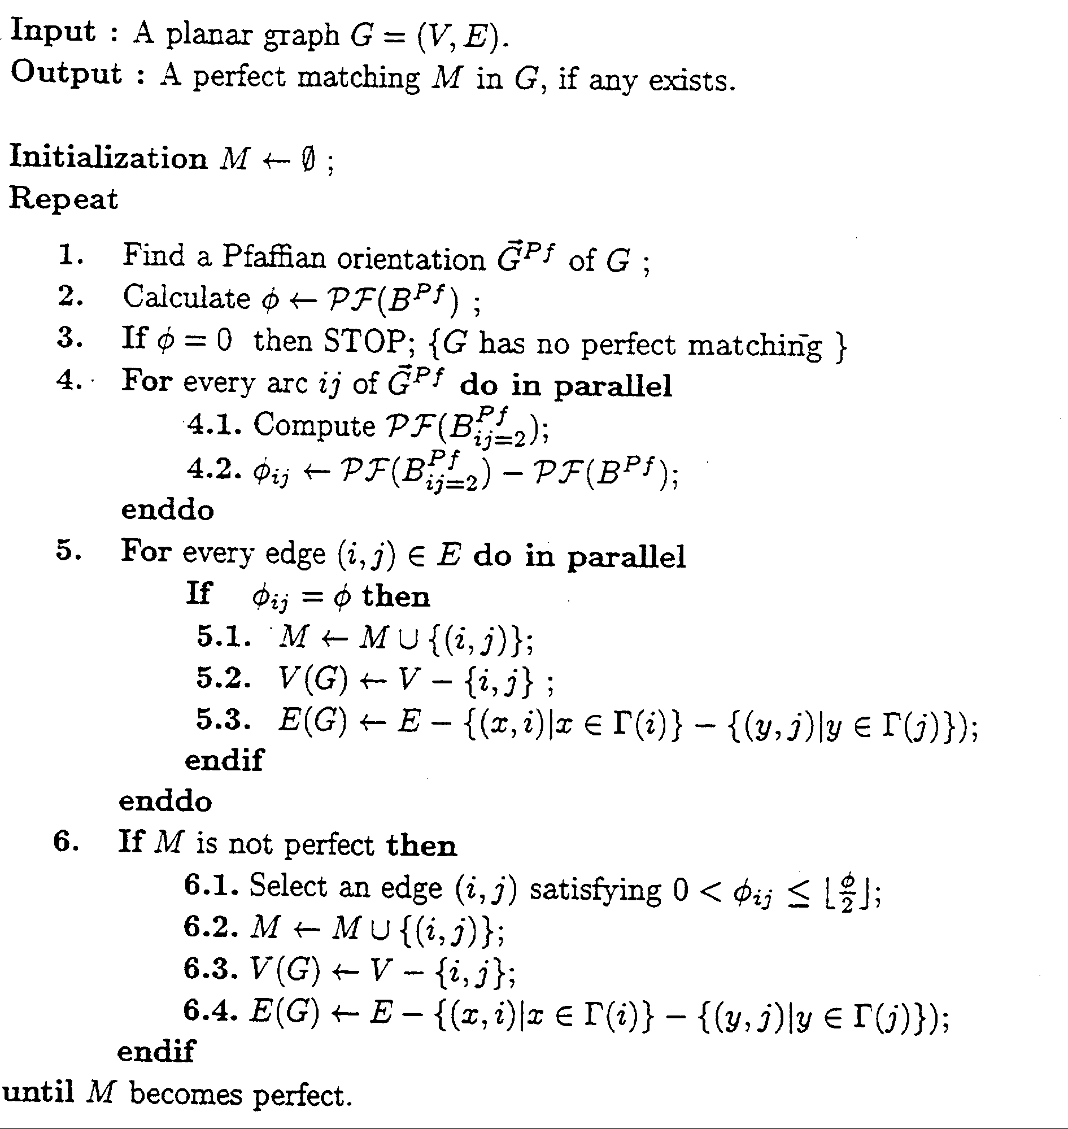
4. Time Complexity

Step1 and 2, costs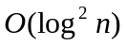deterministic time with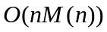 processor
on a CRCW PRAM.

In step 4, the Pfaffian Of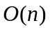matrices is calculated ; thus this step can
be completed indeterministic time with processors

Operations as edge selection, addition to, and deletion from in
step 5 and 6 take 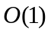 time.

In the worst case, where only one edge is selected at each iteration of
the repeat-until loop, after 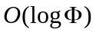 iterations, a graph with a unique
perfect matching occurs and the algorithm finishes in the next loop.

5. Conclusion
Created by : Jenn-Dar Chang
Date : Mar.11, 1999

