Adaptive Image Coding Using Spectral Classification
Hamid Jafarkhani and Nariman Farvardin
IEEE Transactions on Image Processing, Vol. 7, No. 4, Apr. 1998, pp. 605-610

Abstract
We present a new classification scheme, dubbed spectral classification, which uses the spectral characteristics of the image blocks to classify them into one of a finite number of classes. A vector quantizer with an appropriate distortion measure is designed to perform the classification operation. The application of the proposed spectral classification scheme is then demonstrated in the context of adaptive image coding. It is shown that spectral classifier outperforms gain-based classifiers while requiring a lower computational complexity.

Introduction
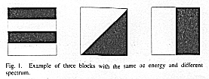
II. Spectral Classification
The two-dimensional (2-D) image blocks to be classified are first converted into a one- dimensional (1-D) sequence by zigzag scanning the block. Then, the linear predication (LP) coefficients of the resulting 1-D signal are used to characterize the spectral behavior of the signal.
The algorithm used for the design of the VQ is the generalized Lloyd algorithm in which the basic idea is to start from an initial codebook and iteratively improve it. The main steps are summarized below:
- Generalized Nearest-Neighbor Distortion Calculations:
For a given input sequence, we wish to select the codevector that minimizes the Itakura-Saito distortion meansure. Buzo et al. have shown that this is equivalent to finding the filter that minimizes α/σ²+lnσ², where α is the residual energy and can be computed as follows:
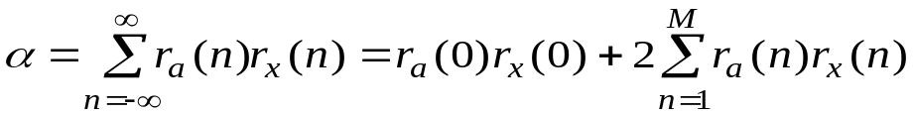
where
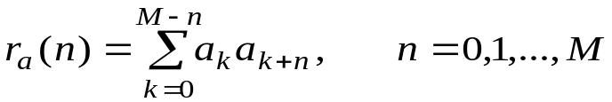
and r_{x}(n) is the autocorrelation of the input sequence.
- Generalized Centroid Calculations:
For each class, we wish to choose the best representative LP vector. The autocorrelation sequences of all blocks in the same class can be averaged to find an average autocorrelation sequence and then by solving the Wiener-Hopf eauations for the average autocorrelation sequence the coefficients of H(z)=σ/A(z) can be calculated, where 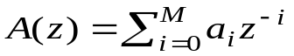and 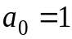. These coefficients represent the generalized centroid of the LP vectors.

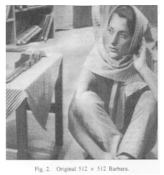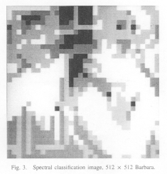

III. Computational Complexity
 | EMNSD | Spectral
Multiplications | NL²+IN | [(M+1)L²-M(M+1)/2+(M+1)log₂n]N
Additions | 3NL²+3N | [(M+3)L²-M(M+1)/2+(M+2)log₂n]N
Divisions | N+3n+2 | N
Comparisons | 2n | n
Sorting | CNlog₂N to N²
Order | Nlog₂N to N² | N

IV. Applications to Image Coding
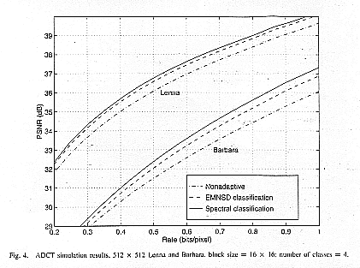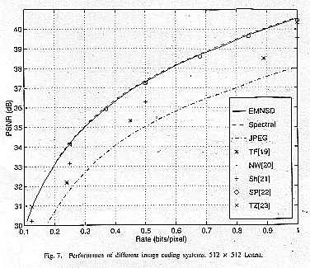
V. Conclusion

Created by: Lih-Ching Lin
Date: Jun. 24, 1998

