Adaptive Lossy LZW Algorithm for Palettised Image Compression

S. W. Chiang and L. M. Po
ELECTRONICS LETTERS 8th May 1997 Vol. 33 No. 10

Abstract
An adaptive lossy LZW algorithm is proposed for palettised image compression, that is a generalised algorithm of the conventional lossless LZW algorithm. The new algorithm employs an adaptive thresholding mechanism with human visual characteristics to constrain the distortion. In addition, the encoded image file format is compatible with the original GIF decoder.

Introduction

Lossy LZW algorithm
The new algorithm generalises the original algorithm by introducing a distortion threshold T in the string matching process. When T = 0, the lossy LZW algorithm will be the same as the conventional lossless LZW algorithm.
In this proposed algorithm, we employ a weighted mean square error distortion measurement between the colour vectors. This distortion is defined in the YUV colour domain instead of the RGB domain, since the former is a more perceptually useful representation of colour for the HVS.
The colour vector of the index i in the YUV domain is given by [Y_{i}, U_{i}, V_{i}] and its component values are determined by
Y_{i} = 0.30R_{i} + 0.59G_{i} +0.11B_{i}
U_{i} = 0.60R_{i} + 0.28G_{i} +0.32B_{i} (1)
V_{i} = 0.21R_{i} + 0.52G_{i} +0.31B_{i}
The weighted mean square error distortion measure D_{ij} between two palettised image pixels of i and j is defined as
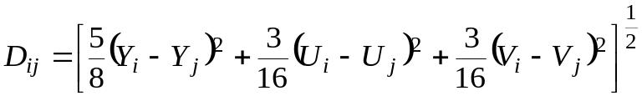 (2)
Based on this distortion measure, the lossy LZW for the GIF compression algorithm can be summarised as follows:
- RGB → YUV
- The dictionary is initialised to contain the 256 colour indices (from 0-255). The first prefixed string ω is initialised to be the first input pixel of the image.
- The next pixel i. A full search is carried out in the dictionary for the string ωi while using the distortion D_{ij} as defined in (2) and minimum D_{ij} is found for it.
- If D_{ij} ≤ T. The string ωi will be used as a prefixed string for the next iteration. Then go to (iii).
- If D_{ij} > T. The code ω will be directed to the output stream andωi will be pushed into the dictionary as a new entry. Then go to (iii).
The process continues until the input is exhausted.

Adaptive threshold
To further enhance the compression efficiency of the lossy LZW, an adaptive threshold is used in the proposed algorithm which is designed according to the HVS properities.
The threshold as a function:
T(JND(Y), K) = JND(Y)⋅ K = JND(Y) ⋅ (mσ² + b) (4)
Where 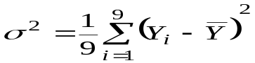
Simulation results for three 8 bit colour palettised image and two greyscale image are shown in Table 1. The values used for m and b in eqn. 4 are 0.027 and 0.9.
Image (512 × 512) | Lossless LZW | Lossy LZW | PSNR
 | % original | % original | db
Lena | 76.16 | 56.42 | 33.585
Airplane | 52.52 | 33.53 | 34.896
Baboon | 96.17 | 72.82 | 29.309
Lena (grey) | 100.00 | 46.46 | 41.018
Mammo (grey) | 66.01 | 26.15 | 42.885

Conclusions

Created by: Lih-Ching Lin
Date: Aug. 14, 1998

