An adaptive decimation and interpolation scheme for low complexity image compression

P.W.M. Tsang, W.T. Lee

Signal Processing 65 (1998) 391-401

Abstract
In this paper, a low complexity image compression scheme based on adaptive decimation is reported. The method involves only small amount of computation and can be implemented to operate in real time with simple hardware and small amount of memory storage.

1. Introduction

2. Adaptive decimation and interpolation (ADI)
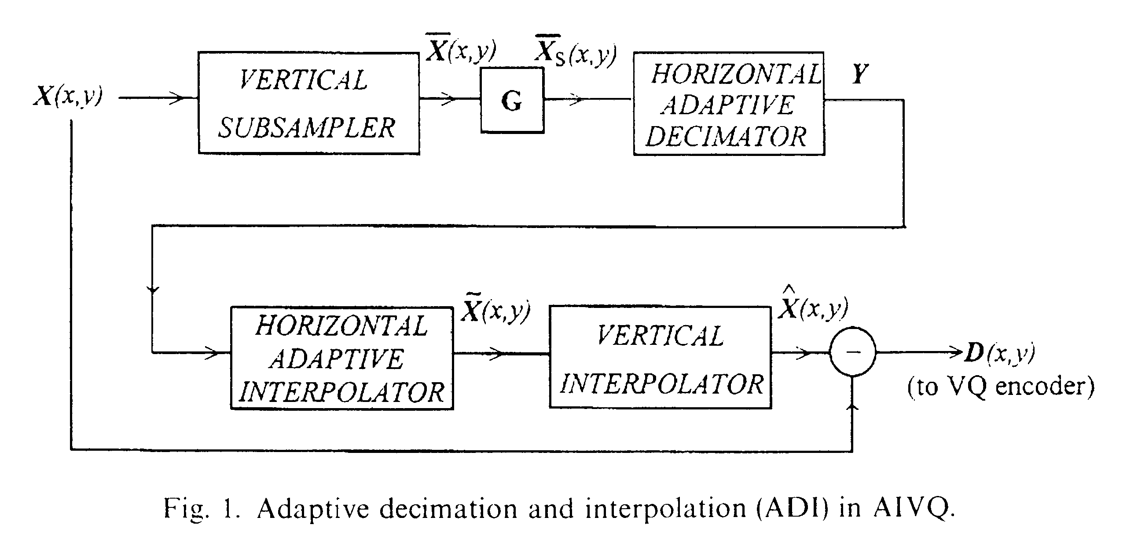

3. Adaptive boundary search (ABS) algorithm
The ABS algorithm provides an alternative solution in overcoming the problem by predicting the missing edge information hence provides better visual effect and reduction in the encoding error.
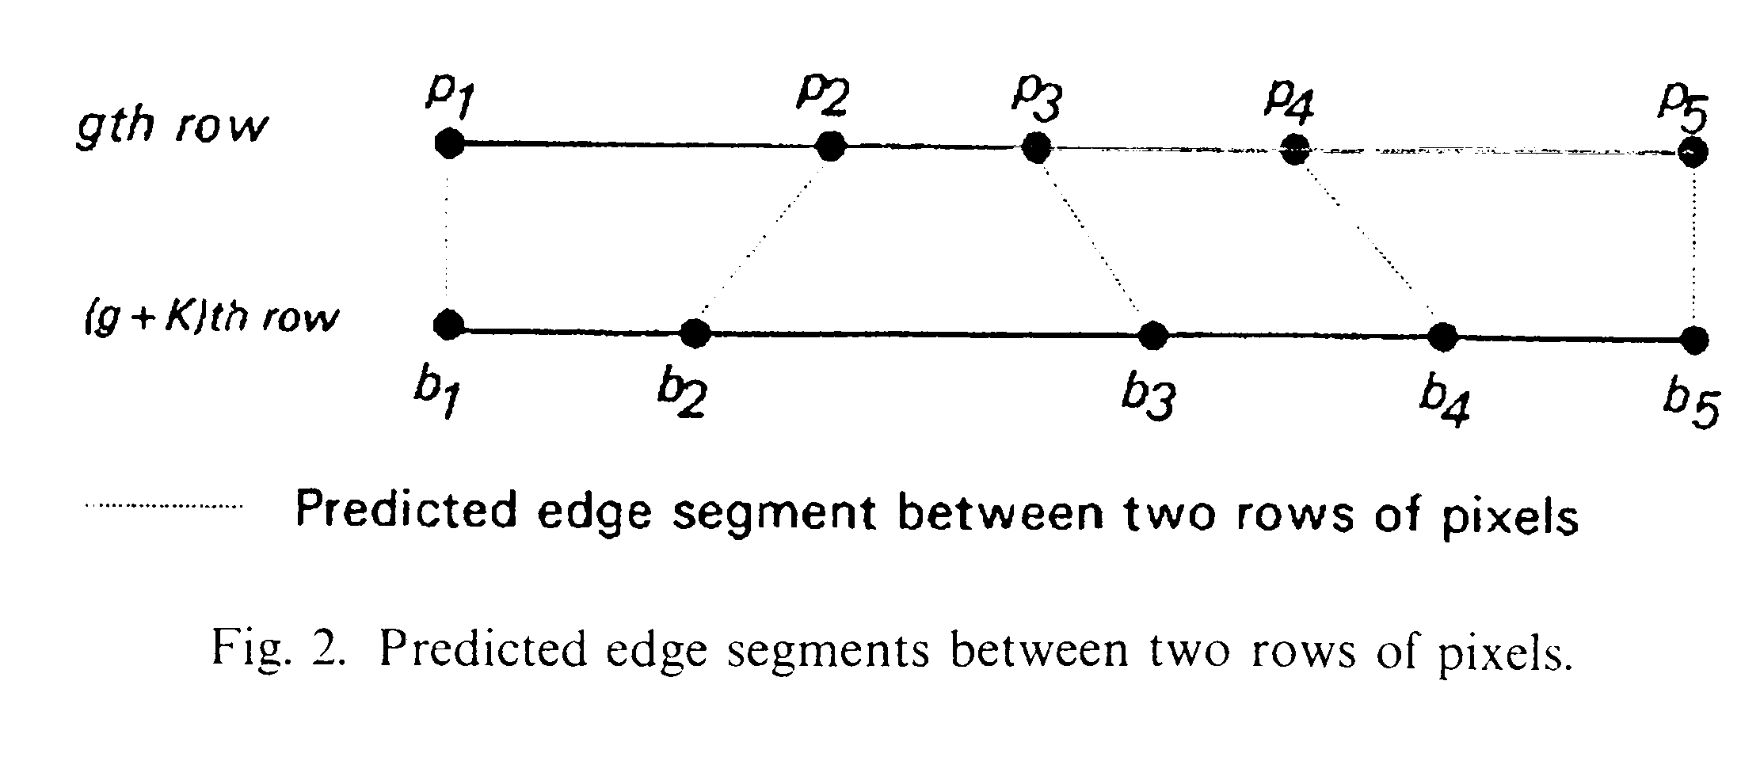
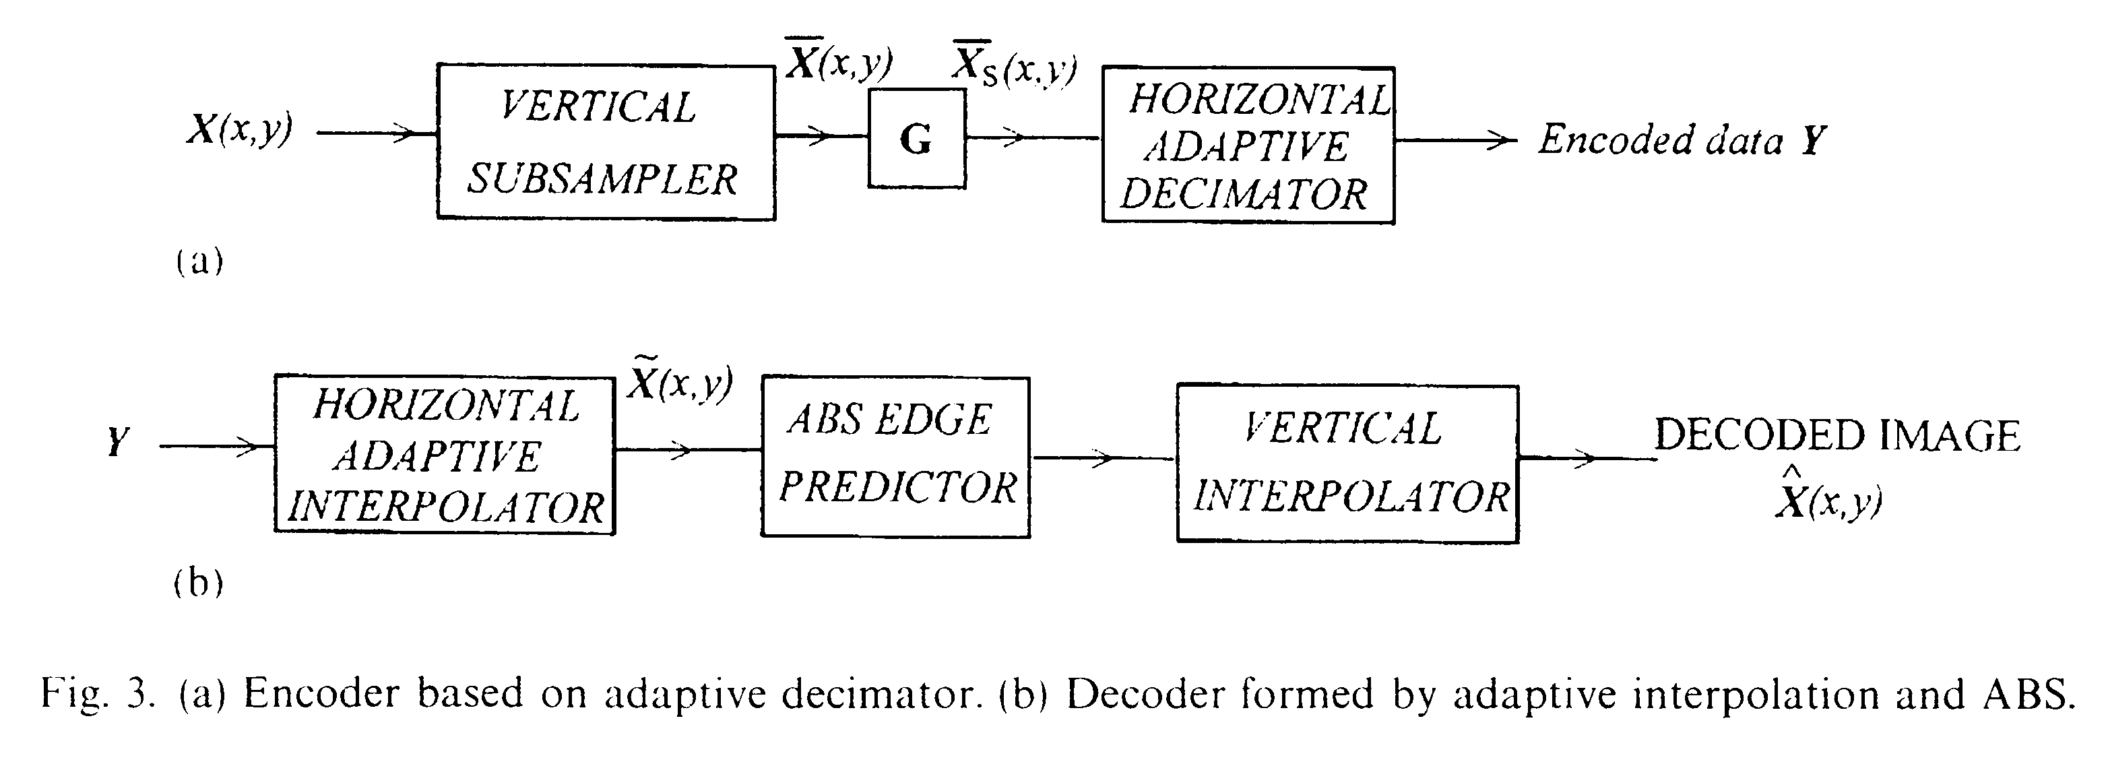
4. Result
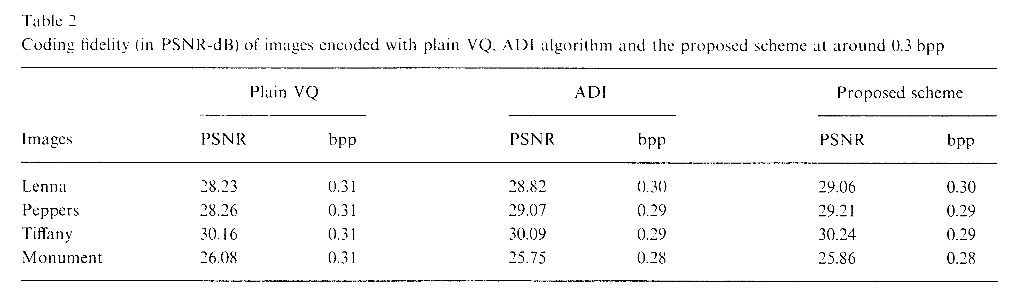
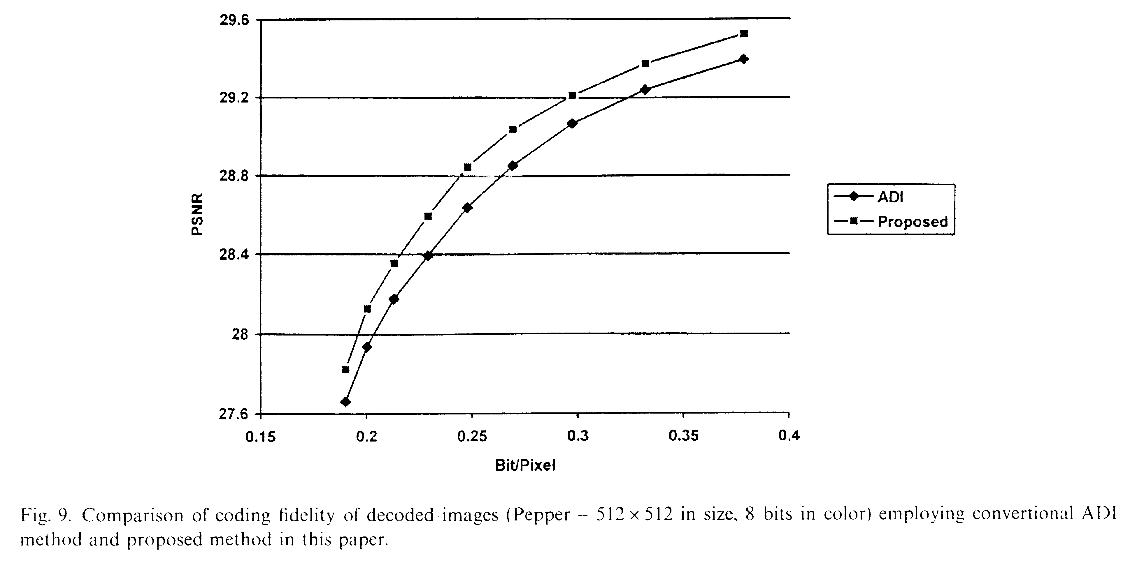
5. Conclusion
Experimental results show that the method is capable of providing good estimation on edge contours even at low bit-rate of around 0.3 bpp. The amount of computation in the encoder and decoder is small and can be implemented to operate in real time at low hardware cost.

Created by: Lih-Ching Lin
Date: Sep. 18, 1998

