Efficient Initial Codebook Generation for LBG Iterations in Image Vector Quantization
Shinfeng D. Lin, Shih-Chieh Shie and Jiann-Liang Chen
1998 Conference on Computer Vision, Graphics, and Image Processing, pp. 78 - 84
Abstract
This paper introduces a simple initialization method for LBG VQ codebook design. It preserves the edge information of image by selecting more edge vectors to be the initial codewords. Simulation results show that the proposed initialization method for VQ codebook generation achieves a faster convergence and a better local optimum than other existing LBG initialization methods.
- Introduction
- Efficient Initialization Algorithm
The details of the proposed initialization algorithm are depicted as follows.
Step 1: Classify the training sets into edge vector and non-edge vector subsets.
Step 2: Sort each subset.
Step 3: Select C₁ initial vectors from non-edge vector subsets and C₂ initial vectors from edge vector subsets by the following steps, respectively.
Step 4: Divide the vectors of subset into 2^{r} subranges.
Step 5: Choose the median vector of each subrange to be the initial codeword for the subrange.
Step 6: If the number of initial codewords is equal to the assigned value in this subset, then stop; else select the subrange having the maximum mean absolute distortion to be further divided into 2^{r} new subranges, and goto step 5.
In order to guarantee that more varying vectors will be selected to be the initial codewords, the proportion of C₁ to C₂ is set to be 1 to 3.
- Simulation results
In computer simulations, five images – “Lana”, “Bridge”, “Boat”, “Elaine”, and “Goldhill” are used as training sets. Image size: 256x256. The dimension of vectors is 16. Therefore, the training sets consist of 20480 vectors. The codebook size is 256.
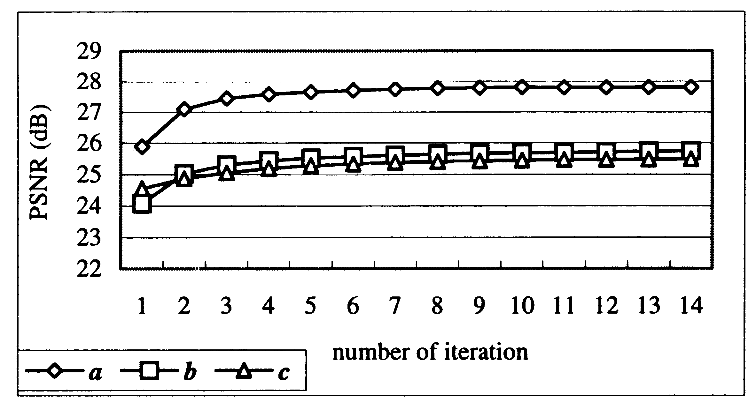
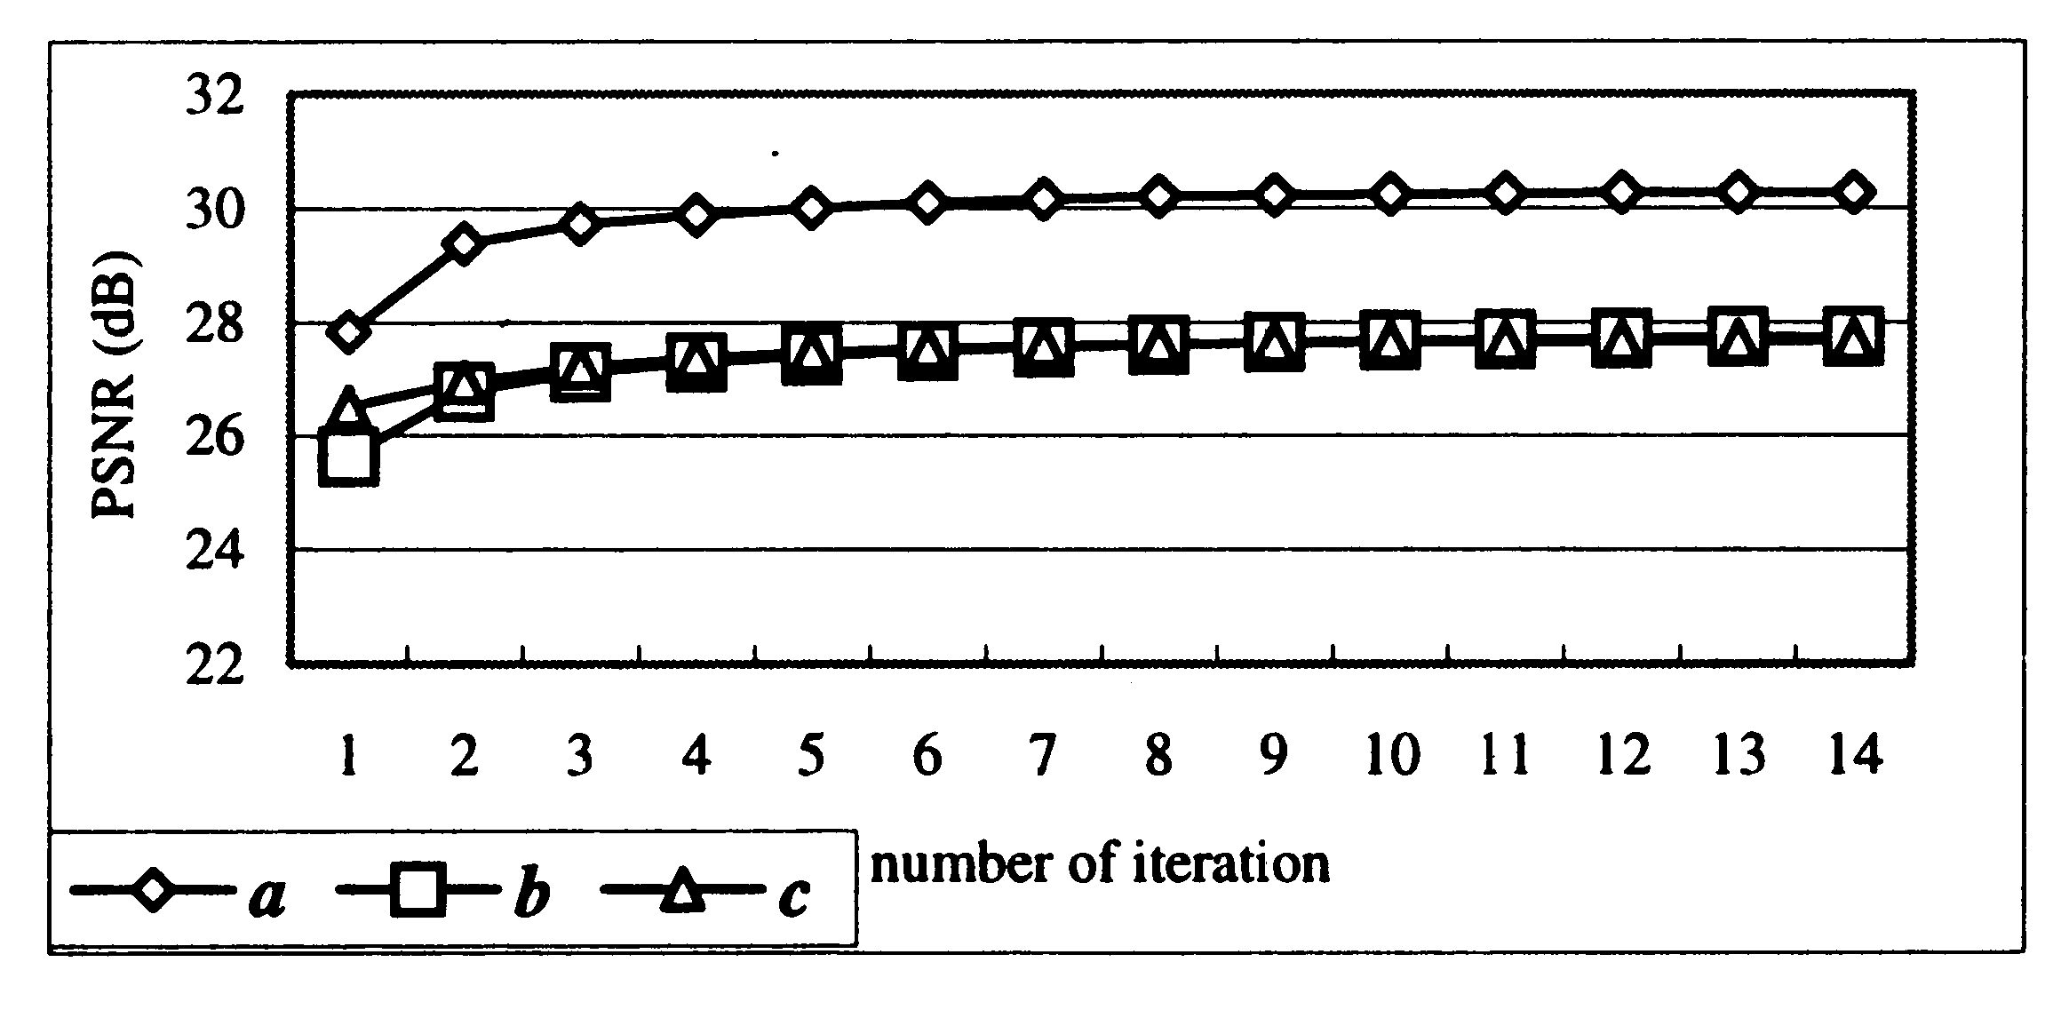
- Conclusion

Created by: Lih-Ching Lin
Date: Oct. 22, 1998

