Encoding-interleaved hierarchical interpolation for lossless image compression

Andrea Abrardo, Luciano Alparone, Franco Bartolini
Signal Processing 56 (1997) 321-328

Abstract
In this correspondence an improved version of the Hierarchical INTerpolation (HINT) algorithm is proposed for multiresolution reversible compression of still images.

1. Introduction

2. The HINT algorithm
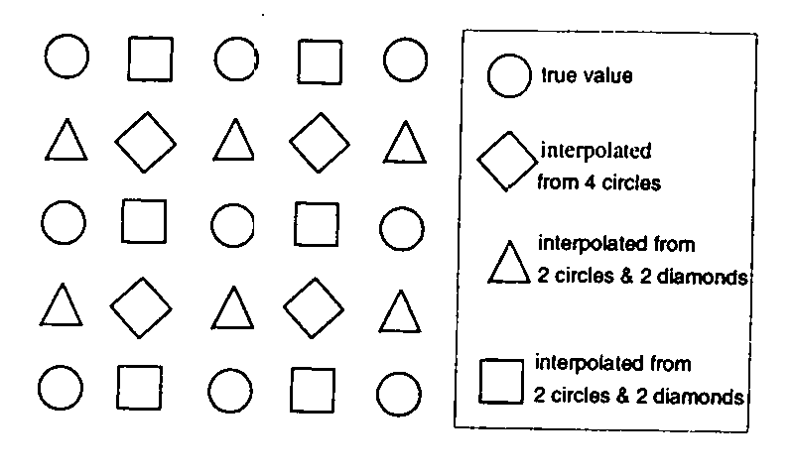

3. Encoding-interleaved HINT
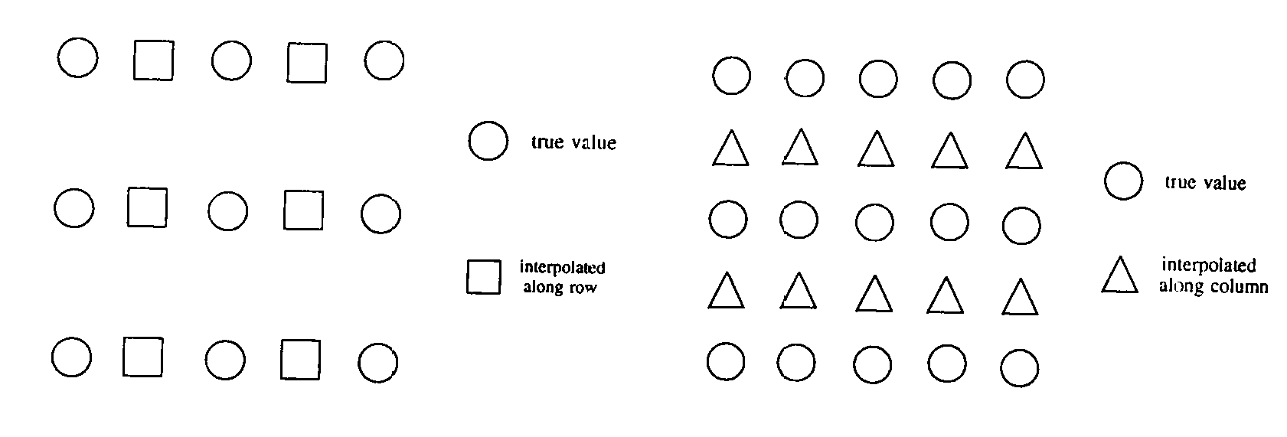

4. Adaptive cyclic difference encoding
Two ways exits to make the difference between x_{n} and 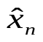:
- compute the arithmetic difference 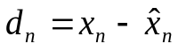 ;
(ii) compute the modulo-L difference 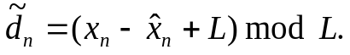
In fact, given the integers x_{n} ,and L, with 0 ≤ x_{n} ,< L, it’s easily to verified that 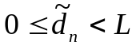.
In most of practical schemes dealing with 8-bit data, L=256. This suggests partitioning the original image into square blocks, finding the maximum, l_{BM}, and minimum, l_{Bm}, grey-levels within each block B, and setting L_{B} = l_{BM} + l_{Bm} + 1; L_{B} ≤ L, but general L_{B} << L, for most blocks.

5. Coding results and comparisons
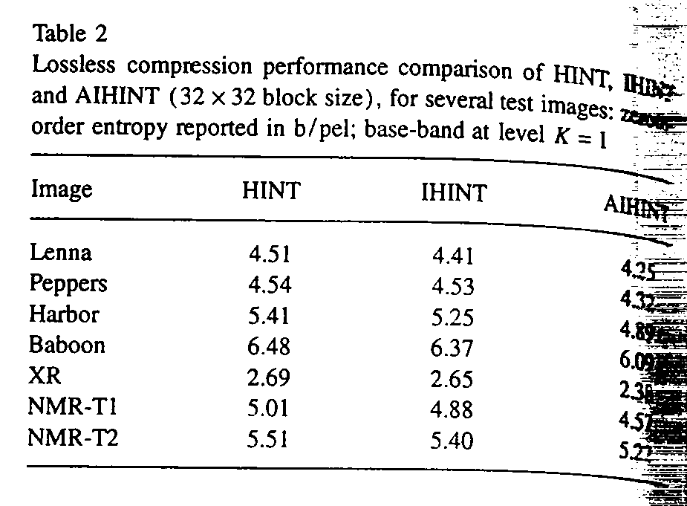

Created by: Lih-Ching Lin
Date: Sep. 4, 1998

