Fractal Image Compression Based on Delaunay Triangulation and Vector Quantization
Franck Davoine, Marc Antonin, Jean-Marc Chassery, and Michel Barlaud
IEEE Transactions on Image Processing, Vol. 5, No. 2,pp. 338-346, February 1996

Abstract
This paper presents a new scheme for fractal image compression based on adaptive Delaunay triangulation and vector quantization.

- Introduction
- Fractal image coding
III. Implementation
- Tools
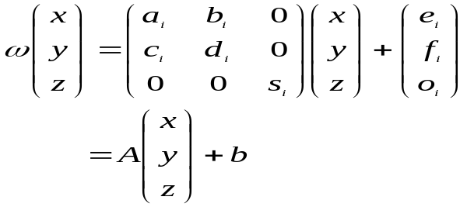
- Delaunay Triangulation
Del(S)={(p_{i}, p_{j}, p_{k})∈S³, B(p_{i}, p_{j}, p_{k})∩S\(p_{i}, p_{j}, p_{k})=∅}

Split and Merge algorithm
Initialization:
Construct a lattice S (triangle vertices) on the image support (Fig. 1)
Split:
Repeat until convergence:
a: calculate the Delaunay triangulation of the set of vertices
b: for each triangle: if the triangle is not homogenous then insert a vertex on its barycenter
Merge:
Extract the useless vertices
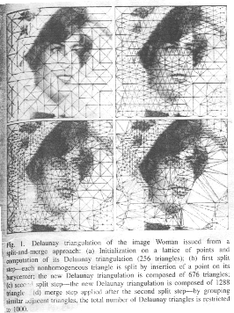
IV. Applications
- Classification
VQ-based classification used LBG algorithm
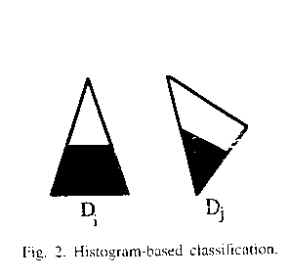Histogram-based classification:
In Fig. 2 the two triangles be considered identical.
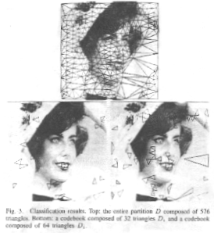
- Encoding
All triangles are recorded in a graph structure. A triangle is coded by its address (position) in the graph.
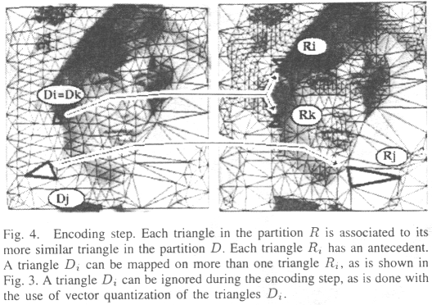
- Decoding
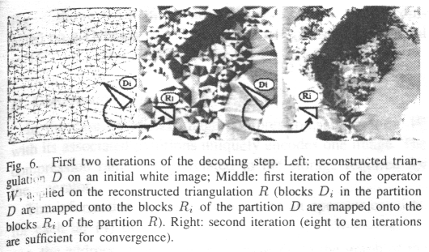
V. Experimental results
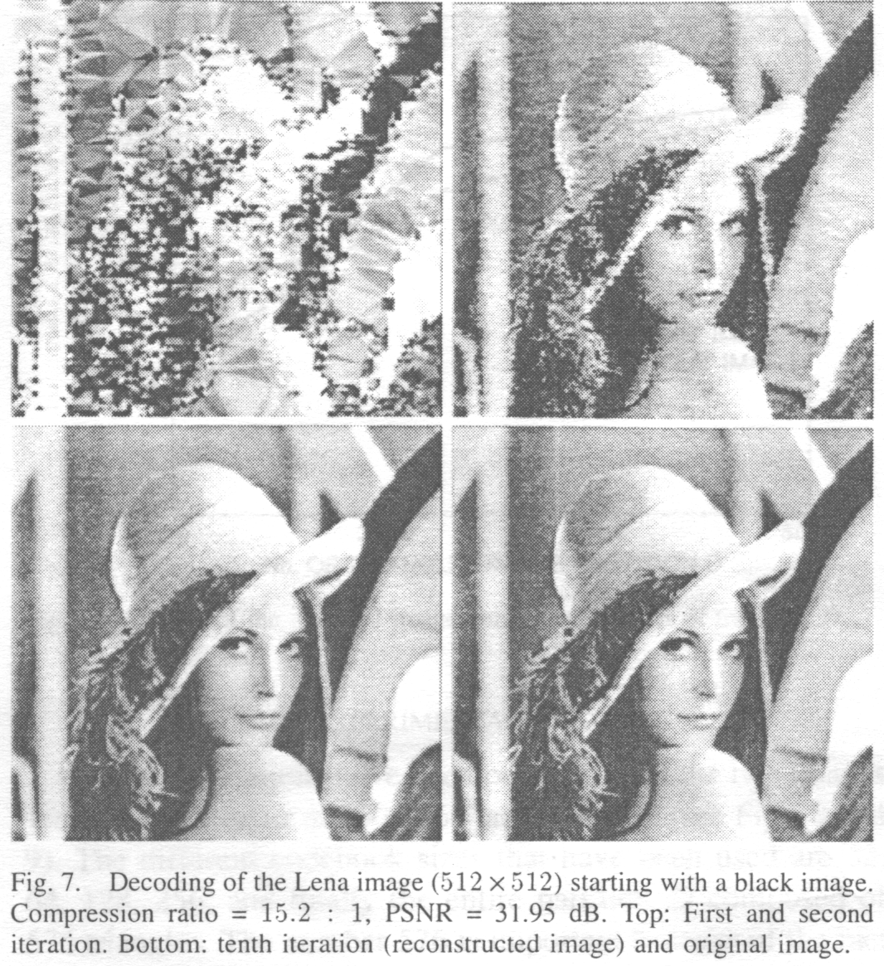
- Conclusions and perspectives
A new partitioning scheme based on Delaunay triangles has been investigated for fractal image compression. Moreover, a classification scheme based on VQ has been used in order to reduce the number of blocks in the domain partition.
In a future work, we propose to improve our classification scheme based on the comparison of the grey level histograms (MSE). The aim will be to find a grey level shape criterion, invariant under spatial affine transformations of the blocks. We propose to merge neighboring stretched triangles into quadrilaterals.

Created by: Lih-Ching Lin
Date: Mar. 6 1998

