Two-dimensional Split and Merge Algorithm for Differential Vector Quantization of Images

Wai-Fong Lee, Chok-Ki Chan
Signal Processing: Image Communication 13 (1998) 1-14

Abstract
In this paper, an image is modeled as a two and a half-dimensional surface and an approximated surface for the image is formed by triangular patches. A new two-dimensional split and merge algorithm (2DSM) for generating the approximated surface has been devised.

1. Introduction
Differential vector quantization (DVQ):
Conceptually, DVQ involves two steps: construction of the approximation for an input image and coding of the residual image (which is the difference between the input image and its approximation) using VQ.

2. Optimal triangulation for image approximation
2.1. Initial triangulation
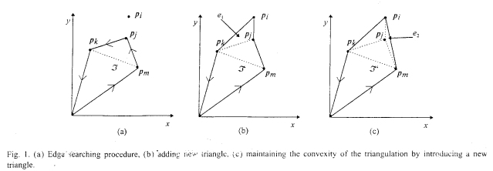
2.2. Optimization process
For any four points in the plane, if they together form a strictly convex quadrilateral Q, two different triangulations are possible as shown in Fig. 2.
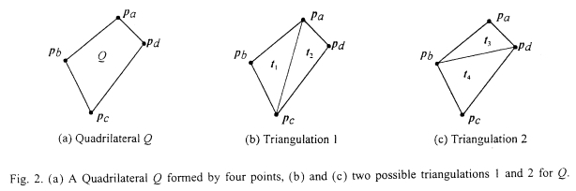
Optimization process is used to select a preferred triangulation out of all possible cases based on a predefined criterion.

2.2.1. Angle criterion optimization
Short fat triangles are preferable to long thin ones.
Circle Criterion (CC) is one of the effective angle criteria tests.
2.2.2. Least-square error-criterion optimization
The LSE criteria follows that ℑ₁ is preferred if
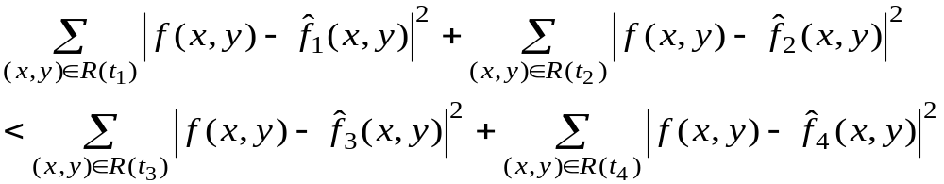
otherwise ℑ₂ is preferred.
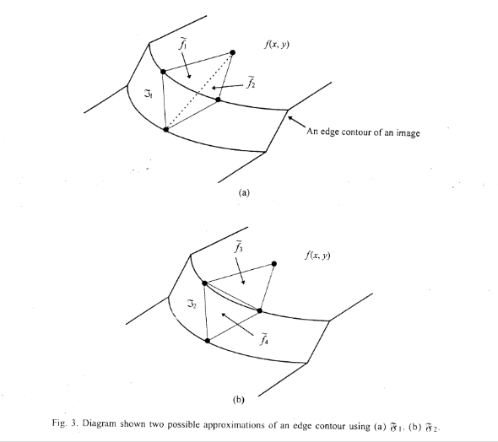
2.3. Image surface reconstruction
The approximated image surface is constructed by piecewise linear interpolation of the triangular patches.

3. Two-dimensional split and merge algorithm
An example is shown in the follow
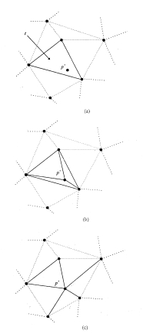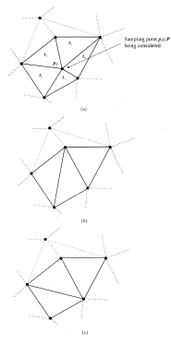
4. Vector quantization of image using 2DMS
5. Experimental results
6. Conclusions
A new two-dimensional split-and-merge algorithm is introduced in this paper. The algorithm provides an effective method in finding a better set of sampling points over the whole two- dimensional plane for image surface approximation. In addition, a new optimal triangulation algorithm for image data approximation is devised for the 2DSM. For image coding application using VQ technique, significant improvement in the reconstructed image quality has been justified by subjective and quantitative analysis.

Created by: Lih-Ching Lin
Date: Jul. 10, 1998
