Viterbi-Based Algorithm for Side-Match Vector Quantization over Noisy Channels
Chung J. Kuo and Chang-Shyan Lin
IEEE Transactions on Communications Vol.44, No.11, November 1996

Abstract
This research shows that the side-match vector quantization is an error-propagating code. Here, it proposes a Viterbi-based algorithm to solve this problem. In addition, the proposed algorithm requires much fewer computations than the Viterbi algorithm.

Introduction
- VQ
- FSVQ

Background: Side-Match Vector Quantization
An SMVQ is a mapping from R^{k} × S to a subset of a super codeword C = {y_{i}, i = 1, …, N_{m}}, where S = {S_{i}, i = 1, …, M} is the state space. With a state function f(p’s).
Def.
- horizontal distortion:
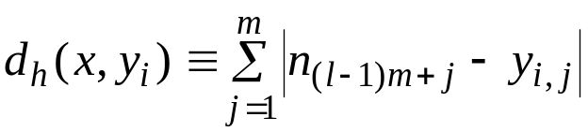
- vertical distortion:
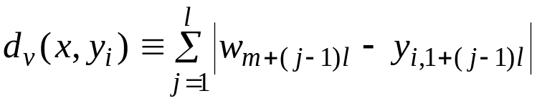
The Side-Match distortion of a codeword y_{i} with respect to input block x is defined as

The Viterbi-Based Algorithm
- Viterbi Algorithm
In the viterbi algorithm, it depends on side-match condition:
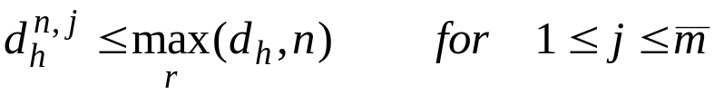
And the first and last block in a row must be protected by as error-correcting code.

- The Modified Viterbi Algorithm
The modified Viterbi algorithm is summarized below. For simplicity, the codeword in the super codebook is abbreviated as codeword.

SMVQ Decoding Test:
- Decode the received bit-stream based on the 1-D SMVQ decoding algorithm.
- Check the last decoded block after a row is completely decoded.
- If the last decoded block does not coincide with the protected last block, then the row is corrupted by noise.
- Otherwise, the row passes SMVQ decoding test.

We further classify the rows, which have passed SMVQ decoding test into the following cases:
- Single-Row: The nth row passes SMVQ decoding test, while the (n±1)th row is noisy.
- Double-Row: The nth row and (n+1)th row pass SMVQ decoding test, while the (n-1)th and (n+2)th row are noisy.
- Many-Row: The nth,… ,(n+i)th row pass SMVQ decoding test, while the (n-1)th and (n+I+1)th row are noisy.

IV. Computer Simulation

V. Conclusion
- SMVQ is first shown be an error-propogating code in this paper.
- In this paper first proposed three different (SMVQ, double- and triple-noisy-row) tests to detect the nosy rows in an 1-D SMVQ encoded image.
- The Viterbi-based algorithm is proposed to decode the 1-D SMVQ encoded images.
- Another contribution of the proposed algorithm is its speed.

Created by: Lih-Ching Lin
Date: Mar. 4, 1998

