VQ-Enhanced Fractal Image Compression
Raouf Hamzaoui, Martin Müller, Dietmar Saupe
IEEE International Conference on Image Processing (ICIP'96), Lausanne, Sept. 1996

Abstract
A novel hybrid scheme combining fractal image compression with mean-removed shape-gain vector quantization is presented. Our scheme is shown to improve the performance of conventional fractal coding in all its aspects.

- Introduction and previous work
Fractal image compression & MRSG-VQ

- Notations and mathematical background
Theorem Let n ≥ 2 and X = R^{n} \ C. Define the function Δ : X × X → [0,√2] by Δ(D, R) = min(||φ(R) + φ(D)||, ||φ(R) - φ(D)||), where φ(Z) = OZ / ||OZ||. For D, R∈ X the least squares error E(D, R) is given by E(D, R) = <R, φ(R)>g(Δ(D, R)) where 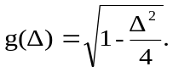

E(D_{i}, R) = min_{a,b∈R}||R-(aD_{i}+bC)||, where C is the block of constant intensity C = (1, …, 1)^{T}. R is range block. D_{i} is the codebook blocks.
O be the orthogonal projection operation, which maps R^{n} onto the orthogonal complement C⊥, where C is the linear span of C.

- The algorithm
Now introduce VQ hybrid scheme which provides a further enhancement. Let c = arg min_{i}||φ(I_{R}(R))-m_{i}||. If
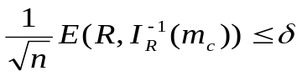 (1)
or if the inequality
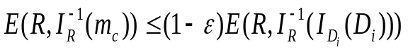 (2)
holds for all codebook blocks D_{i} in the cluster with center m_{c}, then cluster center is m_{c} is retained for VQ encoding of the range block. Here ε and δ are parameter of this method. If neither condition (1) nor condition (2) are satisfied, then the range block will be encoded by the codebook block D minimizing 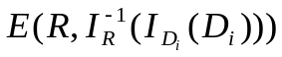in the cluster with center m_{c}.
The decoding proceeds as with a conventional fractal decoder, i.e., though iterations from any initial image with the advantage.

- Results and discussion
ε | δ | N₁ Comp PSNR Time |  | Iteration | Hybrid Fractal
0.1 | 2  3 | 9075 5.67 36.72 49  12662 6.27 36.54 39 |  | 1  3  5  9 | 22.46 11.56  35.48 21.48  36.47 35.20  - 36.29
0.15 | 2  3 | 9947 5.72 36.64 49  13313 6.34 36.47 39 |  | 1  3  5  9 | 22.46 11.56  35.48 21.48  36.47 35.20  - 36.29
0.2 | 2  3 | 10786 5.78 36.53 49  13937 6.40 36.38 39
0.25 | 2  3 | 11523 5.85 36.44 49  14441 6.46 36.29 39

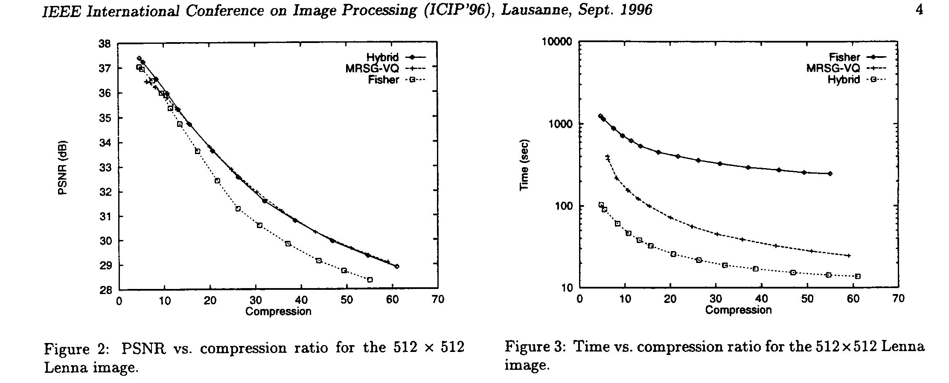
- Conclusion
We have proposed a new hybrid scheme which combines fractal image compression and product code vector quantization. Experimental results show that our hybrid scheme yields superior performance over conventional fractal coding.

Created by: Lih-Ching Lin
Date: Apr. 8,1998

