A Memory Efficient and Fast Huffman Decoding Algorithm
Hong-Chung Chen, Yue-Li Wang and Yu-Feng Lan
1998 International Computer Symposium Workshop on Algorithms, pp. 145-149, Dec. 1998
Abstract
This paper present a fast Huffman decoding algorithm, which takes O(log n) time and uses ⎡3n/2⎤ + ⎡n/2logn⎤ + 1 memory space, where n is the number of symbols in a Huffman tree.
- Introduction
- The Main Idea of Our Algorithm
Let T be a Huffman tree which contains n symbols.
h is the height of the Huffman tree.
w_{i} is the weight of a symbol is defined to be 2^{h-l}.
l is the level of the symbol.
count_{i} = count_{i-1} + w_{i}
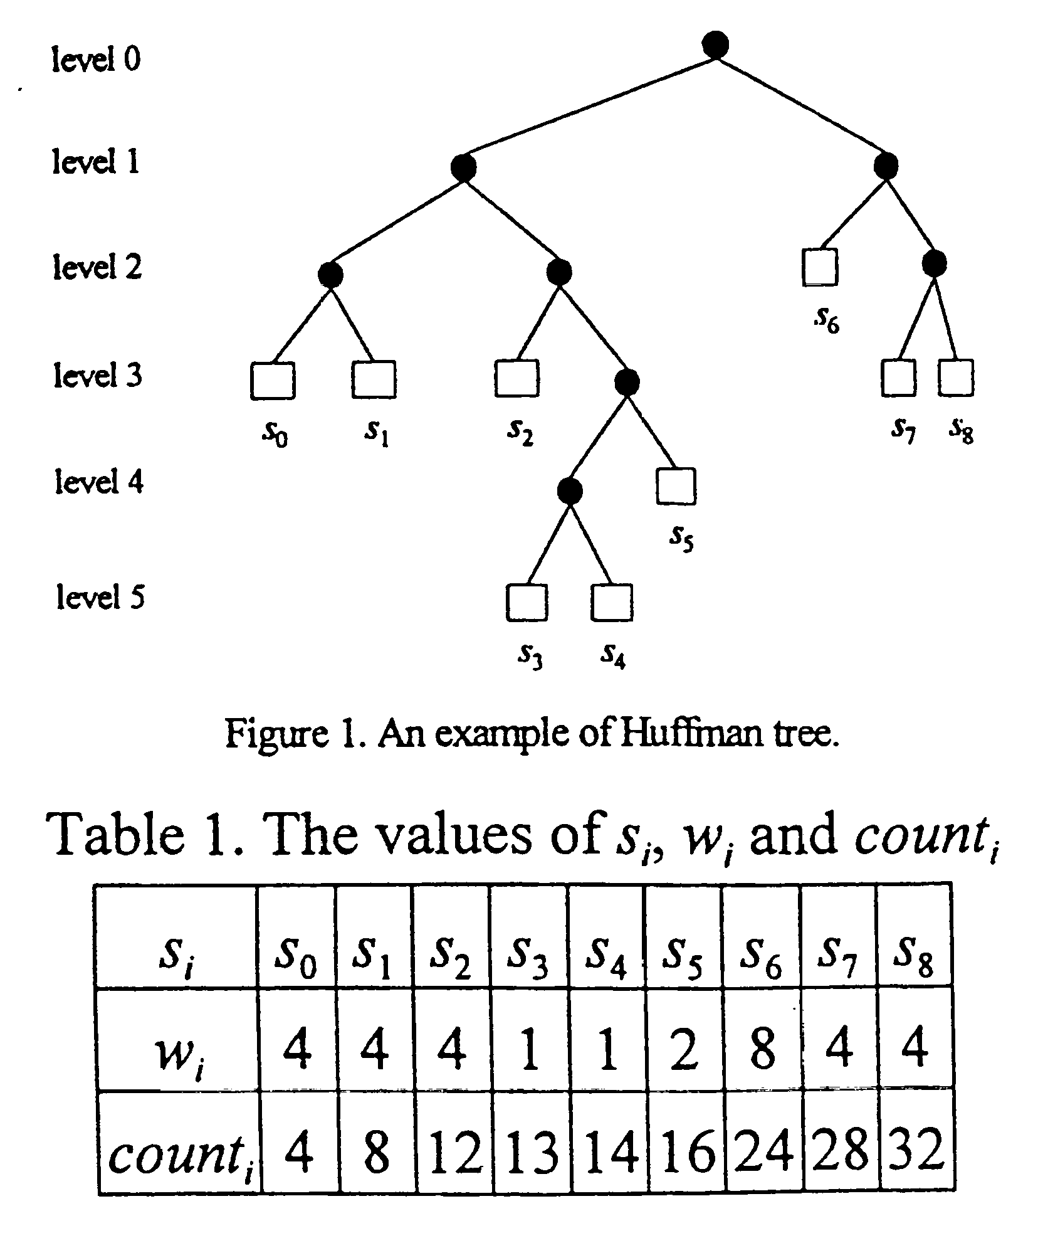
Algorithm A
Input: s_{i}, w_{i} and count_{i,} i=0, 1, …, n-1, h and a binary codeword c.
Output: The corresponding symbol s_{k} of c.
Method:
Step 1. Compute t = (c + 1) × 2^{h-d}, where d is the number of binary digits in c.
Step 2. Search t from array count, if t is not in the array count, the c is not a codeword of T; otherwise assume that count_{k} = t.
Step 3. If w_{k} ≠ 2^{h-d}, then c is not a codeword of T; otherwise s_{k} is the corresponding symbol of codeword c.
End of Algorithm A
Clearly, Algorithm A can be done in O(log n) time. The memory required is 3n+1.
- A Memory Efficient Version of Algorithm A
At first, since w_{i} can be obtained from the equation w_{i} = count_{i} - count_{i-1}, the array w can be omitted. The needed memory space becomes 2n+1. Now, we consider how to decrease the memory space needed by array count. Let W_{i} = w_{2i} + w_{2i+1} and COUNT_{i} = COUNT_{i-1} + W_{i}.
Algorithm B
Input: s_{i}, b and COUNT , h and a binary codeword c.
Output: The corresponding symbol s_{k} of c.
where 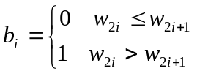
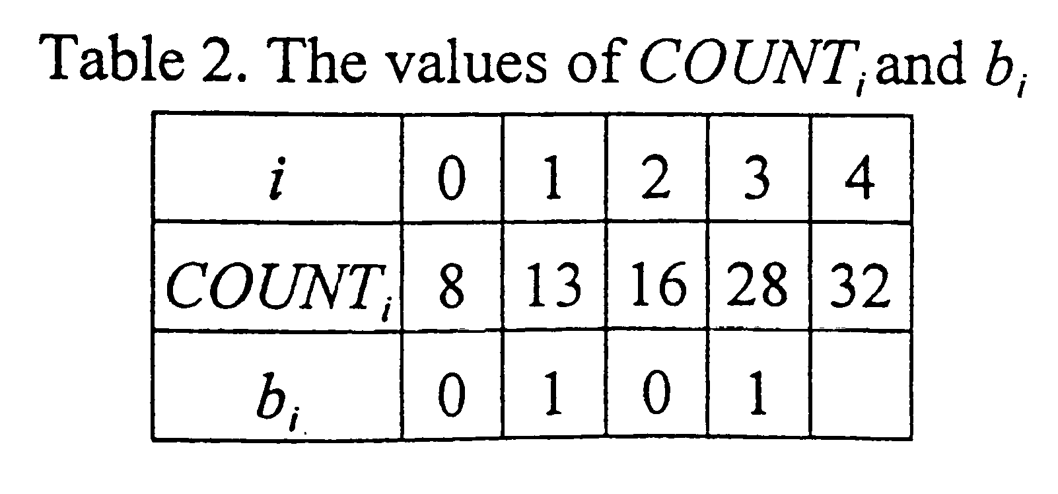
The time complexity of Algorithm B is O(log n). The needed memory space for the s, COUNT, and b and the height of T are n, ⎡3n/2⎤ , ⎡n/2logn⎤ and 1.
- Concluding Remarks
Created by: Lih-Ching Lin
Date: Mar. 17, 1999

