A Fast Linde-Buzo-Gray Algorithm in Image Vector Quantization

Yih-Chuan Lin and Shen-Chuan Tai
IEEE Transactions on Circuits and Systems-II: Analog and Digital Signal Processing, Vol. 45, No. 3, March 1998, pp. 432-435

Abstract
This brief presents a novel algorithm for speeding up the codebook design in image vector quantization that exploits the correlation among the pixels in an image block to compress the computational complexity of calculating the squared Euclidean distortion measures, and uses the similarity between the codevectors in the consecutive codebooks during the iterative clustering process to reduce the number of codevectors necessary to be checked for one codebook search.

Introduction
VQ & LBG algorithm.
The squared Euclidean distortion:
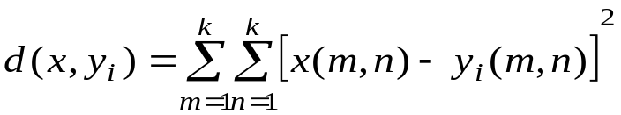 (1)

II. The Proposed Fast LBG Algorithm
These propose fast LBG algorithm for codebook design is based on multiple distortion measures with different levels of computational complexity.
For any vector x(i, j), where i, j = 1, 2, …,k. The three kinds of integral projections are defined in the following.
- Vertical Projections: 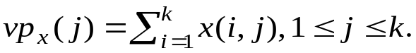
- Horizontal Projections: 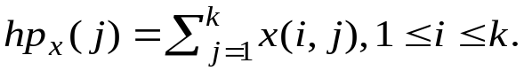
- Massive Projections: 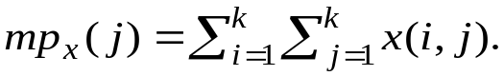
In the proposed algorithm, the three simple distortion measures are defined as follows:
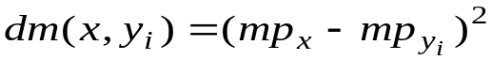 (2)
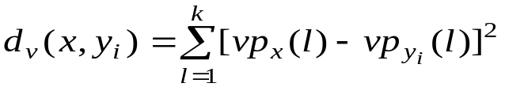 (3)
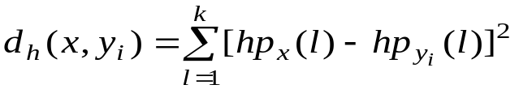 (4)
With these distortion measures defined in (1)-(4), we have the following three inequalities which can be easily proven for every codevector:
d_{m}(x, y_{i}) ≤ k²d(x, y_{i}) (5)
d_{v}(x, y_{i}) ≤ kd(x, y_{i}) (6)
d_{h}(x, y_{i}) ≤ kd(x, y_{i}) (7)
When checking other codevectors y_{j}, if any of the following test conditions is satisfied:
- k²d_{min} < d_{m}(x, y_{j})
- kd_{min} < d_{v}(x, y_{j})
- kd_{min} < d_{v}(x, y_{j})
then by inequalities (5), (6), or (7), the codevector y_{i} can be rejected without calculating the squared Euclidean distortion because d_{min} <d(x, y_{j}) can be induced in this situation.
To increase the search efficiency during each iteration in the proposed fast LBG algorithm, codevectors in the current codebook should first be sorted in an ascending order of their massive projection.

III. Experimental Results and Discussions
Images | Fast LBG |  |  |  |  | LBG
Images | 64 | 128 | 256 | 512 | 1024 | 64 | 128 | 256 | 512 | 1024
Lenna | 73 | 87 | 174 | 295 | 406 | 1674 | 2680 | 5824 | 11510 | 15473
F16 | 145 | 245 | 267 | 441 | 456 | 3178 | 6832 | 9077 | 17076 | 17132
Peppers | 112 | 104 | 166 | 264 | 337 | 2702 | 2978 | 5903 | 9974 | 11802
X-head | 109 | 62 | 129 | 239 | 465 | 2307 | 1178 | 2930 | 6631 | 15514

Images | Fast LBG |  |  |  |  | LBG
Images | 64 | 128 | 256 | 512 | 1024 | 64 | 128 | 256 | 512 | 1024
Lenna | 31 | 53 | 120 | 146 | 219 | 706 | 1345 | 4320 | 5748 | 8627
F16 | 117 | 103 | 125 | 183 | 246 | 2507 | 2871 | 3813 | 6114 | 9351
Peppers | 46 | 111 | 73 | 104 | 155 | 1131 | 4313 | 2714 | 3962 | 6510
X-head | 27 | 55 | 73 | 119 | 170 | 549 | 1475 | 2019 | 3595 | 5044

Images | No. of iterations |  |  |  |  | SNR (in dB)
Images | 64 | 128 | 256 | 512 | 1024 | 64 | 128 | 256 | 512 | 1024
Lenna | 35 | 30 | 32 | 31 | 21 | 27.7 | 29.4 | 30.4 | 31.2 | 32
F16 | 68 | 74 | 49 | 45 | 23 | 28.1 | 28.9 | 29.9 | 30.6 | 31.6
Peppers | 60 | 33 | 32 | 27 | 16 | 27.8 | 28.7 | 29.5 | 30.4 | 31.2
X-head | 49 | 13 | 16 | 18 | 21 | 30.6 | 33.5 | 34.2 | 35.1 | 36

Images | No. of iterations |  |  |  |  | SNR (in dB)
Images | 64 | 128 | 256 | 512 | 1024 | 64 | 128 | 256 | 512 | 1024
Lenna | 16 | 15 | 24 | 16 | 12 | 25.3 | 26.3 | 27.4 | 28.3 | 29.8
F16 | 54 | 31 | 21 | 17 | 13 | 24.2 | 25 | 25.6 | 26.9 | 28.4
Peppers | 25 | 47 | 15 | 11 | 9 | 24.4 | 25.4 | 26.3 | 27.5 | 28.9
X-head | 12 | 16 | 11 | 10 | 7 | 30.5 | 31.4 | 32.3 | 33.4 | 34.7

Codebook size | LBG algorithm | Fast LBG algorithm | PDSLBG algorithm | Splitting algorithm
64 | 14886 | 776 | 2768 | 837
128 | 29914 | 1193 | 5342 | 1040
256 | 59803 | 2029 | 9627 | 1225
512 | 92280 | 2853 | 13476 | 1538
1024 | 236378 | 6033 | 35173 | 1748

IV. Conclusions

Created by: Lih-Ching Lin
Date: July 24, 1998

