A Fast Method of Designing Better Codebooks for Image Vector Quantization
Chok-Ki Chan and Chi-Kit Ma
IEEE Transactions on Communications, Vol. 42, No. 2/3/4, pp. 237-242, February/March/April 1994
Abstract
This paper investigates and compares the performances of various partition techniques in the MD algorithm.
- Introduction
- Maximum Descent Algorithm (MD Algorithm)
The maximum the descent algorithm begins by treating the training vector set X as a global cluster. The cluster is partitioned into two new clusters by an optimal partitioning hyperplane H_{i}. The two clusters are then further partitioned to form three new clusters following a maximum distortion reduction criterion.
Euclidean distortions: 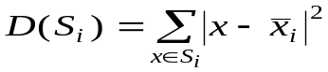
The reduction in sum of distortions due to partition plane H_{i} is:
R_{i}(H_{i}) = D(S_{i}) - | D(S_{ia}) + D(S_{ib})|

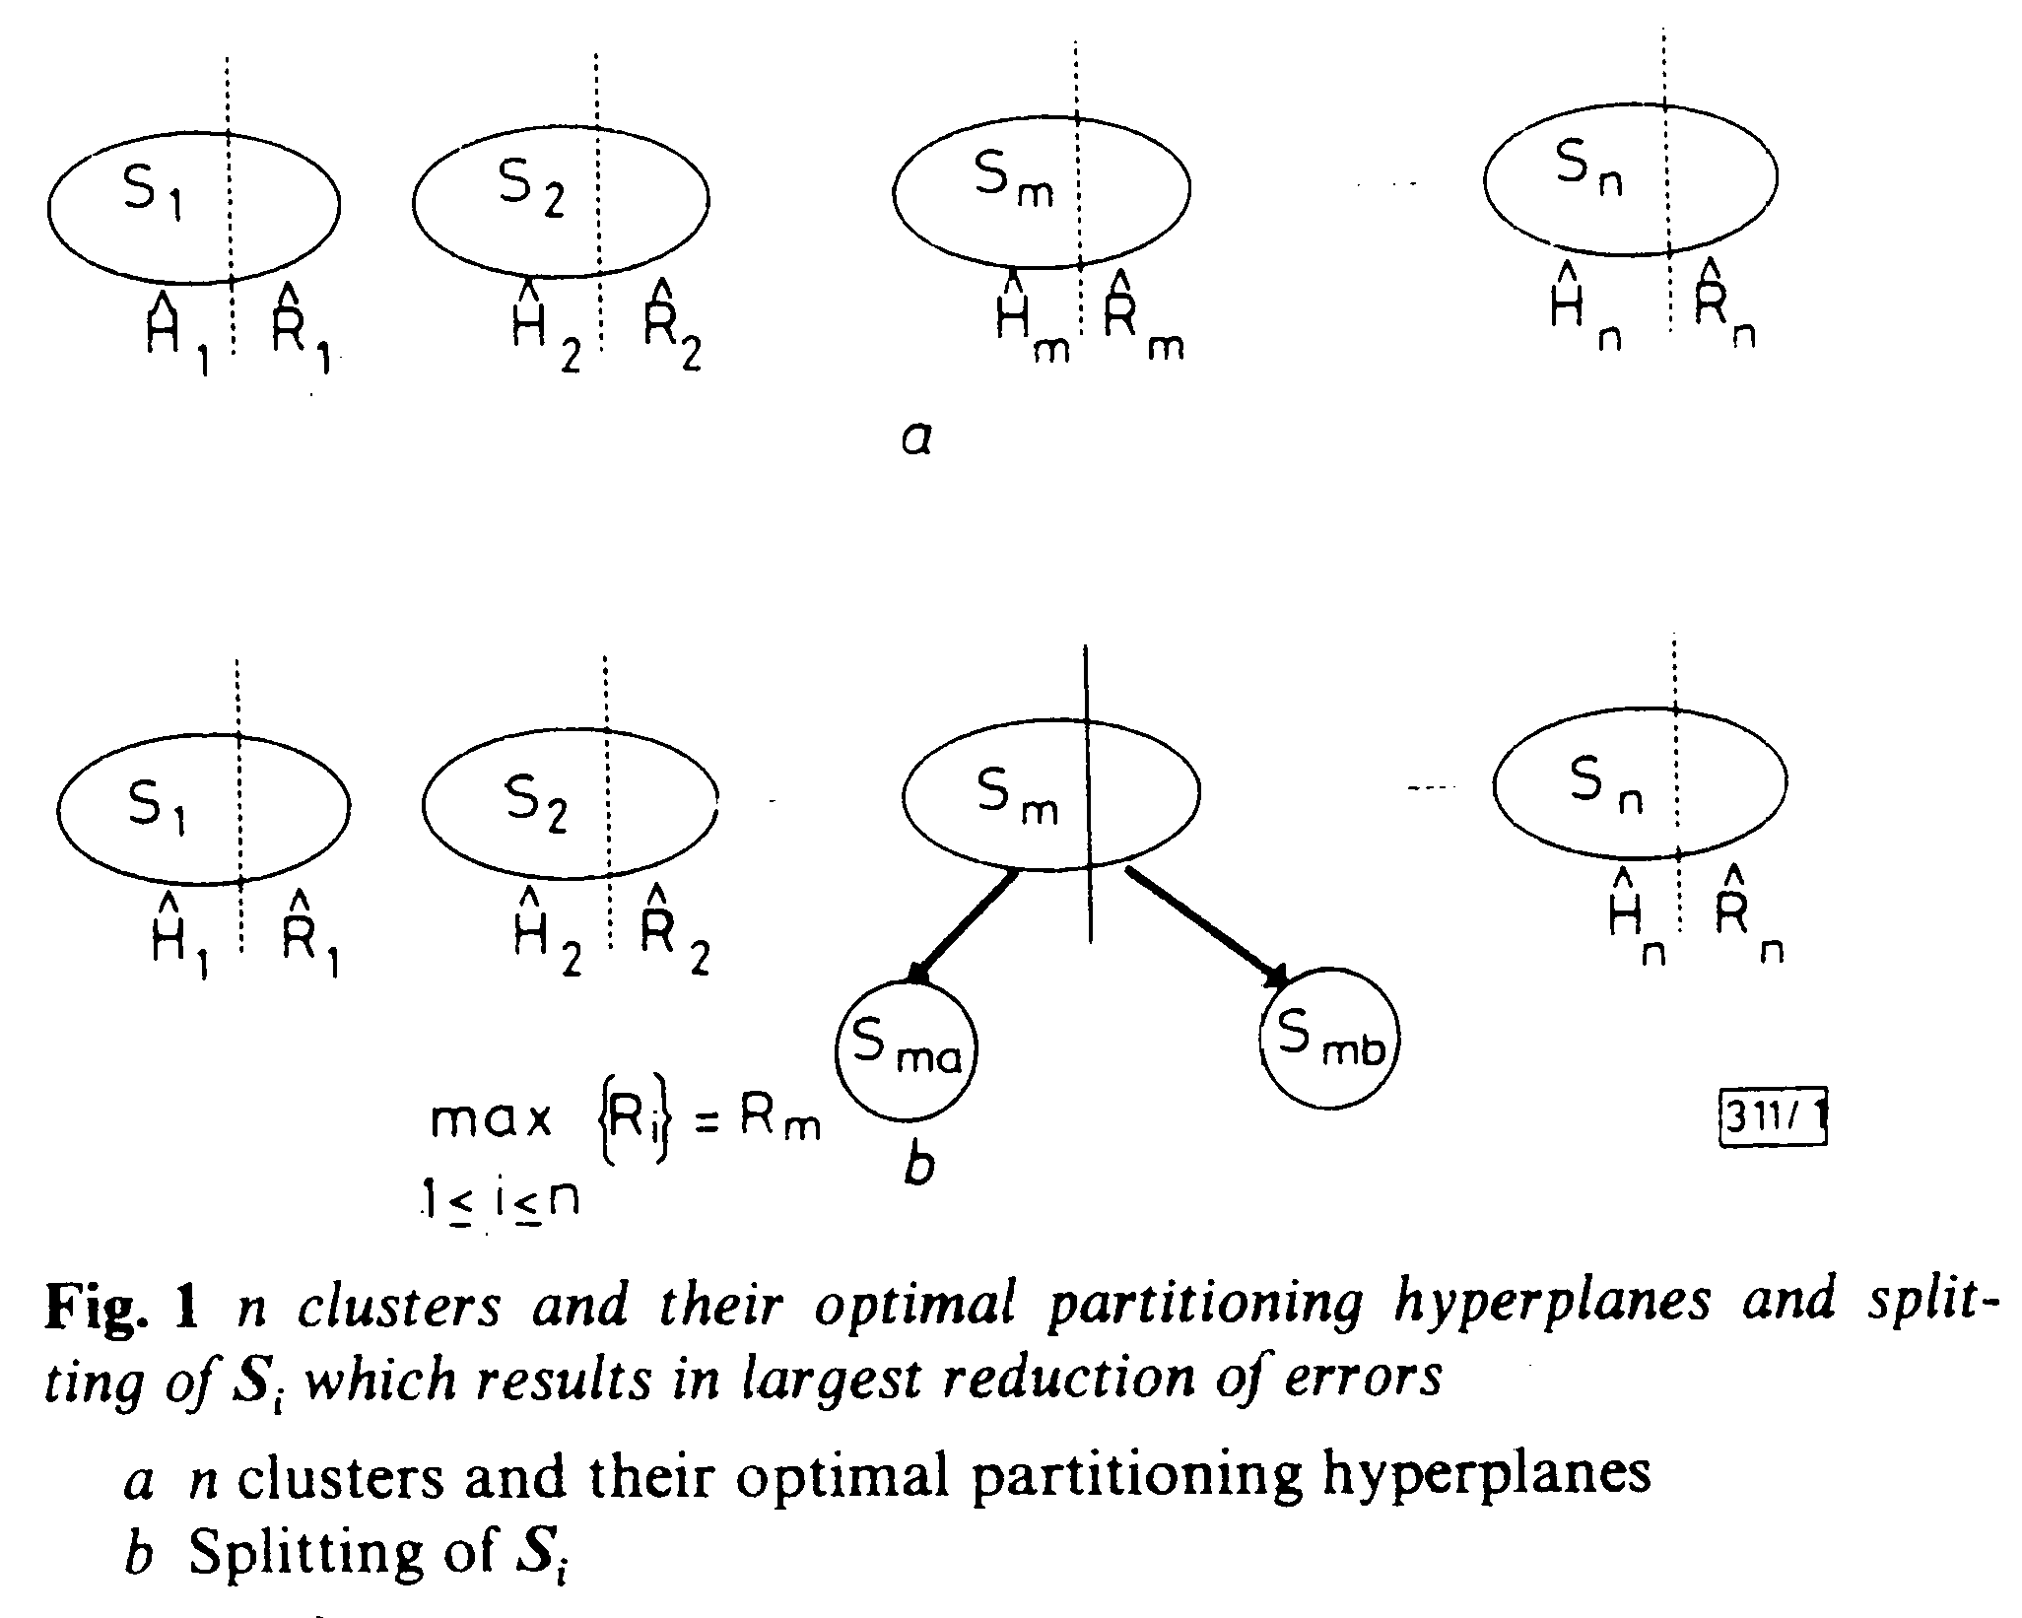
III. Optimal Partitioning Hyperplane
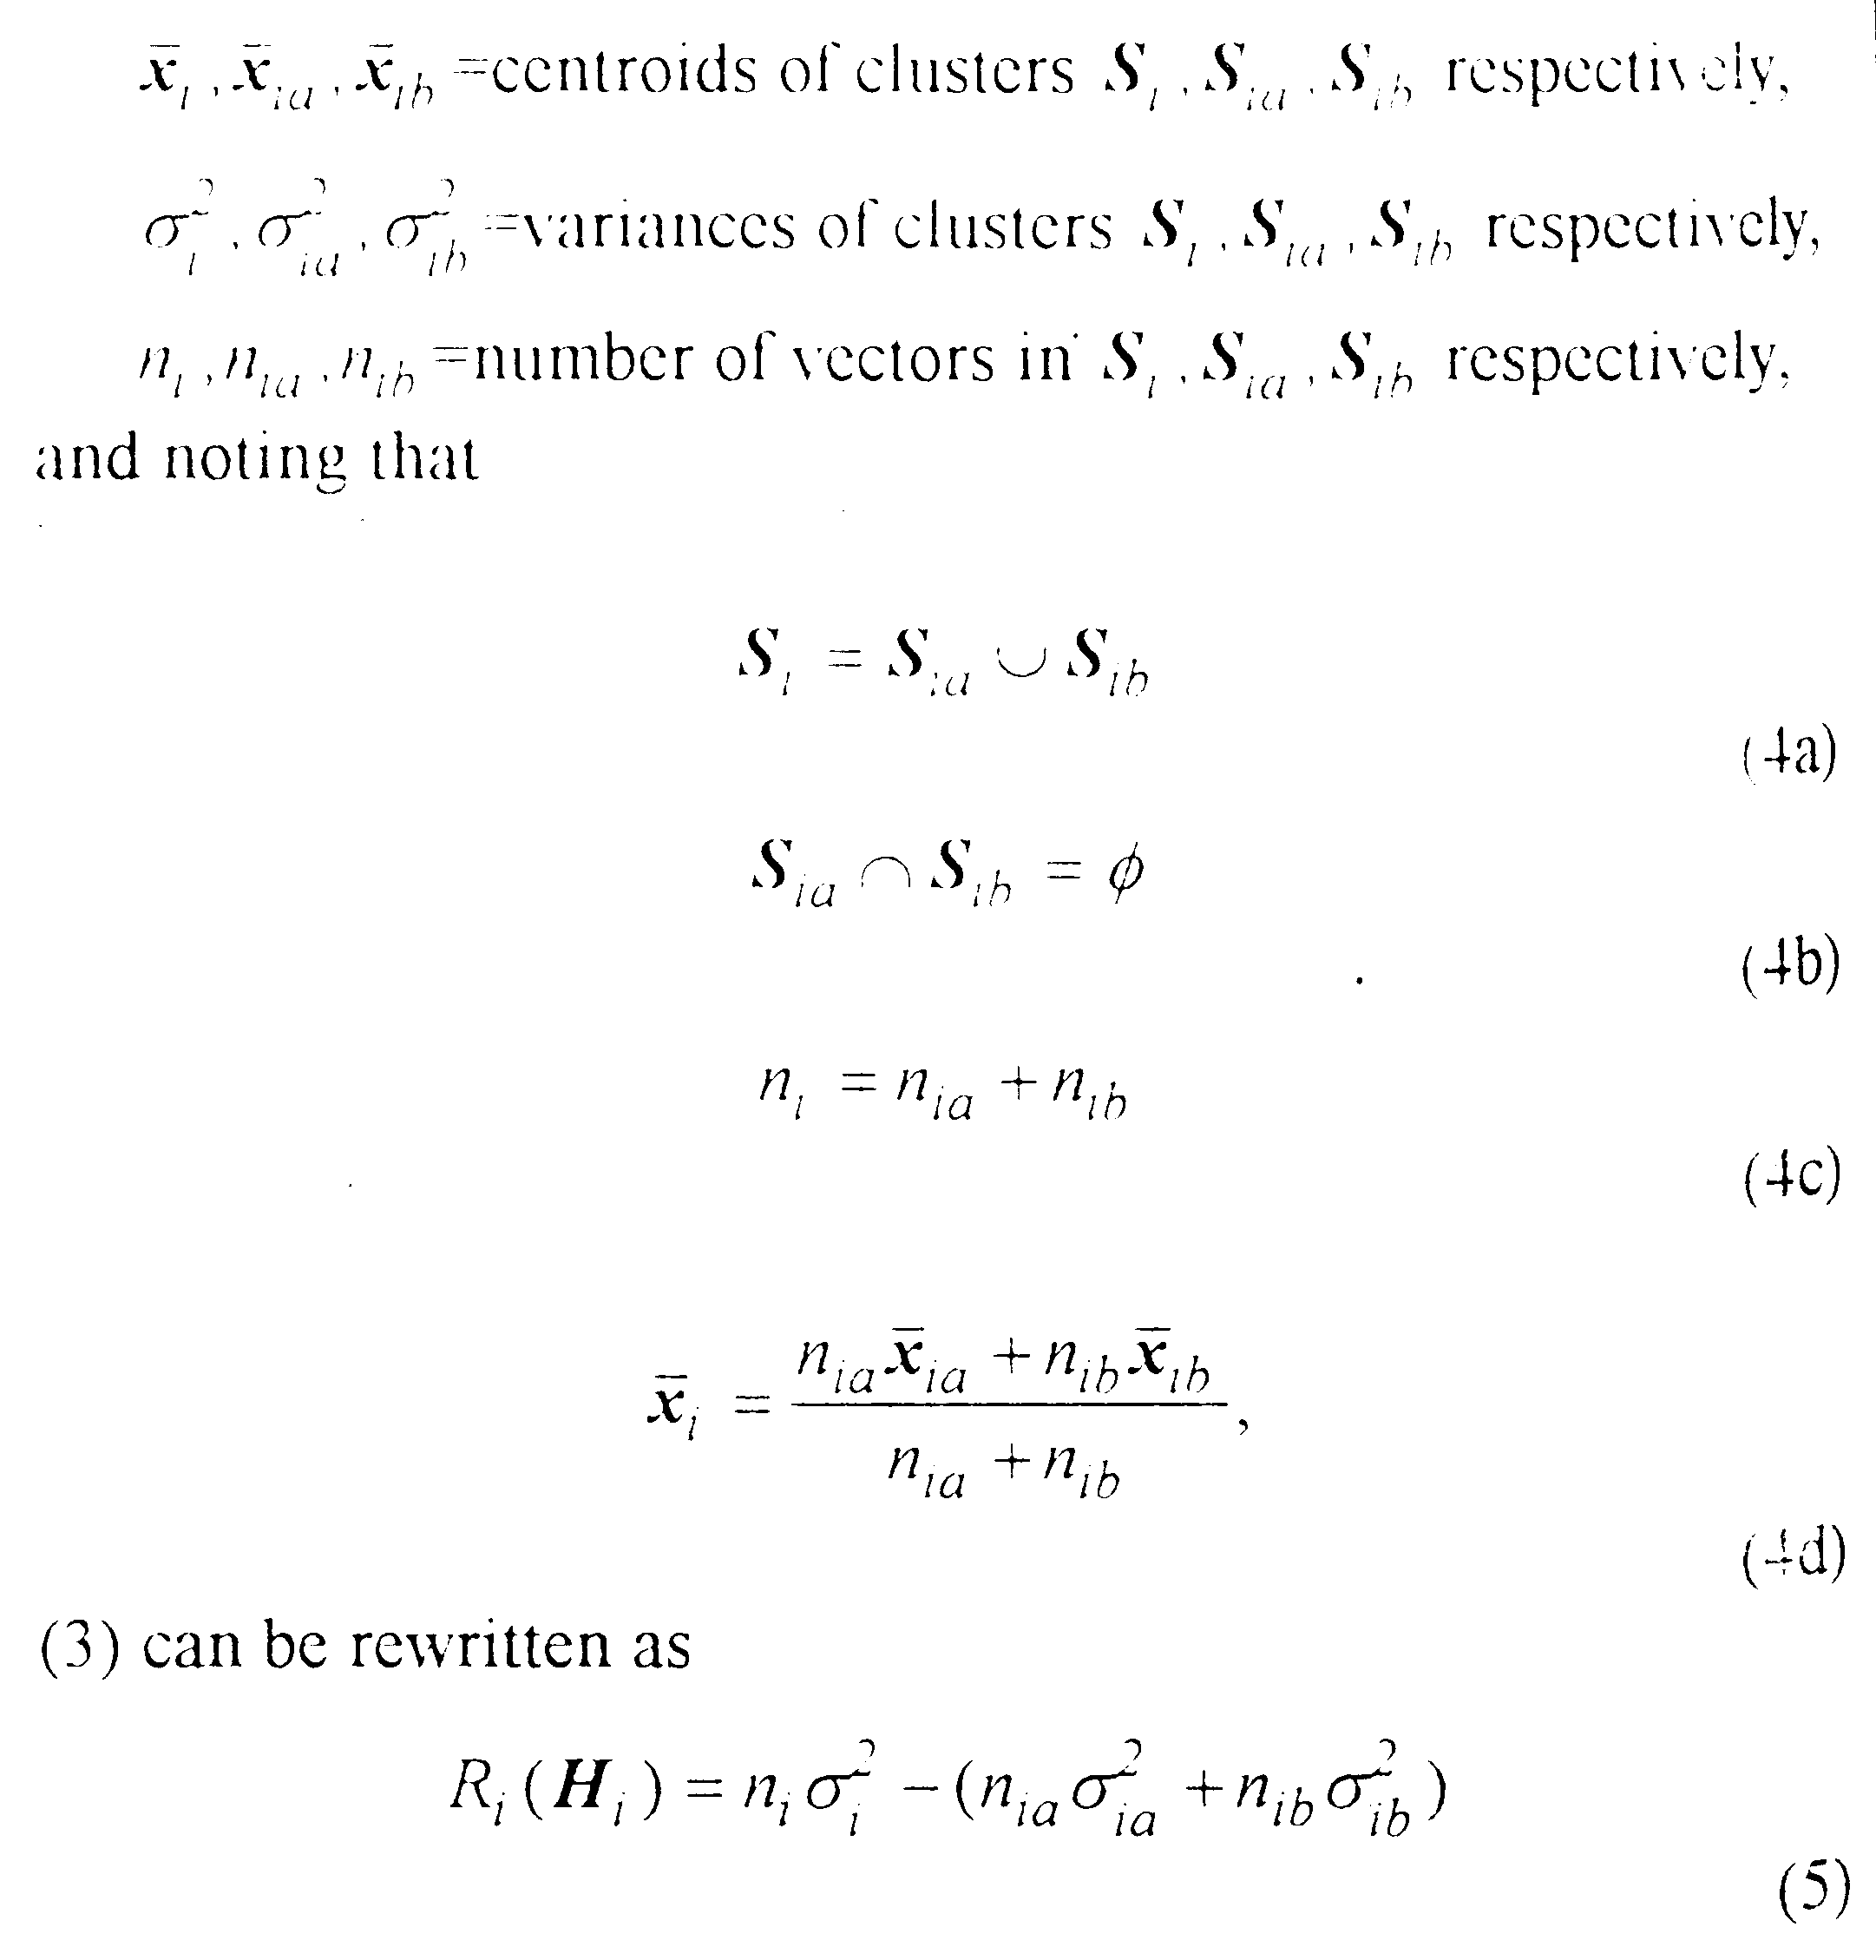
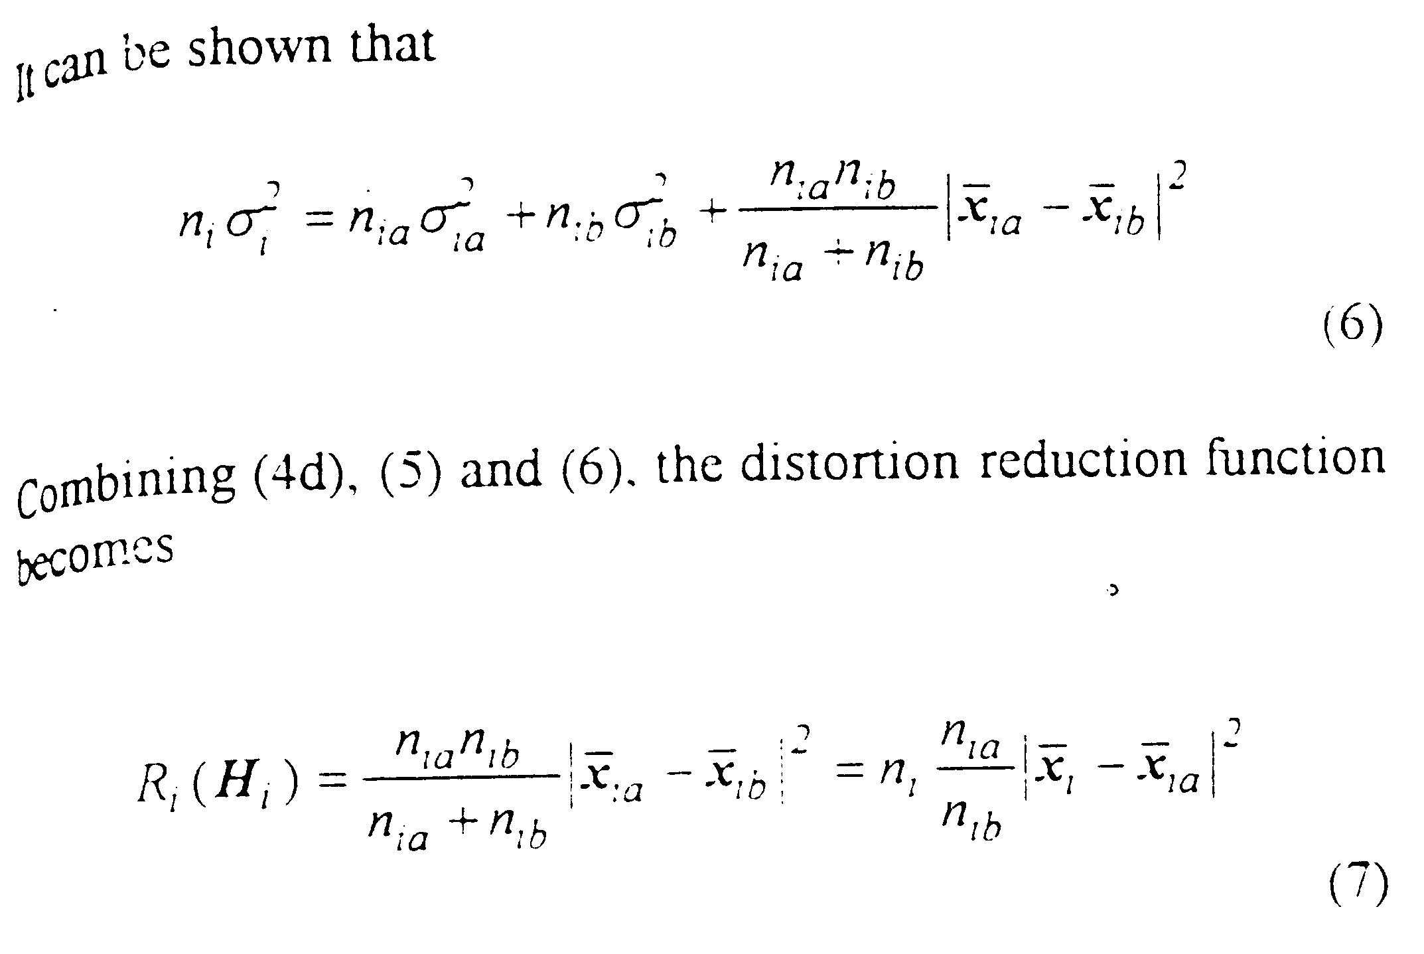
Using (7), three methods of searching the optimal partition hyperplane are investigated.

A. Constrained Exhaustive Search
To reduce the computation load, the search can be restricted to hyperplanes that are perpendicular to the basis vectors of the vector space.
For a cluster S_{i}, the lower and upper bounds of the vectors on one of the DCT basis axes are found. To find the optimal partitioning hyperplane perpendicular to this axis, the algorithm starts by assigning a splitting threshold T to the lower bound. For the training vector whose projection on this axis is smaller than T, it is placed in S_{ia}. Otherwise, it is placed in S_{ib}. Then the R_{i} for T is computed using (7). The threshold T is then incremented. The procedures are repeated until T reaches the upper bound.

B. Successive Search
For gaussian distribution, it can shown that the distortion reduction function is a maximum when D(S_{ia}) and D(S_{ib}) are equal as shown in Fig.2.
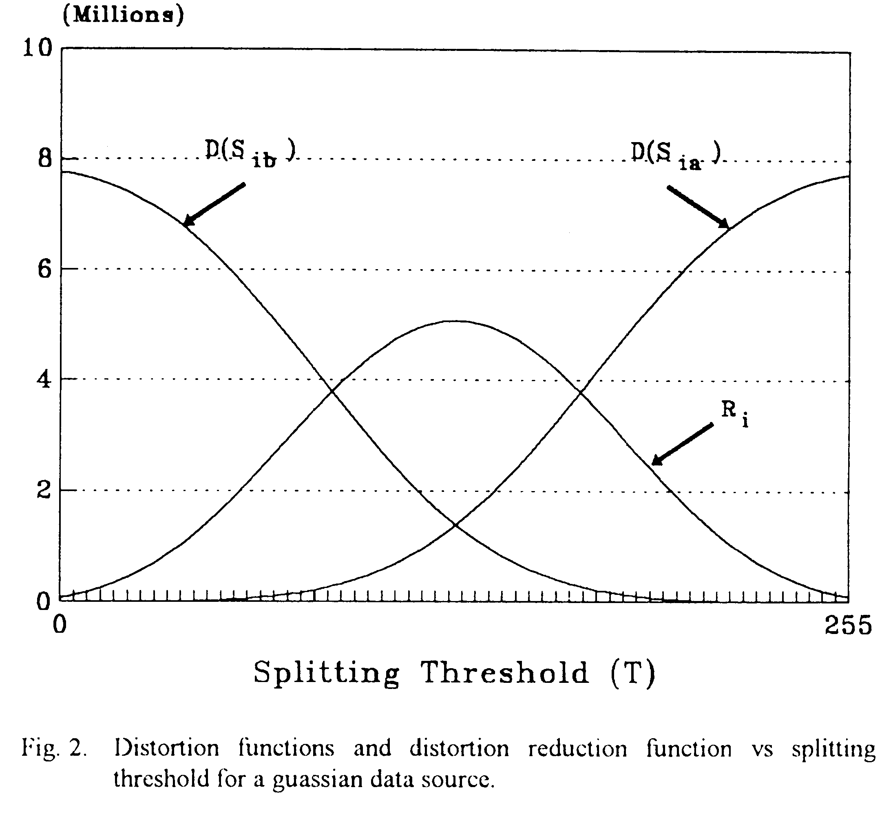
The successive search procedure initially assigns a threshold T half way between the upper and the lower bounds. D(S_{ia}) and D(S_{ib}) are evaluated. If D(S_{ia})>D(S_{ib}), the threshold is set to T₁ which is half way between T and the lower bound. Otherwise, T₁ is set to half way between T and the upper bound. The algorithm stops when the difference between D(S_{ia}) and D(S_{ib}) is within a pre-defined value.

C. Fast LBG Search
The LBG algorithm is a well-known computationally intensive technique. In the binary partitioning process, the input vector x is placed in S_{ia} if
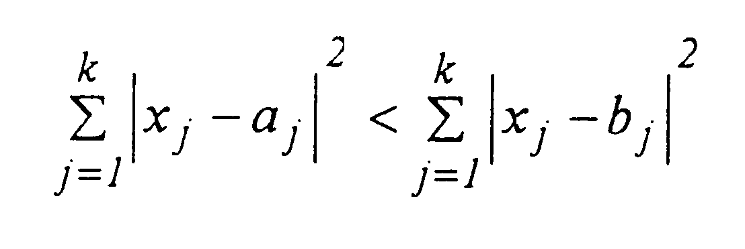
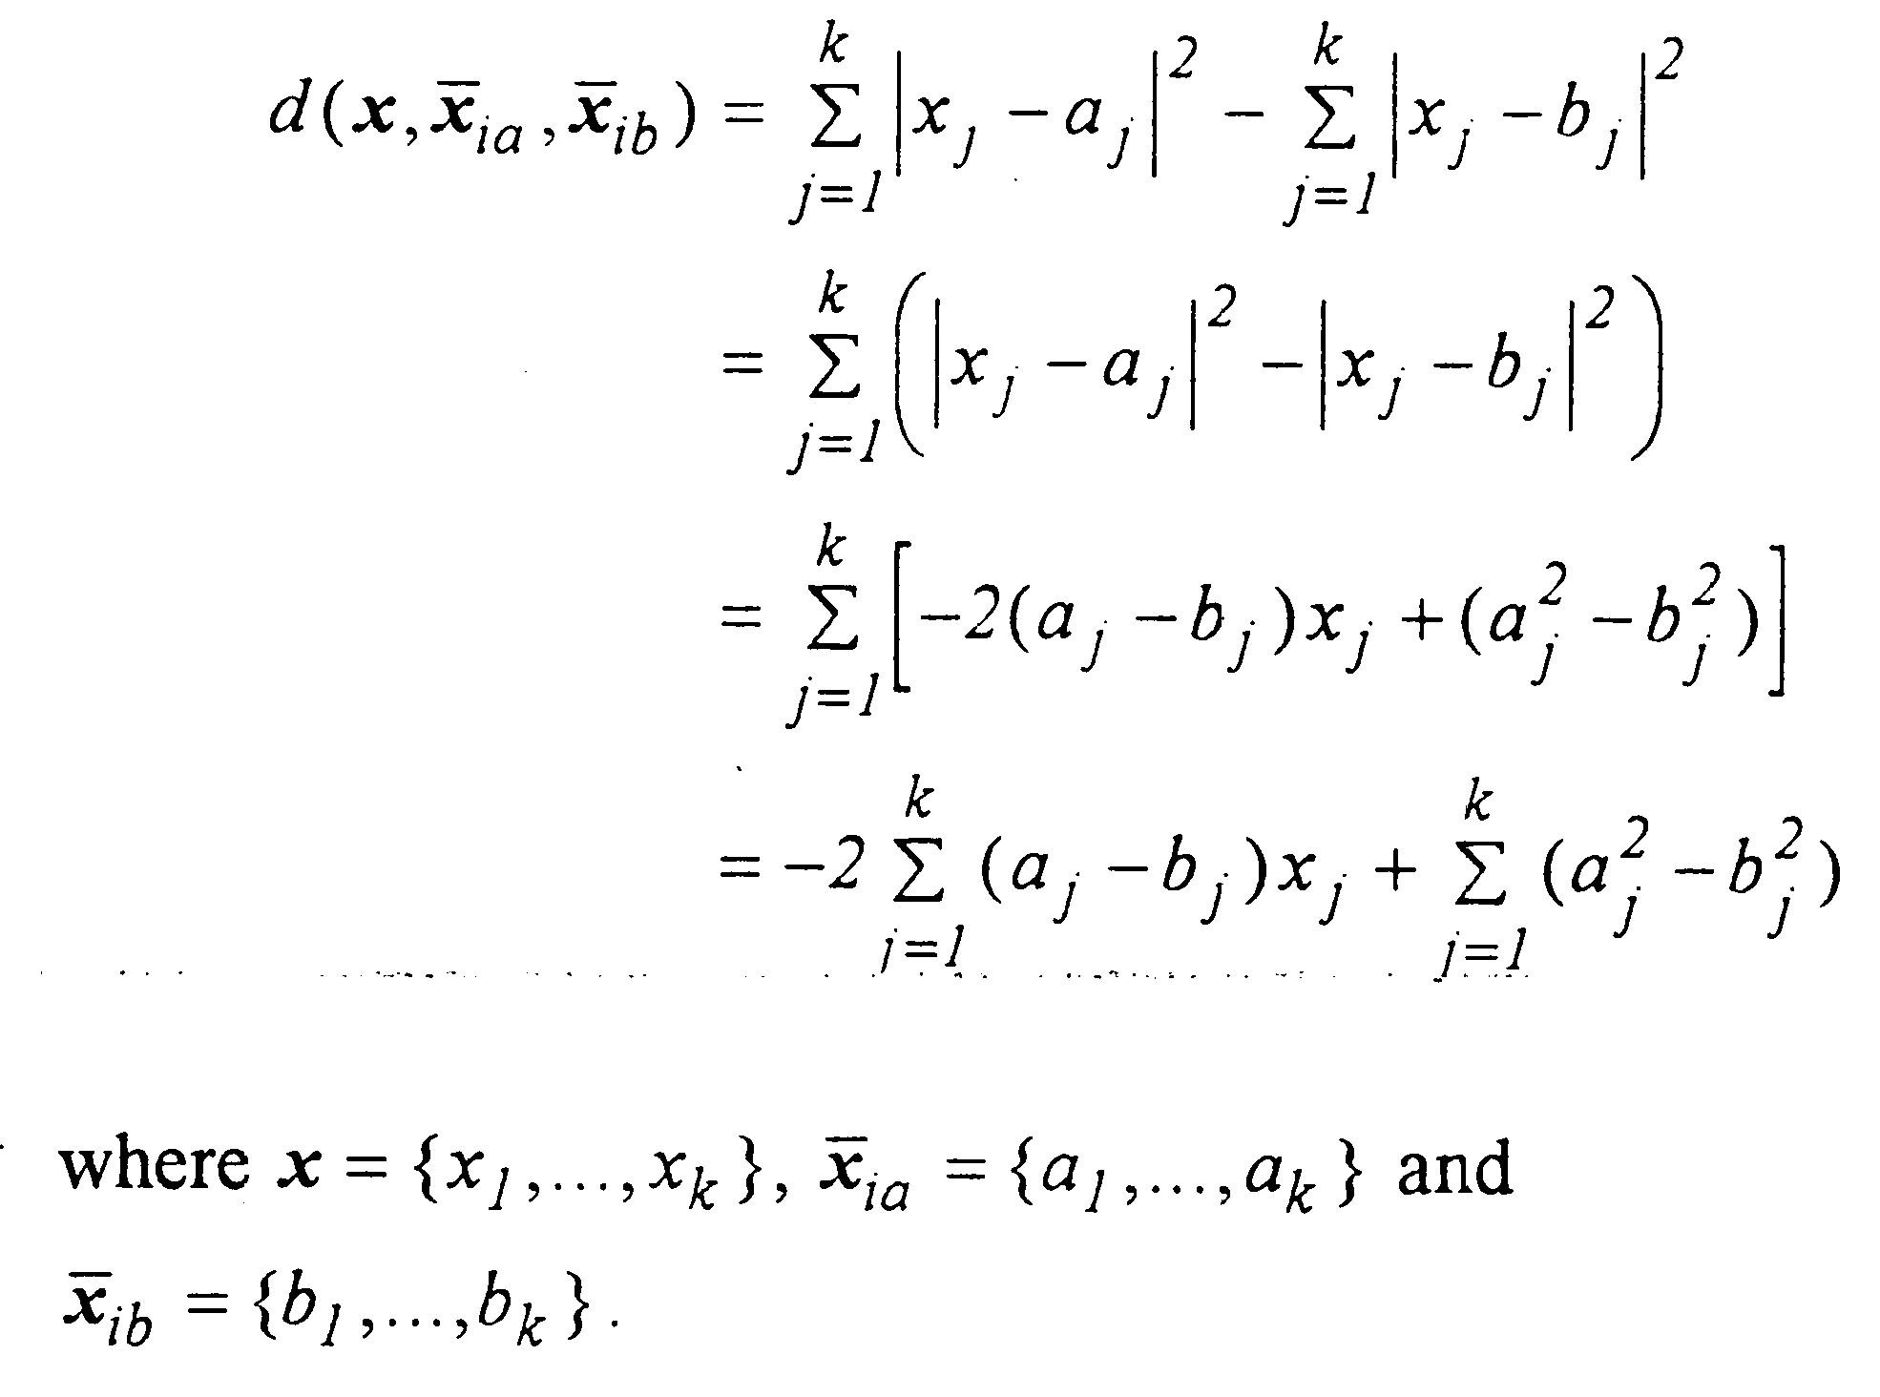
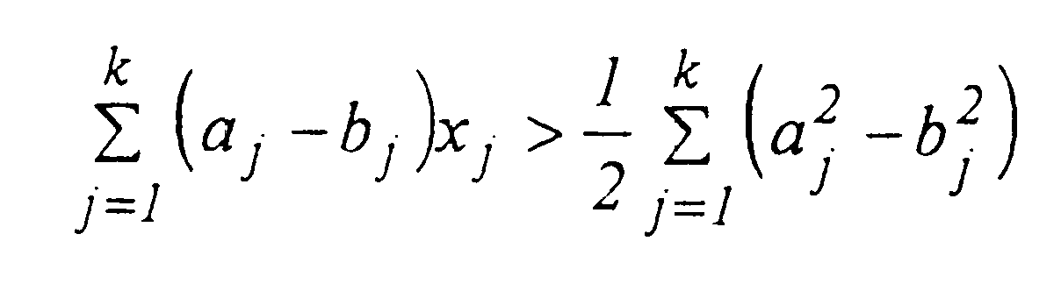
IV. Performance Comparisons in Image Coding
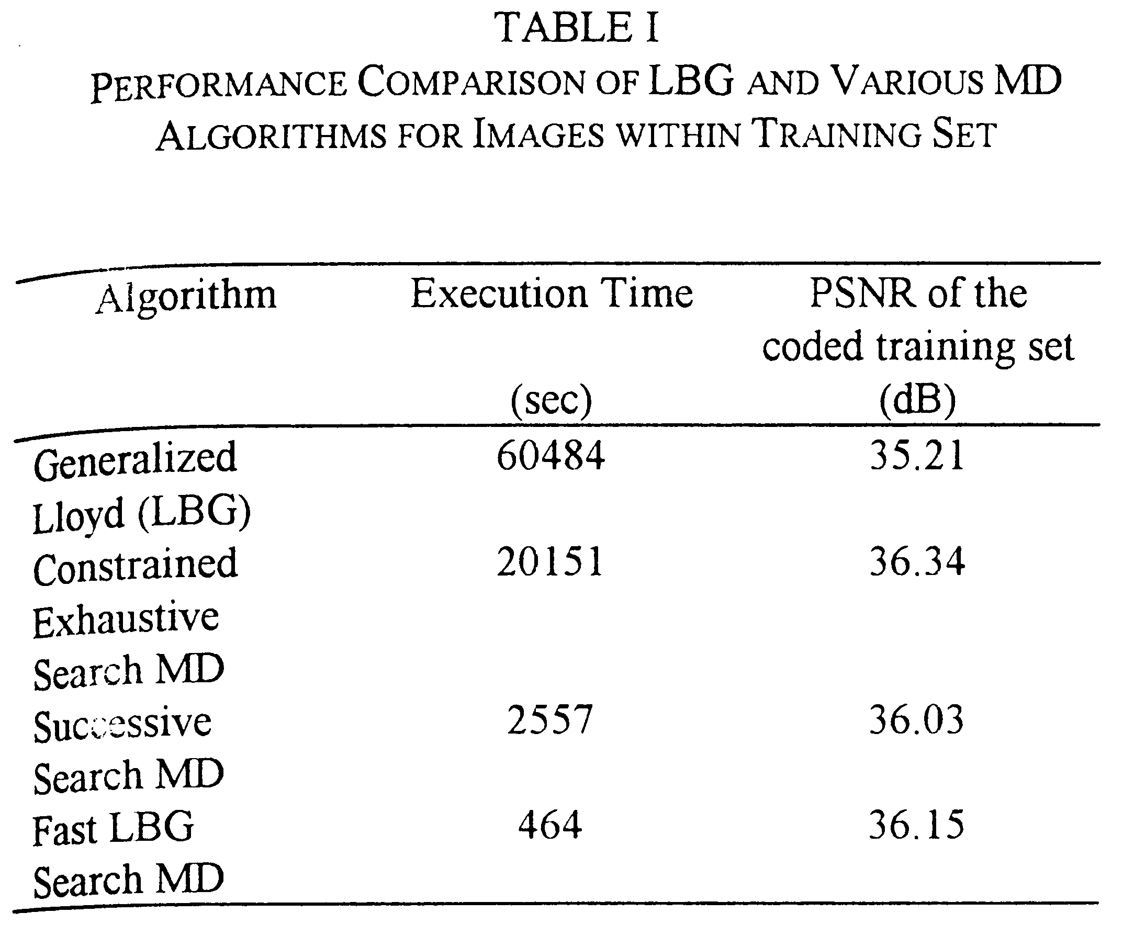
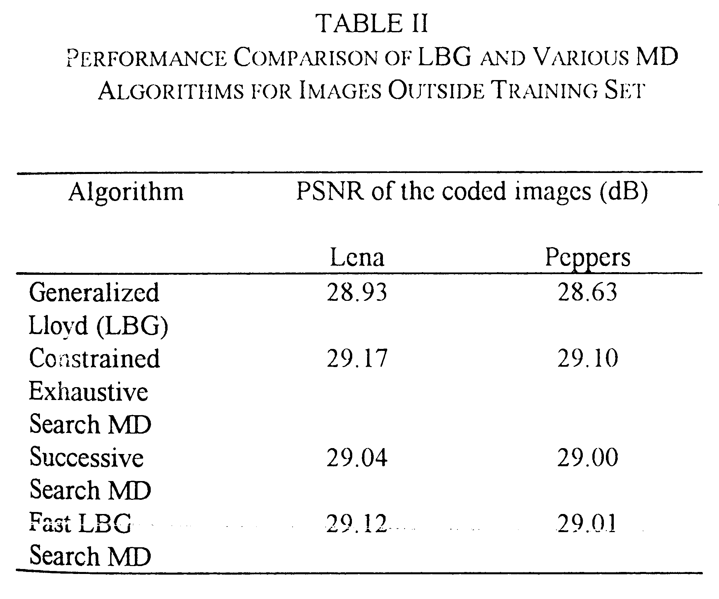
Wu and Zhang have proposed a codebook generation method that is similar to the MD algorithm. Wu and Zhang’s algorithm first restricts the search of the optimal partitioning hyperplane to be on the principle eigenvector axis of the cluster.
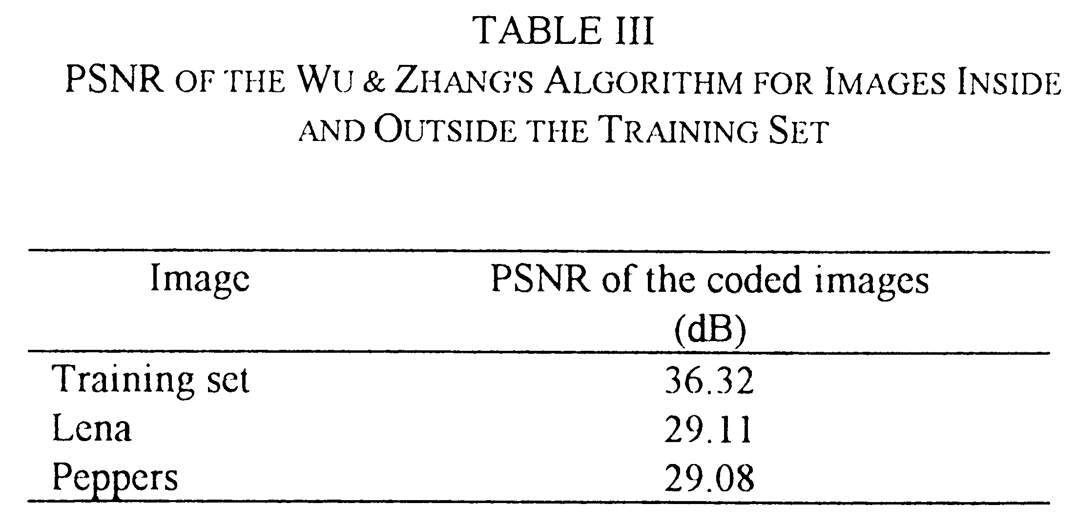
V. Further Improvement
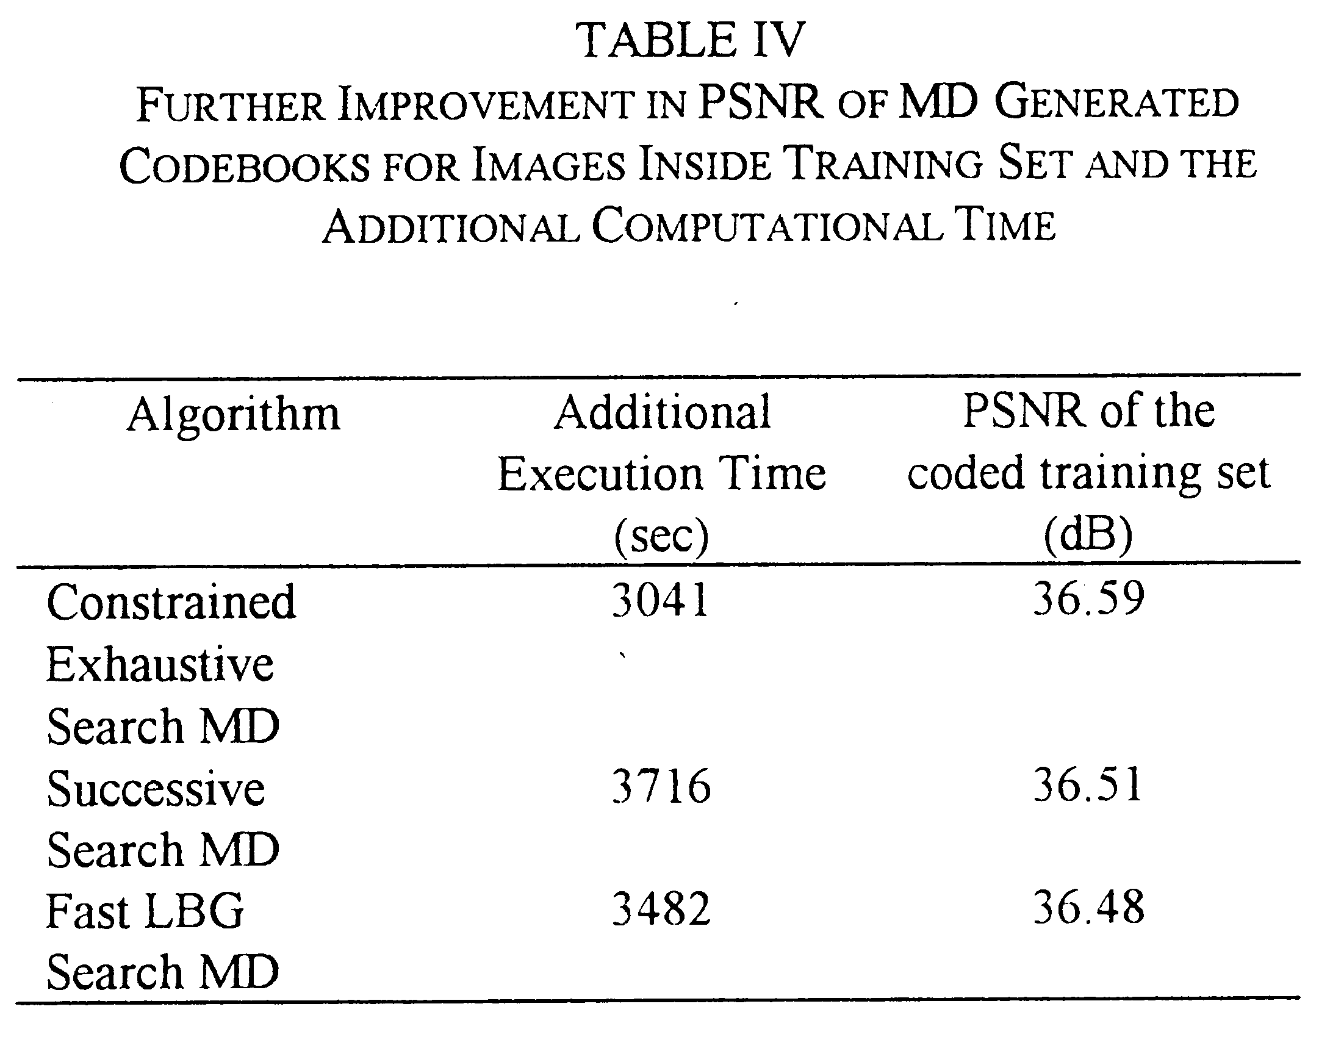
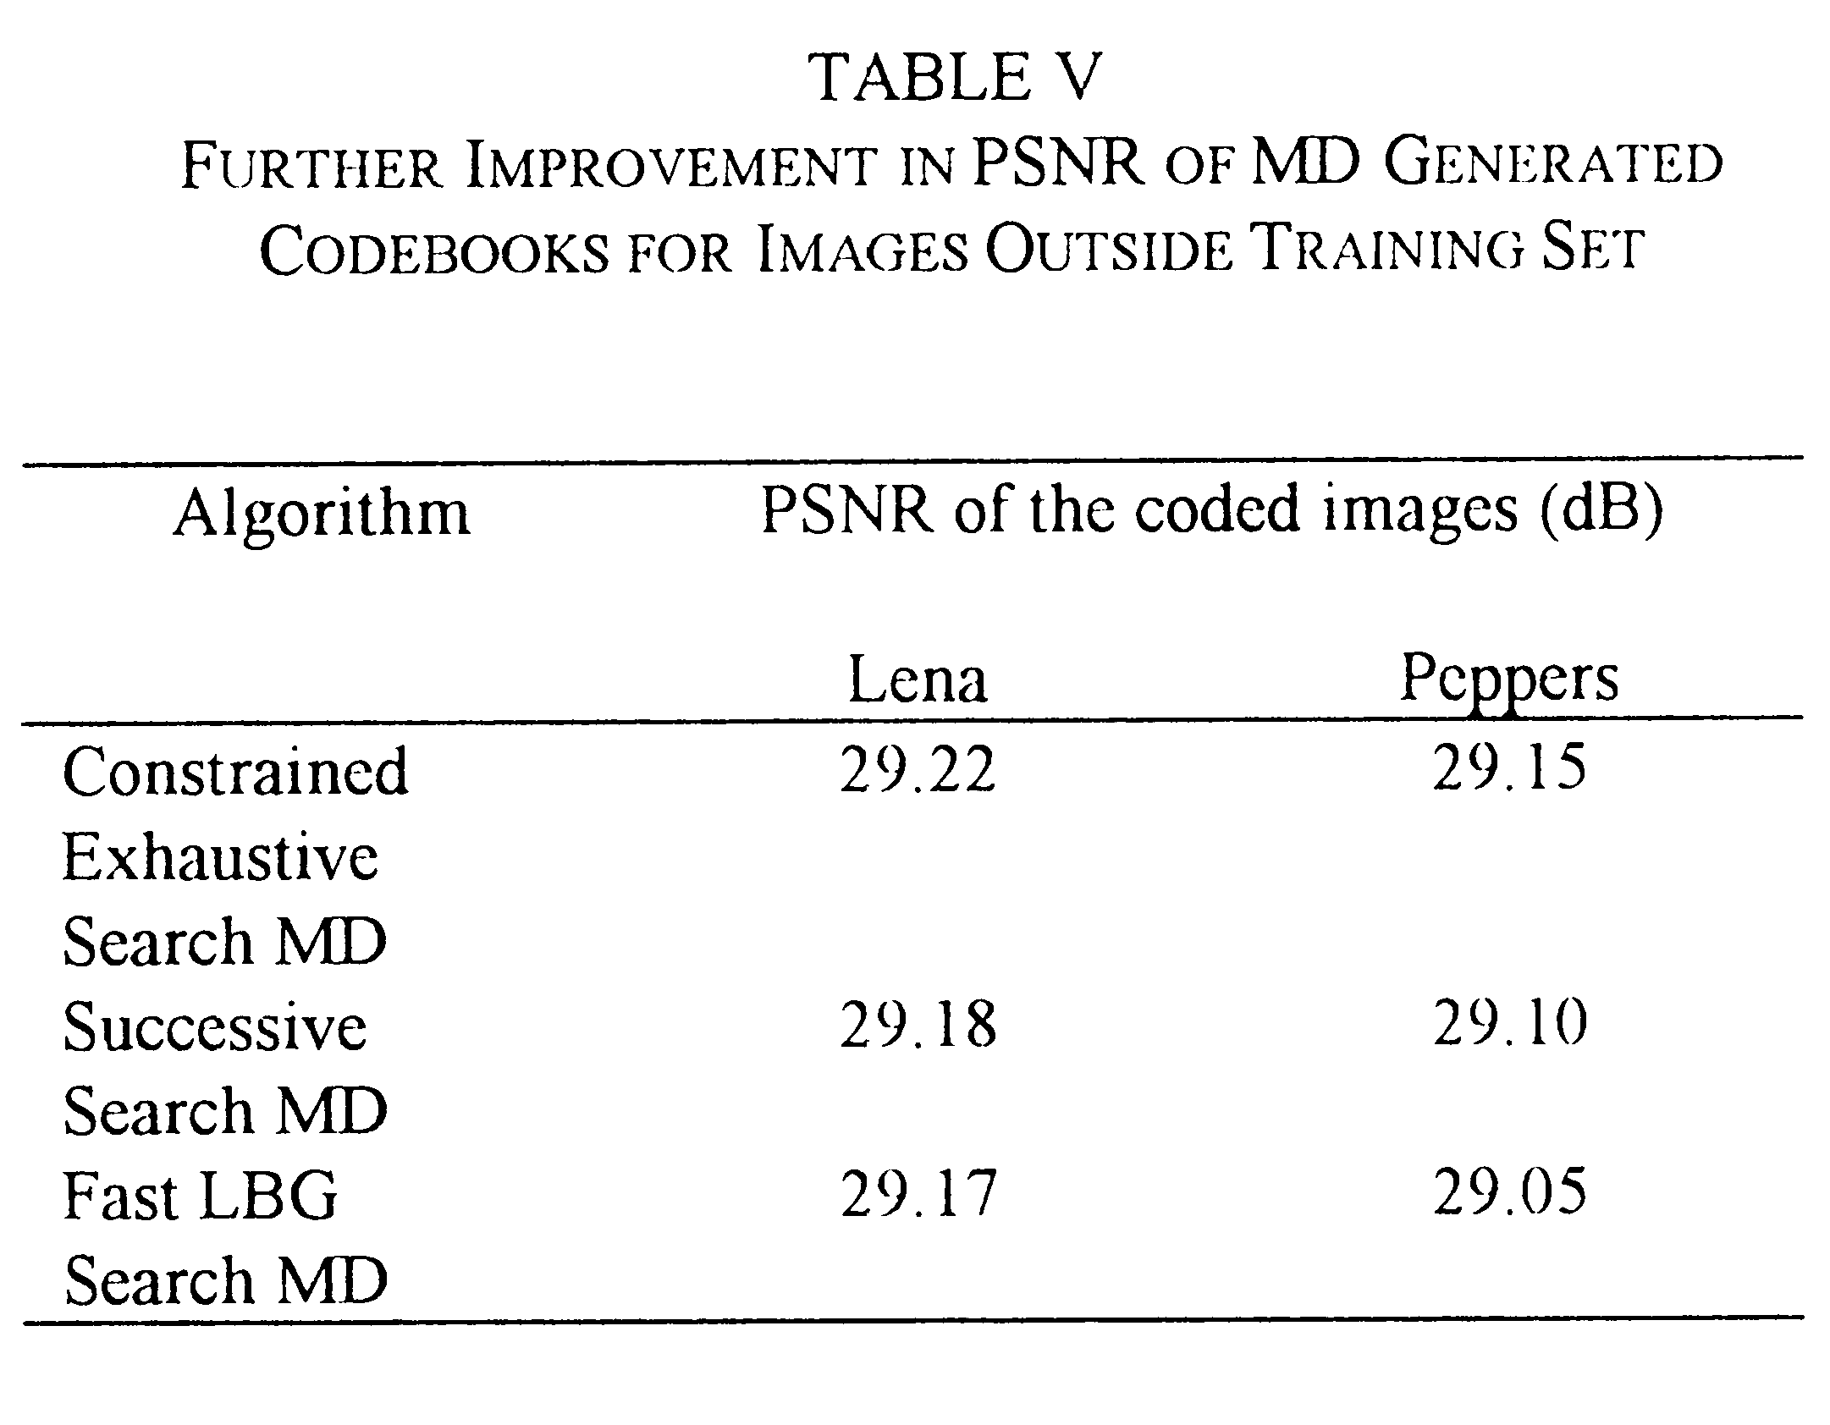
VI. Conclusions

Created by: Lih-Ching Lin
Date: Dec 30, 1998

