A Nonlinear Model for Fractal Image Coding

Dan C. Popescu, Alex Dimca, and Hong Yan

IEEE Transactions on Image Processing, Vol. 6, No. 3, March 1997, pp. 373-382

- Introduction
- Fractal Image Compression
- Nonlinear Transformation
- Experimental Results
- Conclusions
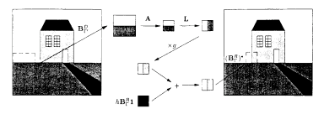Fractal Image Compression
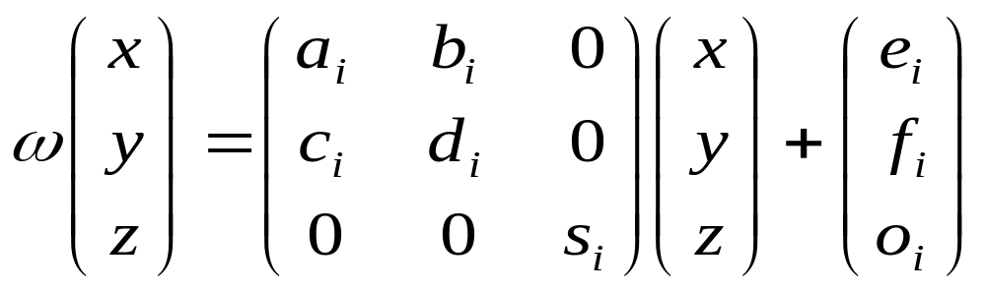

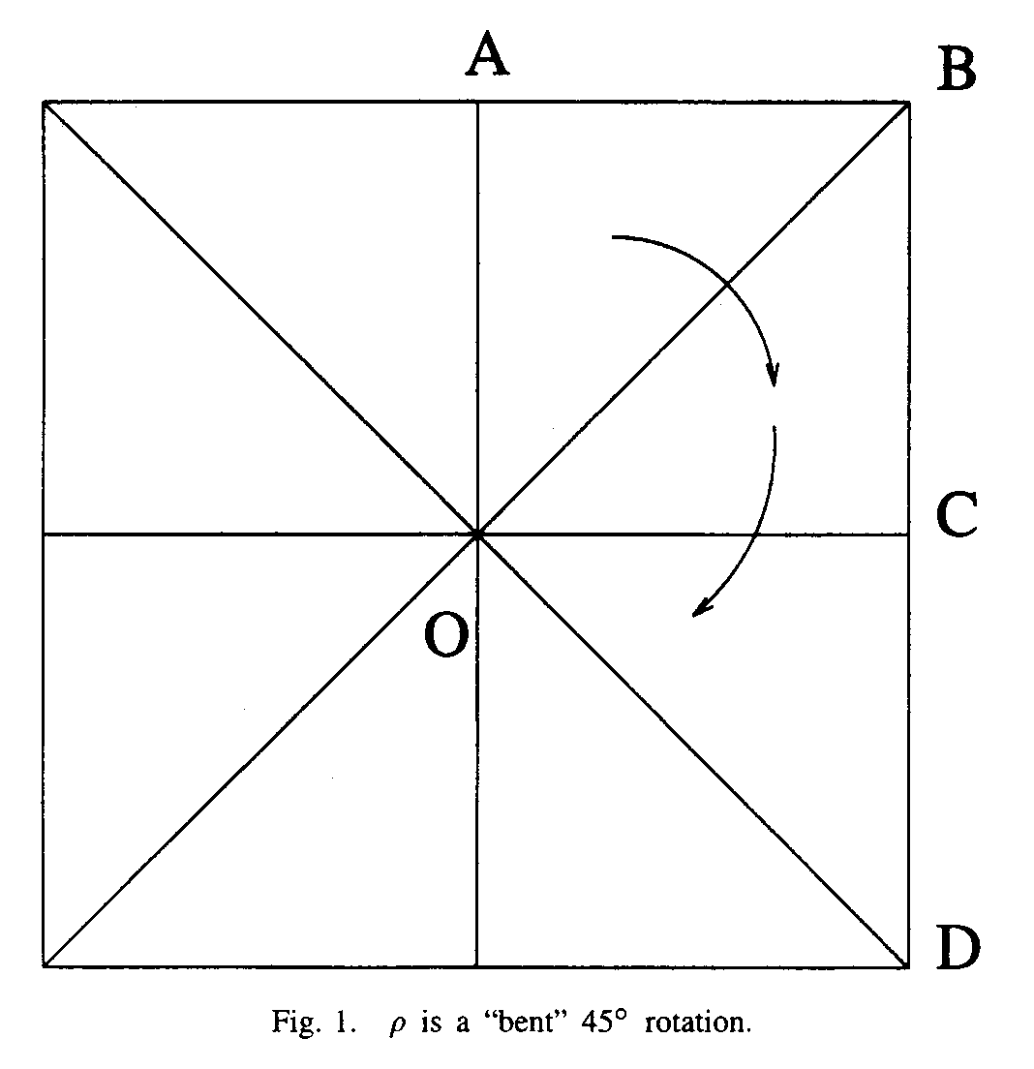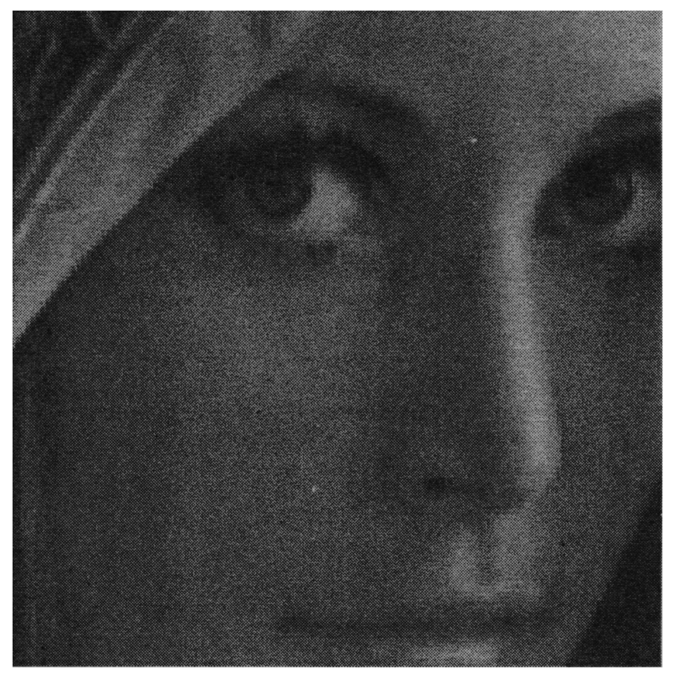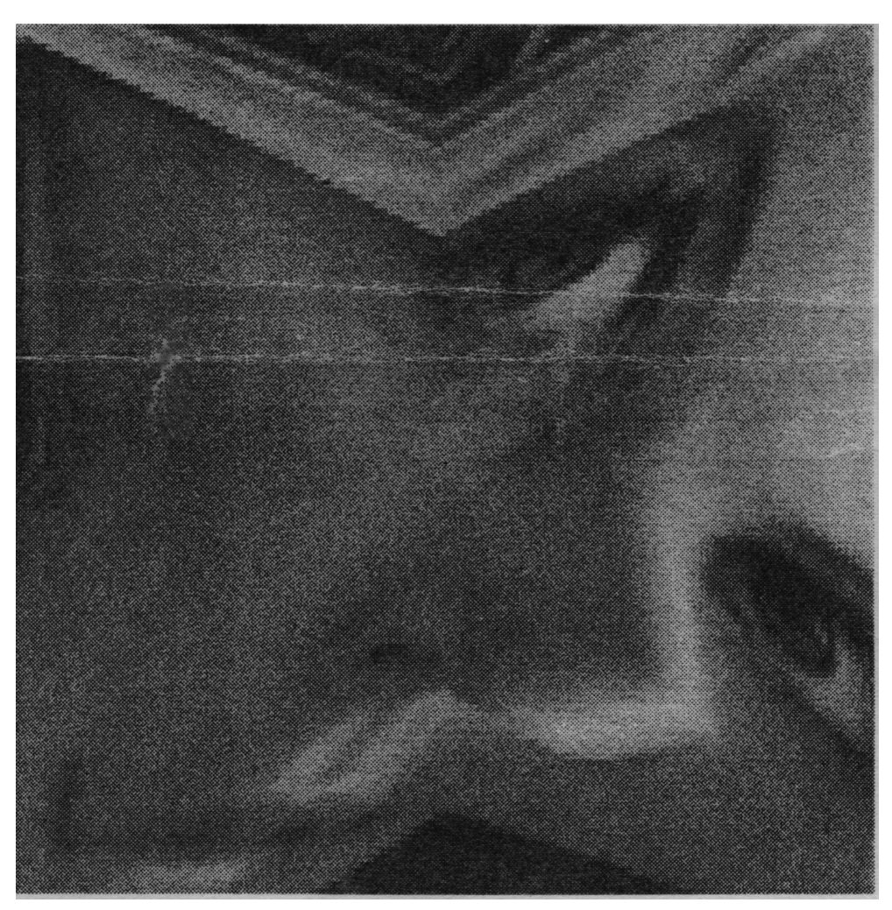
C_ = {z | z ∈ C, Im z ≤ 0}, the lower semiplane;
D = {z | z ∈ C, |z| ≤ 1}, the unit disk;
SQ = {z | z ∈ C, 0 ≤ Re z ≤ 1, 0 ≤ Im z ≤ 1}, the unit square;
DSQ_{α} = {z | z ∈ C, |Re z| + |Im z| ≤ α}, the diagonal oriented square with semidiagonals of lengthα, α>0.
The Weierstrass ℘ function
℘ : SQ  C_
℘(z) = 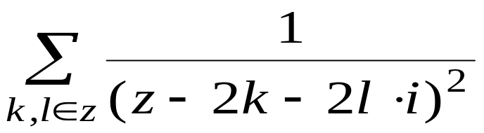
is a conformal one-to-one mapping of the unit square into the lower semiplane
ω : C_  D
ω(z) = 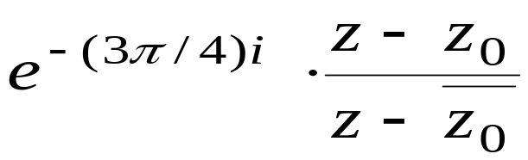
is a one-to-one mapping of C_ onto the unit disk.
φ : SQ  D
φ = ω。℘
is a conformal one-to-one mapping of the unit square into the unit disk.

τ : D  C
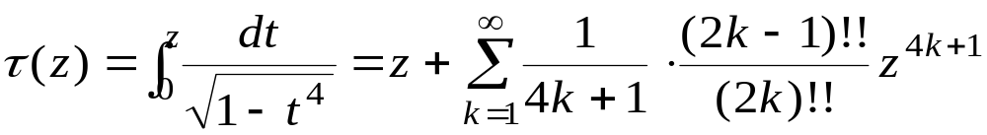
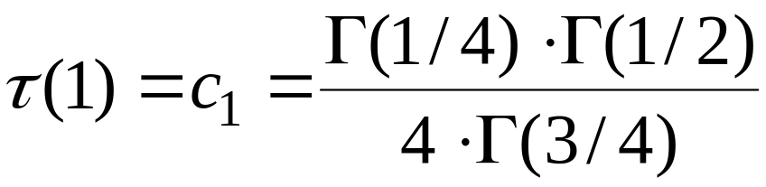
The inverse mapping ofφdefine as:
 : D  SQ
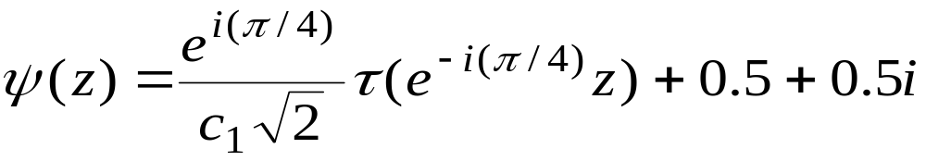
For any angle θ, θ∈ [0, 360°) we denote by r_{θ} the usual clockwise rotation of angleθ as follows:
r_{θ} : D  D
r_{θ} = e^{-(πθ/180)i}z

We also denote by 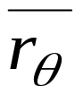 an antirotation of angleθ, i.e., a flip over the real axis followed by a rotation, as follows:
: D  D
= e^{-(πθ/180)i}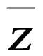

A square rotation of angleθis defined as the transformation
sqr_{θ} : SQ  SQ
sqr_{θ} = 。r_{θ}。φ

Similarly, a square antirotation of angleθis defined as
sqr_{θ} : SQ  SQ
sqr_{θ} = 。r_{θ}。φ
Finally, we define the set  of generalized square isometries as the set of all square rotations and antirotations, that is, ={sqr_{θ} , sqr_{θ} |θ∈[0, 360)].
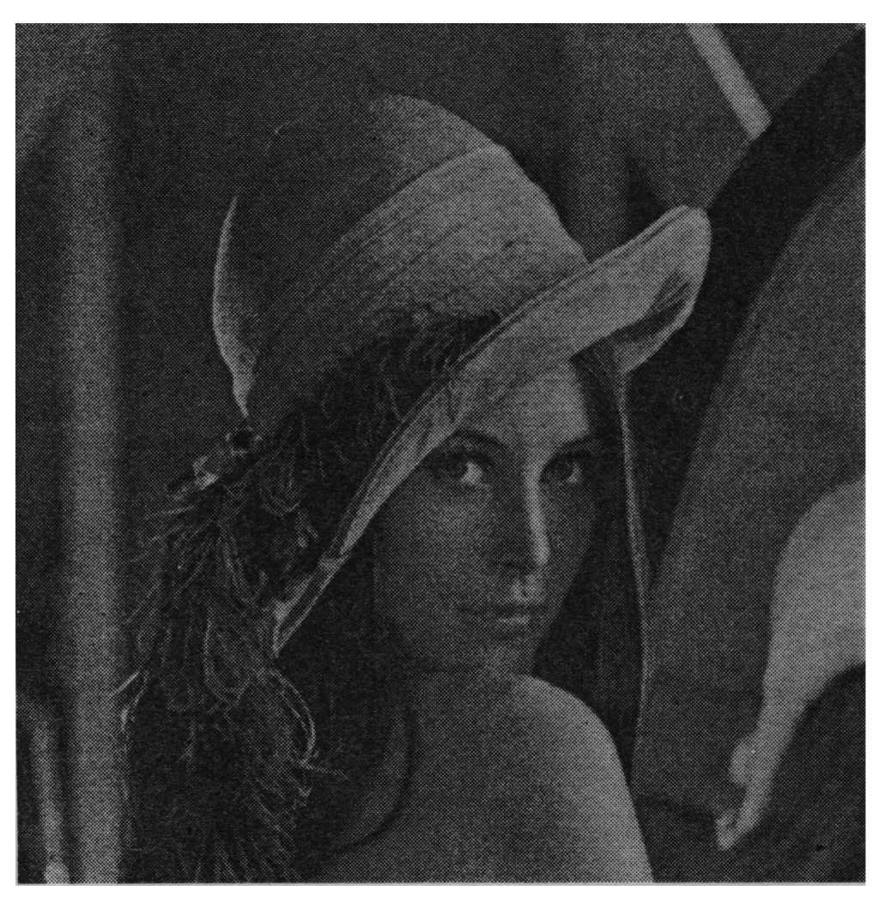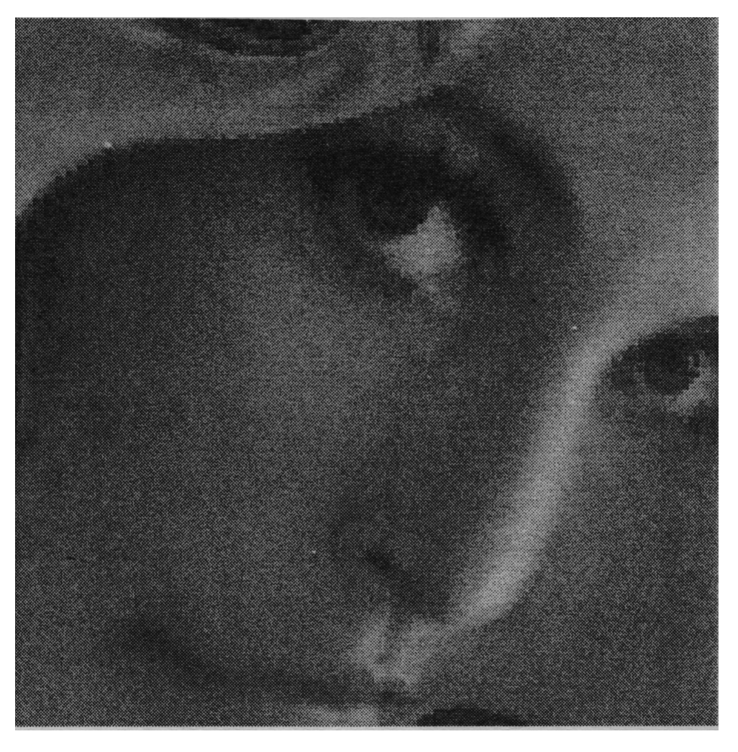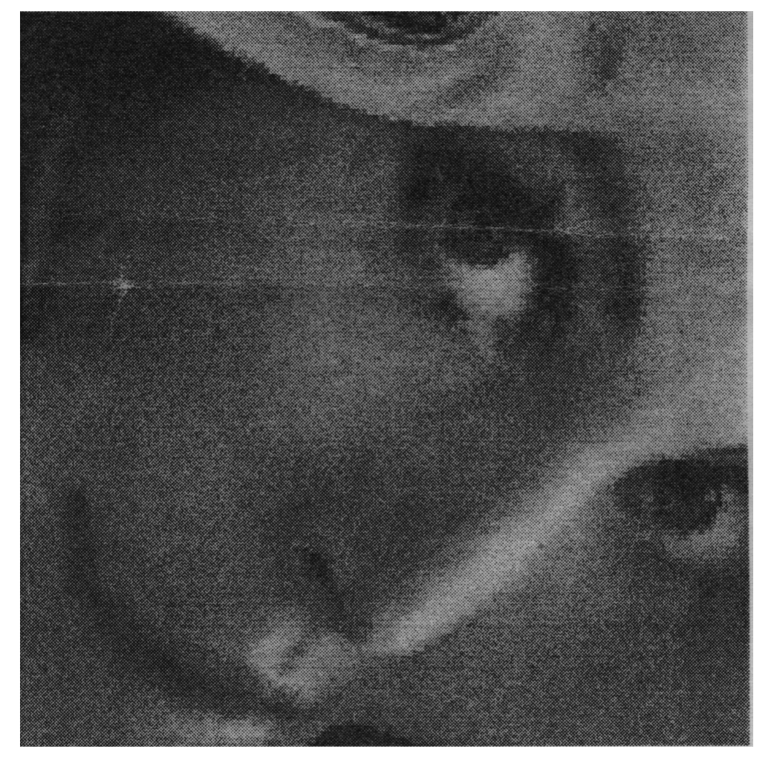
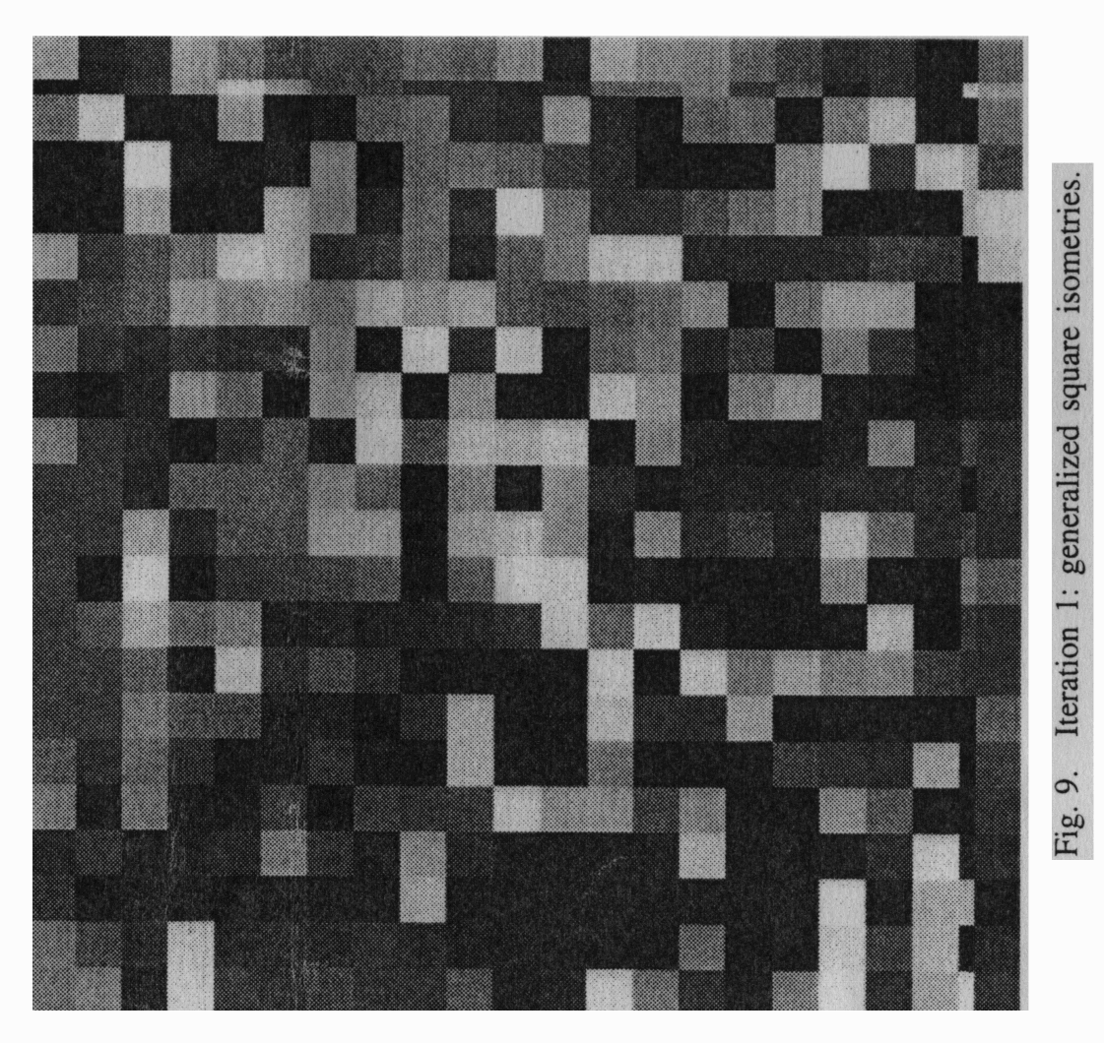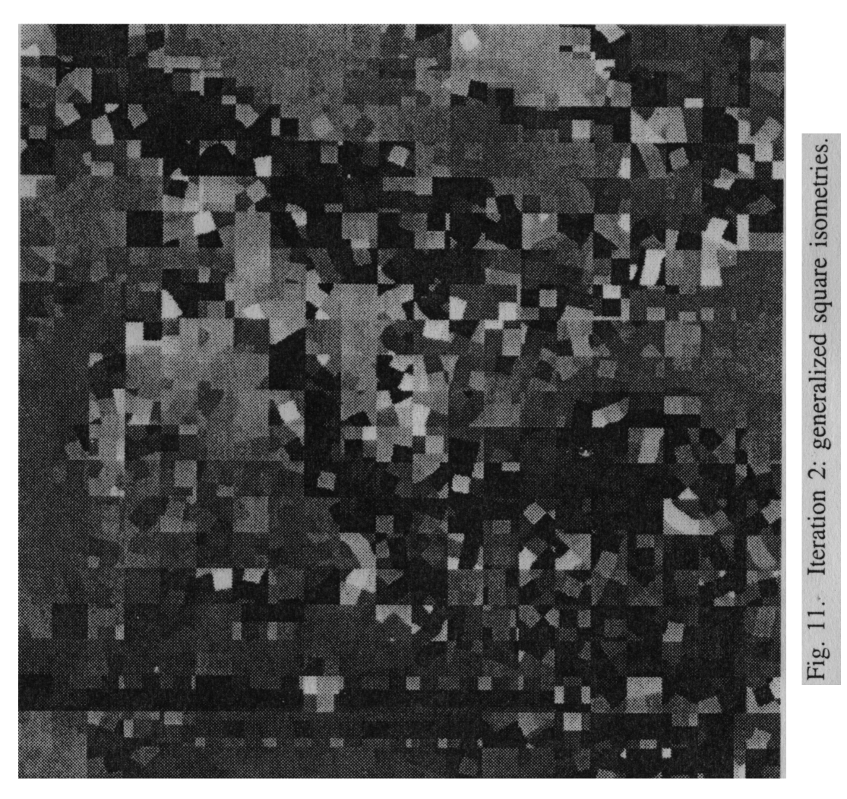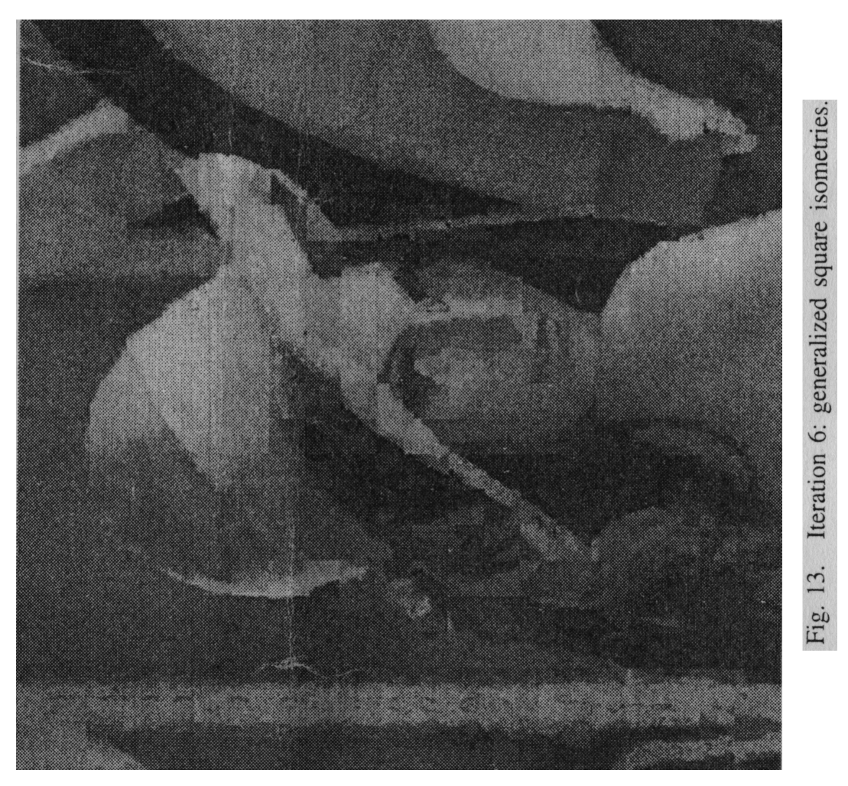
Experimental Results
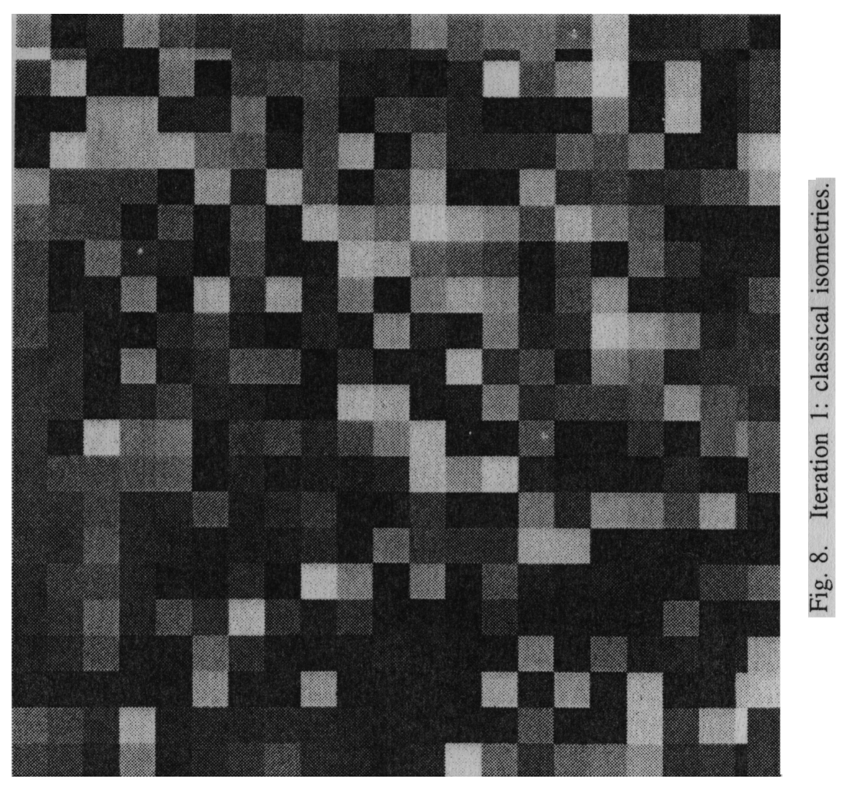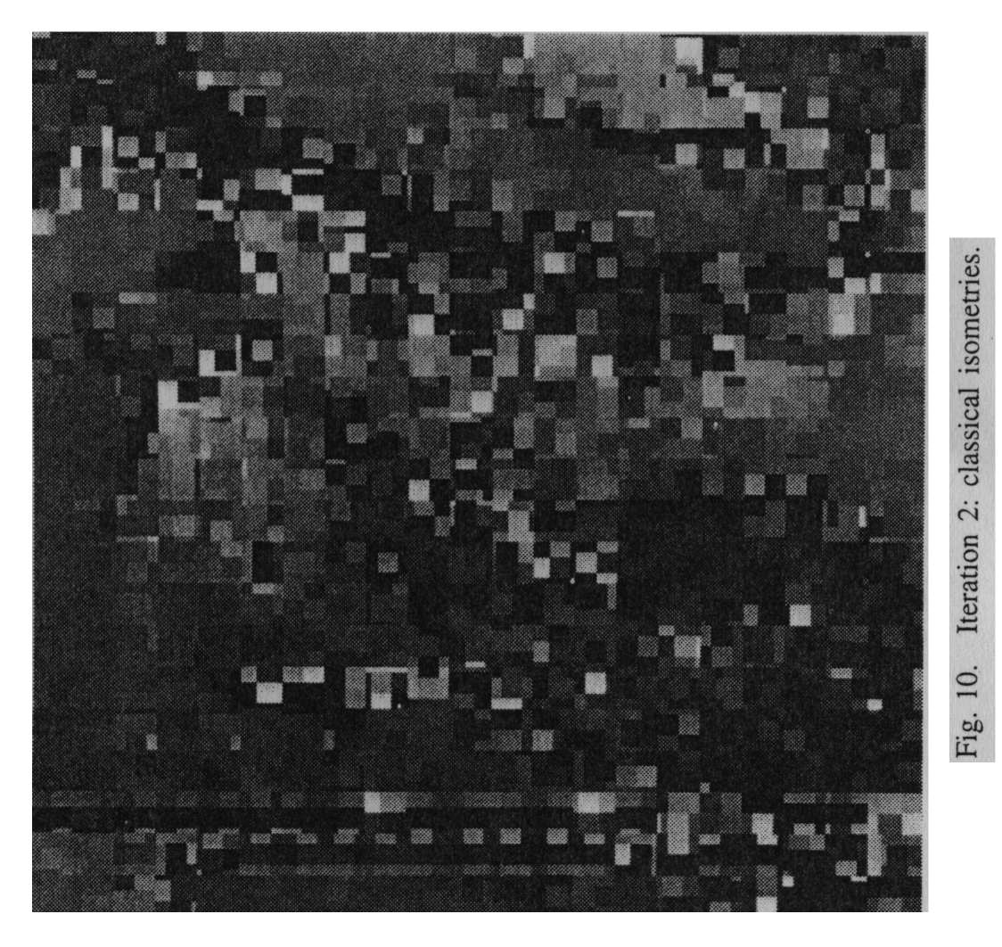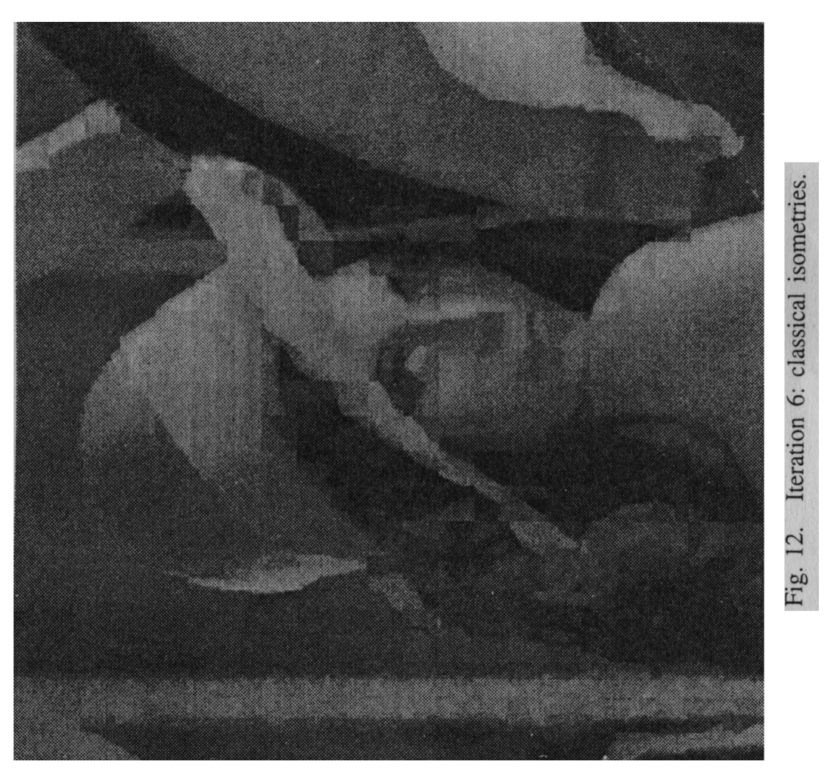
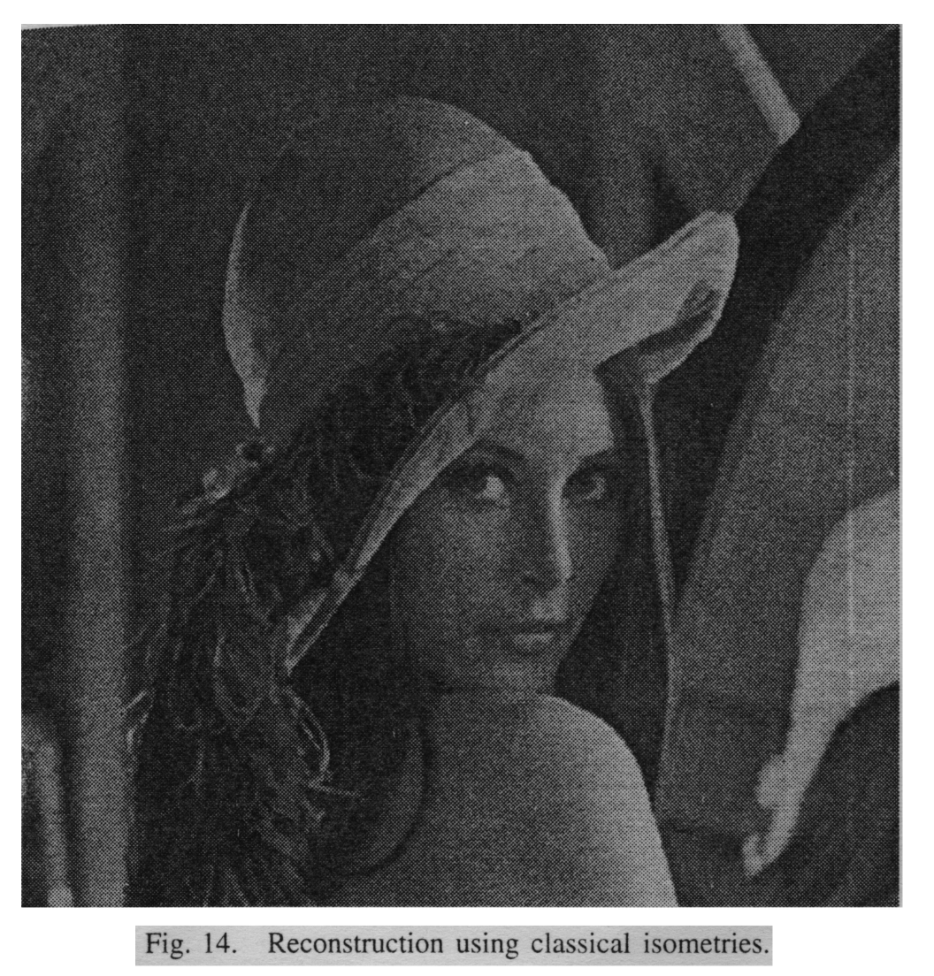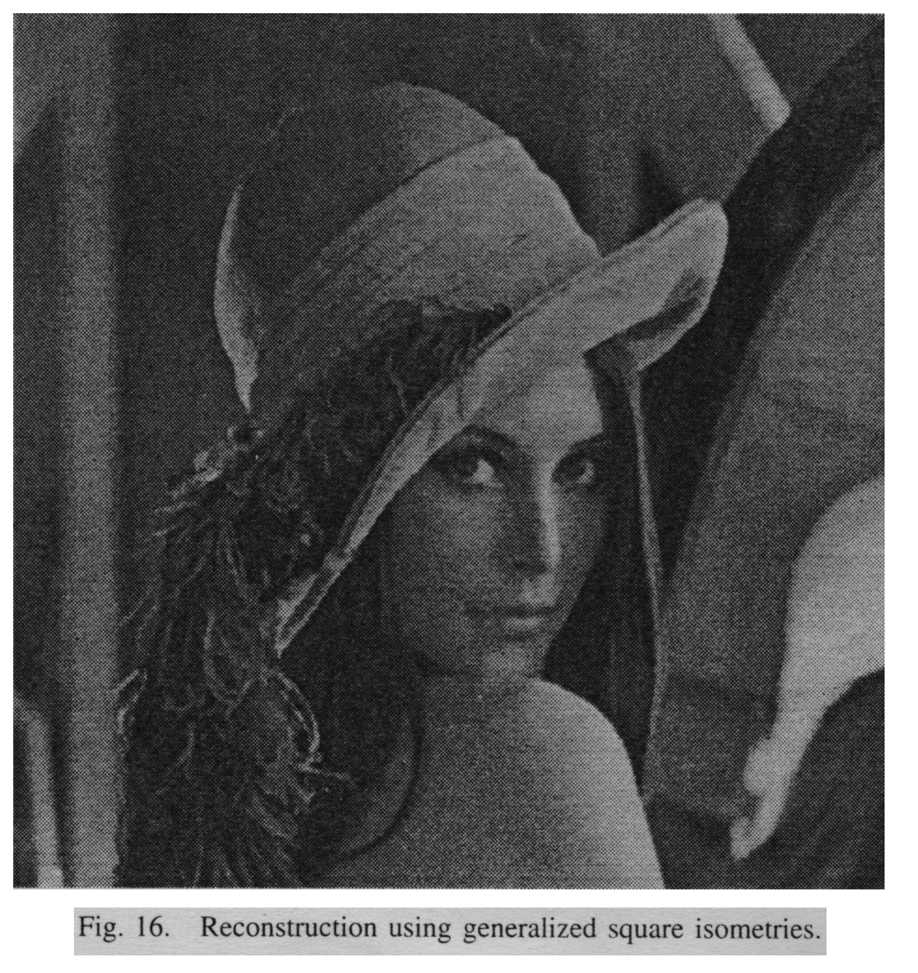
CONCLUSIONS

- Our compression results with an adaptive scheme show improvements over the linear model.

- In trying to match natural patterns, linear transformations are “good”, but are not generating enough variety for larger size blocks.

