A Novel VQ Codebook Design Technique
Jui-Hua Li and Nam Ling
IEEE Transactions on Consumer Electronics, Vol. 43, No.4, pp. 1206-1212, Nov. 1997
Abstract
In this paper, we present an approach to increase the amount of VQ codebook patterns to improve image quality without a large overhead on the codebook memory and search time. Basically, our approach characterizes a pattern into a key value, which is used in codebook search; “Reflection operation” was performed on codewords using the key values to get more patterns to improve image quality.
- Introduction
VQ is a lossy compression technique popular in several industrial implementations of image compression (such as Intel’s Indeo and Apple’s QuickTime) as well as in academic research.
Although the simplicity of the decoder is the greatest advantage of VQ system, the intensive computation of both the encoding and training processes limits VQ in some applications. Large codebooks are required for better image quality. In this paper, we provide a compromised solution to such problems.
- System Overview
This paper adopt the interpolation/residual VQ (I/R VQ). The motivation to adopt the 2-step I/R VQ as our basic system is that the residual vectors are more generic than image vectors in a typical VQ.
The codebook is initialized by the Pair Nearest Neighbor (PNN) algorithm and generated by the LBG algorithm. Color model is RGB to YCbCr.
2.1 Codebook generation (Vectors training)
The codebook is initialized by the PNN algorithm and generated by the LBG algorithm.

2.2 Vector quantizer
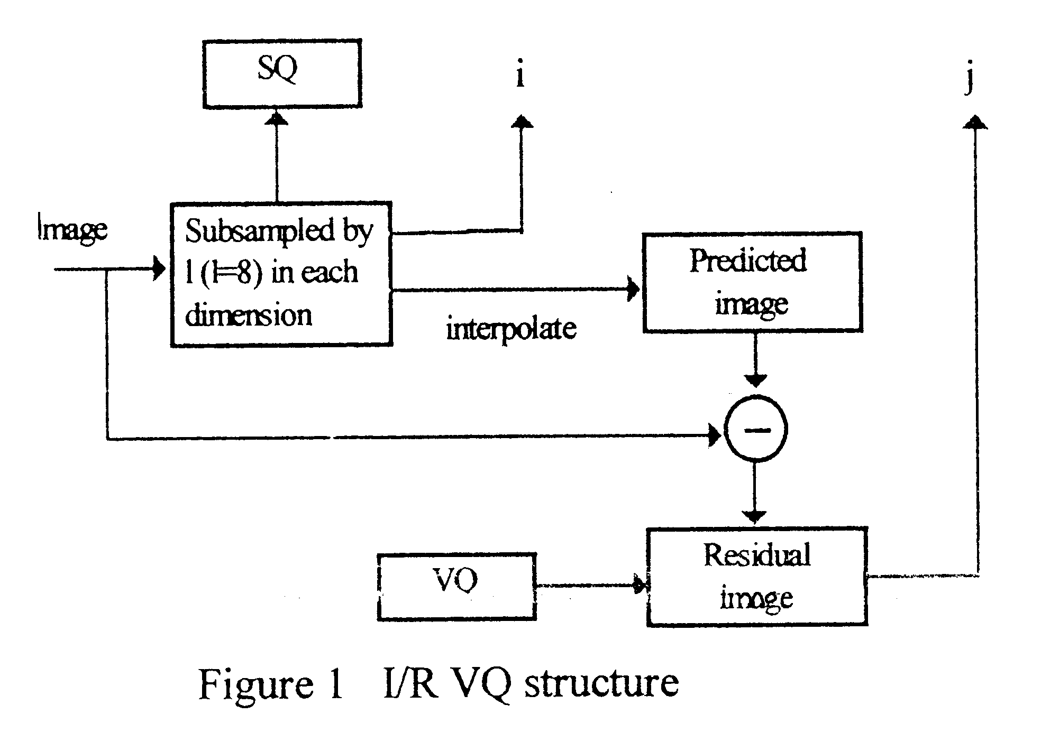
Besides the output symbols from SQ and VQ, the final encoded word also includes the “reflection bit” information, which notifies the decoder whether the retrieved codeword needs to be reflected or not.
- Pattern Characterization
In VQ, an image is partitioned into a set of small blocks. Each block can be treated as a pattern. A pattern can be characterized in several ways, one of which is to find its “gravity center”.
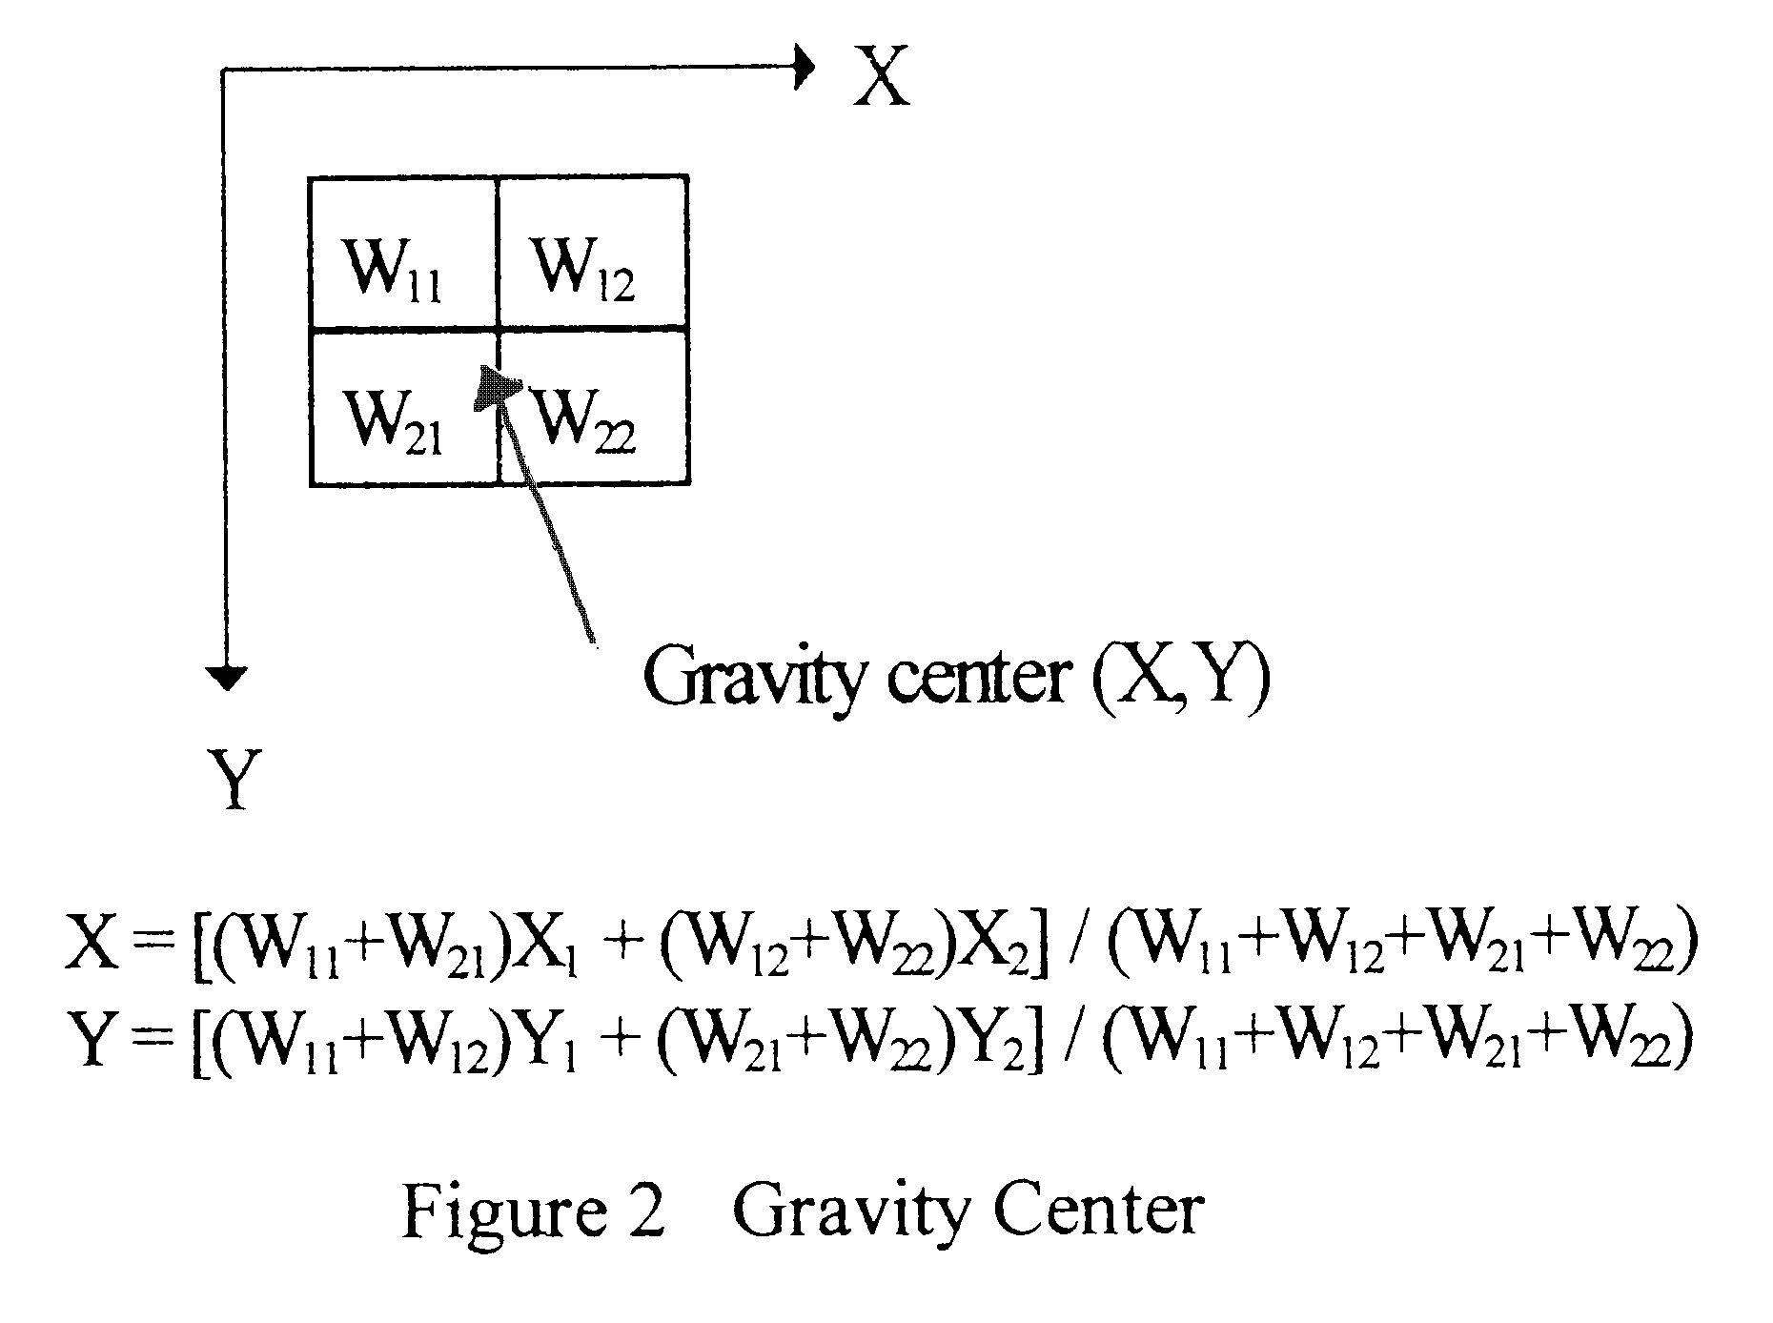
We established a formula to characterize the feature of a pattern (vector) into a key value. The key value of a vector pattern consists of θ, defined for a 4x4 block in figure 3.
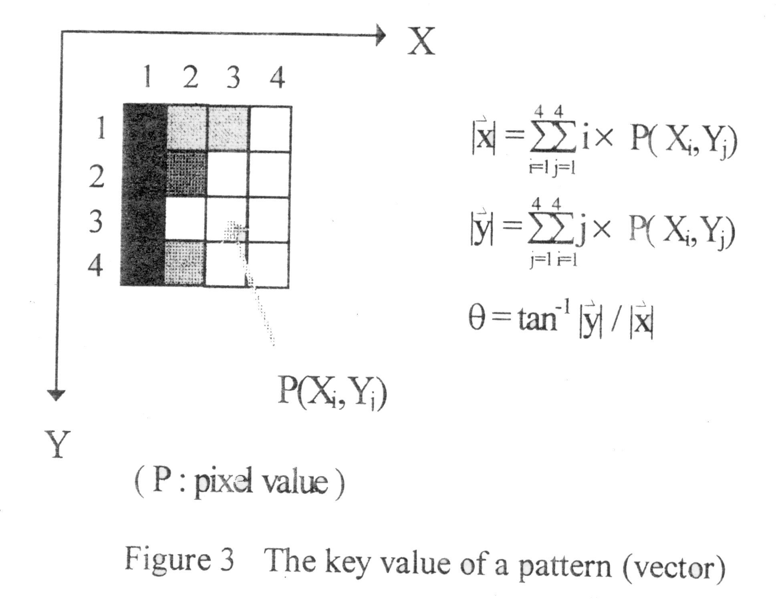
Some properties and applications of θ are:
- For similar patterns, their θ’s will be close to each other.
- If θ’s of two patterns are far away, we can be assured that these two patterns are very different.
- If θ is equal to 45 degrees, it implies that the weights of the pixels in a block are evenly or symmetrically distributed with respect to the diagonal line.
- If we combine two vectors by the centroid method to obtain a new vector, the θ’s of the new vector will between the two old vectors.
- Combing both MSE and θ decision, we can analyze patterns more accurately.
- Pattern Operation
Pattern operations are performed to generate more patterns for choice. We keep the codebook size at N, and by “reflection of pattern” we generate additional codewords to improve image quality. For example, in figure 4, two patterns are identical after reflecting the second pattern along the diagonal line. Hence, it provides twice the number of pattern (2N) for encoding, where in face, only N codewords are kept in memory.
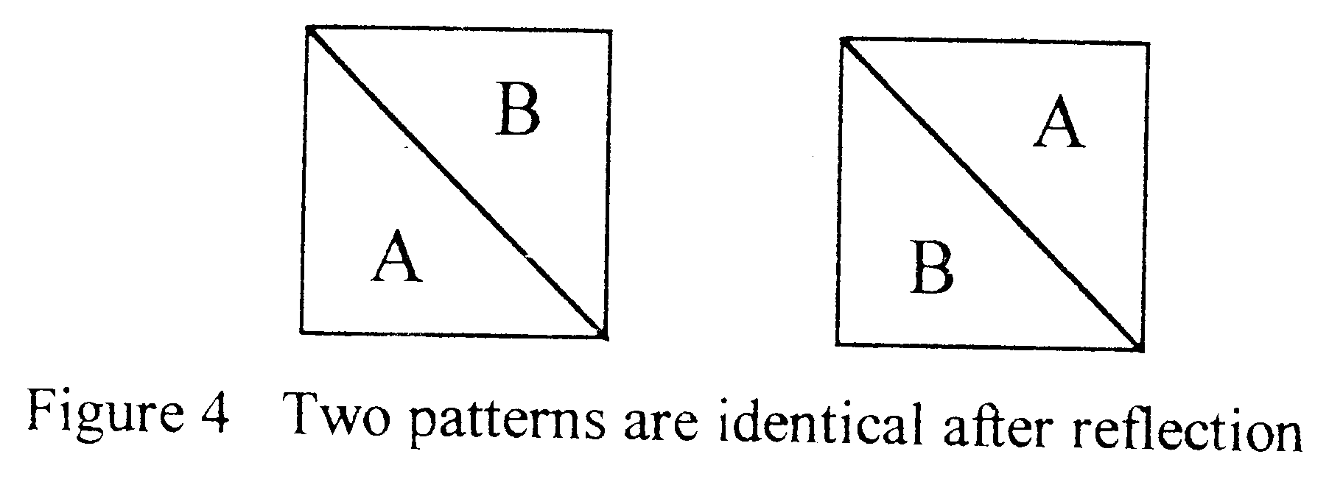
At encoding stage, a best matched codeword is chosen from the set of the original codewords and the reflected codewords for an input vector. The θ is used as a key for codewords search and reflected codewords search. Thus, an extra bit is needed.
- Codebook Structure and Search Time
The codebook is a sorted list, which is sorted by pattern key values. The search strategy is:
- Compute the key value for each input vector.
- Do the binary search to find the entry point in non-reflected codewords according to this key value. The entry point is the codeword which is closest to the input vector. The same way is applied to the search in reflected codewords.
- Evaluation
6.1 Image quality
6.2 Compression ratio
Due to the need for the reflection bit, the length of encoded word is increased by 1. Taking the advantages of neighborhood similarity and run-length code, we reduce the total length for reflection bits in an image. The compression ratio is therefore not affected significantly.
6.3 Memory requirement
6.4 Performance
- Experimental results
- Conclusion

Created by: Lih-Ching Lin
Date: Dec. 10, 1998

