A Wavelet-Based Analysis of Fractal Image Compression
Geoffrey M. Davis
IEEE Transactions on Image Processing, Vol. 7, No. 2, pp. 141-154, February 1998

Abstract
We introduce a new wavelet-based framework for analyzing block-based fractal compression schemes.

- Introduction
- Fractal block coders
- A wavelet framework

II. A wavelet analog of fractal block coding
III. Results
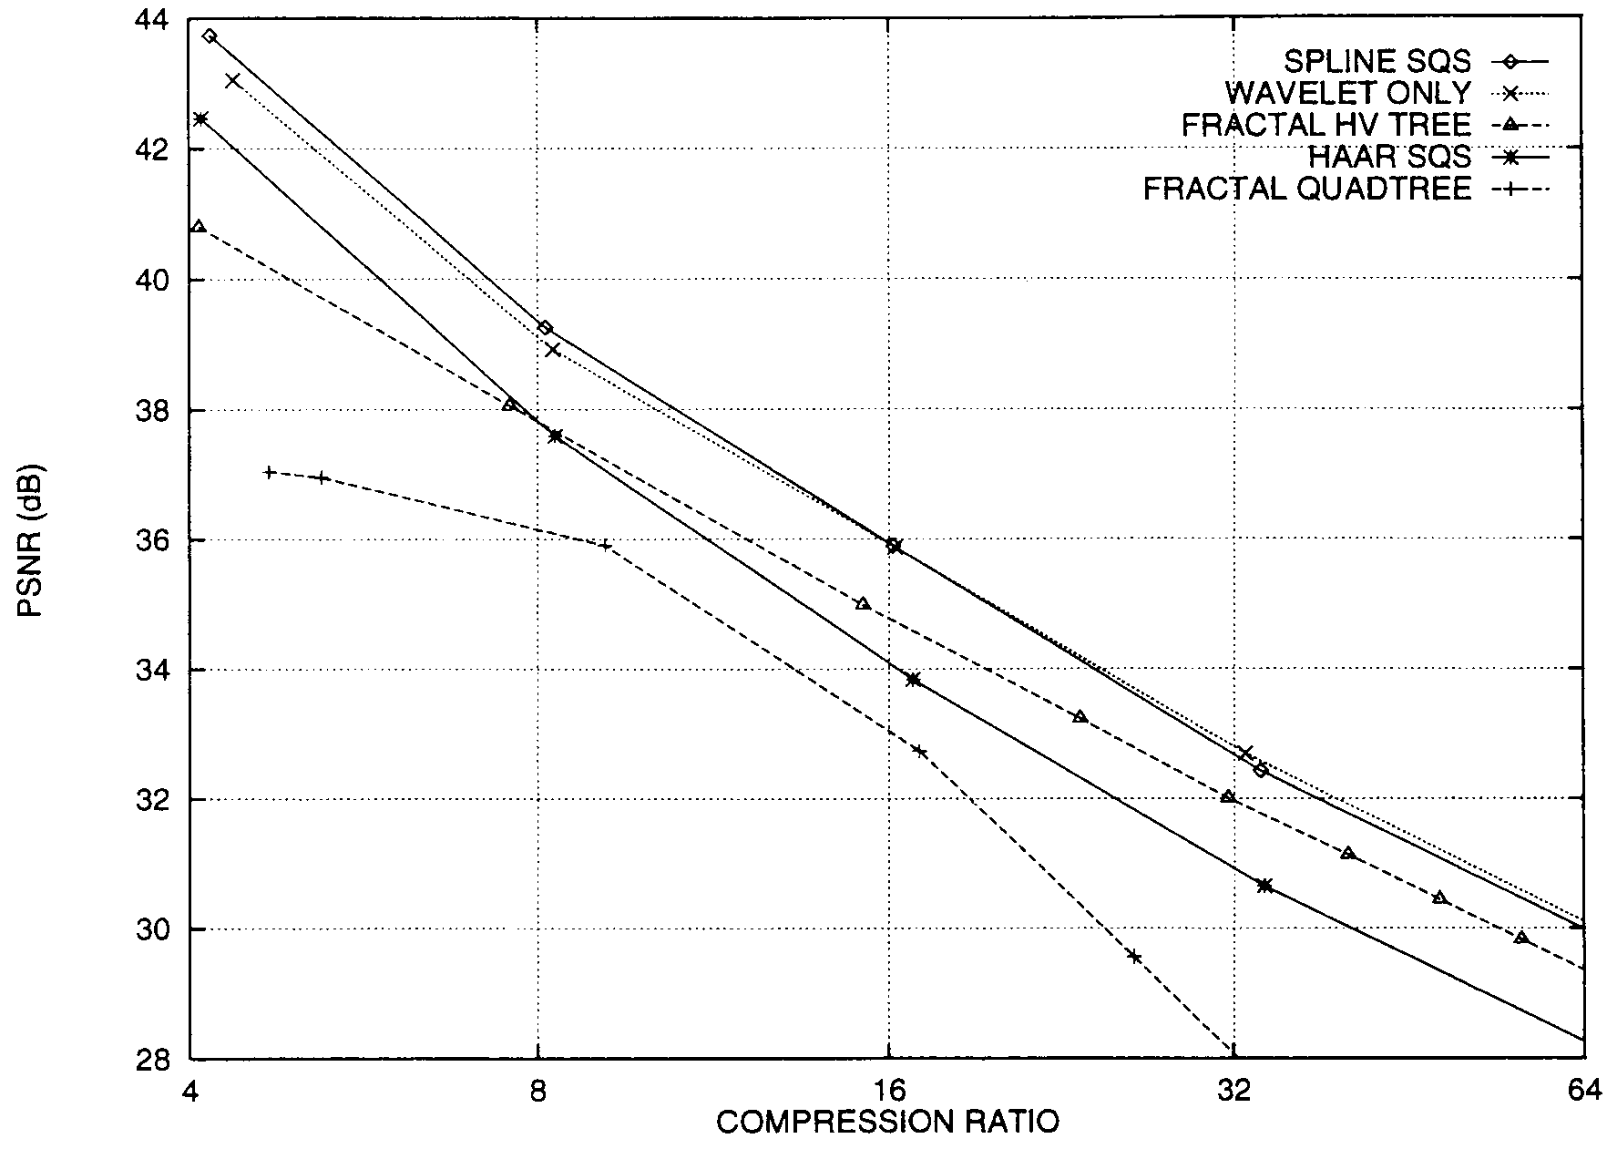

Created by: Lih-Ching Lin
Date: Mar. 20, 1998

