Task Allocation in the Star Graph
Sharhram Latifi
IEEE Trans. On Par. & Dis. Sys., Vol.5, No.11, pp 1120-1124, Nov. 1994.
Abstract
The paper proposes a new code, called star code (SC), to recognize available substars of the required size in the star graph. It is show that task allocation based on the SC is statically optimal. The recognition ability of a given SC or a class of SC’s is derived. The optimal number of SC’s required for the complete substar recognition in an n-dimensional star is shown to be 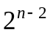.
- Introduction
- Background
- Substar Allocation
Definition 1: A permutation of (n - 1) distinct integers from 2 to n represented by the ordered set (d_{n},d_{n-1}…d₃,d₂) is called a Star Code with parameters, 2≤ d_{i} ≤n. Thus, the number of distinct 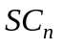’s is (n-1)!. These ’s will be used to partition the network for task allocation.

- The Allocation Tree
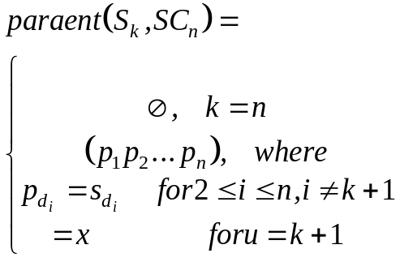
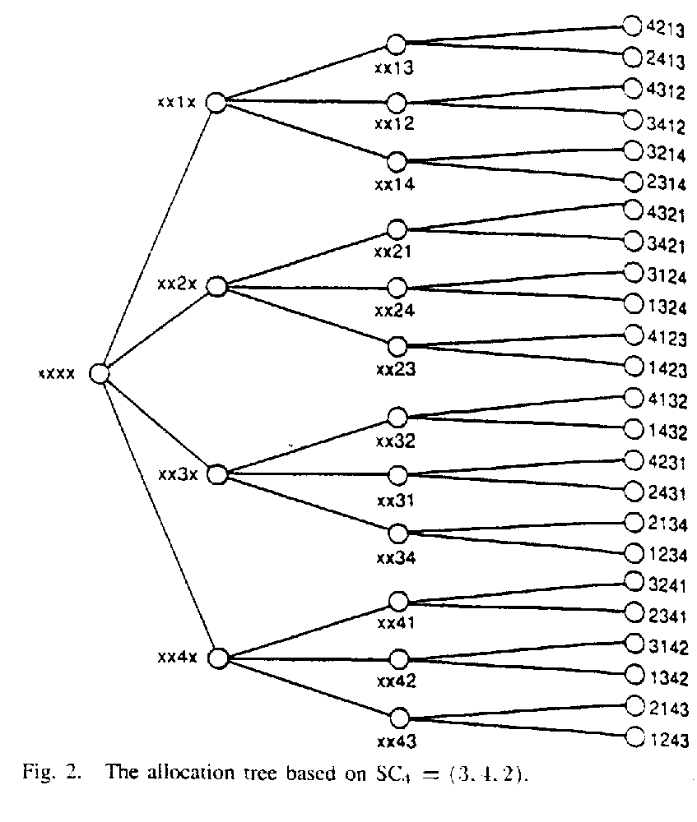

B. Task Allocation Using the Allocation Tree
Definition 2: An allocation strategy is said to be statically optimal if a given 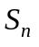 using the strategy can accommodate any sequence of tasks 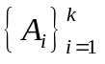, as long as 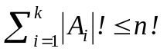, where 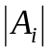 is the dimension of the substar required to host the task 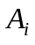.

Example: {xxxx5,xxx5x,xx5xx,x5xxx}

Lemma 1: The allocation strategy based on a given star code is statically optimal for the set of tasks 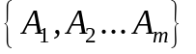, where arrives before 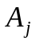, if 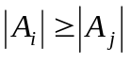.

Theorem 1: The allocation strategy based on a given star code is statically optimal.

Definition 3: The ratio of the k-stars recognizable by a code to the total number of k-stars is called the recognition percentage of that code for k-stars.

Lemma 2: Let 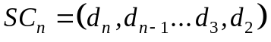. The recognition percentage of the k-stars by a single allocation tree 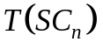 is 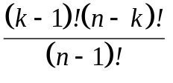.

Lemma 3: For complete recognition of the k-stars, it is necessary to employ 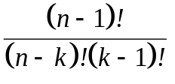 ’s.

Definition 4: Let 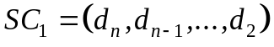 and 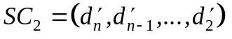 be two distinct star codes. These codes are said to have equivalent left substrings at point j if and only if the following holds true:
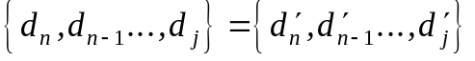.

Corollary 1: Two given star codes recognize the same class of 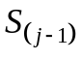’s iff they have equivalent left substrings at point j, for 2≤j≤n.

Lemma 4: The number of star codes that recognize the same class of 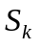’s is 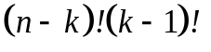.

Theorem 2: The optimal number of ’s required to achieve complete k-star recognition is 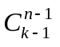.
- Construct of the SC’s for complete Substar Recognition
Theorem 3: The optimal number of codes required for the complete substar recognition in is 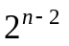.
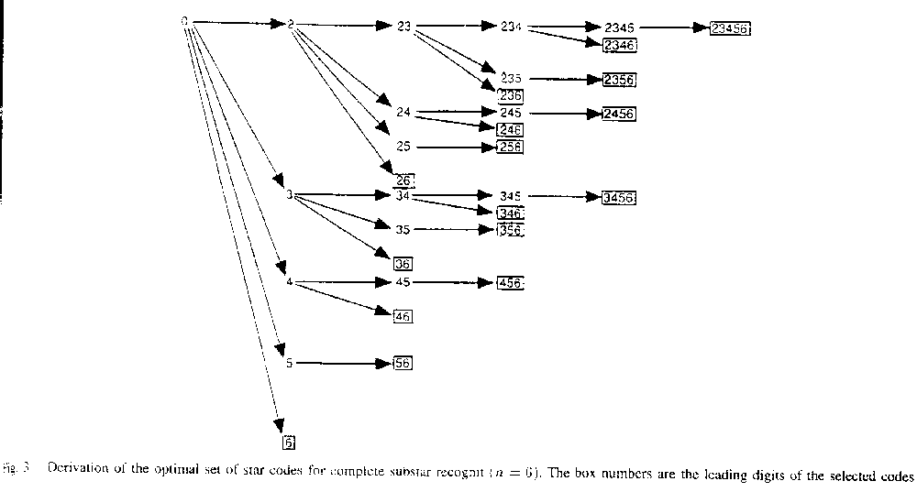

- Comparison with Hypercube

Created by :Tian-shiang Harng
Date : Jan. 14, 1998

