Two Ranking Schemes for Efficient Computation on the Star Interconnection Network

Dilip K. Saikia and Ranjan K. Sen
IEEE Trans. On Parallel and Dis. Sys. , Vol. 7, No. 4, pp. 321-327, 1996
Abstract
A node ranking scheme provides the necessary structural view for developing algorithms on a network. We present two ranking schemes for the star interconnection network both of which allow constant time order preserving communication. The first scheme is based on a hierarchical view of the star network. It enables one to efficiently implement order preserving ASCEND/DESCEND class of algorithms. This class includes several important algorithms such as the Fast Fourier Transform (FFT) and matrix multiplication. The other ranking scheme gives a flexible pipelined view of the star interconnection network and provides a suitable framework for implementation of pipelined algorithms.

The Node Ranking Schemes

Definition 1: Within an n star, Sn, the (i-1)-stars, _{Si}-1s, with a common parent i star, S_{i}, are called sibling substars.

Definition 2: Let 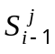 and 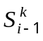 be a pair of sibling substars of a 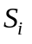and let 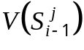 and 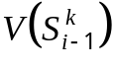, respectively, be their node sets. We define a maping 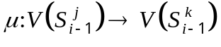 such that for a node 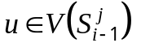 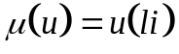, where l is the position of 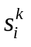 in u, the ith symbol in the permutations associated with the nodes of .
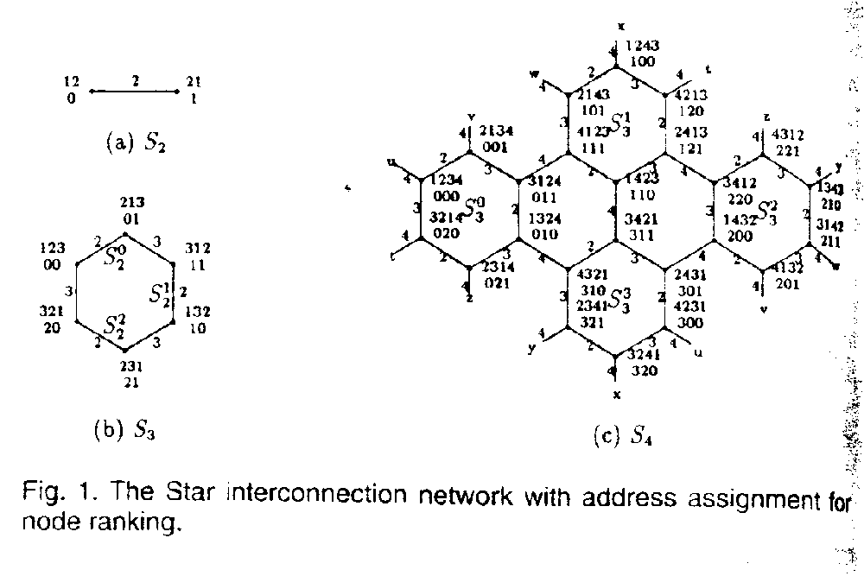
The Hierarchical Ranking Scheme

Definition 3: With the nodes of an n star assigned addresses as described above, the rank of a node v in an i star (2(ión) is computed as

Definition 4: A pair of nodes, u and v in the substars 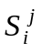 and 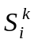, respectively, are said to have the same rank in i stars if and only if 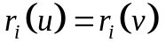. We call u, v to be peer nodes.

Lemma 1: For the hierarchical ranking scheme there is a path of length at most four between any pair of peer nodes in two sibling substars of the star network.

The order preserving communications on the star with the hierarchical ranking scheme can be performed using the
collection and distribution scheme and the
direct communication scheme.
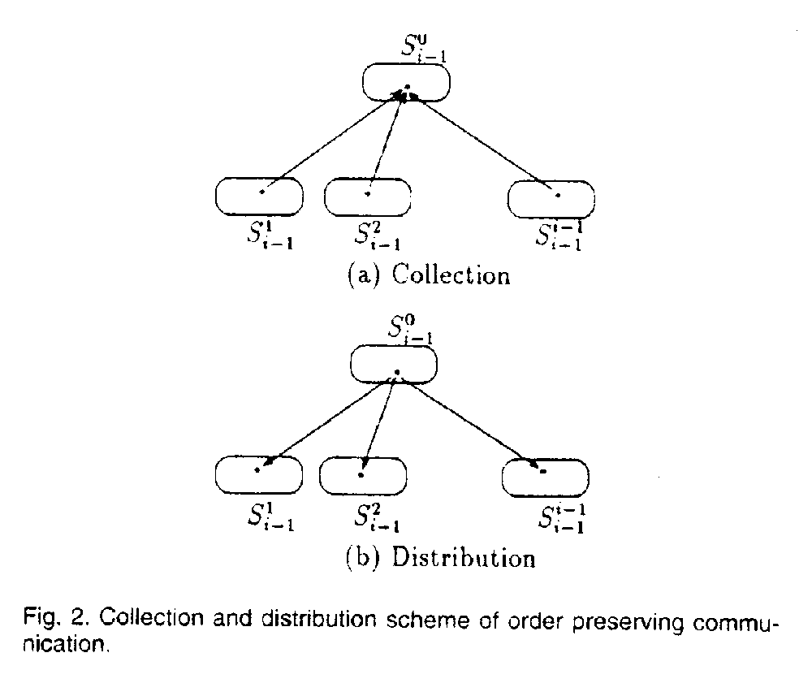
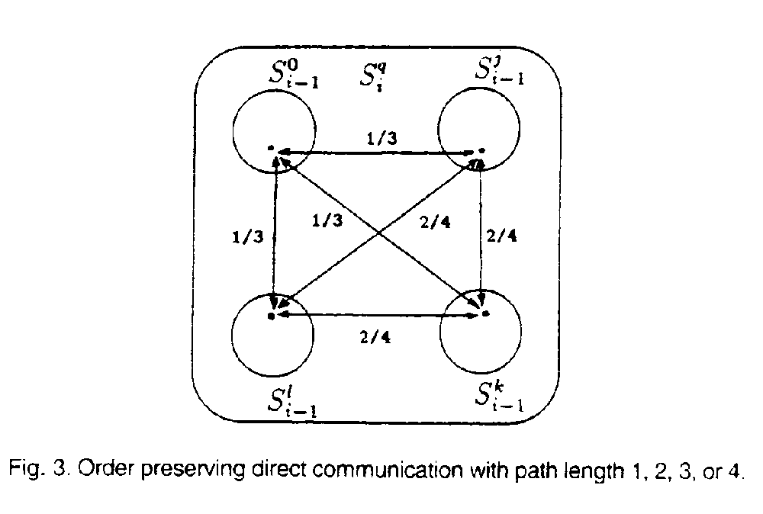
1.2 The Pipeline Structured Ranking Scheme
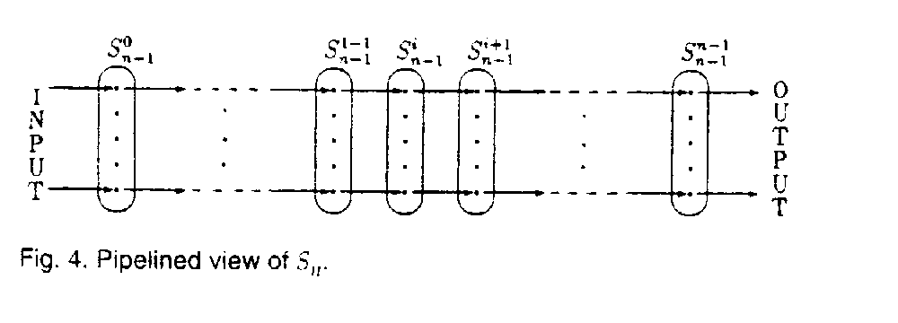
Lemma 2: When the nodes of an n star are ranked using the pipeline structured ranking scheme, there exists a path from any node in 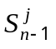 to its peer node in 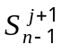 (or 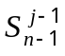) having a length of at most three.

Created by : Tian-shiang Harng
Date : Feb. 18, 1998

