The Grid Protocol: A High Performance Scheme for Maintaining Replicated Data

Shun Yan Cheung, Mostafa H. Ammar, and Mustaque Ahamad
IEEE Transaction On Knowledge and Data Eng., Vol. 4, No. 6, pp. 582-592, Dec. 1992
Abstract
We presented a new protocol for maintaining replicated data that can provide both high data availability and low response time. In the protocol, the nodes are organized in a logical grid.
Introduction
A Distributed system consists of cooperating processors or nodes interconnected by a communication subnetwork.
Each replica is assigned a number of votes, and read and write operations need to obtain a predefined quorum of r and w votes, respectively.
- A minimal group of nodes that can provide the required number of votes for reading and writing are called the read and write quorum groups, respectively.
The collection of read(write) quorum groups is called a read(write) quorum set.
Quorum consensus can also be used to achieve mutual exclusion when each group in a quorum set has a nonempty intersection with every other group in the set. Such sets are called coteries.
Our protocol is designed to increase sharing of read and write requests among the nodes storing replicas and still maintain high availability.
Load sharing can also be achieved with partitioning. When data is split into P fragments and each fragment is stored on a different node, a node that stores a fragment will receive approximately 1/P of all requests if all of the partitions are accessed equally frequently.

The Grid Protocol
System Description
We consider a distributed system in which data are fully replicated and transaction perform two types of operations on the replicated data, namely, read and write. Each node maintains only a single version of a data item if :
read operations return the value installed by the last committed write operation;
conflicting operations (a read and a write operation or two write operations) do not access the same data item at the same time.
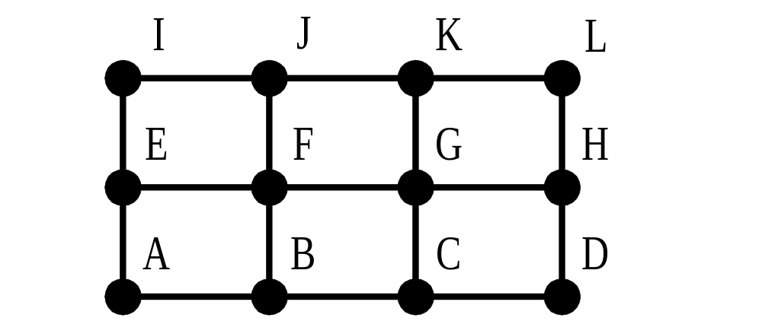
Grid Protocol Description
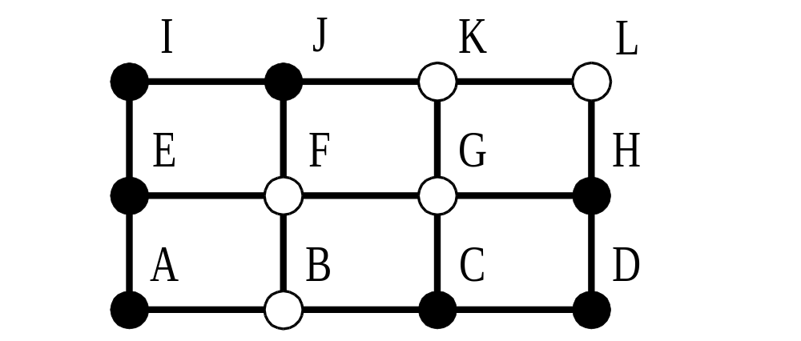

A read quorum group contains exactly one node from each column. A write quorum group consists of nodes in a read group and all nodes in a column of the grid.
Proposition 2.1:
A read operation will return the value installed by the last write operation.
A read and a write operation and two write operations cannot be executed concurrently.

Created by : Tian-shiang Harng
Date : Mar. 18, 1998

