Toward Optimal Broadcasting in a Star Graph Using Multiple Spanning Trees

Yu-Chee Tseng and Jang-Ping Sheu
IEEE Transactions on Computers, Vol. 46, pp. 593-599, 1997
Abstract
In this paper, we try to optimize both costs simultaneously for four types of broadcast problems: one-to-all or all-to-all broadcasting in an n-star network with either one-port or all-port communication capability. As opposed to earlier solutions, the main technique used in this paper is to construct from a source node multiple spanning trees, along each of which ope partition of the broadcast message is transmitted.
Introduction
There are two kinds of cost, namely start-up time and transmission time, associated with the communication. Specifically, sending a packet of b bytes along a link takes µ § time, where µ § is the time to initialize the communication link and µ § is the latency to transmit a byte.
Preliminaries
µ § is node- and edge-symmetric and has a diameter of µ §
Construction of Multiple Spanning Trees
DEFINITION 1.Given any node r in µ §, the directed graph µ §is defined such that µ §and µ §contains the directed edge µ § for all vertices µ §,where
µ §, if µ §

Spanning trees in µ §: (a) L(0123), (b) L(3012), (c) L(2301), and (d) L(1230), where the circled nodes are roots. In (a), the dotted lines are the edges in µ § that are not used by L(0123).

Given any 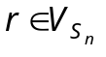,the n--1 directed trees 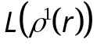,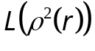,…, 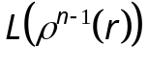 have an edge congestion of at most 2 in 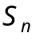.
4. One-to-All Broadcast
Given any node r , let 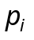 be the (unique) path in the tree 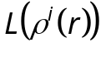 leading from r to 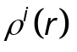. Defined 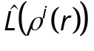, i =1…n-1, to be the directed graph obtained from by reversing the direction of all edges of except those that are along the path .
The height of is 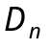+n+gcd(n,i)-2.
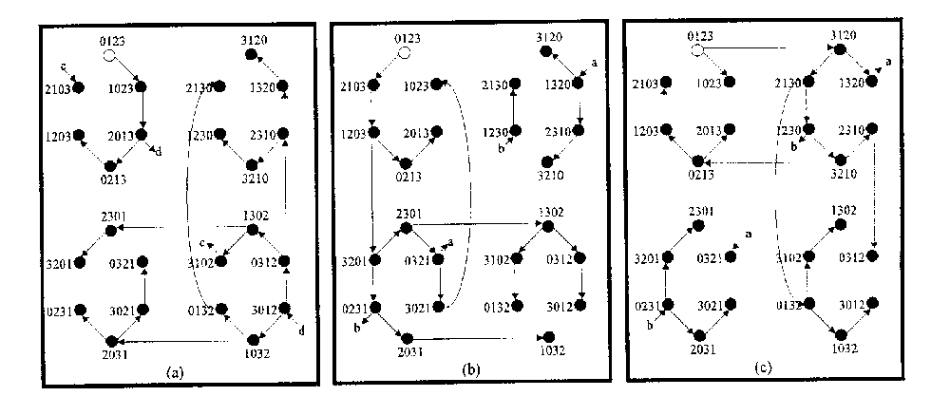
Given any , the n - 1 directed trees 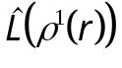,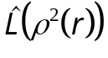,…, 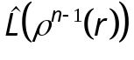 have a congestion of at most 2 in .
All-port Model
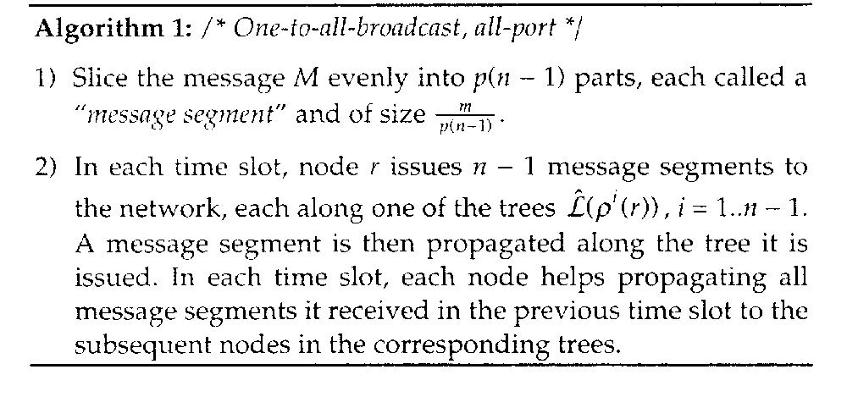
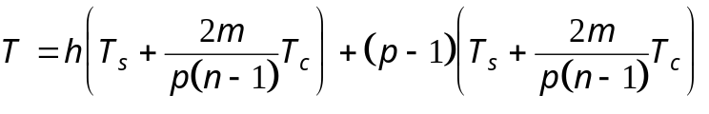
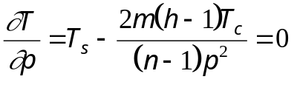
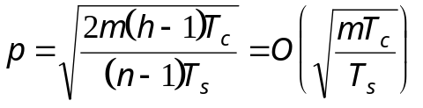
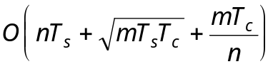
One-Port Model
Under the one-port model, one-to-all broadcast can be performed in within time
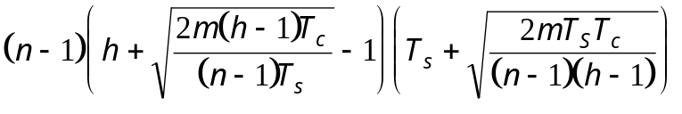
=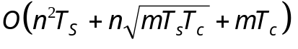.

All-to-All Broadcast
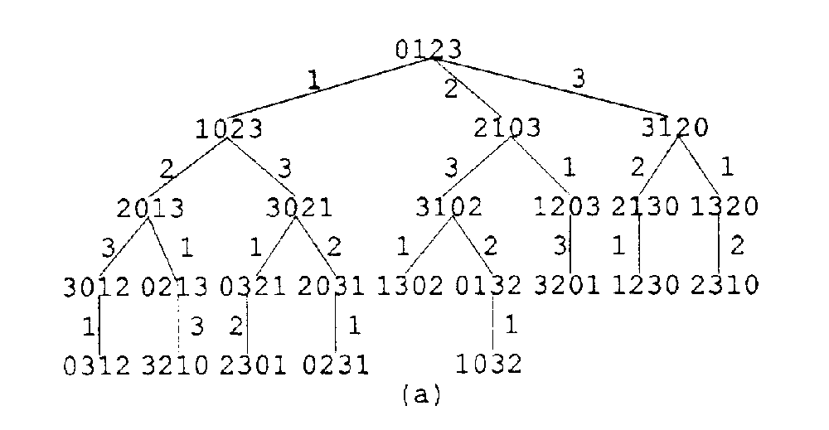
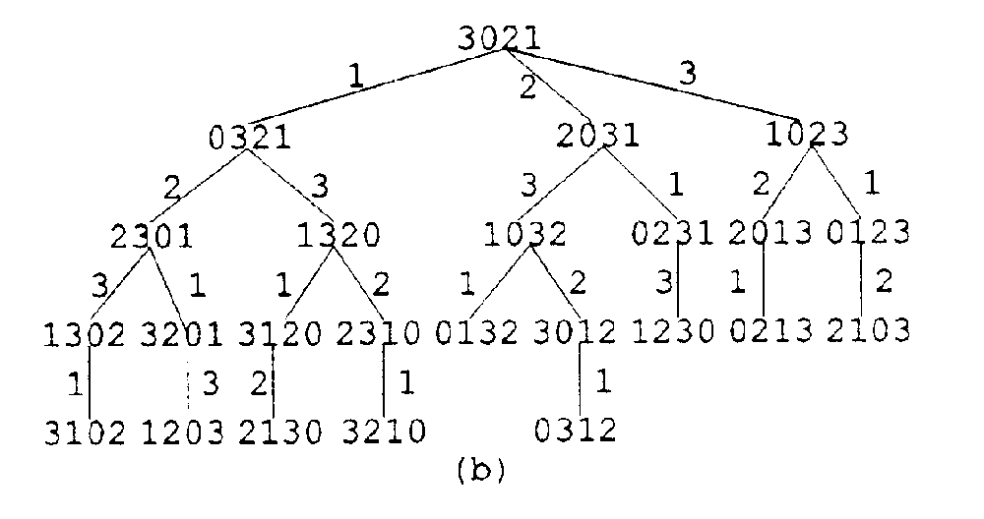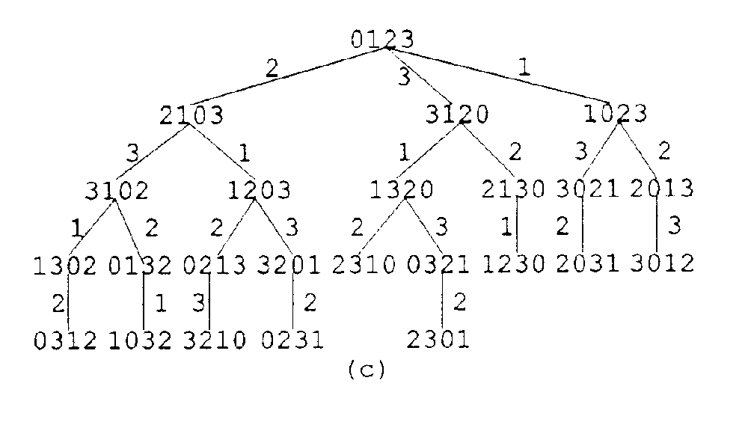
- All-Port Model
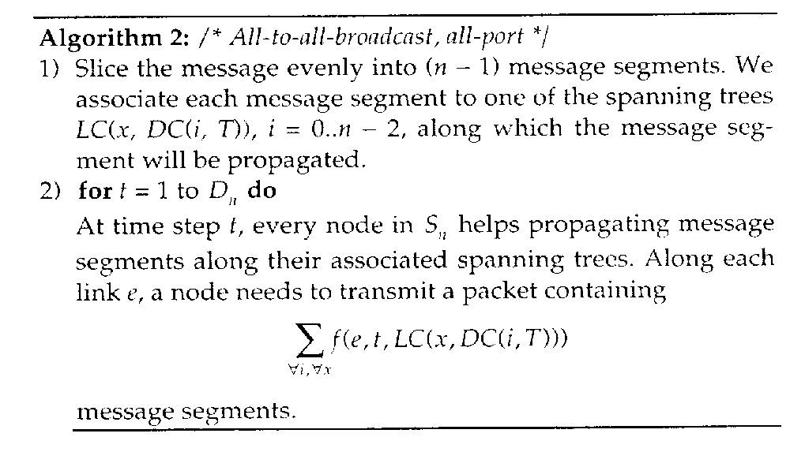
Under the all-port model, all-to-all broadcast can be performed in with time
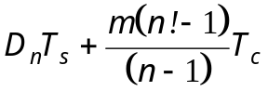

One-Port Model
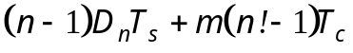
Comparison with Related Works
Comparison of one-to-all broadcast algorithms on start-up cost, transmission cost, and overall time complxity
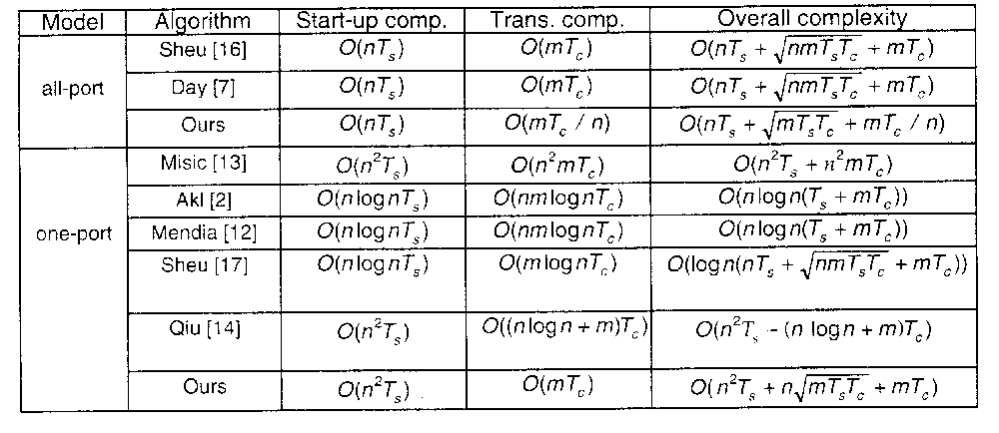
Created by : Harng, Tian-shiang
Date : Oct. 8, 1997

