A Comparative Study of Topological Proerties of Hypercubes and Star Graphs

Khaled Day and Anand Tripathi
IEEE Trans. On Parallel and Distributed Systems, Vol. 5, No. 1, 1994
Abstract
In this paper, we undertake a comprative study of two important interconnection network topologies: the star graph and the hypercube, from the graph theory point of view.
Introduction
Our major result is the characteriation of maximum-sized families of node-disjoint paths between ant two nodes of a star graph.
We define greedy and asymptotically balanced spanning trees to support broadcasting and personalized communication on the star graph. By a balanced spaning tree is meant a spanning tree with maximun fan-out at the root and approximately the same number of nodes in each subtree of the root. By an asymptotically balanced sapnning tree for a star graph, we mean a spanning tree which is balanced for large graphs.

Background
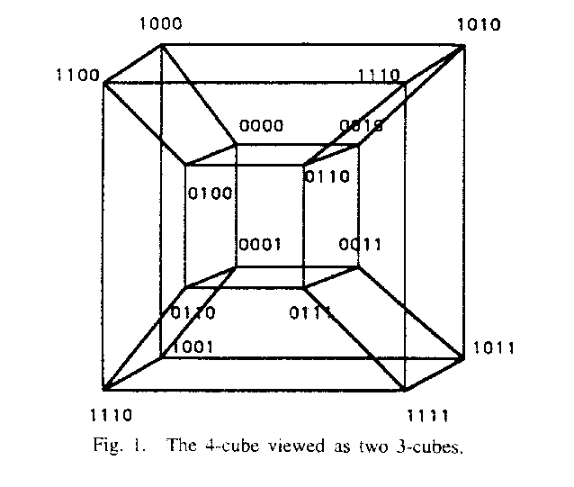
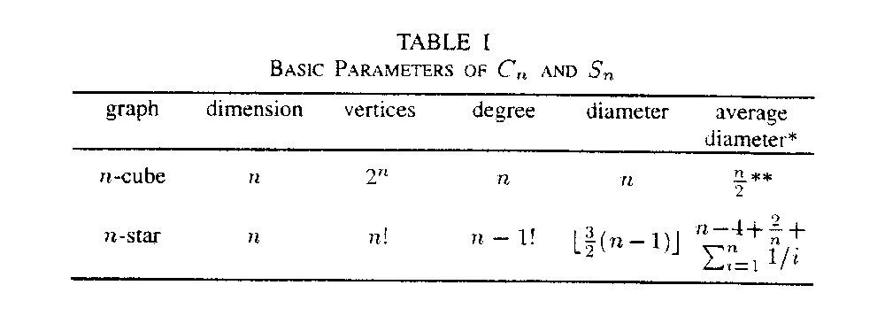
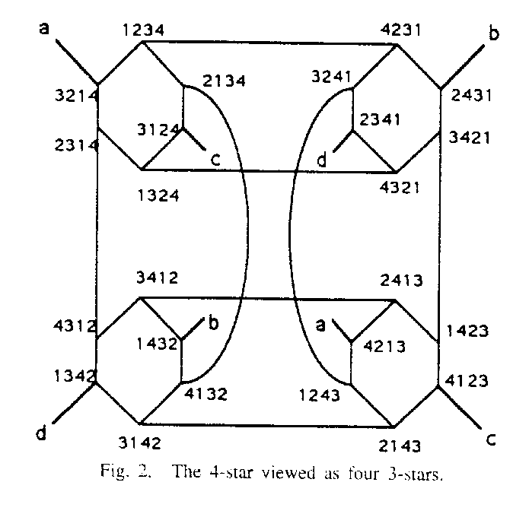
(R1) if symbol 1 is in first position then exchange it with any symbol not in its position, and
(R2) if symbol i (iµ §1) is in first position, then move it to position i.

Akers showed that these rules insure a path ofminimum distance d(P):
d(P) =µ §
3. Shortest Path Routing
Proposition 1: The path µ § form a node labeled with permutation µ § to the node labeled with the identity permutation µ § going through the nodes labeled with permutations µ §,µ §,…,µ § is of minimum distance if, and only if, for any I between 1 and k-1 , µ §+1 is obtained from µ §.
- Parallel Path
- Proposition 2: If A and B are two nodes of an n-star labeled with two permutations 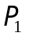 and 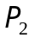 having the same first symbol, then there are m parallel paths of minimum distance, d(,)=c+m, between A and B.

- Example 1: Let =132546 and =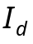=123456 be the labels of two nodes in the 6-star. The -cycles are 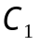=(2,3) and 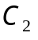=(4,5), c=2 and m=4. We show below four paths of minimum distance, c+m=6, between and ,
- 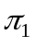= 132456à231546à321546à123546à423516à523416à123456
- 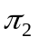= 132546à312546à213546à413526à513426à213456à123456
- 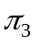= 132546à432516à532416à132456à231456à321456à123456
- 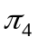= 132546à532146à432156à234156à324156à423156à123456

- Proposition 3: If A and B are two nodes of an n-star labeled with respective labels and having the same first symbol, then there are n-1 parallel paths of minimum distance equal to c+m and the other n-m-1 paths are of length c+m+2.

Example 2: We consider the same permutation =132546 and ==123456 of Example 1. To the four paths show in Example 1, we add the path:
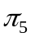=132546à632541à236541à326541à623541à423561à523461 à623451à123456.

Proposition 4: If A and B are two nodes of an n-star labeled with respective labels and having different first symbols, then there are c parallel paths of minimum distance d(,)=c+m-2 between A and B.

Example 3: Let =43215 and ==12345 be the labels of two nodes in the 5-star. The -cycles are =(4,1) and =(2,3), c=2 and m=4. The following are two parallel paths of minimum distance, c+m-2=4, between and .
=43215à13245à23145à32145à12345
=43215à23415à32415à42315à12345

Proposition 5: If A and B are two nodes of an n-star labeled with respective labels and having different first symbols, then there are n-1 parallel paths between A and B.
These paths are grouped as follows:
c paths are of minimum length equal to c+m-2,
m-c-1 paths are of length c+m, and
n-m paths are of length c+m+2.

Example 4: We consider the same source and destination permutations =43215 and ==12345 of Example 3. The -cycles are =(4,1) and =(2,3), c=2 and m=4. To the two paths of minimum distance (four) of Example 3, we add the path of length equal to minimum distance plus two (six) and the path of length equal to minimum distance plus four shown below.
=43215à34215à24315à14325à41325à21345à12345
=43215à53214à13254à43251à23451à32451à42351 à52341à12345

- 5. Spanning Trees
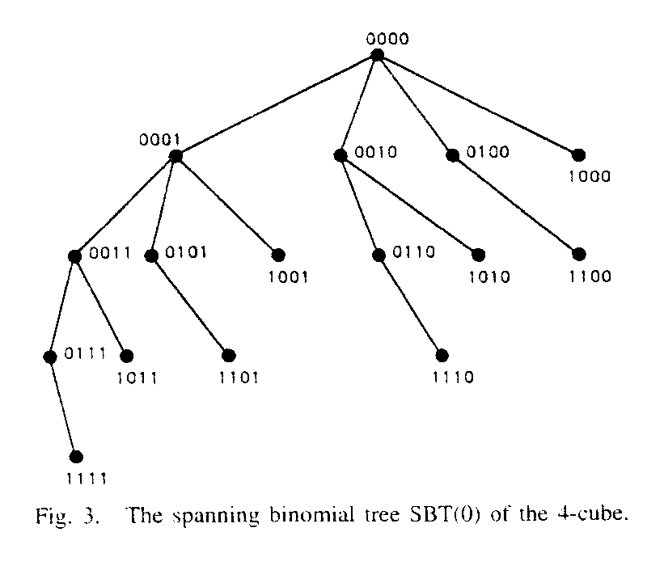
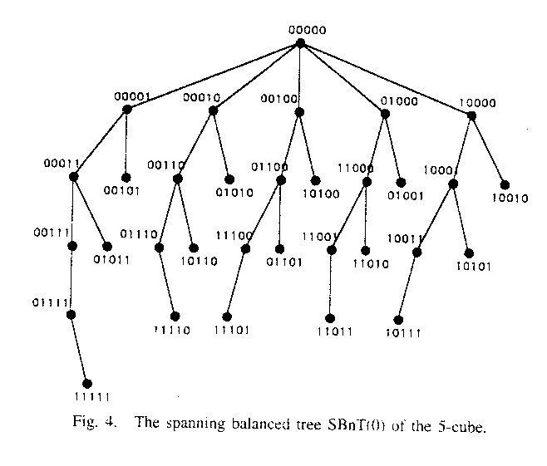
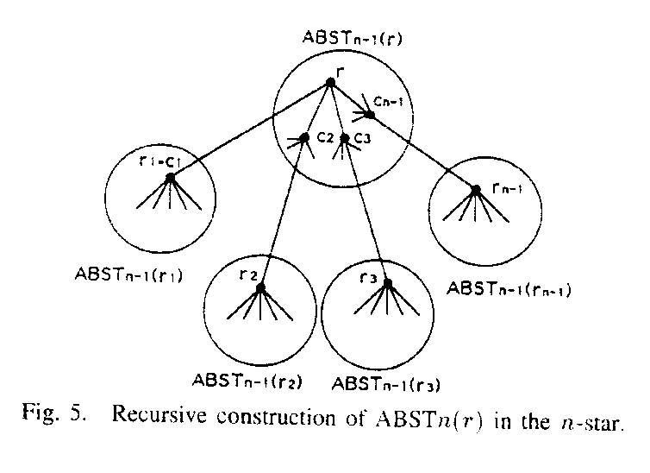
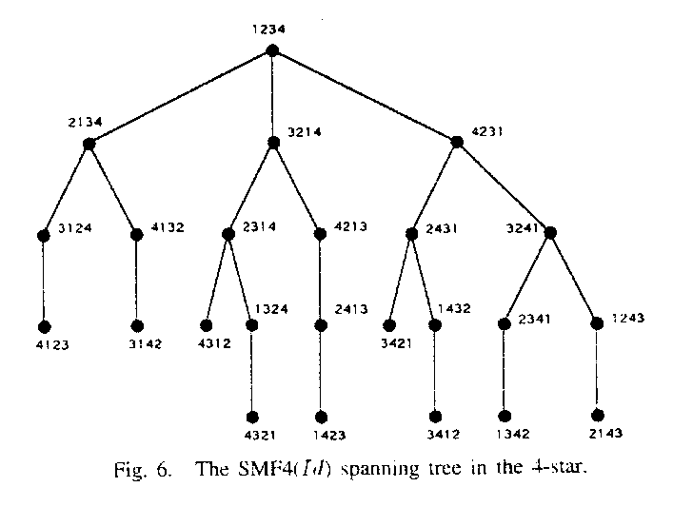
Created by : Harng, Tian-shiang
Date : Oct. 22, 1997

