A Routing and Broadcasting Scheme on Faulty Star Graphs

Nader Bagherzadeh, Nayla Nassif, and Shahram Latifi
IEEE Transcations on Computers, Vol. 42, No.11, 1993
Abstract
In this correspondence, we present a routing algorithm that uses the depth first search approach combined with a backtracking technique to route messages on the star graph in the presence of faulty links.
In the absence of an optimal path, the algorithm always finds a path between two nodes within a bounded number of hops if the two nodes are connected. Otherwise, it returns the message to the originating node.
Finally, we use the routing algorithm to present an efficient broadcast algorithm on the star graph in the presence of faults.

The Star Graph
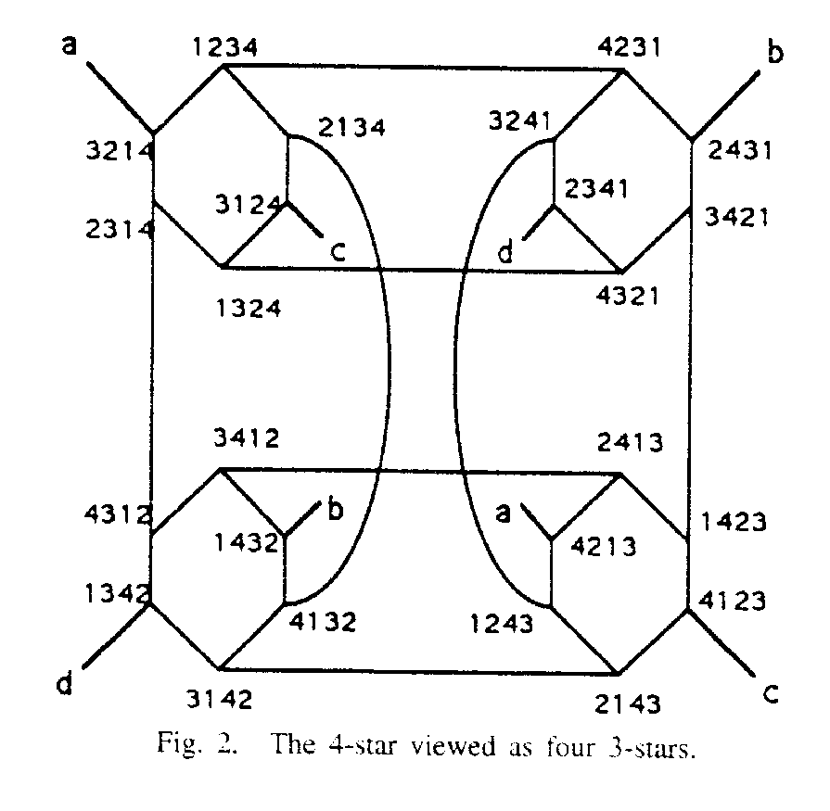
- Routing on a Star Graph with Faults
- General Description of the Routing Algorithm
- At each node that receives a message, compute relperm if the node is different from the identity. If the message is forward, mark the node visited and append the link just traversed to the linklist, otherwise delete the link from the linklist.
- Select the leftmost symbol in relperm. If link x is valid, then send the message forward along it and go to step 1, else go to the next step.
- Starting from the rightmost position of the rightmost pcycle and proceeding to the left, select the first symbol that belongs to a pcycle.
- If link x is valid, then send the message forward along to it and go to step 1, else select the next symbol.
- If all symbols in all pcycles have been selected, starting from the rightmost position and proceeding to the left, select the first icycle.
- If link x is valid, then send the message forward along to it and go to step 1, else select the next icycle.
- If all icycles have been selected and the current node is not the destination, the destination cannot be reached from the current node. Send a return message along the last link in linklist and go to step1.
B. Routing Algorithm
(m, d, f/w, visited, linklist)
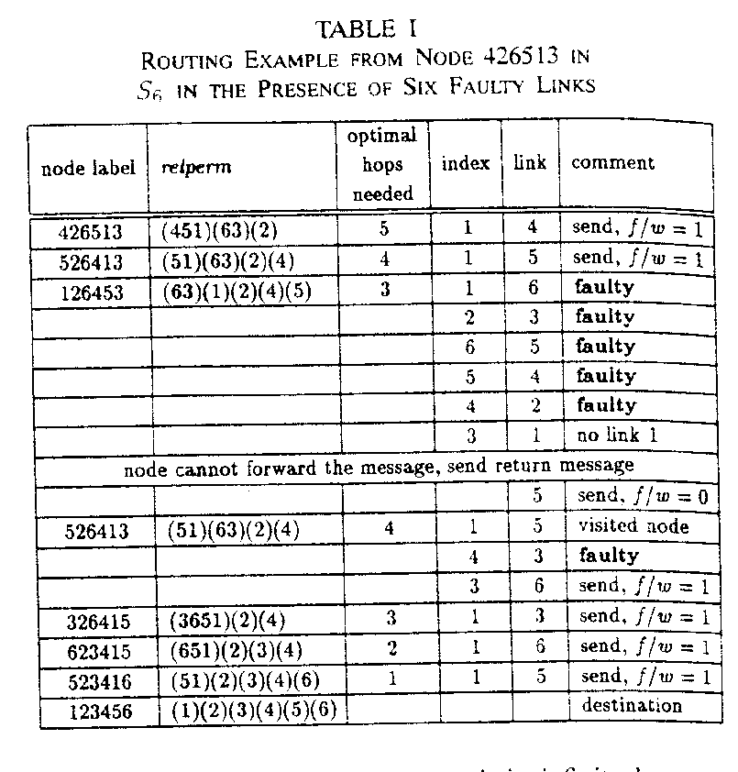
C. Correctness of the Routing Algorithm
Lemma 1: When DSR routes a message from s, the total number of messages is bounded.
Lemma 2: When DSR routes a message from s to d, the average of all messages over all visited nodes, other than s and d, is one forward and one return message in the worst case.
Lemma 3: When DSR routes a message from s to d, the message is either successfully delivered to d within a finite number of hops or returned to s.
Theorem 1: Let s and d be in the same connected component of Sn, DSR routes a message from s to d after at most 2(n!-1)-h0 hops, where h0 is the number of hops needed to route the message on an optimal path in the absence of faults. If s and d is returned to s by DSR after at most 2(n!-2) hops.
Performance of the Routing Algorithm
Lemma 4: According to our convention, if symbol 1 is not in its correct position, then it can only be the rightmost symbol in pcycle1.
Theorem 2: If there are no faulty links in the star graph, DSR is optimal.
Theorem 3: DSR is optimal in the presence of faults if and only if the faults are such that, at each node that receives the routed message, there exists at least a nonfaulty link ai, where ai is
any symbol in any pcycle in relperm, if pcycle1 does not contain 1, or
any symbol in any pcycle in relperm excluding pcycle1 if it contains 1.
Theorem 4: If all links ai, as defined in Theorem 3, are invalid and if the faults are such that node u can still forward the message along some valid link aj, the extra added hops due to aj do not exceed four hops.
Theorem 5: When routing on a star graph with f faults, where f ó n-2, the penalty is at most 2i + 1 ñ 1 hops, where i =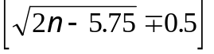
Broadcast on a Star Graph with Faults
å = 23424232
- to node(2) with 34324232
- to node(3) with 4324232
- to node(4) with 324232.
Created by : Harng, Tian-shiang
Date : Nov. 5, 1997

