Edge-Disjoint Spanning Trees on the Star Network with Applications to Fault Tolerance

Paraskevi Fragopoulou, Selim G. Akl
IEEE Trans. On Computers, Vol.45, No.2, pp 174-185, Feb. 1996.
Abstract
In this paper, we construct n-1 directed edge-disjoint spanning trees, on the star network. These spanning trees are used to derive a near optimal single-node broadcasting algorithm, and fault-tolerant algorithms for the single-node and multi-node broadcasting, and for the single-node and multi-node scattering problems. We consider broadcasting and scattering from a single processor of the network and simultaneously from all processors of the network.
1. Introduction
Broadcasting is the distribution of the same group of messages from one processor to all the other processors. Scattering is the distribution of distinct groups of messages from one processor to all the other processors.
The algorithms are derived for the store-and-forward communication model. A processor must receive an entire message before it can process it and retransmit it. The communication is bidirectional, meaning that an edge can be used for message transmission in both directions at each time step.
Notation and Definitions
Definition 1. Translation
µ §

Definition 2. Rotation
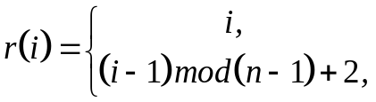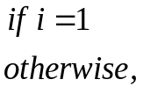
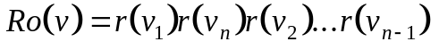
The Edge-Disjoint Spanning Trees
Definition 3. For each node v (excluding node 12…n and its neighbors), we define p or vp as follows:
- For 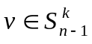, with 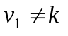, we define p=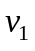. For example, for node v=4123 of 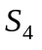, p=4.
- for , with =k, we define 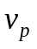 to be the first symbol among 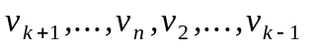, that does not occupy its correct position in v. For example, for node v=4321 of ,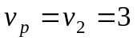.

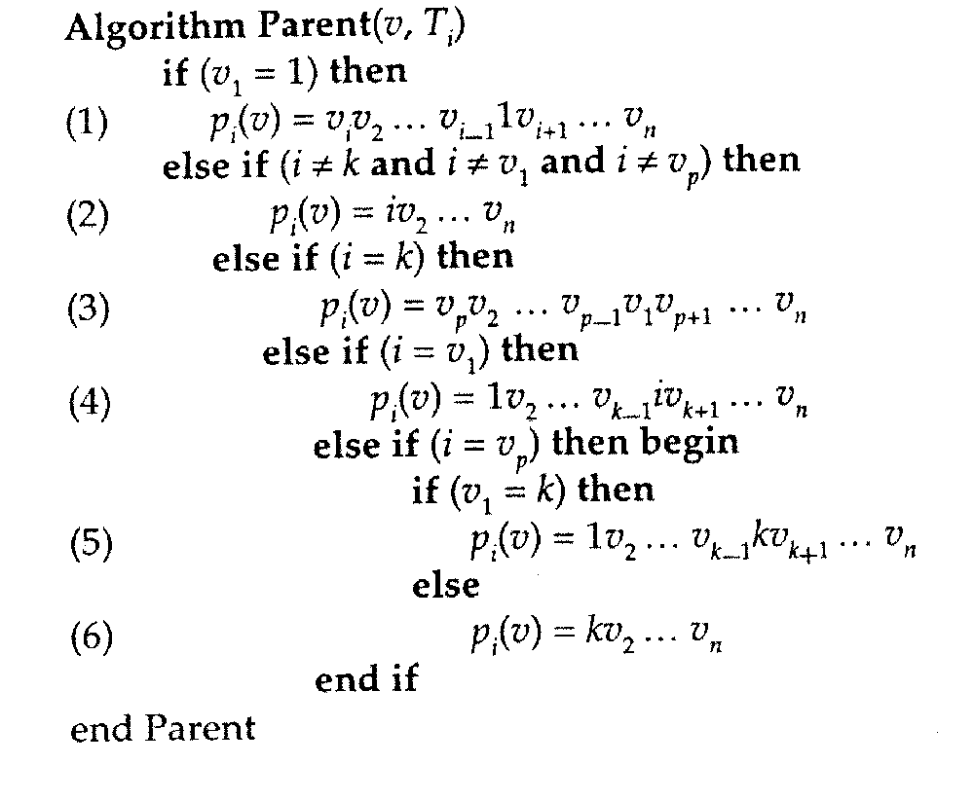
- 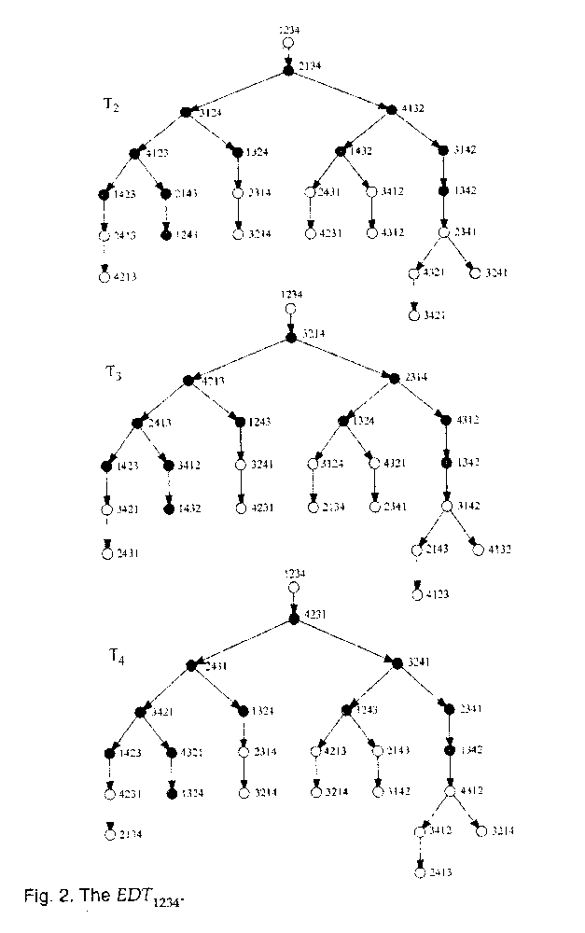
- Lemma 1. At each time step i of the algorithm, if the n -1 directed edges in 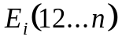 are all of different dimensions, then the sets of directed edges 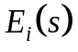, where s ranges over all nodes of 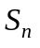, are disjoint.
- Lemma 2. The Parent(v, 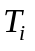) algorithm defines a spanning tree, rooted at the neighbor of 12…n over dimension i, node i2…(i-1)1(i+1)…n. The n-1 spanning trees construct by the Parent algorithm possess the following properties:
- If all the edges of the spanning trees are directed from parent to children nodes, these spanning trees are edge-disjoint. Consequently, 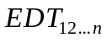 contains all edges of expect those edges that are directed toward node 12…n.
- The identity node has n-1 disjoint paths to each other node of , one path through each one of the n-1 spanning trees of . The lengths of these paths differ from the shortest possible lengths by a small additive constant.
- The depth of the graph is less than or equal to 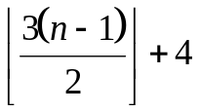, which is optimal to within a small additive constant. This constant is less than or equal to 3.
- Each spanning tree can be derived from its preceding one, cyclically, by the application of a rotation. From the properties of the rotation operation, we conclude that all subtrees are isomorphic and that n-1 corresponding edges of the spanning trees are all of different dimensions.
- Applications
4.1 Lower Bounds
- 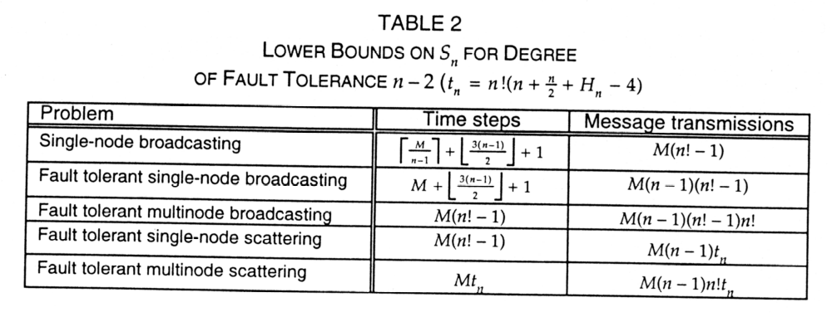
- Single-Node Broadcasting
- Fault Tolerant Single-Node Broadcasting
- Fault Tolerant Multinode Broadcasting
- Fault Tolerant Single-Node Scattering
- Fault Tolerant Multinode Scattering
- 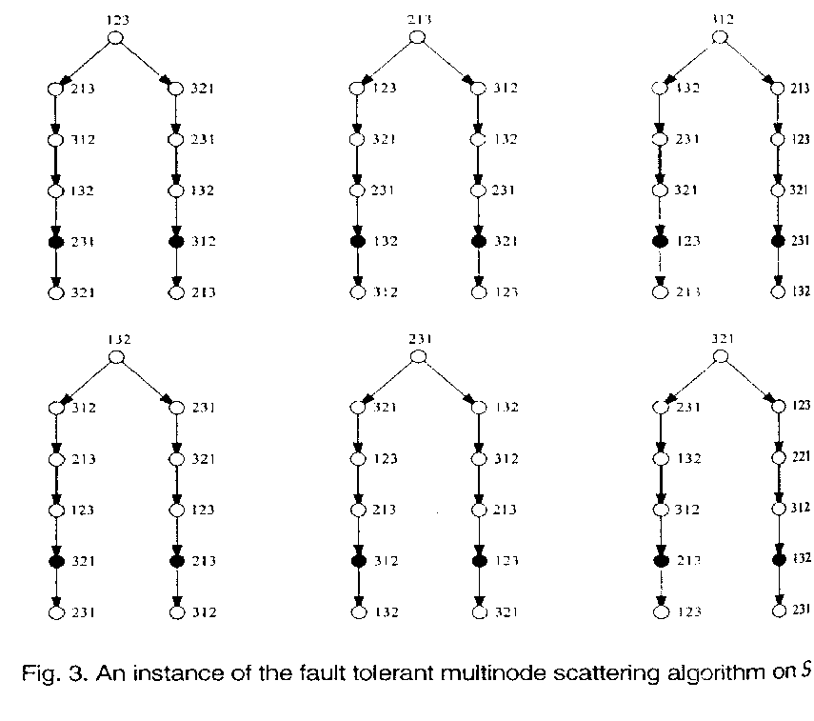
- Conclusion
- 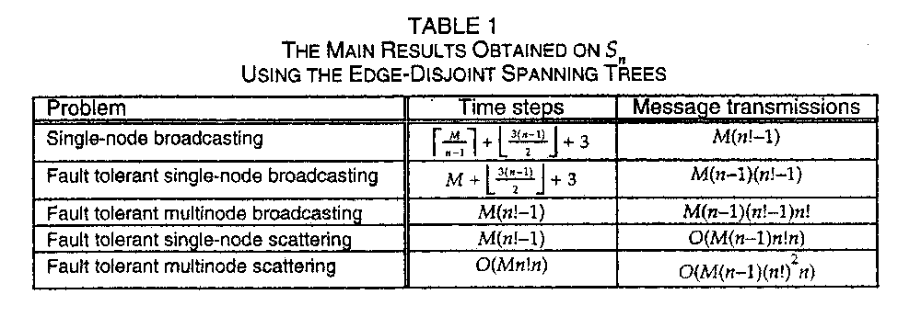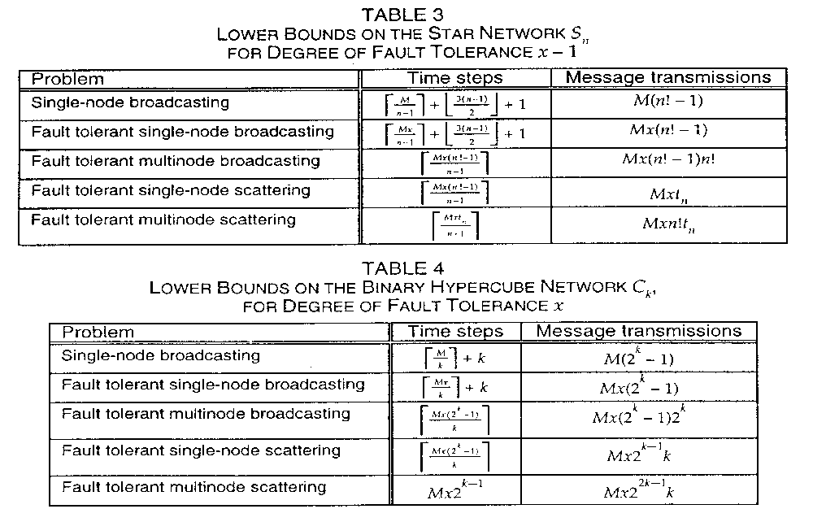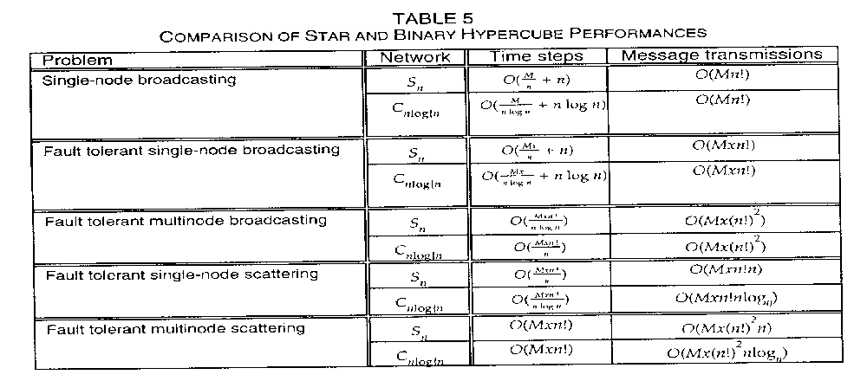
- Created by :Tian-shiang Harng
- Date : Nov. 26, 1997

