Communication Aspects of the Star Graph Interconnection Network

Jelena and Zoran Jovanovic
IEEE Trans. On Par. and Dis. Sys., Vol.5, No.7, pp 678-687, Jul. 1994.
Abstract
Communication algorithms for each node can be expressed only as sequences of generators corresponding to the communication channels.
Introduction
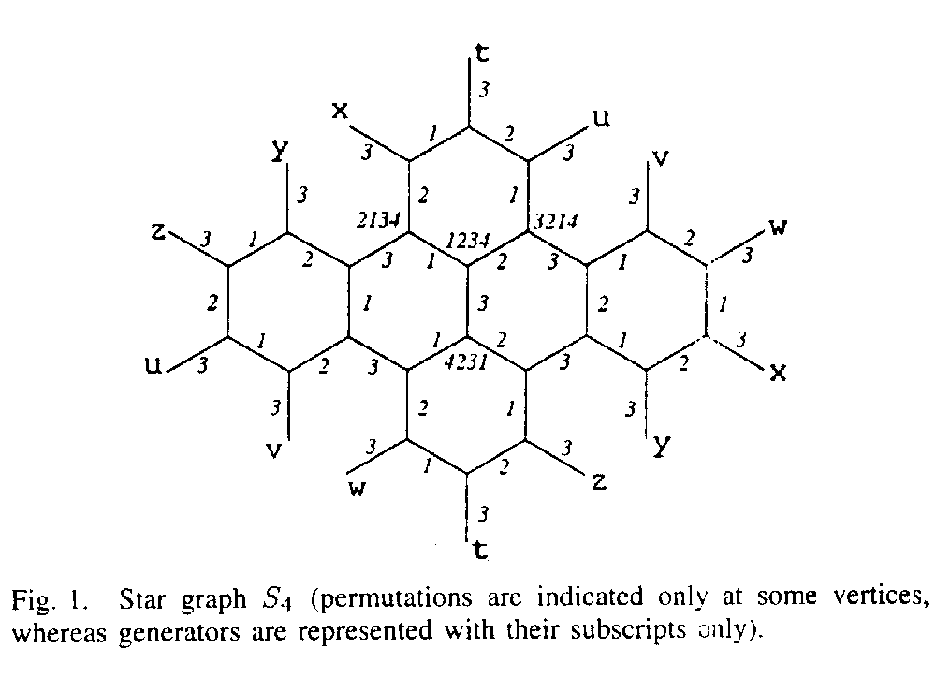

Graph parameter µ §-cube µ §-cube graph
Size N=µ § N=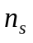
Node degree µ § µ §
Diameter µ µ §
Average distance µ § µ §
Background
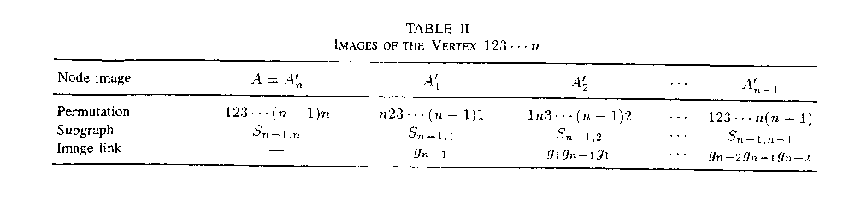
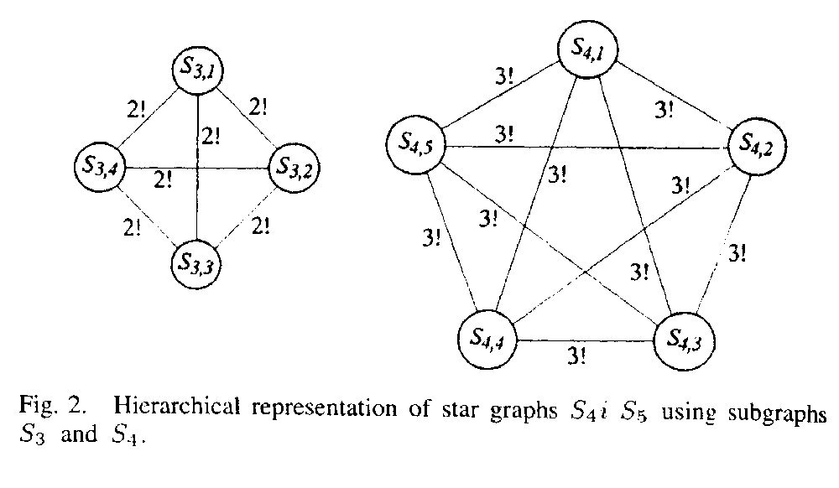

Definition 1: The node A residing in subgraph µ § and having symbol I in the last position has an image node µ § in the subgraph µ § µ §, with symbol j in the last position. According to the position of symbol j in the last position A, its image has one of the following properties:
If A has symbol j in its first position, its image in µ § is µ §, with symbol i in the first position. Both A and µ § have identical symbols in all other positions, expect in the first and last ones. Consequently the path µ § exists between A and µ §.
If A has symbol j in its kth positionµ §,then its image in µ § is µ §,which has symbol i in the kth position. The symbols in all other positions, expect the kth and last positions, are identical. Consequently the path µ § exists between A and µ §.
Assertion 1: Two subgraphs µ § and µ § µ § are connected with (n-2)! Edges that correspond to µ §.

Assertion 2: Every node in µ § has one image in every subgraph µ §,µ § including the node itself.
Assertion 3: Node A and µ §µ § are connected with path µ § of minimal length.
Assertion 4: Mapping of vertices of one subgraph § into vertices of subgraph µ § µ § through images is an isomorphism.
- Assertion 5: When two subgraphs µ § and µ § exchange data through images, communication load on all of (n-2)! channels µ § that interconnect them is the same.
- Communication Algorithms
Single-Node Broadcast (SNB)

µ §
µ §
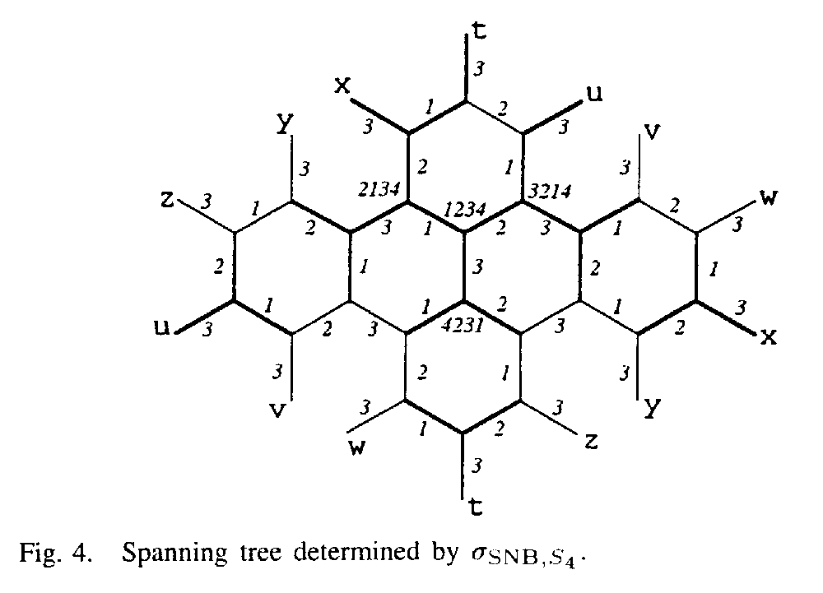
µ §
Multinode Broadcast (MNB)
=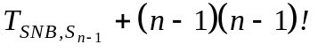
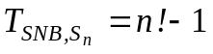
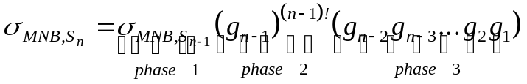
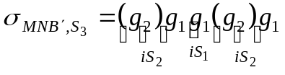
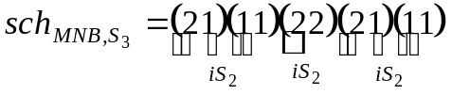
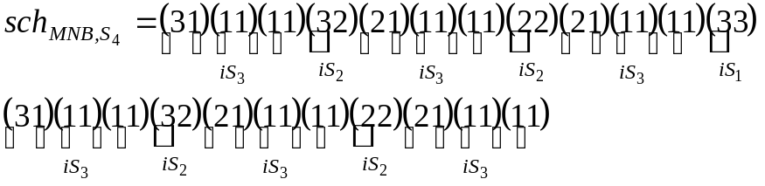
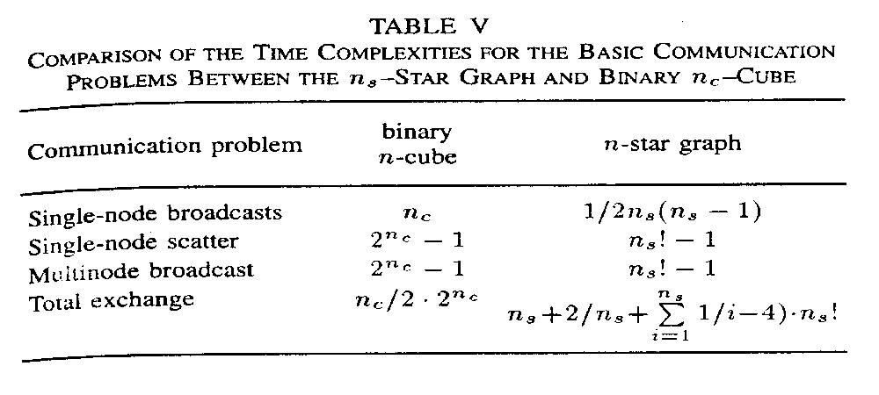
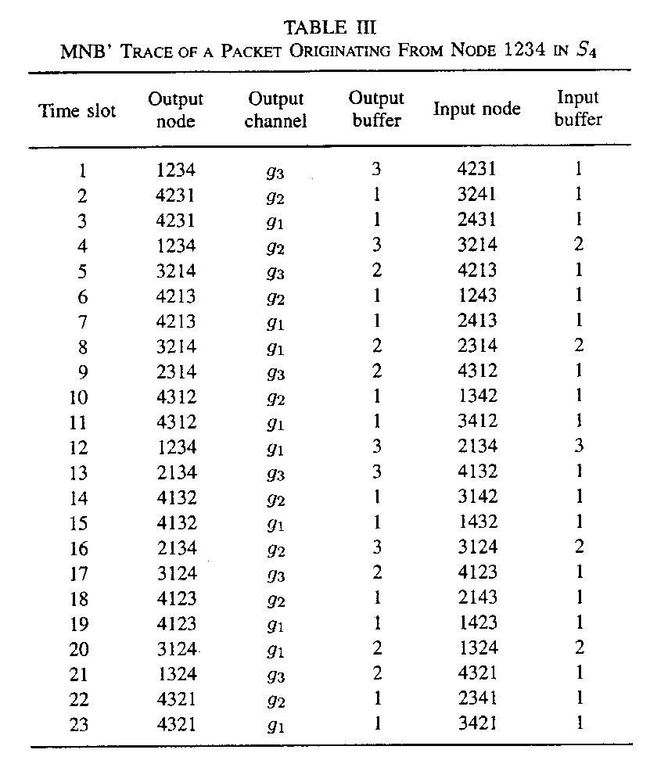
Single-Node Scatter (SNS)
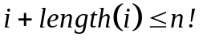
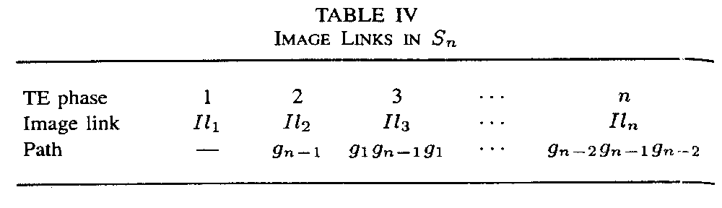
Total Exchange (TE)
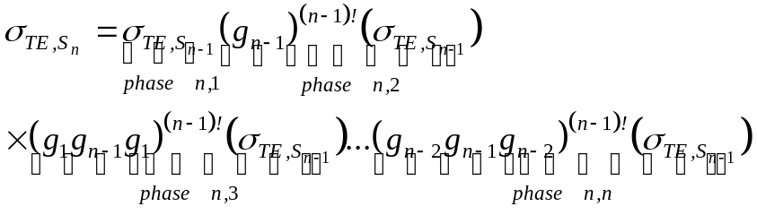
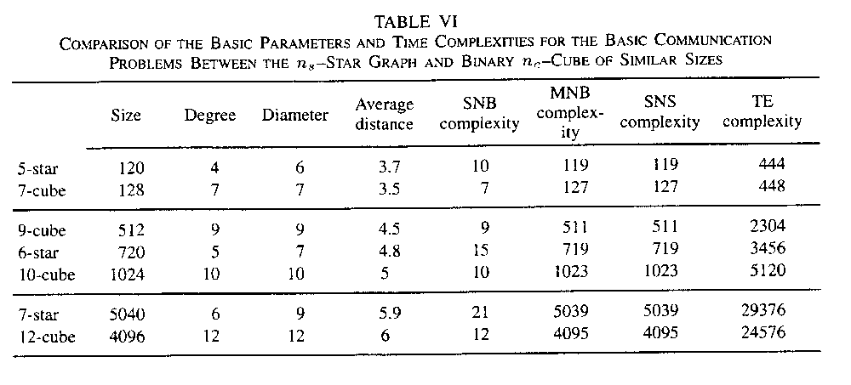
Created by :Tian-shiang Harng
Date : Dec.10 1997

