Incomplete Star: An Incrementally Scalable Network Based on the Star Graph
Shahram Latifi, Nader Bagherzadeh
IEEE Trans. On Par. And Dis. Sys., Vol.5, No.1, pp 97-102, Jan. 1994.
Abstract
We introduce a new interconnection network for massively parallel systems called the incomplete star graph. We describe unique ways of interconnecting and labeling the nodes and routing point-to-point communications within this network.

- InComplete Star Graph Description
- Construction
coefficient vector à (n-1)-tuple b_{n-1}b_{n-2}…b₂b₁ (where 1≤b_{i}≤i)

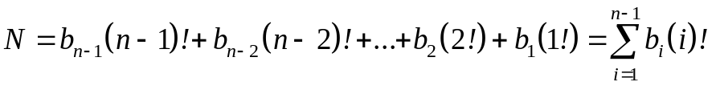
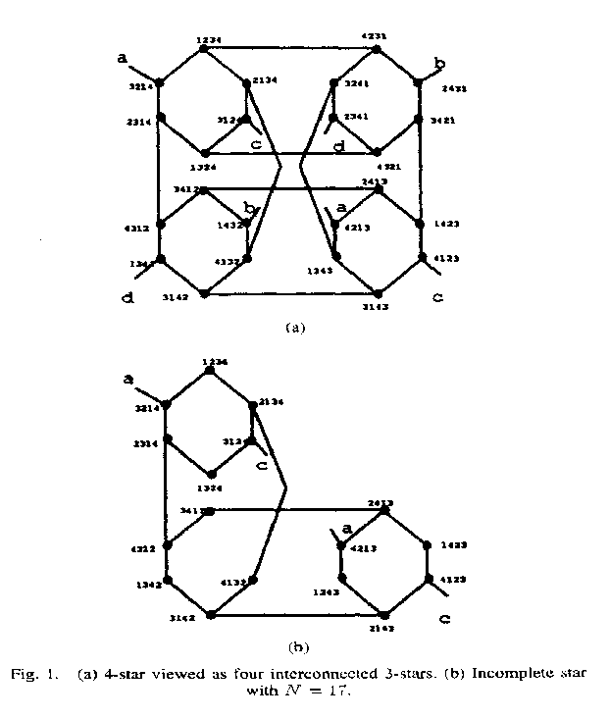
- Labeling
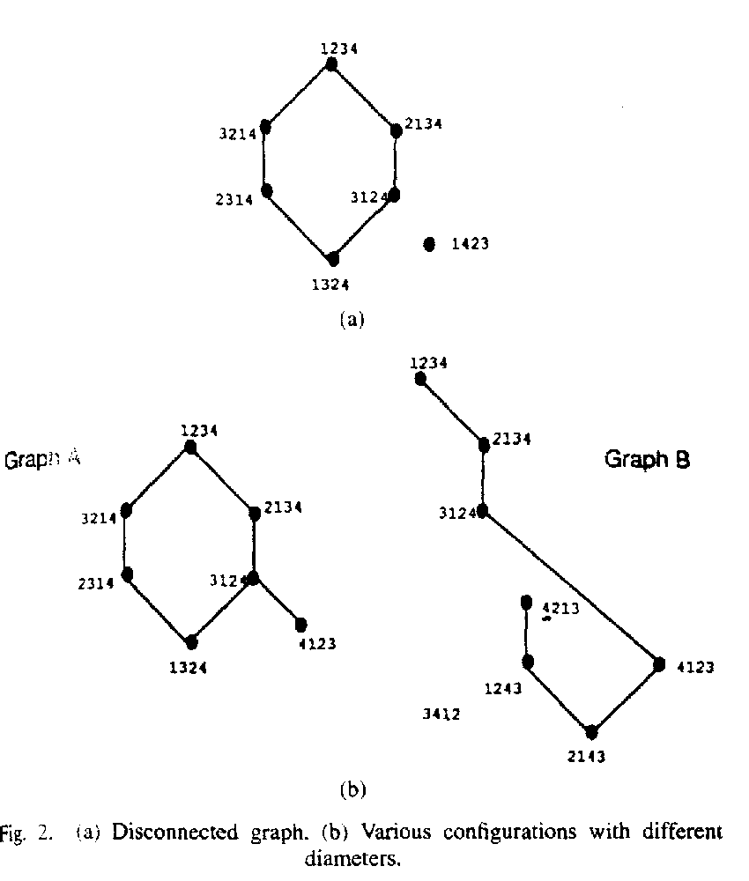

For N= 95 ( where the coefficient vector is 3321)

{xxxx5, xxxx4, xxxx3},
{xxx12, xxx52, xxx42},
{xx132, xxx532}
{51432}

- Routing
Case 1. In this situation, we have nodes 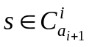 and 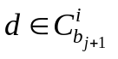. Thus ,both s and d belong to two different i-stars that reside in the same class, 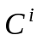.
- 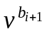 ( within 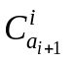);
- 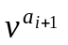 ( which is equivalent to ( i + 1 );
- route to d in 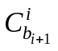.

Case 2. and 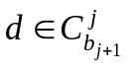, i > j and ,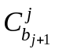 are adjacent in the labeling hierarchy.
Label of is : 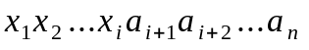.
Label of
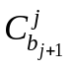: 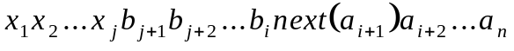,
if i ≤ n - 1
: 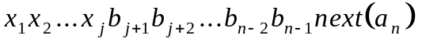,
if i = n - 1
- route s to node s’ in with label 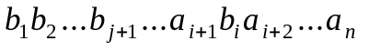;
- 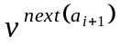;
- (i+1) to reach ;
- route to d in 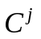.

Case 3. and ,, are not adjacent in the labeling hierarchy.

- C^{n-1} Graph
N_{(n-1)}=(n-n+b_{n-1}-1+1-1)*(n-2)!*b_{n-1}
=(b_{n-1}-1)b_{n-1}(n-2)!
N_{(n-2)}=(n-b_{n-1})b_{n-1}(n-2)!

For example, a 12-node C^{n-1} graph has the coefficient vector = 200 and b_{n-1} = 2. The graph labeling is xxx4 and xxx3 with N₍₃₎ = 4 and N₍₂₎ = 8.
A. Diameter
Theorem 1: The diameter of a C^{n-1} is the same as the diameter of an n-star, i.e., 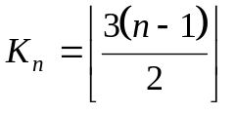.

- Average Distance
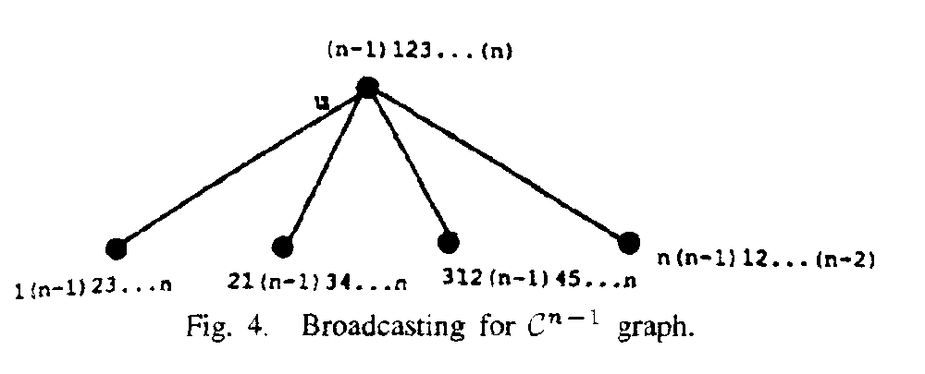
- Brocasting in a C^{n-1} Graph

- Hamiltonian Cycle in C^{n-1} Graph

Created by :Tian-shiang Harng
Date : Dec. 27, 1997

