Horizontal Rotate Crossed Cube:

HCQ Interconnection Network
Susumu Horiguchi and Masayuki Konuki

1.Abstract
Hypercube (HC ) network has attractive properties; strongly connectivity, recursive interconnection, simple routing, and a good complexity of links. However, as the number of processing elements ( PEs) increases, the diameter and average distance of HC become large in proportion to a logorithm of the number of PEs. This causes a large latency of communication between PEs and consequently reduces the system performance. To solve this problem, two approaches have been investigated. One is a theoretical approach to find a network topology reducing a diameter and an average distance between PEs. Other is a physical approach to reduce the physical distances between PEs by integrating a huge interconnection on a small chip on silicon wafer.
In this paper, we propose a new interconnection network; HCQ ( Horizontal Rotate Crossed Cube) by taking account of WSI implementation.
2.Introduction
A typical theoretical approach is the Crossed cube (CQ). CQ has attractive network properties such that the diameter is half and the average distance is of the HC for the same number of PEs.
In this paper, we investigate a new interconnection network based on the crossed cube; HCQ(Horizontal Rotate Crossed Cube) for both theoretical and physical approaches.

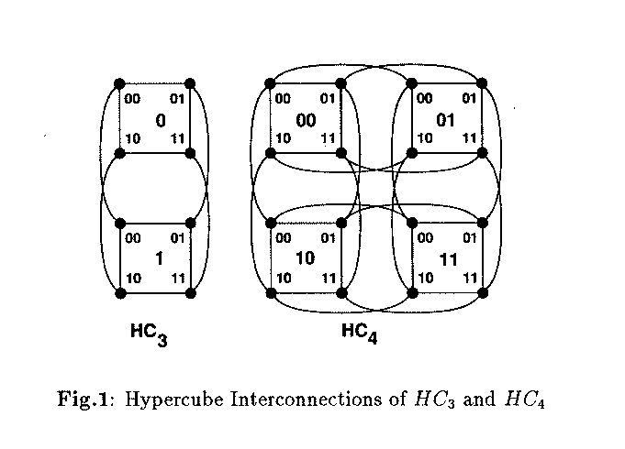
The HCn has attractive network properties such as the diameter is n, the average distance is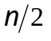, and the number of links is 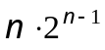.

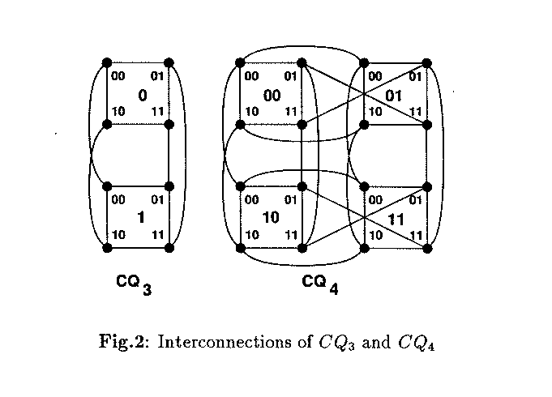
The diameter 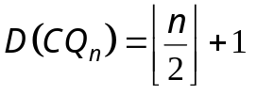
The average distance d of CQn 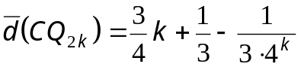
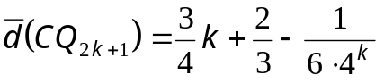
The CQ has the merits that the diameter is only half of HC and the average distance is 75% of the HC.

3.HR-Crossed Cube Interconnection
The following two approaches obtain the HCQ by rearranging the CQ. The first one is to reduce the number of links with same distance to obtain the CQ from the HC. The second one is to apply the interconnection rule based on the different most left bit between two PEs connected in the CQ. When the order of the different most left bit is an even number, then the horizontal crossing interconnection of ((00,01), (01,00)) are given in the HCQ instead of the vertical crossing interconnection ((01,11), (11,01)) in the CQ.
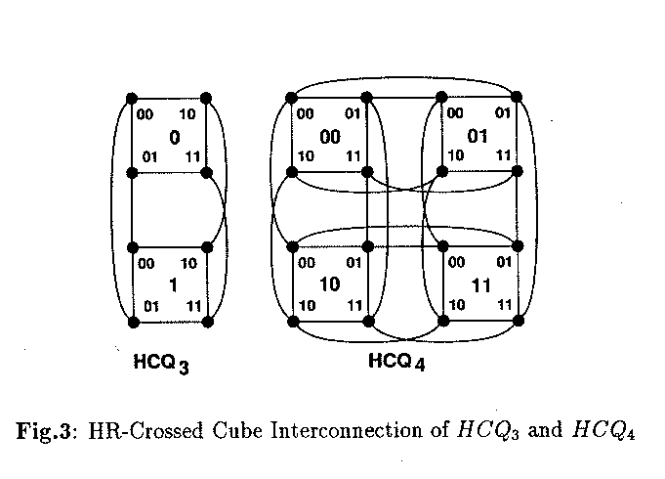
- Interconnection of HCQ

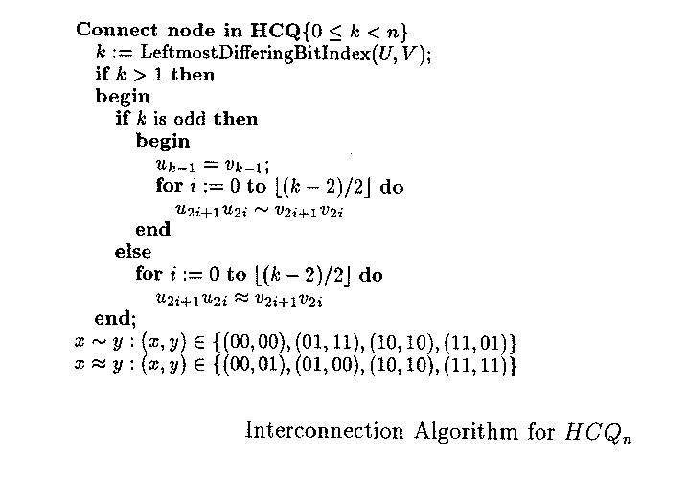
The average distance of HCQ
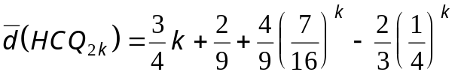
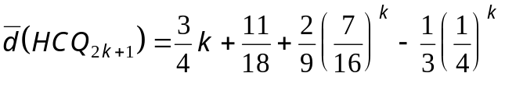
4.Routing Algorithm of HCQ
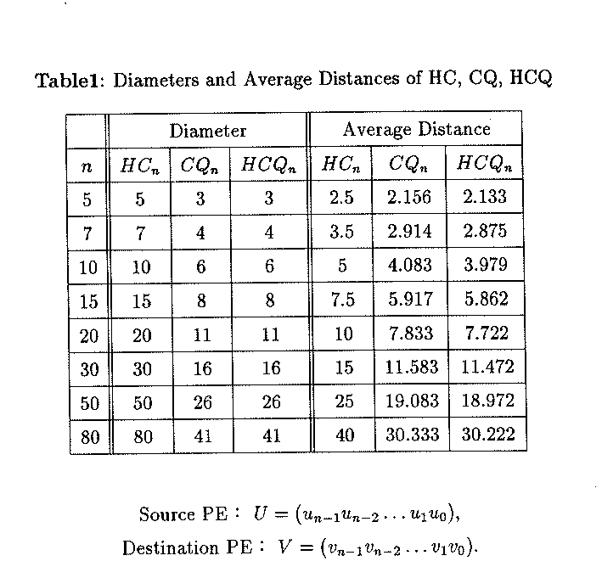

Created by : Tian-Shiang Harng
Date : Aug. 20, 1997

