Broadcasting Algorithms for the Star-Connected Cycles Interconnection Network

M. Azevedo, N. Bagherzadeh, and S. Latifi
Journal of Parallel and Distributed Computing, Vol. 25, pp. 209-222, 1995
Abstract
The star-connected cycles (SCC) graph was recently proposed as an alternative to the cube-connected cycles (CCC) graph, using a star graph to connect cycles of nodes rather than a hypercube. This paper presents an analysis of broadcasting algorithms for SIMD and MIMD SCCs, covering both one-port and multiple-port versions.
Introduction
In this paper, we investigate different broadcasting algorithms for the SCC graph, considering both the SIMD and the MIMD computational models.
Also included in this paper is a comparison between SCC, star, and CCC graphs of similar size in respect to the number of steps required by their corresponding broadcasting algorithms.

- 2. Background
The Star Graph
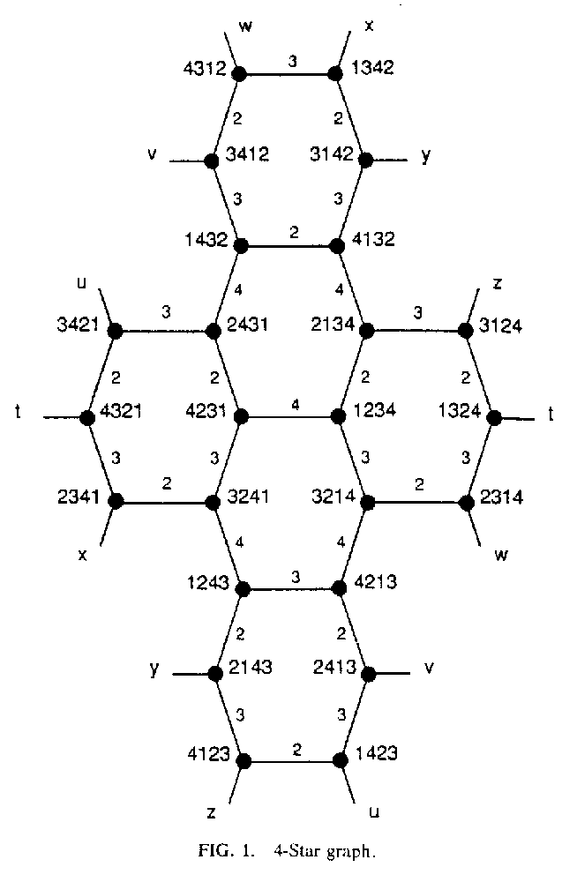
- 2.2 The Star-Connected Cycles Graph

- 3. Broadcasting in the SCC Graph
- One-Port Broadcasting in the SCC
- 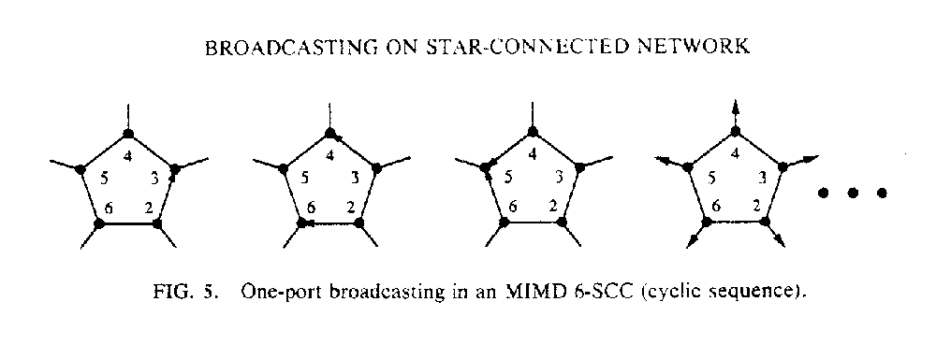
- 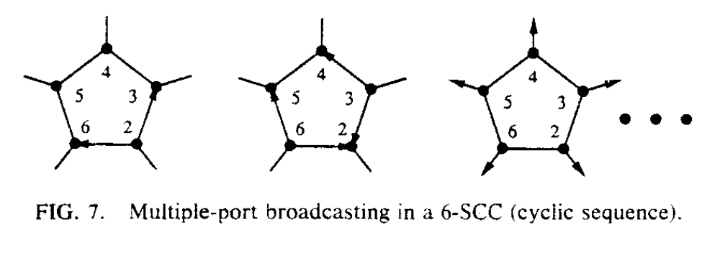

- 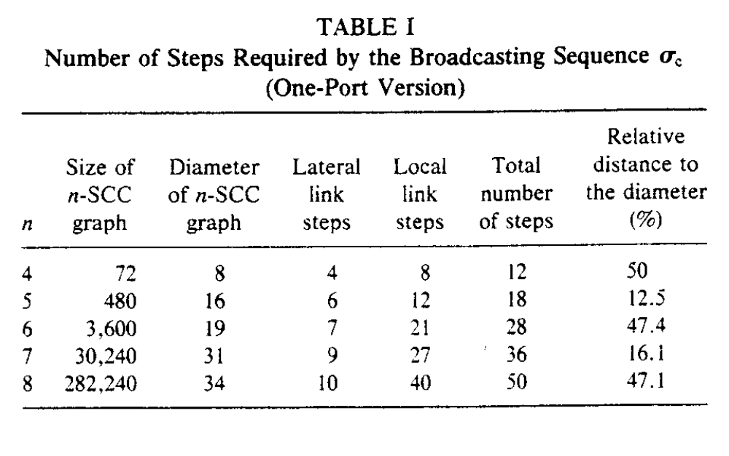

- Multiple-Port Broadcasting in the SCC

- 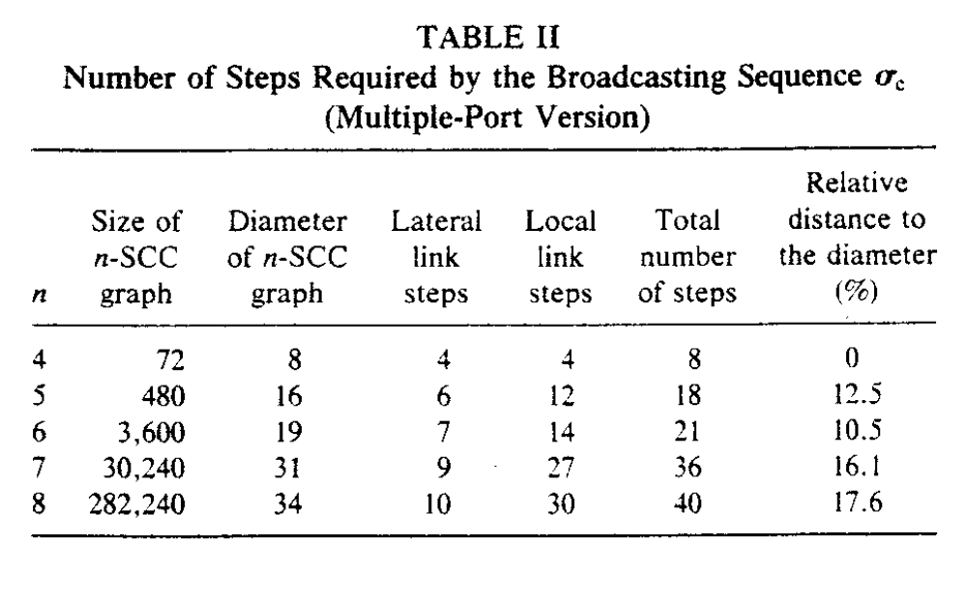
4. Comparison of Broadcasting Algorithms for the SCC and the Star Graph
- 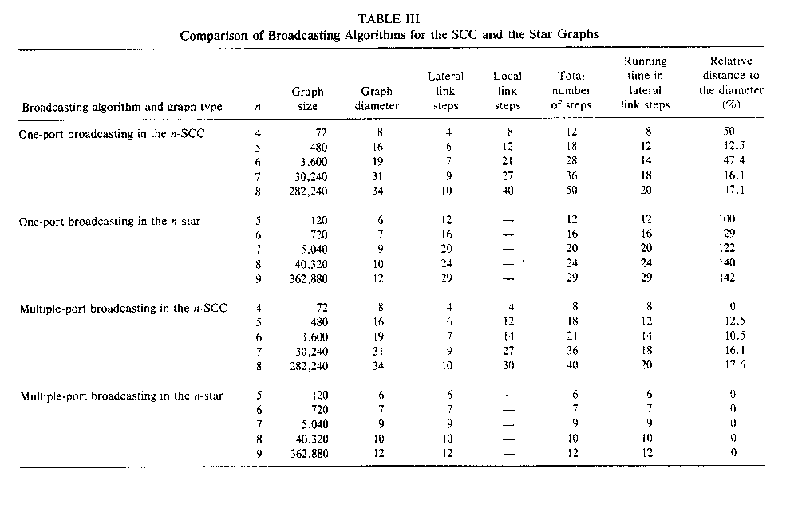
- Comparison of Broadcasting Algorithms for the SCC and the CCC graphs
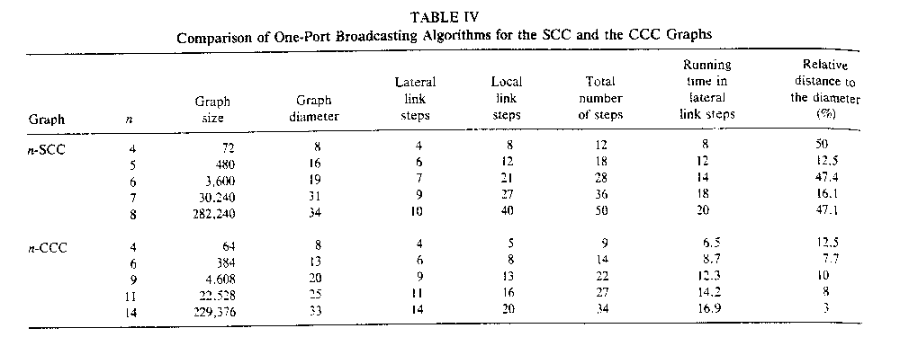
Created by : Harng, Tian-shiang
Date : Sep. 13, 1997

