Safety Levels- An Efficient Mechanism for Achieving Reliable Broadcasting in Hypercube
Jie Wu
IEEE Transaction on Computers, Vol. 44, No. 5, pp. 702-706, 1995
Abstract
We consider a distributed broadcasting algorithm for injured hypercubes using incomplete spanning binomial trees. The incomplete spanning binomial tree proposed in this paper is a useful structure for implementing broadcasting in injured hypercubes.A method is proposed to locate a large subset of the l-node set using the concept of safety level. The safety level of each node in an n-dimensional hypercube can be easily calculated through n - 1 rounds of information exchange among neighboring nodes. When a nonfaulty source node is unsafe and there are at most n - 1 faulty nodes in an injured n-dimensional hypercube, the proposed broadcasting scheme requires at most n + 1 steps.
- Introduction
Efficient broadcasting of data is one of the keys to the performance of a hypercube system. The concept of incomplete spanning binomail tree is introduced to implement the broadcasting process. An incomplete spanning binomail tree in an n-dimensional injured hypercube is a connected subgraph of an n-level spanning binomail tree with the same root that connects all the faulty nodes in the cube, and its root node is called l-node.
In this paper, we propose the concept of safety level, which is an enhancement of the safe node concept by further weakening its definition. Each node in an n-dimensional hypercube is assigned an integer within the range of 0 to n.
A broadcasting scheme is proposed which uses the safety level of each node. It is shown that broadcast from a safe node is both time and traffic optimal, where time is measured by the number of hops required to complete a broadcasting and traffic is a measure of the total number of message transmitted from one node to another in the broadcasting process.

- Notation and Preliminaries

Definition 2: Let 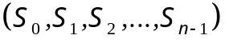, 0≤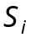≤ n, be the ascending safety-level sequence of node a’s n neighboring nodes in an n-cube, such that 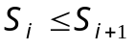,0≤i≤n-1. The safety level of node a is defined as: if ≥ 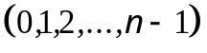 then 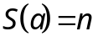 else if 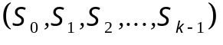 ≥ 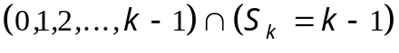then 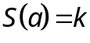.

Algorithm GLOBAL_STATUS(GS)
{Initially all nonfaulty nodes are n-safe and round = 1. }
begin
while round ≤ Δ
parbegin
NODE_STATUS(a(i)), 0≤i≤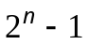
parend
round := round + 1
end.
Procedure NODE_STATUS(a(i))
begin
at node a(I) determine the ascending status sequence of neighboring node
if ≥
then mark a(i) as n-safe( or safe);
if ≥
then mark a(i) as k-safe;
end.

THEOREM 2. The GS algorithm identifies a k-safe ( k ≠ n) node of an n-cube in k rounds, i.e., at the kth round this node reaches a stable status.
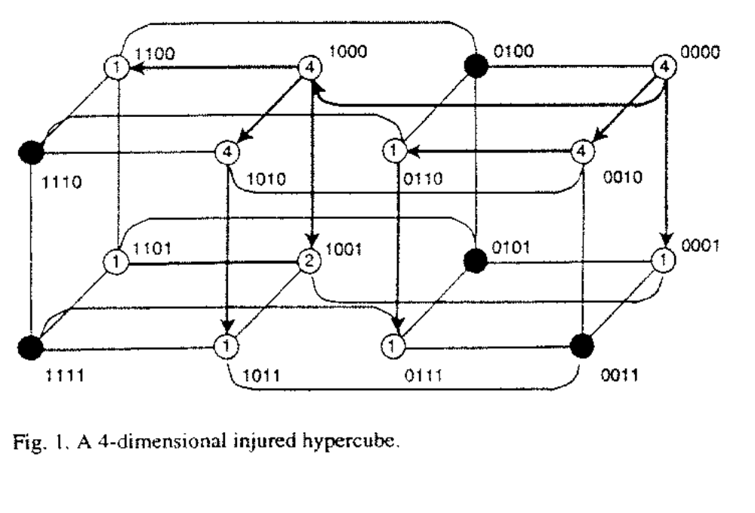
- Injured Hypercube Broadcasting

For example, the splitting process of 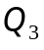 = *** at s = 010 with coordinate sequence 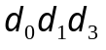=213 can be described as follows:
***() = *1*(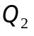) + *0*(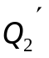)
*1*() = *10(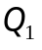) + *11(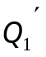)
*10() = 010(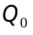) + 110(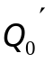)
Clearly, { ,,,= s} = { *0*, *11, 110, 010} forms a partition of =***.
ALGORITHM INJURED_HYPERCUBE_BROADCASTING (IHB)
{At the source node, LABEL[j] = 1, 0 ≤ j < n. }
begin
for j = n - 1 downto 0
if LABEL[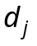] ≠ 0 and 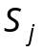≠ 0 /* if = 0 then the neighbor
along dimension is fault */
then begin
LABEL[]:=0;
send the broadcast data and LABEL to the
neighbor along the 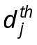 dimension;
end
- end.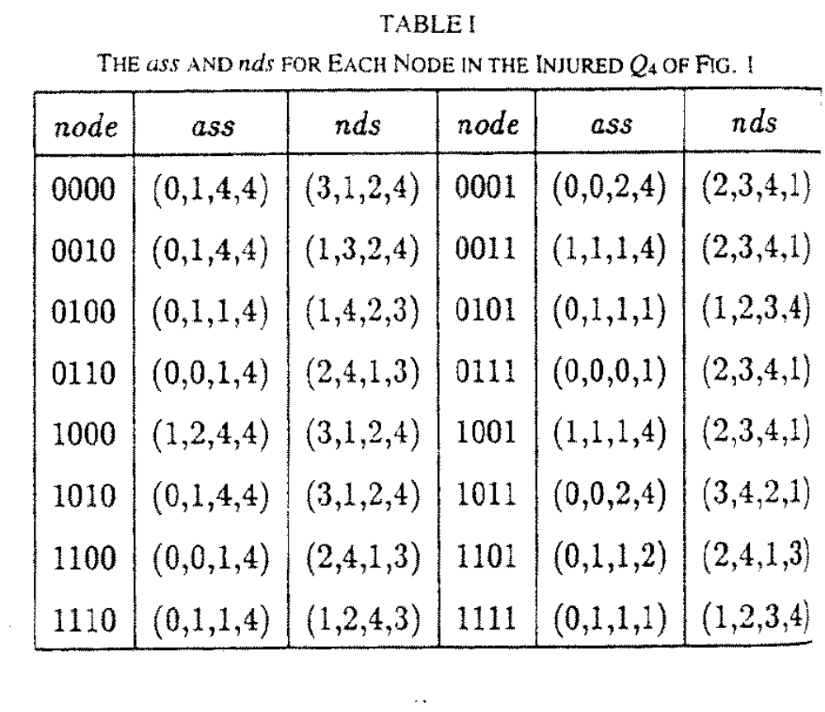

- 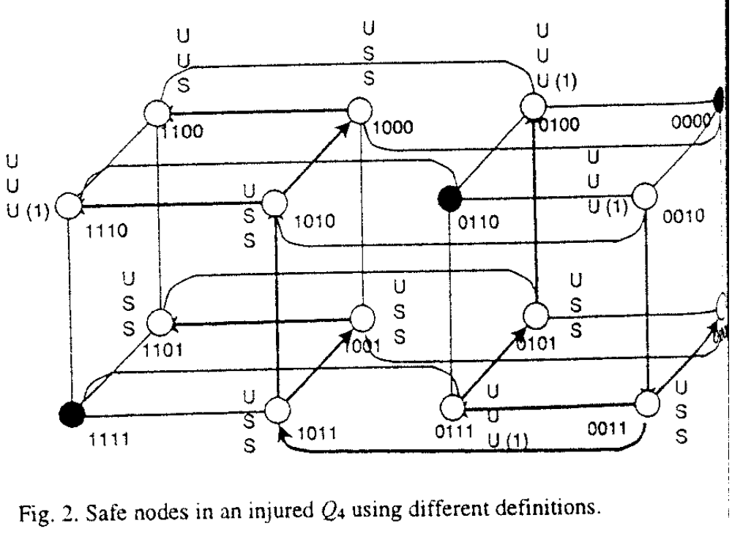
- 4. Comparisons
- ( Lee and Hayes) A nonfaulty node is unsafe if and only if there are at least two unsafe or faulty neighbors.
- ( Wu and Fermandez ) A nonfaulty node is unsafe if and only if either of the following conditions is true:
- There are two faulty neighbors or
- There are at least three unsafe or faulty neighbors.

Created by : Harng, Tian-shiang
Date : Aug. 28, 1997

