★★★★☆
題組：Problem Set Archive with Online Judge
題號：288: Arithmetic Operations With Large Integers
解題者：李承諺
解題日期：2025年5月15日
題意：
給定一串數學式，算出答案。
題意範例：
1+2**3-4*5 -> -11
1+2**3*4+5 -> 38
解法： 大數運算，用陣列存數字
解法範例：
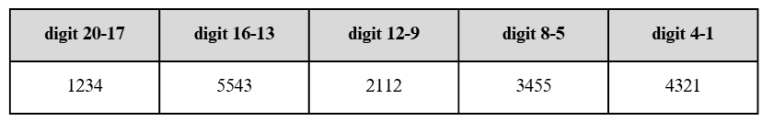
對於每一個數字，我們都用一個陣列來儲存，例如我們要儲存12345543211234554321，將會用下圖的方式來儲存數字。
我們用 Bignum(12345543211234554321) 表示這個數字。
接下來，讀入每一行的數學式後，我們用一個陣列儲存每一個數字，另
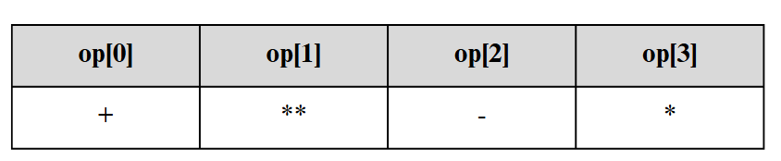
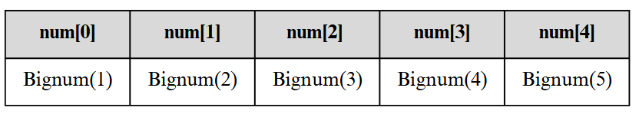
一個陣列儲存符號。
接下來，根據符號的優先級處理運算，對於op[i]來說，我們會把運算完
的結果儲存到num[i]，並把num[i+1]刪掉。當然，也要把op[i]刪掉。刪
到最後面，num[0]就是我們要的結果。
最後，我們實際操作一次 1+2**3-4*5 = -11 。

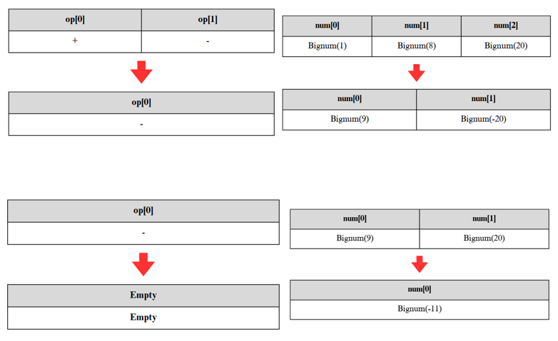
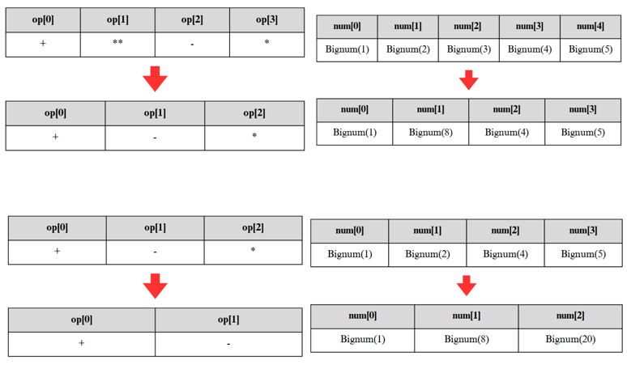

討論：
- : 此題因為每一個數字最多有1000位，且最多有100個運算，所以如
果用 k 格陣列存放 k 個 digit，如果做高指數的運算，可能造成TLE。
- : 這題用C++解非常痛苦，但如果用Python實作，只需要5行程式碼，所以選對程式語言非常重要。
程式：
#include <bits/stdc++.h>
using namespace std;

#define N 10000
#define width 4

class Bignum {
public:
Bignum(string str = "");
Bignum operator + (Bignum &other);
Bignum operator - (Bignum &other);
Bignum operator * (Bignum &other);
Bignum operator ^ (Bignum &other);

bool operator < (Bignum &other);
void operator *= (Bignum &other);

friend ostream& operator<<(ostream &out, Bignum &other);

bool sign; // 0: 正數, 1: 負數
int digit[1001]; // 每4位為一單位
int cnt; // 有效位數

void CountDigit();
bool IsZero();
void decrement();

};

Bignum::Bignum(string str) : sign(0), cnt(0) {
memset(digit, 0, sizeof(digit));
if (str[0] == '-') {
sign = 1;
str.erase(0, 1);
}
for (int i = (int)str.size(); i > 0; i -= width) {
int start = max(0, i - width);
int size = i - start;
digit[cnt++] = stoi(str.substr(start, size));
}
}

void Bignum::CountDigit() {
for (int i = 1000; i >= 0; --i) {
if (digit[i]) {
cnt = i + 1;
return;
}
}
cnt = 1;
}

bool Bignum::IsZero() {
return (cnt == 1 && digit[0] == 0);
}

void Bignum::decrement() {
if (cnt <= 0) return;
digit[0]--;
for (int i = 0; i < cnt; ++i) {
if (digit[i] < 0) {
digit[i] += N;
digit[i + 1]--;
}
else break;
}
CountDigit();
}

void Bignum::operator*=(Bignum &other) {
*this = (*this) * other;
}

bool Bignum::operator < (Bignum &other) {
if (sign != other.sign) {
return sign > other.sign;
}
if (!sign) {
if (cnt != other.cnt){
return cnt < other.cnt;
}
for (int i = cnt - 1; i >= 0; --i){
if (digit[i] != other.digit[i]) {
return digit[i] < other.digit[i];
}
}
}
else {
if (cnt != other.cnt) {
return cnt > other.cnt;
}
for (int i = cnt - 1; i >= 0; --i){
if (digit[i] != other.digit[i]) {
return digit[i] > other.digit[i];
}
}
}
return false;
}

Bignum Bignum::operator + (Bignum &other) {
Bignum result;
if (sign == other.sign) {
result.sign = sign;
for (int i = 0; i < max(cnt, other.cnt); ++i) {
result.digit[i] += digit[i] + other.digit[i];
result.digit[i + 1] += result.digit[i] / N;
result.digit[i] %= N ;
}
}
else {
if(!sign){
Bignum tmp = *this;
tmp.sign = other.sign;
result = other-tmp;
}
else{
Bignum tmp = other;
other.sign = sign ;
result = *this - tmp;
}
}
result.CountDigit();
return result;
}

Bignum Bignum::operator - (Bignum &other) {
Bignum result;
if (*this < other) {
result = other - *this;
result.sign = 1;
return result;
}
for (int i = 0; i < cnt; ++i) {
result.digit[i] = digit[i] - other.digit[i];
if (result.digit[i] < 0) {
result.digit[i] += N;
digit[i + 1]--;
}
}
result.CountDigit();
return result;
}

Bignum Bignum::operator * (Bignum &other) {
Bignum result;
result.sign = (sign != other.sign);
for (int i = 0; i < cnt; ++i) {
for (int j = 0; j < other.cnt; ++j) {
result.digit[i + j] += digit[i] * other.digit[j];
}
}
for (int i = 0; i < cnt + other.cnt; ++i) {
result.digit[i + 1] += result.digit[i] / N;
result.digit[i] %= N;
}
result.CountDigit();
return result;
}

Bignum Bignum::operator ^ (Bignum &other) {
Bignum result("1");
Bignum exp = other;
while (!exp.IsZero()) {
result *= *this;
exp.decrement();
}
return result;
}

ostream& operator << (ostream &out, Bignum &other) {
if (other.cnt == 0 || (other.cnt == 1 && other.digit[0] == 0)){
return out << 0;
}
if (other.sign){
out << '-';
}

out << other.digit[other.cnt - 1];
for (int i = other.cnt - 2; i >= 0; --i){
out << setw(width) << setfill('0') << other.digit[i];
}

return out;
}

int main() {
string input;
while (cin >> input) {
string temp = input;
vector<Bignum> number;
vector<string> op;

char *ptr = strtok((char*)input.c_str(), "+-*");
while (ptr) {
number.push_back(Bignum(ptr));
ptr = strtok(NULL, "+-*");
}

input = temp;
ptr = strtok((char*)input.c_str(), "0123456789");
while (ptr) {
op.push_back(ptr);
ptr = strtok(NULL, "0123456789");
}

for (int i = op.size() - 1; i >= 0; --i) {
if (op[i] == "**") {
number[i] = number[i] ^ number[i + 1];
op.erase(op.begin() + i);
number.erase(number.begin() + i + 1);
}
}
for (int i = 0; i < op.size(); ++i) {
if (op[i] == "*") {
number[i] = number[i] * number[i + 1];
op.erase(op.begin() + i);
number.erase(number.begin() + i + 1);
--i;
}
}

for (int i = 0; i < op.size(); ++i) {
if (op[i] == "+") number[i] = number[i] + number[i + 1];
else if (op[i] == "-") {
if(number[i].sign != number[i+1].sign){
if(!number[i].sign){
number[i+1].sign = number[i].sign;
number[i] = number[i] + number[i+1];
}
else{
number[i+1].sign = number[i].sign = 0 ;
number[i] = number[i] + number[i+1];
number[i].sign = 1;
}
}
else{
number[i] = number[i] - number[i + 1];
}

}
op.erase(op.begin() + i);
number.erase(number.begin() + i + 1);
--i;
}
cout << number[0] << endl;
}
return 0;
}

// 98654*192363-98765**128+5**987
// 0**0
// 98654*192363-98765**128+5**987

