An O(1) Time Optimal Algorithm for Multiplying Matrices on Reconfigurable Mesh
Heonchul Park, Hyoung Joong Kim, Viktor K, Prasanna
Information Processing Letters Vol.47 No.2, pp.109-113, 20 August, 1993
- Introduction
- Reconfigurable Mesh
- Matrix Multiplication
Lemma 1. Given a 0/1 sequence of length N in a row, the prefix modular k computation can be performed in O(1) time on 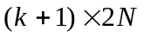 reconfigurable mesh.
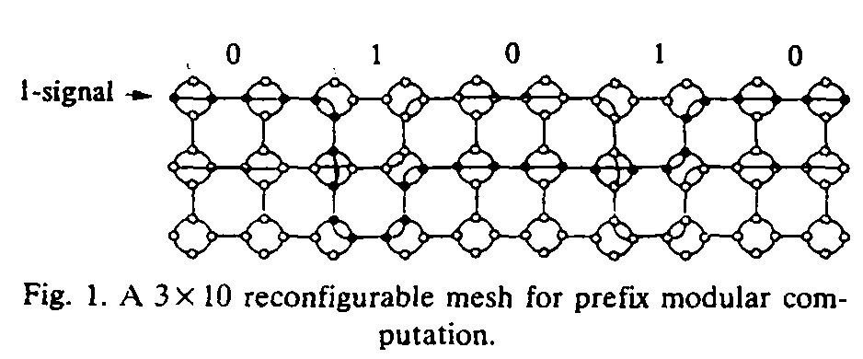

Lemma 2. Counting the number of 1’s in a 0/1 sequence of length N can be performed in O(1) time on 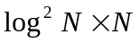 reconfigurable mesh.

Lemma 3. Given N (log N)-bit binary numbers, these numbers can be added in O(1) time on a 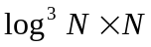 reconfigurable mesh.
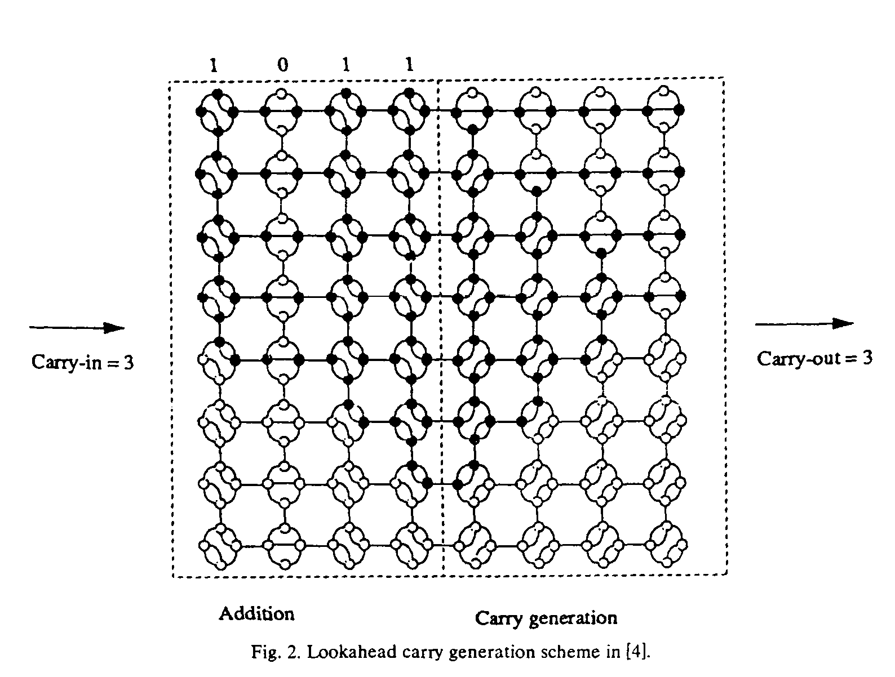

Lemma 4. Given an 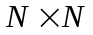 matrix and an 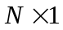 vector assuming each element is represented using 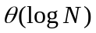-bits, the matrix-vector multiplication can be performed in O(1) time on an 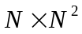 reconfigurable mesh.

Theorem 5. Given two 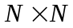 matrices assuming each element is represented using -bits, the matrix multiplication can be performed in O(1) time on an 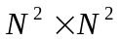 reconfigurable mesh.

Corollary 6. Given two matrices assuming each element is represented using -bits, the matrix multiplication can be performed in O(r) time on an 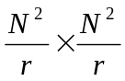 reconfigurable mesh, where 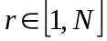.
- Conclusions
Creator: Shin-Si Chen
Date: Sep. 21, 1999

