An Improved Zero-Searching Fractal Image Coding Method
Zin-Ming Zhang and Si-Le Yu
IEEE Transactions on Consumer Electronics, Vol. 45, No. 1,February 1999
Abstract
In this paper, an improved Monro’s zero-searching fractal coding method is presented. It is enabled to use only one affine transformation and sliding domain block structure to get the fractal approximation for each image block.
- Introduction
Fractal image compression methods can be classified into two main kinds, one is Jacquin’s fractal block coding method, which is based on PTS( Piecewise Transformation System). The other one is Monro’s zero-searching fractal coding method, which is based on SAS( Self Affine System, or STS Self-transformation System).
- SAS Affine Transformation
The IFS( Iterated Function System) is one of the most important representations of deterministic fractals. Their most common form is the SAS, which is a set of affine transformations W={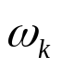; k=1,2,….,N}, where :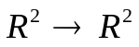 can be described as follows:

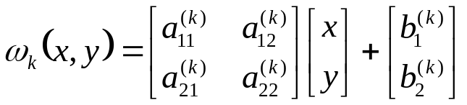
- Monro’s Zero-Searching Fractal Coding Method
Monro introduced Bath Fractal Transform( BFT), whose general form is as follows:

The first order transformation is often used, which is bilinear as:

and the zero order(flat) form

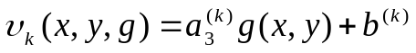

First, the image is partitioned into nonoverlapping DD domain blocks, every block is divided into four tiles, for which we borrow the notion of range blocks. Their size is BB, where D=2B, so we can get four affine transformations:
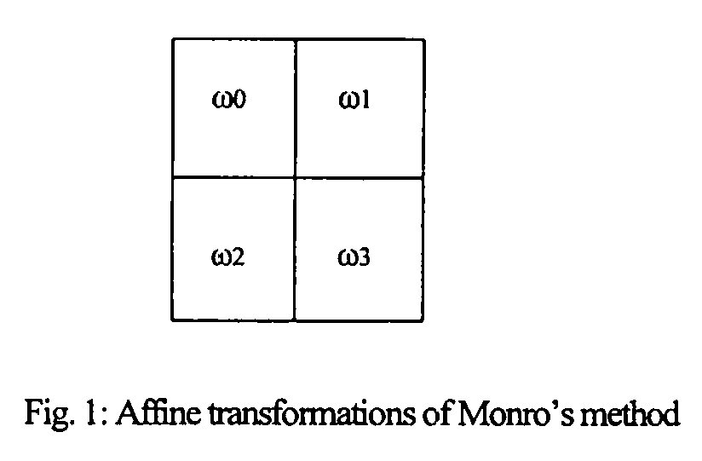
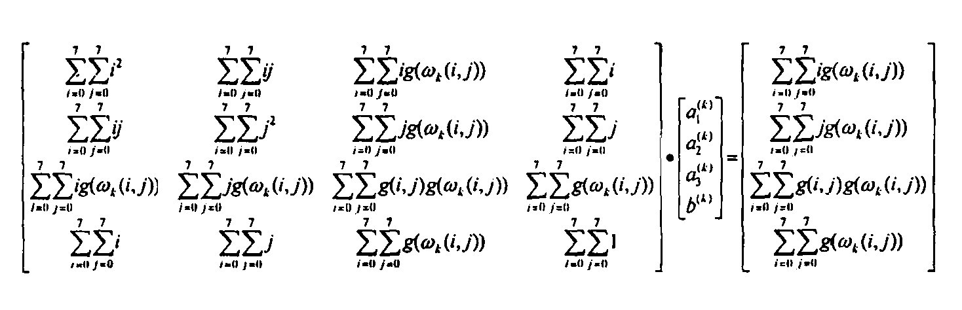
- Improved Zero-Searching Fractal Method
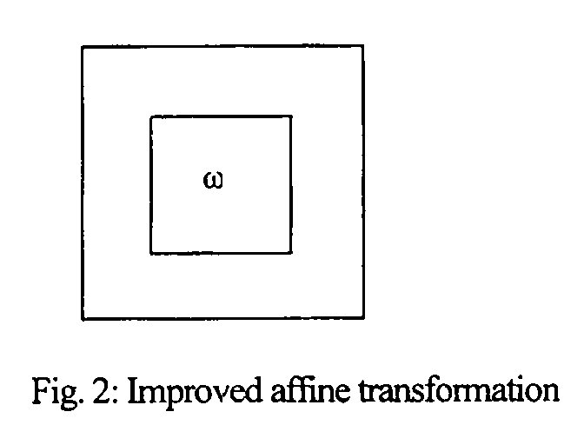

- Experiment Comparison and Conclusions
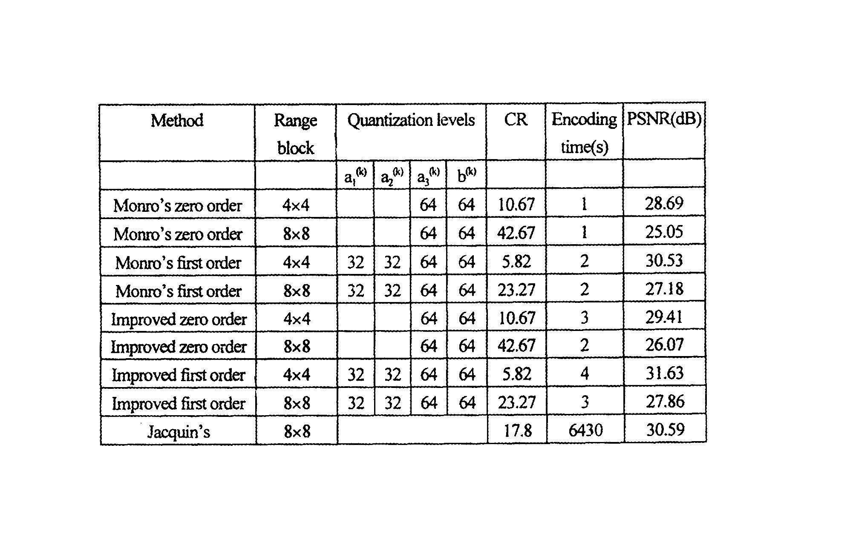
Created by: Shin-Si Chen
Date: Nov. 19, 1999

