Edge-Disjoint Spanning Trees on the Star Network with Applications to Fault Tolerance
Paraskevi Fragopoulou, Selim G. Akl
Computers, IEEE Transactions on Volume: 45 2 , Feb. 1996 , Page(s): 174 –185
Abstract
In this paper, we construct n-1 directed edge-disjoint spanning trees on the star network. These spanning trees are used to derive a near optimal single-node broadcasting algorithm, and fault tolerant algorithms for the single-node and multimode broadcasting, and for the single-node and multimode scattering problems.
- Introduction
In order for a network of processors to be a candidate for parallel processing, it must lend itself to the derivation of efficient communication and fault tolerant algorithms. Working towards this direction in this paper, we construct on the star network a graph that consists of n-1 directed edge-disjoint spanning trees.
EDT_{s} : A node s of S_{n} is the root of such a graph.
Root : Each of the n –1 nodes adjacent to s.
Degree : n-1
Depth : Differs from the minimum possible depth by a small additive constant.
- Notation and Definition
dim(v, v’) = i, v = v₁v₂…v_{i-1}v_{i}v_{i+1}...v_{n}, v’=v_{i}v₂…v_{i-1}v₁v_{i+1}…v_{n}

S^{k}_{n-1} 2≦k≦n, is the subnetwork induced by all nodes of S_{n} with symbol 1 in the kth position of their permutation.

EDT_{(12…n)} rooted at the identity node of S_{n}.

Definition1. The translation of a node v with respect to node s, is defined to be node Trs(v) = s。v = sv₁sv₂…sv_{i}…sv_{n} (This is the operation of permutataion composition). By translation of a network with respect to s, we mean that each node of the network is translated with respect to s.
For example, edge(3124, 4123) of S₄ and its translation with respect to node 3421, edge(2341, 1342), are both of dimension 4.

Definition2. Let us define a bijection r from the set {1, 2, …, n} to itself as follows:
r(i) = 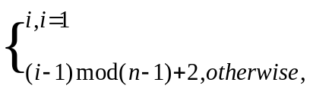
(notice that r maps symbol 1 to itself and the remaining symbols as follows: 2→ 3→ …→ n-1→ n→ 2). The rotation of a node v of Sn, is defined to be node:
Ro(v) = r(v₁)r(v_{n})r(v₂)…r(v_{n-1})
Ro(v) = v’ so that v’_{r(i)} = r(v_{i}), 1≦i≦n. This means that the position of each symbol of v and the symbol itself are mapped through r.
For example, Ro(4123) = 2413, Ro(1324) = 1243.

E_{i}(12…n) is the set of n-1 directed edges on which message originating at the identity node are transmitted at time step I of the algorithm.

Lemma 1. At each time step I of the algorithm, if the n-1 directed edges in E_{i}(12…n) are all different dimensions, the the set of directed edges E_{i}(s), where s ranges over all nodes of S_{n}, are disjoint.
- The Edge-Disjoint Spanning Trees
Definition 3. For each node v (excluding node 12…n and its neighbors), we define p or v_{p} as follows:
- For vS^{k}_{n-1}, with v₁k, we define p = v₁. For example, for node v=4123 of S₄, p = 4.
- For vS^{k}_{n-1}, with v₁=k, we define v_{p} to be the first symbol among v_{k+1}, …, v_{n}, v₂, …v_{k-1}, that does not occupy its correct position in v. For example, for node v = 4321 of S₄, v_{p}=v₂=3.
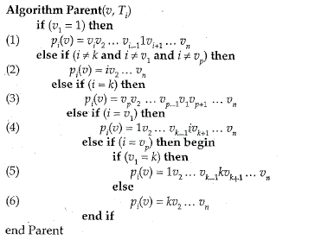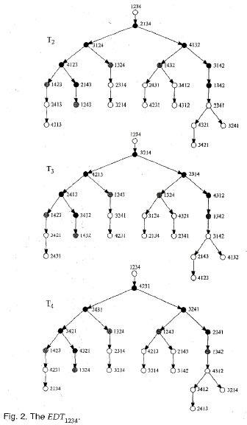
Lemma 2. The Parent(v, T_{i}) algorithm defines a spanning tree, rooted at the neighbot of 12…n over dimension i, node i2…(i-1)1(i+1)…n. The n-1 spanning trees construct by the Parent algorithm posses the following properties:
- If all the edges of the spanning trees are directed from parent to children nodes, these spanning trees are edge-disjoint. Consequently, EDT_{12…n} contains all edges of S_{n} except those edges that are directed towards node 12…n.
- The identity node has n-1 disjoint paths to each other node of S_{n}, one path through each one of the n-1 spanning trees of EDT_{12…n}. The lengths of these paths differ from the shortest possible lengths by a small additive constant.
- The depth of the EDT_{12…n} graph is less than or equal to 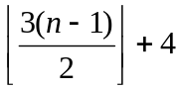, which is optimal to within a small additive constant. This constant is less than or equal to 3.
- Each spanning tree can be derived from its preceding one, cyclically, bye the application of a rotation. From the properties of the rotation operation, we conclude that all subtrees are isomorphic and that n-1 corresponding edges of spanning trees are all of different dimensions.
- Applications
  - Lower Bounds
  - Single-Node Broadcasting
  - Fault Tolerant Single-Node Broadcasting
  - Fault Tolerant Multinode Broadcasting
  - Fault Tolerant Single-Node Scattering
  - Fault Tolerant Multinode Scattering
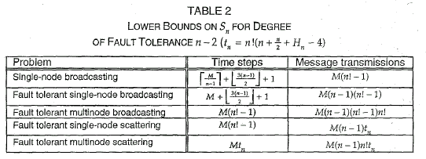
- Conclusion
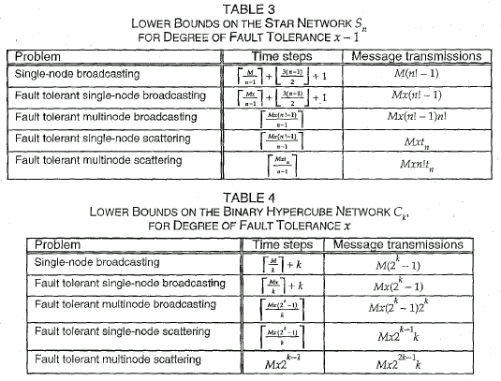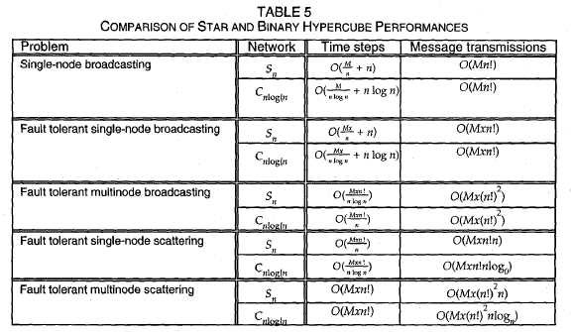
Created by: Ming-Cheng Lin
Date: June 22, 2000

