MATRIX OPERATION USING ARRAYS WITH RECONFIGURABLE OPTICAL BUSES
SANDY PAVEL and SELIM G. AKL
Parallel Algorithm and Applications. Vol. 8, pp. 223-242(1996)
Abstract
This paper examines the possibillity of implementing matrix
operations on an array with reconfigurable optical buses(AROB).

1. Introduction
2. The Array with Reconfigurable Optical Buses
A linear array of n processors connected to an optical bus as in Figure 1.
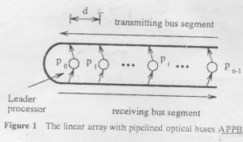

- all transmissions are synchronized.
- d >= bwc_{g}
b: each message is b bits long.
w: an optical signal of width w seconds for a binary value of 1.
cg: the velocity of light in the waveguide.

The Linear Array with Reconfigurable Optical Buses(LAROB)

3. Basic Simulations and Applications
3.1 Binary Prefix Sums on a Linear APPB
The n-values BPS problem can be solved on a linear APPB with n processors in constant time.

3.2 Compaction on a Linear APPB

3.3 2D Compaction
4. Dense Matrix Multiplication
The addition of b (logn)-bit binary numbers can be performed in O(1) time on the (logn)×n AROB.

Matrix-Vector Multiplication

The transpose of a matrix 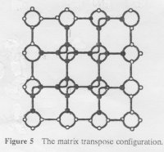

Matrix Multiplication Algorithm
5.Sprse Matrix Computions
Matrix-Vector Multiplication

The Multiplication of Two Sparse Matrices

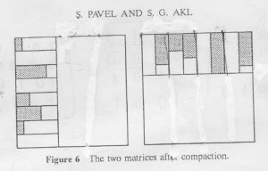
6.Gaussian Elimination
Pivot Selection

Gaussian Elimination Algorithm

- Applt the Pivot Selection Algorithm and determine an element a_{h,k}.
- Let v be the kth column of [A | b] without the pivot, and let w^{T} be the hth row of [A | b] without the pivot. Compute the matrix C = -a_{h,k}⁻¹(vw^{T}).
- Let [A’ | b’] be the matrix obtained by removing the kth column and the hth row from [A | b]. Compute [A | b] = [A’ | b’] + C.

Repeat n-1 times.
7.Conclusion

Created by : Ming-Chang Lin
Date : Oct. 8, 1999

